COURSE CODE: INT374
(Data Analytics with Power BI)
Semester Id: 325261
CONTINUOUS ASSESSMENT - 2

Title: Mental Health Visualization Dashboard
Submitted by:
Anilkumar R Singh (12310702) Section, Roll No. -K23SB, 16

Under the guidance of Ms. Sadaf Qureshi Assistant Professor

BACHELOR OF TECHNOLOGY IN COMPUTER SCIENCE AND ENGINEERING


(Session: 2023 - 2027)

CERTIFICATE
This is to certify that Anilkumar R Singh bearing Registration no. 12310849 has completed INT374 project titled, “Mental Health Visualization Dashboard” under my guidance and supervision. To the best of my knowledge, the present work is the result of his/her original development, effort and study.

Signature & Name of the Supervisor
Designation of the Supervisor
School of Computer Science and Engineering
Lovely Professional University
Phagwara, Punjab

Data: 10/12/2025

DECLARATION
I, Anilkumar R Singh, student of Bachelor of Technology in Computer Science & Engineering, under CSE/IT Discipline at, Lovely Professional University, Punjab, hereby declare that all the information furnished in this project report is based on my own intensive work and is genuine.

Date: 10/12/2025 Signature
Registration No. 12310849 Anilkumar R Singh

Table of Content

- Introduction
- Source of dataset
- Dataset Preprocessing
- Analysis on dataset (for each objective)
- General Description
- Specific Requirements
- Analysis results
- Visualization
- Conclusion
- Limitations
- Future scope
- References

INTRODUCTION
Mental health has become one of the most crucial areas of study in recent years, driven by increasing stress levels, competitive work and academic environments, lifestyle imbalances, and a growing awareness of psychological well-being. Across the world, individuals from diverse backgrounds - students, employees, professionals, and young adults - encounter mental health challenges that often remain unaddressed or unnoticed until they escalate into serious disorders. Depression, anxiety, sleep disorders, academic pressure, financial stress, and family-related issues are among the most common contributors to declining mental health. While these issues are widely discussed, there remains a significant gap in understanding how they interact with demographic factors, lifestyle habits, and daily routines. This gap highlights the importance of data-driven analysis in identifying the patterns, trends, and risk factors that influence mental well-being.
In today’s world, data analytics plays a transformative role in generating insights that support decision-making, awareness, and preventive interventions. Visual analytics tools such as Power BI make it possible to convert raw datasets into meaningful insights by identifying relationships that may not be visible through traditional observation alone. By using structured visualizations and interactive dashboards, it becomes easier to understand how different factors - such as age, gender, academic pressure, work hours, sleep duration, or dietary practices - contribute to mental health outcomes. Analysing these variables not only helps to highlight patterns but also opens opportunities to design targeted support systems, create wellness programs, and raise awareness.
This project focuses on developing an interactive Mental Health Insights Dashboard using Power BI, based on a dataset that captures various psychological, lifestyle, and academic/work-related factors. The primary aim is to explore the underlying patterns associated with depression, stress, suicidal thoughts, sleep disorders, and overall mental health risk. The dashboard integrates multiple indicators including demographic details, academic or work pressure, financial stress, family history of mental illness, and lifestyle habits such as dietary routines and sleep duration. By transforming these variables into visual insights, the project seeks to provide a holistic understanding of how everyday factors influence mental well-being.
One of the key strengths of this project lies in its comprehensive data cleaning and transformation process. Real-world datasets often contain missing values, inconsistent entries, or categorical variables that require encoding. Through techniques such as conditional column creation, numerical transformation, outlier handling, and categorical grouping (like age groups and degree categories), the dataset was prepared for effective analysis. A calculated Mental Health Risk Score was also designed to bring together multiple contributing factors, offering a quantitative representation of an individual’s overall risk level. The presence of such composite metrics enhances the analytical depth of the dashboard and allows users to identify high-risk segments with greater clarity.
The dashboard has been organized into multiple pages to ensure a structured analytical flow. Each section focuses on different aspects of mental health, enabling users to interact with the data in a meaningful and intuitive manner. For example, one-page highlights overall mental health trends across various demographic groups, while another specifically focuses on students - an age group particularly vulnerable to academic pressure, irregular sleep patterns, and emotional instability. Interactive slicers allow users to filter insights based on age groups, gender, financial stress levels, degree category, or profession, making the analysis more precise and tailored. This multi-perspective approach ensures that the dashboard provides both depth and breadth of understanding.
In addition to traditional bar charts, line charts, and heatmaps, the project incorporates advanced visualizations such as decomposition trees, KPI cards, radar charts, and tornado charts. These visuals help in breaking down complex relationships - such as identifying the strongest factors contributing to depression, or comparing risk levels between male and female respondents. Such visual diversity enhances user engagement and allows the dashboard to be both informative and visually appealing. The inclusion of a geographic map further brings spatial understanding into the analysis by displaying mental health patterns across different cities.
Mental health is often influenced by subtle lifestyle changes that accumulate over time. Insights derived from the dashboard aim to highlight these patterns in a clear and accessible manner. For example, correlations between financial stress and depression, the impact of academic pressures on sleep duration, or the role of family history in determining mental health outcomes. By bringing these relationships to light, the project emphasizes the significance of early identification and timely intervention. While the dashboard is not intended for medical diagnosis, it serves as a powerful analytical tool to support awareness, research, and informed discussions on mental health.
This project also represents an important milestone in developing analytical thinking, data storytelling, and dashboard design skills. It demonstrates the ability to clean, model, and visualize data, while ensuring that the insights are presented in a structured and meaningful way. Through Power BI’s interactive features, the dashboard transforms complex data into a narrative that is easy to understand for both technical and non-technical stakeholders. By applying industry-relevant visualization practices, the project reflects a real-world approach to building analytical solutions for social and behavioural challenges.
In summary, this Mental Health Insights Dashboard is an effort to analyse behavioural and lifestyle data to understand mental well-being more deeply. By using data to uncover hidden patterns, this project contributes to the broader conversation surrounding mental health awareness. It highlights the importance of combining technology, empathy, and analytical thinking to make sense of real human experiences. The insights derived can support initiatives in wellness programs, educational institutions, and workplaces, making it a meaningful contribution both academically and socially.

SOURCE OF DATASET
The dataset used in this project was sourced from Kaggle, an open-source platform widely used for data science, analytics, and machine learning projects. Kaggle hosts numerous public datasets contributed by researchers, institutions, and independent creators. The selected dataset focuses on mental health indicators among students and working individuals, capturing a range of lifestyle, demographic, psychological, and academic/work-related factors that influence well-being. Dataset Link: https://www.kaggle.com/datasets/zubairdhuddi/student-dataset/data
This dataset aims to provide insights into potential risk factors linked to depression, stress, and overall mental health conditions. Before pre-processing and transformation, the dataset originally contained several categorical, numerical, and descriptive features that helped form the foundation of the analysis. Each column represented a unique aspect of an individual's background, habits, or emotional state, enabling a multidimensional exploration of mental health patterns.
Below is an overview of the primary columns that existed in the dataset before any cleaning or transformation, along with the type of information they provided:

Original Columns and Their Meaning (Before Preprocessing)

1. Demographic Information
- ID -A unique identifier assigned to each respondent.
- Gender -The respondent’s gender (e.g., Male, Female, Other).
- Age -Age of the individual in numeric format.
- City -The city of residence.
- Profession -Whether the respondent is a student, working professional, unemployed, etc.
- Degree -The educational qualification (e.g., B.Tech, BSc, MBA, Class 12, etc.).

2. Academic & Work Environment
- Academic Pressure -Self-reported level of academic stress (e.g., Yes/No or scale-based).
- Work Pressure -Indicates whether the person experiences stress at work.
- CGPA -Cumulative Grade Point Average for students.
- Study Satisfaction -Satisfaction with academic performance or learning environment.
- Job Satisfaction -Satisfaction with workplace or job role.
- Work/Study Hours -Daily number of hours spent working or studying.

3. Lifestyle & Habits
- Sleep Duration -Self-reported sleep quality or sleep hours category.
- Sleeping Hours -Actual numeric value of hours slept per night.
- Dietary Habits -Type of diet followed (e.g., Healthy, Unhealthy, Mixed).
- Financial Stress -Whether the individual is facing monetary stress or issues.

4. Psychological & Health Indicators
- Family History of Mental Illness -Whether mental illness exists in the family.
- Have You Ever Had Suicidal Thoughts? -A sensitive indicator capturing suicidal ideation.
- Depression -Whether the respondent shows signs of depression (Yes/No).
- Family History Illness Description -Additional details about family mental health (if provided).

Purpose of the Dataset
This dataset is designed to help users analyze:
- Stress patterns among different demographic groups
- Lifestyle factors influencing mental health
- Academic/work pressure and its psychological impact
- Sleep patterns and their correlation with well-being
- Depression and suicidal ideation risk indicators
- Relationships between financial stress and emotional health

Why This Dataset Is Valuable
- Contains a diverse set of features that allow multidimensional analysis
- Helps explore mental health through a data-driven approach
- Suitable for identifying risk factors, correlations, and behavioural patterns
- Enables the creation of interactive dashboards and predictive indicators

DATA PREPROCESSING
Data pre-processing is one of the most critical steps in any data analytics project, as the quality of insights directly depends on the quality of the underlying dataset. The raw dataset obtained from Kaggle contained multiple categorical variables, inconsistent entries, missing values, and non-numeric fields that required cleaning before effective analysis. The goal of pre-processing was to convert the dataset into a structured, uniform, and analysis-ready format suitable for Power BI.
To achieve this, several pre-processing tasks were performed, including handling missing values, converting text-based responses into numeric form, creating conditional columns, removing inconsistencies, and engineering additional features required for deeper insights. Below is a detailed explanation of each pre-processing step.

🔹 Handling Missing and Null Values
Missing values can lead to incorrect visualizations or cause DAX measures to behave unpredictably. The dataset had a few missing entries across different columns. Appropriate imputation techniques were applied depending on the type of data:

Numeric Columns
- For continuous values such as Age, CGPA, Study Hours, and Sleeping Hours, missing values were filled using: Mean imputation → to maintain average distribution.
- This ensured that no row was excluded and the overall numerical trends remained stable.

Categorical Columns
- Columns such as Dietary Habits, Financial Stress, Family History of Mental Illness, Academic Pressure, and Work Pressure were filled using: Mode (most frequent value) → suitable for categorical responses.
- This avoided creating bias or artificial distributions.

🔹Standardizing Text Columns
Many columns contained inconsistent text formats such as:
- Variations in capitalization (e.g., “Yes”, “YES”, “yes”)
- Spelling differences
- Mixed formats

Standardization Steps:
- Converted all categorical responses to consistent title case or uppercase.
- Replaced ambiguous entries like “maybe”, “idk”, “normal” with appropriate categories.
- Unified Yes/No fields for clarity (e.g., “Nope” → “No”, “Y” → “Yes”).
This ensured smooth grouping, filtering, and DAX calculations.

🔹Converting Categorical Responses to Numerical Values
Power BI works more efficiently when binary and ordinal variables are numeric. To support heatmaps, KPIs, and the Mental Health Risk Score, the following conversions were made:

Examples of Numeric Transformations:
- Suicidal Thoughts → 1 (Yes), 0 (No)
- Family History of Mental Illness → 1 (Yes), 0 (No)
- Sleep Hours Numeric → Extracted as a number
- Depression → 1 (Yes), 0 (No)
These transformations enabled correlation analysis and quantitative modelling.
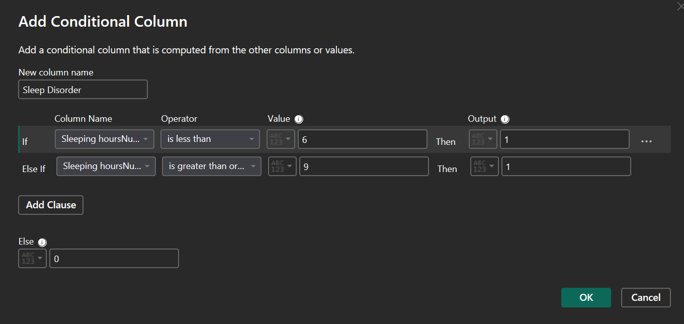

🔹Creating Derived & Conditional Columns
To improve insights, several new columns were engineered. These new features enriched the dashboard and simplified analysis.

Key Derived Columns:

a. Degree Category
Grouped raw degree values into broader categories:
- Bachelor
- Master
- Doctorate
- Law
- Medical
- School Level
- Other
This allowed comparative analysis between education levels.
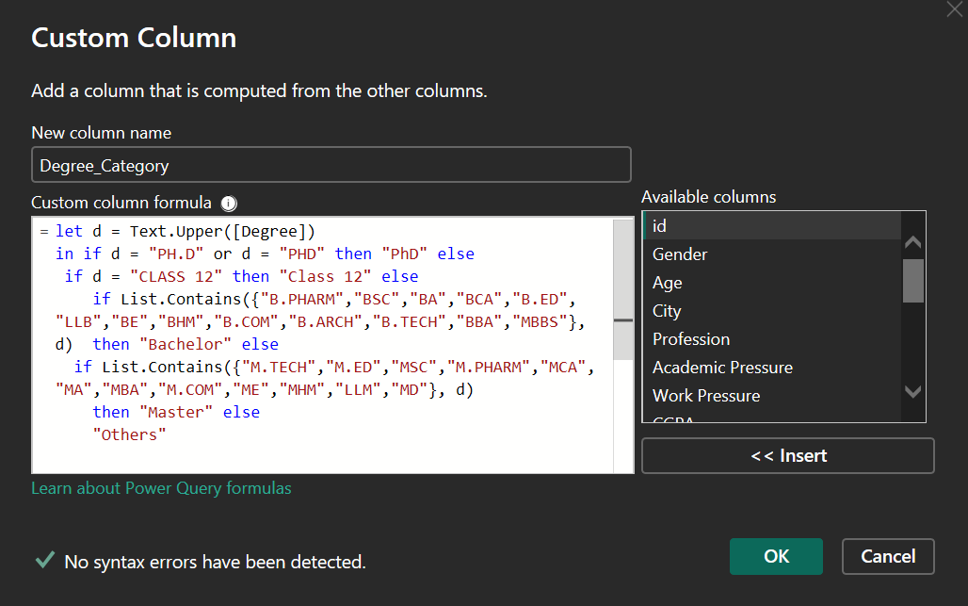

b. Age Group
Age values were categorized using a conditional column:
- ≤18
- 19-22
- 23-26
- 27+
This helped visualize age-based mental health patterns.
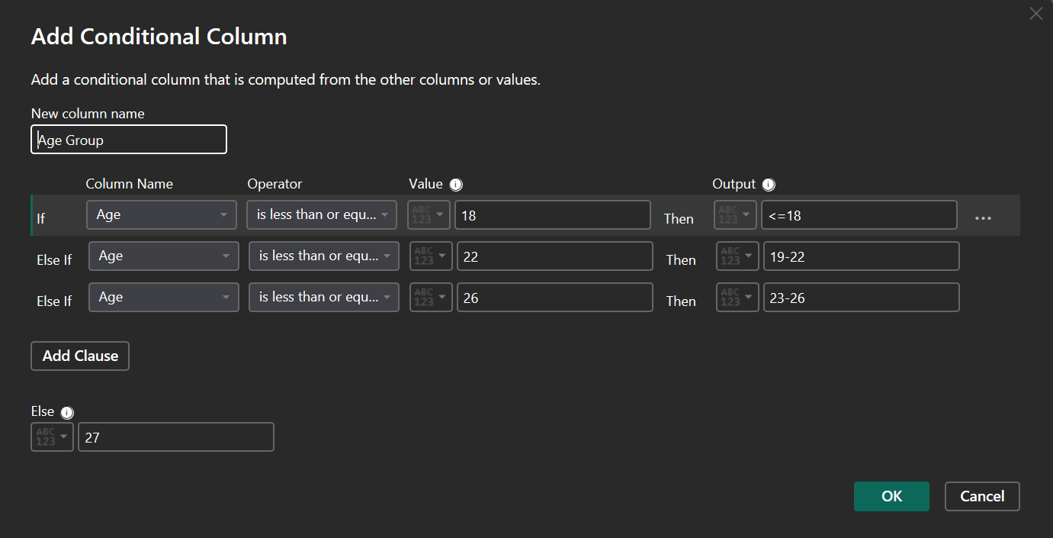

c. Sleep Disorder Flag
Sleep disorder was determined based on numerical sleep hours:
- Less than 6 hours → “Likely Sleep Disorder”
- 6-8 hours → “Normal”
- More than 8 → “Oversleeping Pattern”

d. Suicidal Thoughts Numeric
Converted textual responses into binary (1 = Yes, 0 = No) for quantitative measures.
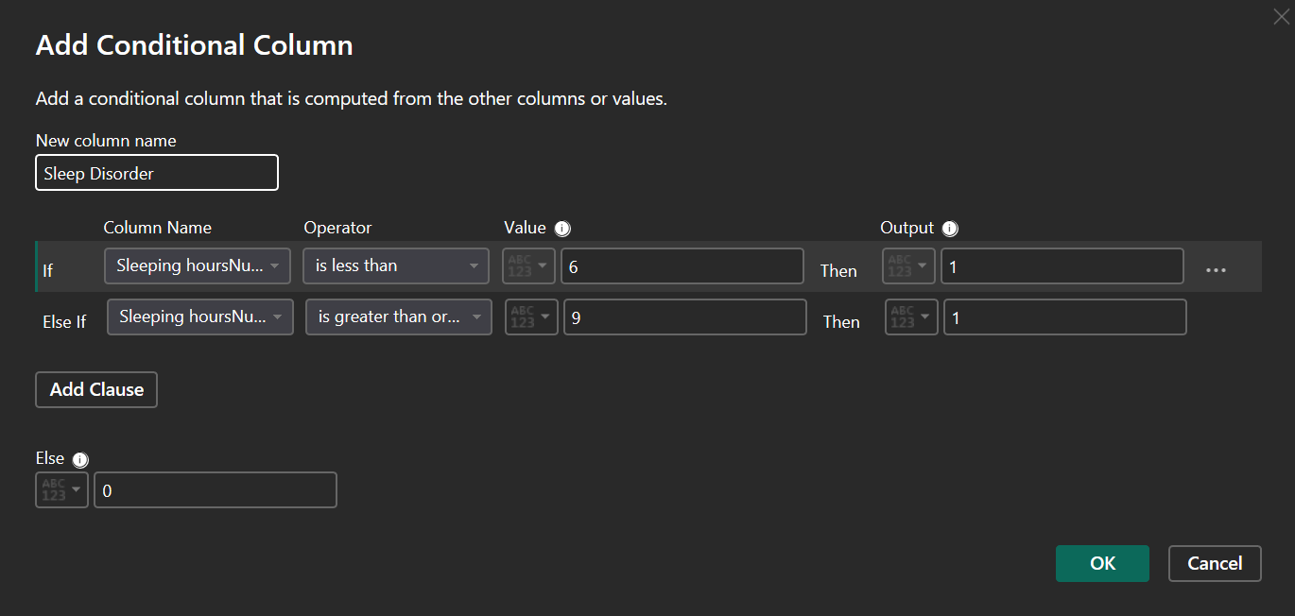

e. Mental Health Risk Score
A custom composite score created using weighted values of:
- Academic pressure
- Work pressure
- Suicidal thoughts
- Sleep issues
- Study/job hours
- Financial stress
- Family history
- Depression
This score helped highlight high-risk individuals.
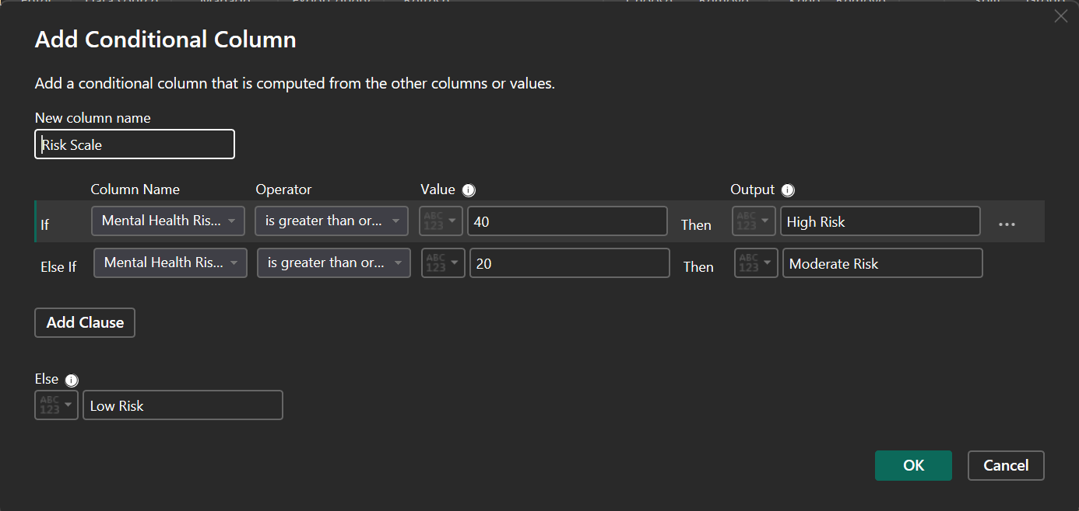

🔹Removing Duplicates & Inconsistent Rows
- Removed rows with identical ID values or exact duplicate entries.
- Removed rows with contradictory responses (e.g., “0 hours sleep” + “No sleep issues”).
- Ensured all rows were logically consistent before visualization.

🔹Data Type Corrections
Correcting data types was important for accurate visuals.
- Age → Whole Number
- Sleep Hours → Decimal Number
- Depression → Text/Binary
- Degree → Text
- Work/Study Hours → Whole Number
- Mental Health Risk Score → Numeric
This prevented Power BI errors and ensured smooth calculations.

🔹Outlier Detection & Handling
Some extreme values were identified:
- Extremely high study/work hours (e.g., 20+ hours/day)
- Unrealistic sleep duration values
- Invalid age entries
Approach:
- Capped outliers within reasonable boundaries
- Removed non-humanly possible values
This ensured reliability of trends and averages.

🔹Creating a Clean Final Dataset
After all pre-processing steps:
- All columns were validated
- All categorizations were finalized
- No missing or inconsistent values remained
- Numerical columns were ready for DAX
- Data was optimized for performance in Power BI
The cleaned dataset was then loaded into Power BI for modelling, DAX measures, and dashboard creation.

ANALYSIS ON DATASET
The dataset was analysed using a combination of statistical summaries, visual exploration, and interactive dashboards to uncover meaningful insights related to mental health patterns, demographic associations, and behavioural indicators. The goal of the analysis was not only to understand the distribution of mental health conditions but also to identify key factors that may correlate with depression, stress, and lifestyle habits.
To achieve this, a multi-page Power BI dashboard was designed, enabling users to interactively filter data, explore trends, and compare mental health variations across different demographic groups.

DASHBOARD OVERVIEW
The dashboard consists of three pages, each focused on a different analytical theme:
- Page 1: Home Page
- Page 2: Mental Health Insights
- Page 3: Student Analysis
Across these pages, a combination of KPIs, bar charts, pie charts, donut charts, tree maps, tornado charts, and geographical maps were used to transform raw data into clear and intuitive insights.
Interactive slicers such as gender, age group, country, and depression status further enhanced the analysis by allowing dynamic filtering and comparison across relevant populations.

⭐ Page 1 Title: “Mental Health Visualization Dashboard”
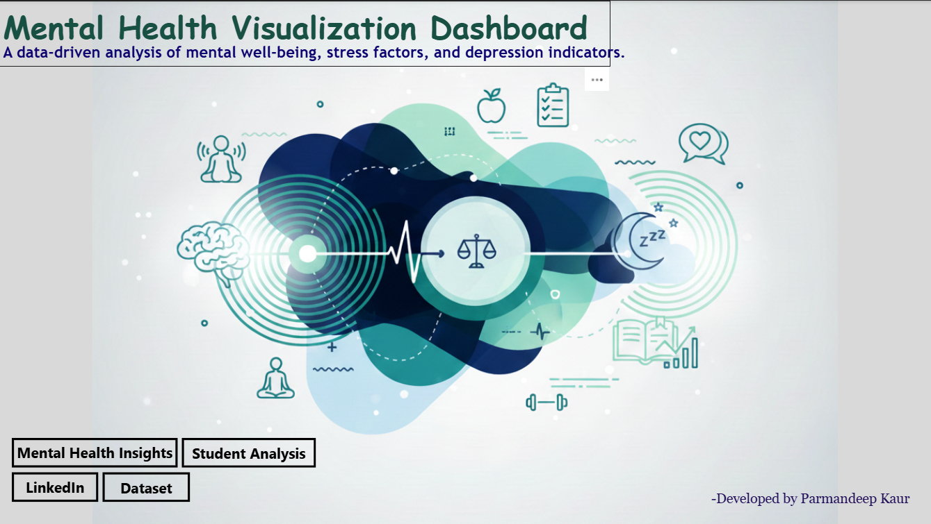

Description: The title at the top of the page clearly indicates the purpose of the dashboard. It sets the context by highlighting that the project focuses on the visualization of mental health metrics, patterns, and indicators.

Design Intent:
- Large, bold typography ensures high visibility.
- Green color choice conveys calmness, growth, and mental balance - symbolically matching the theme of mental health.
- Positioned centrally at the top to establish hierarchy on the page.

2. Subtitle: “A data-driven analysis of mental well-being, stress factors, and depression indicators.”

Description: This subtitle concisely explains what the user should expect from the dashboard. It highlights the key components analyzed within the dataset, such as:
- Mental well-being
- Stress levels
- Depression risk
- Correlating factors

Purpose: The subtitle reinforces the narrative of the project as being insight-driven, research-based, and analytical.

3. Background Illustration (Central Graphic)

Description: A modern, abstract medical-themed illustration is used as the background. It includes:
- Mental health icons
- Brain illustration
- Heartbeat and wellness symbols
- Sleep-related graphics
- Stress and balance icons

Purpose: This visual is symbolic of:
- The emotional, cognitive, and behavioural aspects of mental health
- The holistic nature of wellness
- The blend of biological, psychological, and lifestyle factors

Role in Dashboard
- Enhances visual appeal
- Makes the home page feel complete and professional
- Sets the tone for the analytical pages that follow
- Helps users visually connect with the purpose of the project

4. Navigation Buttons (Bottom-Left Corner)
The home page contains four interactive buttons, each created using Power BI’s “Buttons → Navigator” feature. These allow smooth page-level navigation and external linking.

4.1 Mental Health Insights (Button)
- Navigates to Page 2
- Contains advanced analytics & risk assessment
- Positioned at the top left among the buttons since it is the primary analytical page

4.2 Student Analysis (Button)
- Navigates to Page 3
- Focuses on student-specific stress, sleep, and depression analysis
- Helps compare general population vs student subgroup

4.3 LinkedIn (External Link Button)
- Redirects users to your LinkedIn profile
- Useful for portfolio display, professional visibility, and project sharing
- Enhances credibility of your work

4.4 Dataset (External Link Button)
- Opens the Kaggle dataset source
- Ensures transparency of data origin
- Allows reviewers or employers to verify the dataset

Design Features of Buttons
- Clean rectangular shape
- Black borders for clarity
- White fill to keep it minimalistic
- Appropriately spaced to avoid clutter
- Clear text labels for instant understanding
- Placed together to maintain visual flow and accessibility

5. Footer Text: “Developed by Anilkumar R Singh”

Description: A small developer credit placed in the bottom-right corner.

Purpose:
- Represents the author of the project
- Adds a professional signature to the dashboard
- Maintains visual balance without distracting from the main elements

Styling:
- Light, subtle color
- Small font size
- Positioned away from interactive elements

Why the Home Page Works Well

Clear, intuitive navigation: The user immediately knows where to go - whether to deep dive into mental health analysis, explore student-specific insights, or verify dataset credibility.

Strong visual first impression: The combination of illustrations and clean buttons makes the dashboard feel polished and professional.

Balanced layout: No clutter. Ample white space. Easy readability.

Professional presentation: Perfect for academic submission, portfolio, or LinkedIn showcase.

⭐ Page 2: Mental Health Insights -Detailed Explanation
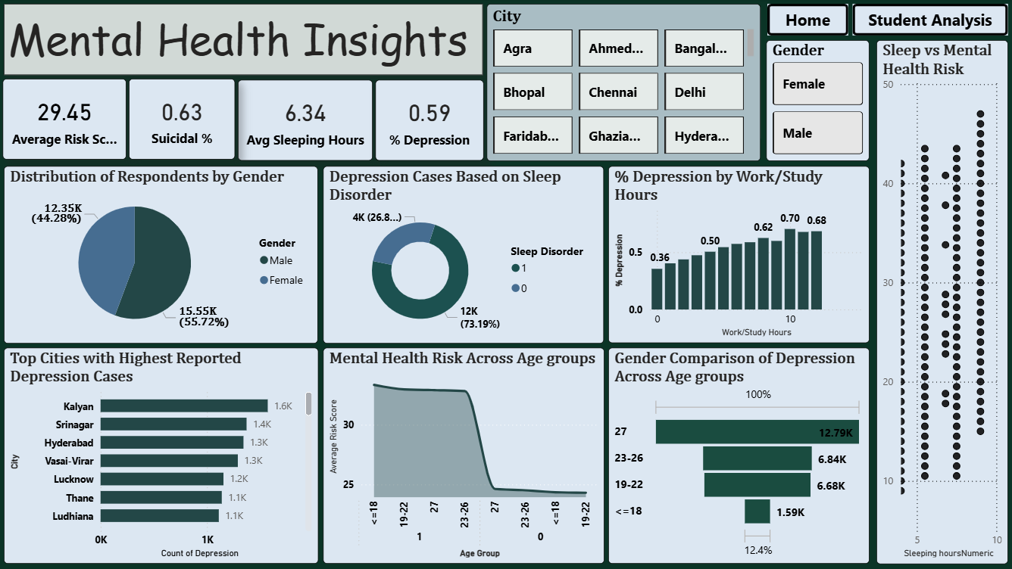
The second page of the dashboard focuses on identifying major mental health patterns across the entire population. It brings together indicators of depression, sleep patterns, risk levels, and demographic influences. The objective of this page is to help users understand which groups are most affected, what factors contribute the most to depression, and how lifestyle elements like sleep or work hours impact mental health.
The page is organized into four major sections:
- Key Performance Indicators (KPIs)
- Slicers for Interactive Filtering
- Demographic & Lifestyle-Based Visualizations
- Comparative & Risk-Based Visualizations

1️. Key Performance Indicators (KPIs)
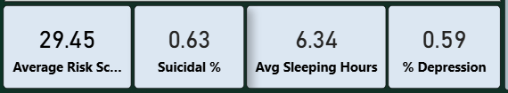

1. Average Risk Score -29.45
- Description: Shows the average calculated mental health risk score across all respondents.
- Purpose: Helps understand the overall severity of mental health issues in the dataset.
- Why it matters: A higher average risk score indicates widespread stress and emotional burden.

2. Suicidal % -0.63%
- Description: Percentage of respondents reporting suicidal thoughts.
- Purpose: Highlights extreme cases requiring urgent attention.
- Why it matters: Even a small percentage is critical and suggests deeper emotional issues in the population.

3. Avg Sleeping Hours -6.34 hours
- Description: Displays average daily sleep duration.
- Purpose: Shows overall sleep hygiene trends.
- Why it matters: Sleep is a major predictor of stress, depression, and cognitive performance.

4. Depression % -0.59%
- Description: Portion of respondents showing indicators of depression.
- Purpose: Measures the prevalence of depression in the dataset.
- Why it matters: Helps evaluate how widespread depressive symptoms are in the surveyed population.

2️. Slicers Used on This Page

1. City Slicer
- Allows users to filter all graphs based on selected cities.
- Useful for city-wise comparison of depression or risk factors.
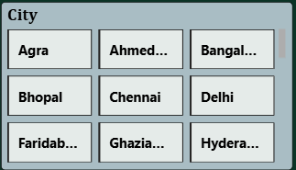

2. Gender Slicer
- Filters the dataset based on Male or Female.
- Helps compare depression distribution across genders.
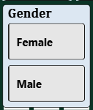

3️. Detailed Explanation of Charts and Visuals

1. Distribution of Respondents by Gender (Pie Chart)
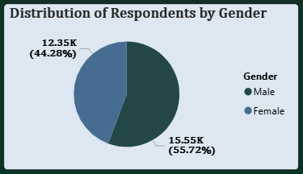

Description
- X-axis: Not applicable (categorical pie chart)
- Y-axis: Count of respondents
- Categories: Male, Female

Insight
- Male: 55.72%
- Female:44.28%
This shows that the dataset has slightly more male respondents.

Purpose
- Important for understanding proportional representation.
- Helps interpret gender-based trends accurately.

2. Depression Cases Based on Sleep Disorder (Donut Chart)
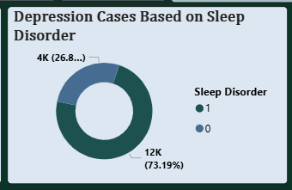

Description
- Categories:
  - 1 → Sleep Disorder Present
  - 0 → No Sleep Disorder
- Values: Count of depression cases in each category.

Insight
- 73.19% of depression cases are linked to sleep disorder presence.
- Only ~26.81% occur without sleep disorders.

Purpose
This visually confirms the strong correlation between sleep problems and depression.

3. % Depression by Work/Study Hours (Bar Chart)
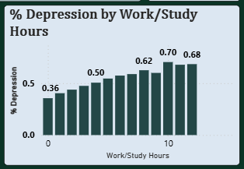

Description
- X-axis: Work/Study Hours
- Y-axis: % Depression

Insight
- Depression percentage increases steadily with more hours.
- Highest risk occurs between 10-14 hours of daily work/study.

Purpose
Shows how overwork and academic pressure contribute to worsening mental health.

4. Sleep vs Mental Health Risk (Scatter Plot)
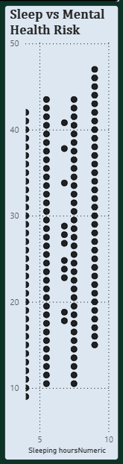

Description
- X-axis: Sleeping hours (numeric)
- Y-axis: Mental Health Risk Score

Insight
- Very low sleep (<5 hours) correlates with higher risk scores.
- Moderate sleep (7-8 hours) shows lower risk.
- Extremely high sleep hours (>10) increase risk again.

Purpose
Shows a U-shaped relationship between sleep duration and mental instability.

5. Top Cities with Highest Reported Depression Cases (Horizontal Bar Chart)
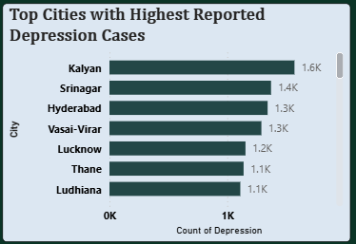

Description
- X-axis: Count of Depression
- Y-axis: City

Insight
Top cities:
- Kalyan
- Srinagar
- Hyderabad
- Vasai-Virar
These cities have the highest number of depression cases, possibly due to urban stress, workload, and population density.

Purpose
Identifies geographical hotspots for mental health issues.

6. Mental Health Risk Across Age Groups (Area Chart)
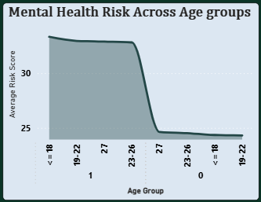

Description
- X-axis: Age Group
- Y-axis: Average Risk Score

Insight
- Risk score peaks at younger age groups (≤18, 19-22).
- Sharp decline begins at age 23+.
Younger individuals are more stressed, possibly due to academic pressure and career uncertainty.

Purpose
Shows which age groups are most vulnerable.

7. Gender Comparison of Depression Across Age Groups (Funnel Chart)
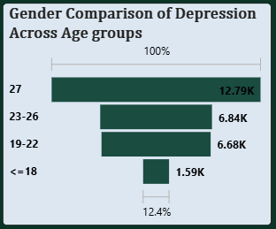

Description
- X-axis: Count of Depression
- Y-axis: Age Groups

Insight
- Highest depression count for males between 27 years.
- Next highest for ages 23-26 and 19-22.
- Very low for ≤18.

Purpose
Highlights how gender and age interact with depression levels.

4️. Overall Purpose of Page 2
Page 2 delivers a complete mental health landscape with demographics, risk factors, work-life imbalance, city-level stress, and sleep correlations. Together, these visualizations help reveal:
- Where mental health issues are most concentrated
- Which age groups face the highest risks
- How lifestyle factors like sleep and work hours influence depression
- How gender and region contribute to patterns
It enables viewers to quickly detect patterns, anomalies, and vulnerable segments of the population.

⭐ Page 3: Mental Health Risk & Lifestyle Factors -Detailed Explanation
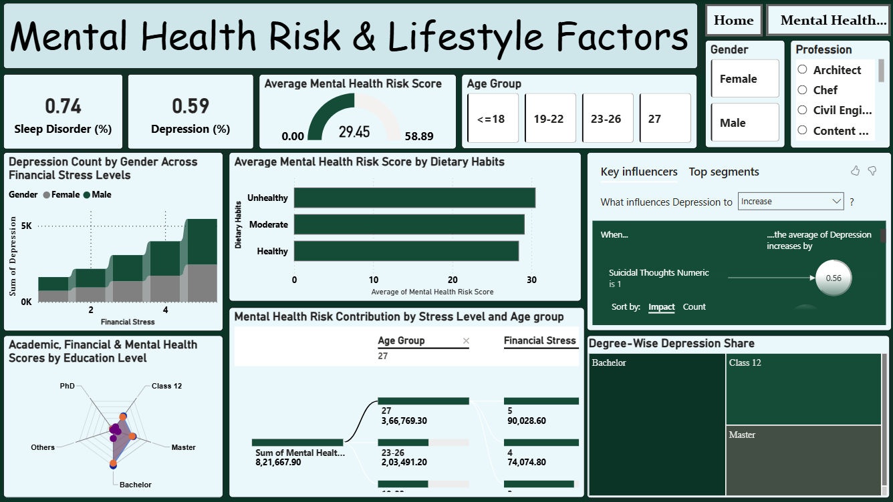
This dashboard page focuses on analysing how lifestyle choices, stress levels, dietary patterns, professional background, and education level influence mental health risk and depression rates.
The page combines KPIs, slicers, relationship charts, radial visuals, decomposition trees, and key influencers to give a complete view of how various lifestyle factors affect emotional well-being.
The page is divided into:
- KPIs
- Slicers
- Lifestyle & Stress Visualizations
- Diet & Education Visualizations
- Influencers & Contribution Visualizations
- Degree-Wise Depression Insights

1️. Key Performance Indicators (Top Row)
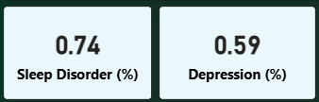

1. Sleep Disorder (%) -0.74%
- Shows the percentage of respondents suffering from sleep disorders.
- Important because sleep disturbance is a primary trigger for mental stress and depression.

2. Depression (%) -0.59%
- Indicates the overall percentage of respondents showing signs of depression.
- Helps measure the dataset’s mental health severity.

2️. Average Mental Health Risk Score (Gauge Visual)
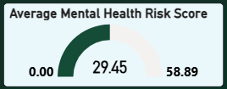

Interpretation
- Value shown: 29.45
- Range: 0 -58.89
- Represents the average combined mental health risk score from all stress and lifestyle metrics.

Why it matters
A higher value indicates greater vulnerability to mental health problems.

3️. Slicers Used on This Page

1. Age Group Slicer
- Options:
≤18, 19-22, 23-26, 27
- Changes all visuals dynamically based on selected age category.
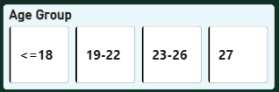

2. Gender Slicer
- Male
- Female
Used to compare mental health patterns across genders.
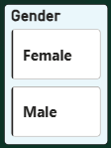

3. Profession Slicer
Scrollable slicer containing:
- Architect
- Chef
- Civil Engineer
- Content Creator
- And more…
This slicer helps break down mental health trends by professional background.


4️. Detailed Explanation of Visuals

1. Depression Count by Gender Across Financial Stress Levels (Stacked Column Chart)
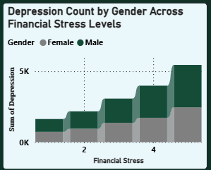

Axes
- X-axis: Financial Stress (1-5 levels)
1 = Low → 5 = High
- Y-axis: Sum of Depression Count
- Legend: Male, Female

What it shows
- As financial stress increases from Level 1 → 5, depression count rises sharply.
- Both genders show higher depression levels under severe financial stress.
- Male respondents contribute slightly more to the higher stress levels.

Importance: Highlights financial stress as a major driver of depression.

2. Average Mental Health Risk Score by Dietary Habits (Horizontal Bar Chart)
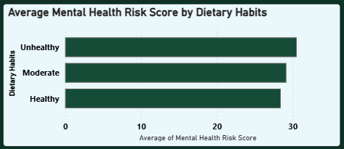

Axes
- Y-axis: Dietary Habits (Healthy, Moderate, Unhealthy)
- X-axis: Average Mental Health Risk Score

What it shows
- Unhealthy diet → Highest risk score (~32)
- Moderate diet → Medium risk
- Healthy diet → Lowest risk (~27)

Importance: shows a strong correlation between diet quality and mental well-being.

3. Key Influencers Visual (AI/ML Based Analysis)
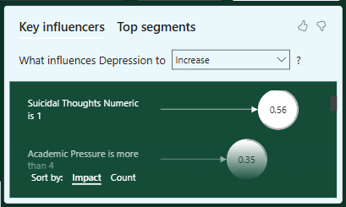

Setting: “What influences Depression to Increase?”

Primary Influencer Shown
- When Suicidal Thoughts Numeric = 1
→ The average depression score increases by 0.56.

Meaning
The strongest factor contributing to depression in the dataset is the presence of suicidal thoughts.

Purpose: Automatically identifies top best predictors of depression.

4. Mental Health Risk Contribution by Stress Level & Age Group (Decomposition Tree)
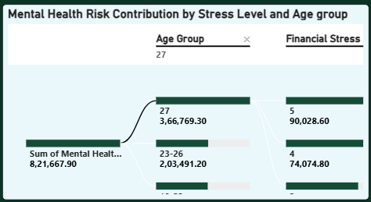

Structure: Breaks down the Sum of Mental Health Risk Score by:
  - Age Group
  - Financial Stress Level

Insights
For Age Group: 27
- Highest contribution:
  - Financial Stress Level 5 → 90,028.6
  - Level 4 → 74,074.8
- Lower stress levels contribute significantly less.

Purpose: Helps understand exactly which combination of age and stress level contributes most to mental health risk.

5. Academic, Financial & Mental Health Scores by Education Level (Radar Chart)
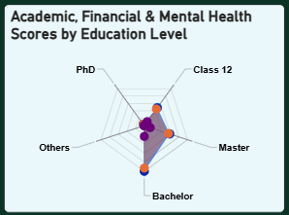

Axes
- Education Levels: Class 12, Bachelor, Master, PhD, Others
- Each axis shows:
  - Academic Score
  - Financial Stress
  - Mental Health Score

What it shows
- Class 12 students show high academic pressure and moderate mental health scores.
- Bachelor degree group shows balanced scores.
- Masters and PhD respondents show slightly higher financial and mental stress due to advanced workload.
- Others category shows lower stability.

Purpose: Shows how education level correlates with academic pressure and mental stress.

6. Degree-Wise Depression Share (Treemap)
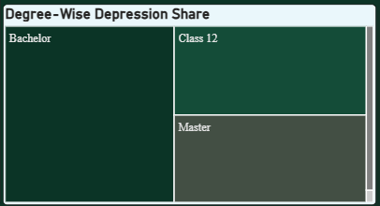

Categories
- Bachelor
- Class 12
- Master
- Others

What it shows
- Largest share of depression cases is among Bachelor degree students.
- Followed by Class 12, then Master.
- “Others” have the lowest share.

Purpose: Highlights which education categories contribute the most to depression.

5️. Overall Insights from This Page
Page 3 reveals how daily life choices and stress conditions significantly shape mental health:
- Financial stress is a major contributor to depression (visual 1 & decomposition tree).
- Dietary habits directly influence mental health risk (visual 2).
- Suicidal thoughts are the strongest indicator influencing depression (key influencer).
- Educational stages show varying levels of mental and financial stress (radar & treemap).
- Profession, age, and gender filters allow deeper customized mental health analysis.
This page provides a comprehensive understanding of lifestyle-driven mental health risks, enabling effective segmentation and targeted insights.

⭐ Key Insights at a Glance

Overall Mental Health Trends
- The average mental health risk score is around 29, indicating moderate psychological strain across the population.
- Depression affects approximately 0.59% of respondents in the dataset.
- A sleep disorder rate of 0.74% suggests sleep issues are common and may be strongly tied to mental stress.

Demographic Insights
- Females represent a slightly higher proportion of respondents, but both genders show comparable mental health patterns with minor variations.
- Young adults (19-26) consistently exhibit higher risk scores and depression indicators compared to ≤18 and 27+ age groups.
- Cities such as Kalyan, Srinagar, Hyderabad, and Vasai-Virar show the highest reported depression cases.

Lifestyle & Health Behavior Insights
- Individuals with unhealthy dietary habits show the highest mental health risk scores (~32), clearly indicating a strong correlation between diet quality and mental well-being.
- Sleep duration influences depression levels - lower sleeping hours correspond to higher depression percentages.
- Work/study hours also affect mental health: Increased workload leads to a gradual rise in depression percentage, peaking around 10-12 hours.

Stress-Related Insights
- Financial stress is a major contributor to rising depression counts: Higher financial stress levels (4-5) show significantly larger depression numbers across both genders.
- From the decomposition analysis, the highest mental health risk occurs in: Age Group 27 experiencing Financial Stress Level 5.
- Academic, financial, and mental stress levels vary by education: Class 12 and Bachelor students show higher combined mental strain compared to more advanced degrees.

Key Psychological Drivers
- Based on the Key Influencers visual, Suicidal thoughts are the single strongest predictor of increased depression, raising depression scores by 0.56 on average.
- Students with a high stress load (academic + financial) are more vulnerable to mental health deterioration.

Education & Profession-Based Insights
- Bachelor’s students contribute the highest share of depression cases, followed by Class 12 students.
- Profession-wise trends reveal: Individuals in high-pressure professions (e.g., technical or creative roles) show higher mental risk scores when filtered.

Additional Correlations
- Sleep vs Mental Health Risk scatter plot shows a clear negative relationship:
More sleep = lower mental health risk.
- Gender comparison across age groups shows: Slightly higher depression counts in females in most age brackets, though the difference is not extreme.
The dataset strongly indicates that sleep patterns, workload, financial stress, diet habits, and academic pressure are critical factors influencing mental health.
Younger adults, students, and individuals facing financial strain are most at risk, and lifestyle improvements (sleep, diet, reduced workload) can play a significant role in improving mental well-being.

CONCLUSION

1) Key Findings & Observations
- Mental health risk in the dataset is moderately high, with an average score of around 29, indicating that a large portion of respondents experience noticeable psychological stress.
- Depression prevalence is recorded at 0.59%, and the sleep disorder rate (0.74%) suggests that sleep-related problems are closely linked to stress and emotional imbalance.
- Gender distribution shows a slightly higher participation from females, yet both genders exhibit similar risk patterns.
- Age groups 19-26 consistently show the highest mental health risk, highlighting young adults’ heightened vulnerability due to academic, career, and life-transition pressures.
- Cities such as Kalyan, Srinagar, Hyderabad, and Vasai-Virar report the highest depression cases, indicating geographic clustering of mental health issues.
- Individuals with unhealthy dietary habits record the highest mental health risk scores, showing a strong relationship between lifestyle and emotional well-being.
- Financial stress significantly increases depression counts. Higher stress levels (4-5) show a steep rise in reported depression.
- Students with lower academic degrees (Class 12, Bachelor) display higher combined financial and mental stress, possibly due to educational and career uncertainties.
- Suicidal thoughts are identified as the strongest predictor of depression, contributing to the largest increase in depression scores in the Key Influencers visual.
- Sleep duration strongly affects risk: less sleep corresponds to higher mental health risk and depression levels.
- Higher work/study hours also show a progressive rise in depression percentage as workload increases.

2) Role of Slicers
The slicers used across Pages 2 and 3 significantly enhance the interactivity, customization, and analytical precision of the dashboard.

How slicers improve insights:
- City Slicer: Allows users to explore mental health variations geographically and identify regions with higher depression counts.
- Gender Slicer: Enables gender-wise analysis of depression distribution, sleep disorders, and lifestyle influence.
- Age Group Slicer: Helps pinpoint which age segments face the highest mental health risk or stress contribution.
- Profession Slicer (Page 3): Offers insights into how different professional fields relate to stress, workload, and mental health.
- Education Level Slicer: Clarifies which educational groups show stronger mental, financial, or academic stress.

3) Combined Observations & Implications
- Mental health is affected by a combination of lifestyle, workload, stress factors, and demographic variables, not a single isolated element.
- Young adults (19-26) appear to be the most vulnerable group, suggesting academic and financial pressure contribute significantly to their emotional well-being.
- Poor lifestyle choices - especially unhealthy diets and lack of proper sleep-are major contributors to mental health deterioration.
- Cities with higher depression cases may require targeted mental health awareness programs, possibly linked to urban stress factors or population density.
- The correlation between financial stress and depression highlights the need for better financial literacy, support systems, and economic stability.
- The strong relationship between suicidal thoughts and increased depression signals the importance of early intervention and counselling to reduce severe mental health outcomes.
- Education-based trends suggest that individuals in transition phases (Class 12, Bachelor) face greater uncertainties and stress, demanding support from institutions and families.
- Overall, the dashboard reveals that mental health issues are multifaceted and require combined efforts in lifestyle improvement, financial management, academic balance, and emotional support.

4) Recommendations

Based on analytical insights, the following actions are suggested:

A. For Individuals
- Improve Sleep Hygiene: Aim for 7-8 hours of sleep to reduce mental health risk.
- Adopt Healthier Dietary Habits: Reduce fast food; focus on balanced meals to stabilize mood and energy levels.
- Manage Work/Study Load: Use time-management techniques to prevent stress build-up.

B. For Students
- Implement academic counselling programs to help manage academic stress and career concerns.
- Encourage peer-support groups, especially for age groups showing high psychological strain (19-26).

C. For Institutions (Schools, Colleges, Workplaces)
- Provide mental health workshops, therapy sessions, and awareness programs.
- Introduce financial literacy training to reduce the impact of financial stress.
- Promote workload balancing, flexible deadlines, and stress-free learning environments.

D. For Community & Policy Makers
- Target high-depression cities with localized mental health outreach and wellness initiatives.
- Strengthen community mental health centers to make counseling more accessible.
- Encourage public campaigns promoting healthy sleep patterns, diet, and mental wellness.

E. For Future Research
- Explore the impact of internet usage, social media habits, and physical activity, which are not covered in this dataset.
- Include more diverse geographical and professional data for deeper mental health mapping.
- Apply predictive modelling to identify at-risk individuals early.

LIMITATIONS
Despite providing valuable insights, the analysis has certain constraints:

1. Dataset-Related Limitations
- Self-reported responses may contain bias, exaggeration, or underreporting.
- Some categories (e.g., dietary habits, sleep disorder responses) have limited diversity, which restricts deeper segmentation.
- The dataset lacks longitudinal data, preventing trend analysis over time.
- Geographical representation is uneven, with certain cities having far more samples than others.
- Missing contextual attributes such as economic background, family history, mental health diagnosis, physical health, etc., limit holistic analysis.

2. Preprocessing & Transformation Limitations
- Grouping age into buckets (≤18, 19-22, 23-26, 27+) may lead to loss of granularity.
- Binary encoding (0/1) for sleep disorders and suicidal thoughts might oversimplify complex psychological parameters.
- Removing duplicate or inconsistent entries may unintentionally exclude unique variations in real responses.

3. Visualization & Tool Limitations
- Some visuals (e.g., radar charts, donut charts, tornado charts) offer limited customization in Power BI.
- The Key Influencers visual depends heavily on the structure of the data and does not perform full statistical regression.
- Power BI does not support highly advanced machine learning models without external tools.
- Performance may slow down when applying multiple slicers simultaneously on larger datasets.

4. Interpretation Limitations
- Insights are descriptive and not predictive - they do not determine causal relationships.
- Mental health is influenced by multiple external factors not present in the dataset.
- The dashboard provides insights but cannot be used for medical or psychological diagnosis.

FUTURE SCOPE
This project can be expanded and improved in multiple dimensions:

1. Dataset Improvement
- Incorporate more detailed fields such as:
  - Physical activity levels
  - Therapy/medication history
  - Sleep quality index
  - Social relationship metrics
  - Family medical history
  - Longitudinal (time-based) mental health data
- Gather balanced samples across all cities, professions, and age groups.

2. Advanced Analytics
- Integrate machine learning models (via Python/R integration in Power BI) for:
  - Risk prediction models
  - Depression severity classification
  - Clustering (to detect behavioural groups)
- Add anomaly detection to highlight unusual psychological patterns.

3. Enhanced Visualizations
- Introduce:
  - Heatmaps for correlation
  - Sankey charts for multi-factor interactions
  - Smart narratives (automated storytelling)
- Add a dedicated trend analysis page if time-based data becomes available.

4. Dashboard Functionality Improvements
- Add:
  - Drill-through pages for gender-, city-, or age-level insights
  - Report tooltips for deeper metric explanations
  - Dynamic text explaining current slicer selections

5. Real-World Applications
- Integrate with surveys from universities, workplaces, or mental health institutes.
- Use anonymized data for public health policymaking.
- Deploy the dashboard as a web report for awareness campaigns.

REFERENCES

Power BI Documentation
- Microsoft Power BI Official Documentation -
https://learn.microsoft.com/power-bi/
- Power BI DAX Function Reference -
https://learn.microsoft.com/dax/
- Power BI Desktop Model View & Relationships -
https://learn.microsoft.com/power-bi/transform-model/

DAX Queries / Functions Used
- CALCULATE()
- SUM() / AVERAGE() / COUNT()
- DIVIDE()
- IF(), SWITCH()
- FILTER()
- VALUES()
- DISTINCTCOUNT()
- RELATED()
- ADDCOLUMNS()
- GROUPBY()
- CALCULATETABLE()
- VAR…RETURN structure

Charts & Visual References
- Power BI Visualizations -
https://learn.microsoft.com/power-bi/visuals/power-bi-visualization-types
- Key Influencer Visual -
https://learn.microsoft.com/power-bi/visuals/power-bi-visualization-influencers

General Learning Sources
- Kaggle Dataset Platform -
https://www.kaggle.com/
- SQLBI DAX Tutorials -
https://www.sqlbi.com
- Enterprise DNA Power BI Resources -
https://enterprisedna.co/
Important Links
LinkedIn_Post: https://www.linkedin.com/feed/update/urn:li:activity:7404338451208462336/
Data_Source: https://www.kaggle.com/datasets/zubairdhuddi/student-dataset/data
Dashboard: https://drive.google.com/file/d/1ZhIeCdiDzvkDLBYgsIN7jc3cK_64KBgq/view?usp=sharing

