DESIGN & IMPLEMENTATION OF COURSE REGISTRATION
AND RESULT PROCESSING SYSTEM
(A case study of Federal Polytechnic Ilaro.)

BY

OBAYOMI OLAWALE SOLOMON (H/CS/14/0214)

A PROJECT REPORT SUBMITTED IN PARTIAL FULFILMENT OF THE REQUIREMENTS FOR THE AWARD OF HIGHER NATIONAL DIPLOMA IN THE DEPARTMENT OF COMPUTER SCIENCE, SCHOOL OF APPLIED SCIENCE, THE FEDERAL POLYTECHNIC, ILARO.

AUGUST, 2016

CERTIFICATION
This is to certify that this project was carried out by OBAYOMI, OLAWALE SOLOMON under the supervision of Mrs. J .Soyemi in the Department of computer science: School of Applied Science, The Federal Polytechnic, Ilaro, Ogun State.

------------------------------------------
Supervisor’s signature and Date

--------------------------------------------
Head of Department’s signature and Date

DEDICATION

All the work done in coming up with this system is dedicated to my family for being with/part of me in the whole process especially my dear mum Mrs. Obayomi Folake, my dear uncle Mr. Olubukola Ogundare, my brothers Mr. Obayomi Olalekan and Mr. Obayomi Abiodun who stood by me in all situations even at the times of financial support.

ACKNOWLEDGEMENT

I express my gratitude to ALMIGHTY GOD for his grace and mercies granted unto me throughout the period of my study.
The enduring pages of the work are the cumulative sequence of extensive guidance and Arduous work. I wish to acknowledge and express my personal gratitude to all those without whom this work could not have been reality. I feel very delighted to get this rare opportunity to show my profound senses of reverences and indebtedness to my esteemed guide Mrs. J .Soyemi (Project Supervisor) for her keen and sustained interest, valuable advice, and technical support throughout the course of which led my new technology analysis to a successful completion. For this kind act of consideration I beholden to them in special manner and no one can fully convey my feelings of respect and regard for them. I can’t express my thanks in words for my parents who have given me this opportunity and family members for their great support and love. Last but not least I would like to thank those who have directly or indirectly helped and co-operated in accomplishing this report.

ABSTRACT

This study was carried out to verify all the manual process involved in generating Students Examination Result and to seek a way of automating the system for effective operations. Since there is continuous moves towards technological advances that enhanced productivity of labor and free human beings of task more economically by machines. Computer and its appreciations have become vital tools in economic, industrial and social development of advanced countries of the world. This system is designed to efficiently handle processes like inputting scores, storing results, classifying the grade points automatically calculated, and interpreting data of students overall result. The usual manual process now reached a level where it is difficult for the available man power to cope with the magnitude of examination work, in the given time span, The balance between the man power availability and the magnitude of the examination work result in the delay in the release of results. The most effective measure, which can improve the efficiency of the examination system, therefore is the introduction of computerization especially with the use of Examination Result Processing Software in various activities related to the conduct of result reduces the time span required for the release of results by 60 percent and reduces the process by almost 50 percent.

TABLE OF CONTENTS

TITLE PAGE…………………………………………………………………………..i
CERTIFICATION……………………………………………………………………...ii
DEDICATION………………………………………………………………………….iii
ACKNOWLEDGEMENT………………………………………………………………iv
ABSTRACT…………………………………………………………………………….v
TABLE OF CONTENTS……………………………………………………………….vi
LISTS OF TABLES…………………………………………………………………….vii
LIST OF FIGURES……………………………………………………………………..viii

CHAPTER ONE
- INTRODUCTION 1
  - STATEMENT OF PROBLEM 2
  - SIGNIFICANCE OF THE STUDY 2
  - AIM AND OBJECTIVES OF STUDY 3
  - SCOPE OF THE STUDY 3
  - LIMITATION TO THE STUDY 3
  - DEFINITON OF TERMS 3
CHAPTER TWO
- LITERATURE REVIEW 5
2.1 THE CONCEPT OF COMPUTER SYSTEMS 5
2.2 STUDENT RESULT GUIDE 8
2.3 RELEVANCE OF COMPUTER SYSTEM IN DATA PROCESSING 9
2.4 PROBLEMS ASSOCIATED WITH DATA PROCESSING 10
2.5 FORMATS OF RESULT 11
2.6 THE FEATURES OF RESULT PROCESSING 11
2.7 COMPUTER SYSTEMS AND RESULT PROCESSING 11
2.8 TYPES OF RESULT PROCESSING 12
2.9 THE BASIC FEATURES OF RESULT PROCESSING 13
3.0 FACTORS DETERMINING THE METHODS OF RESULT PROCESSING 13

CHAPTER THREE

- METHODOLOGY AND ANALYSIS OF THE PRESENT SYSTEM 17
3.1 OVERVIEW OF THE NEW SYSTEM 18
3.2 INPUT DESIGN 19
3.3 OUTPUT DESIGN 23
3.4 FILE DESIGN 23
CHAPTER FOUR

4.0 RESULT AND DISCUSSION 25
4.1 SYSTEM IMPLEMENTATION 25
4.2 HARDWARE REQUIREMENTS 25
4.3 SOFTWARE REQUIREMENTS 25
4.4 DISPLAY OF GRAPHICAL USER INTERFACE 26
4.5 PROGRAM DESCRIPTION 29

CHAPTER FIVE

5.0 CONCLUSION AND RECOMMENDATIONS 38
5.1 CONCLUSION 38
5.2 RECOMMENDATIONS 39
REFERENCES
APPENDIX

LIST OF TABLES

Table 4.3: Course Registration Form (Front)

Table 4.4: Carry Over/Referred Courses form
Table 4.5: Score Sheet

LIST OF FIGURES

Fig 2.2: Decentralized Data Processing
Fig 2.1: Centralized Data Processing
Fig 2.3: Distribute Data Processing
Figure4. 1: Snapshot of index menu
Figure 4.2: Snapshot of course introduction menu
Figure4. 3: Snapshot for department introduction menu
Figure 4.4: Snapshot student profile registration menu
Figure4. 5: Snapshot for student course registration menu
Figure4. 6: Question table

CHAPTER ONE

- INTRODUCTION
The effort expended in the process of registration of students and computation of their examination results is much. Quite worrisome is the fact that these processes are carried out every academic session, putting the operators in a continuous and ever demanding cycle. The computation of examination results and registration of students is obviously an object-centered activity, the student being the dominant object in this case. Hence, the need to evolve a computerized process that will effectively and efficiently capture all the important data associated with the registration and examination result processing within the tertiary institutions and the interactions among the objects.
Students’ Examination Result is the summary of each of the semester performance in schools. A students’ Result is also demanded by a student who has finished his/her program. and wishes to transfer to another school or student who wishes to get a job. A Transcript is not given directly to a student. It is sent to the school that the student wishes to be transferred, or to the organization or establishment that requires the result.
A students’ Result is prepared or formed by the scores entered on the designed score sheet by the individual course lecturers on semester examinations. This genuine and noble desire necessitated the design and development of the Undergraduate Registration and Examination Processing System software.
There were three fundamentally distinct education systems in Nigeria in 1990: the indigenous system, Quranic schools, and formal European-style education institutions. In the rural areas where the majority lived, children learned the skills of farming and other work, as well as the duties of adulthood, from participation in the community. This process was often supplemented by age-based schools in which groups of young boys were instructed in community responsibilities by mature men. By the 1970s, education experts were asking how the system could be integrated into the more formal schooling of the young, but the question remained unresolved by 1990. Western-style education came to Nigeria with the missionaries in the mid-nineteenth century. Although the first mission school was founded in 1843 by Methodists, it was the Anglican Church Missionary Society that pushed forward in the early 1850s to found a chain of missions and schools, followed quickly in the late 1850s by the Roman Catholics. In 1887 in what is now southern Nigeria, an education department was founded that began setting curricula requirements and administered grants to the mission societies. By 1914, when north and south were united into one colony, there were fifty-nine government and ninety-one mission primary schools in the south; all eleven secondary schools, except for King's College in Lagos, were run by the missions.
The education system focused strongly on examinations. In 1916 Frederick Lugard, first governor of the unified colony, set up a school inspectorate. Discipline, buildings, and adequacy of teaching staff were to be inspected, but the most points given to a school's performance went to the numbers and rankings of its examination results. This stress on examinations was still used in 1990 to judge educational results and to obtain qualifications for jobs in government and the private sector.
As more information is made available in a variety of formats and media and in a variety of locations, the need to manage information/data efficiently becomes more and more critical. Both staff and public users want access to stored information and want to access it more efficiently. It is the Polytechnic Policy to improve both the efficiency and effectiveness of course registration and result processing operations and services through the implementation of an integrated automated database System.

1.1 STATEMENT OF PROBLEM
Database of information is vital in today’s educational system with respect to course registration and examination result processing. This has become a very vital issue as students spend so much time trying to know the number of credit units for each semester. This problem has lead to time wasting, inaccuracy of results and even open to fraud. Cases of missing results have been recorded thereby making examination processing more difficult and untimely.
There has been this problem of too much work for the Head of Department of Exams and Records owing to the increase of students in the institution, the Head of Department of the Exams and Records is faced with heaps of files .At times sorting out a particular students file takes time. This bitter complaint and the delay in the preparing of this students examination Result has been the major concern and therefore has intensified the need to design a generating software which will go a long way in tackling these problems and proffering solutions, at the same time to quicken the generating of student’s result.

  - SIGNIFICANCE OF THE STUDY
The significance of this study is to design and implementation of Student Examination Result Processing System is to achieve the speedy registration process, speed of the results processing, to eliminate error due to manual processing and to provide security measure to check student mischievous act of changing marks on the result sheet. The Software will also provide a well functionality of student experience activity on student portal with various student and lecture’s interactions. The project work will help in a good number of ways to ease the delay in manual examination processing.
1.3 AIM AND OBJECTIVES OF STUDY
The aim of this study is to develop student registration, course registration, examination registration, result processing and student transcript in less time, accurately and fast processing.
The objectives of this study are to:
- Provide a reliable solution to result processing that is corruption free.
- To enhance the speed of the results processing.
- Ensure that normal credit load in line with the school is maintained.
- Provide a software that will generate result that is accurate, timely and error free.
- To keep accurate record of students examination Results in the school and prevent lost of result, which are vital to the exams and records.
- To provide a long time database backup.
- To process and transfer student academic transcript.

1.4 SCOPE OF THE STUDY
This research work will concentrate on student registration, course registration, academic transcript, examination processing, result processing system in Federal Polytechnic Ilaro, Ogun State and can be extended to other Polytechnics.

1.5 LIMITATION TO THE STUDY
The limitation to this study include the lack of needed time frame, lack of needed materials to complete the project.
1.6 DEFINITON OF TERMS
The following are some terms commonly used in this project.
DATA: Raw information or it is fact and figure collected together for references.
DIRECT DATA CAPTURED: Data is capture directly without a conversion stage, by means of the input devices such as mouse, keyboard, pen writers, cameras, fax, e.t.c.
INPUT: is the term denoting either an entrance which are inserted into a system. These are hardware that helps to send data in form of input to the computer.
ON-LINE DATA ENTRY: Data is entered directly into the computer one transaction at a time (also known as transaction processing) under program control.
OUTPUT: These are computer hardware that are responsible for giving out processed information.
SOFTWARE: The program and other operating information used by computer; also a set of programs written to carry out some task in the computer. Logical related programs that works together to control hardware.
PROCESS: This is the management of transportation of data into useful information.
STUDENTS EXAMINATION RESULT: An official record of student’s work that show the courses they have taken and the marks they have achieved.
DESIGN: The art or process of deciding how something will look, works etc.
DOCUMENTATION: Material that provides official information or evidence or that serves as record, written specifications and information that describes the product. The act of recording something in a document.
Information System: It is a collection of procedures, people, Instructions and equipment to produce information in a useful form.
Technology: It is study of techniques or process of mobilizing Resource (such as information) for accomplishing objectives that benefits man and his environment.
Information: Information can be defined as the process of gathering, transmitting, receiving, storing and retrieving data or several items put together to convey a desired message.

Computer Network: Computer Network is a system that connects two or more computers together using a communication link.

Databases: A systematically arranged collection of computer data, structured so that it can be automatically retrieved or manipulated. It is also called databank.

File Transfer: Any kind of computer file can be sent via the Internet from one Internet user to another. Table of accounts on spreadsheets, design by a graphic artists, music sound files etc, can all be exchanged in this way.

CHAPTER TWO

LITERATURE REVIEW

2.1 THE CONCEPT OF COMPUTER SYSTEMS
The introduction of computer into information technology has massively improved the information needs of organization. The success of this machine is dependent on the knowledge base. Therefore, one can be prompted to ask aloud “what is a computer?”. Funk (1980), defined a computer as an electronic device that can perform automatically and at a high speed, a sequence of logical operations according to instructions given to it in form of a pre-arranged program. Anigbogu (2000) defined a computer as an electronic device capable of accepting data and instructions, processing the data based on the instructions to generate results or output in such a manner that is yet to be equaled by any other known machine to mankind. Chimezie (1990) stated that “Computers are looked upon as obedient servants who are ever ready to free man from tedious procedures and produce results as compared with human computing time”. Obilikwu (1995) described computer as a machine that is capable of accepting input data, store and process the data based on instructions given by the computer user and in this way produce expected results, generally called output. These definitions of computer would lead us to answer the question “what is a program?”
In his definition Obilikwu (1995), defined a program as a sequence of instructions given to the computer to perform a specific operation. From Encarta Encyclopedia, computer program is a set of instructions that directs a computer to perform some processing function or combination of functions. The above definitions of computer clearly demonstrates the limitless area of operations of computer in as much as such task is programmable. Computer is applicable in virtually all areas of human endeavor ranging from Agriculture, Education, Business, Sports, Entertainment, Medicine, Construction and Military etc.
French (1992), in his book titled” computer Science” fourth edition, he relates the relevance of computer to management and stated that “a company needs information in which to base decisions concerning the current operations and future plans. It requires the information to be timely and accurate”. He then cited the example of the use of computer in the area of management control to production and stated “production must be able to respond quickly to changes in demand and other circumstances. To do so requires the provision of up to date information this is accurate and timely”. Aluko (1991), stated that “in virtually any job whether clerical, technical, business, or professional; whether it is a banking, medicine, education etc. Computers are useful tools” and that “computers are tools with which we calculate, measure, assess, store, retrieve, regulate and monitor information”. Hence, the blood and life – wire of any system is information. A typical system (Education, Management etc.) cannot survive without good management information system (MIS). Management information system (MIS) are information systems, typically computer- based, that are used within an organization. The concept of management information system is a complex variable although Murdick (1971), simplified it when he said “there is probably no more challenging and diversified subject than management theory, system theory and computer science”. Admission processing system, result processing system, course registration system is typical information processing system or organizational information system on candidates’ admission and performances.
World Net describes an information system (I.S) as “a system consisting of the network of all communication channels used within an organization, and includes software and hardware”. It may also be defined as “a system that collects and processes data (information) and provides it to managers at all levels that use it for decision making, planning, program implementation and control. The aim of information system to admission, registration and result processing in polytechnics is improving the quality and accuracy of information provided to all involved as well as assisting polytechnics in compiling and reporting information.
The information system (IS) has common data set on admission, admittance regulations of different polytechnics and admission procedures. Computerization is a social process for providing access to and support for computer equipment to be used in activities such as teaching, accounting, writing, designing, circuits, file processing etc. Computerization entails social choices about the levels of appropriate investment and control over equipment and expertise, as well as choices of equipment.
Kling (1991), by the early 1990s, computing and telecommunications accounted for half of the capital investments made by private firms. However, paper Feigenbaum (1980) and McCorduck (1983) and Yourdon (1986) stated that the most fervent advocates of computerization have argued that the actual pace of computerization in schools, factories and homes is too slow. Taylor (1980), classified computer-based education as to include both computer-assisted instruction programs that interact with students in a dialogue and a broader array of educational computer applications such as simulations or instruction in computer programming. There is major national push for extended application of computer-based education at educational levels. For example, in the mid 1980s private several colleges and Polytechnics required all their fresh students to buy a specific kind of Micro-computers and others invested heavily in visions of “wired Campus”.
Kling (1983) asserts that computer-based education has been promoted with two different underlying ideologies in all levels of education. Some educators argue that computer- based instructional approaches can help fulfill the traditional values of progressive education: the simulation of intellectual curiosity, initiative, and democratic experiences. For examples, (1984) has argued that computerized polytechnics are qualitatively different than traditional polytechnics: College students with micro computers in their dorm rooms, will stimulate them to learn because they will have easy access to instructional materials and more interesting problems to solve. Papert (1979), argues that in a new computer – based school students will no longer simply be taught mathematics. These visions portray an enchanted social order transformed by advanced computing technologies. Other advocates are a bit less romantic, but not less enthusiastic.
For example Cole (1972), states that because of the insatiable desire of students for more and more information at a higher level of complexity and more sophisticated level of utilization, more effective means of communication must be used so that Computers can provide a unique vehicle for this transmission”. Hence, it is important to note that computer- based education goes a long way in helping the students as well as the staff to effectively make use of the computerized course registration system. It also helps in convincing the stakeholders of the importance and need for adopting the computerized admission, registration and result processing system as it provides effective and accurate handling of student’s files.
Therefore, a computerized course registration system is usually a system, which is implemented with a computer to achieve the utmost efficiency and desired goals. In well developed countries, where education systems are computerized; course registration system should be and/or is one of the modules contained in the college portal. A “College Portal” therefore is personalized software that captures the entire education business process and makes all operations accessible via the web, thus allowing schools to effectively serve all stakeholders, students, lecturers, administrators and parents. It provides many functionalities including Admissions, Registration, Financial Services (transactions- processing), Exams & Records, Grading, Staff Management, Facility Management, Student self-care (My school), Alumni Records, Library and College shop, etc and supports workflow and Messaging and provides other collaboration tools and advanced reporting engines.
Russell, M. (1987), dealt extensively on the need for the use of computers on such database system like computerized course registration system. In the words of Dimorji (2003), at the center of any information system is a database, which is any collection of related information grouped together as a simple item. The term can also be applied to the ways in which information in catalog is used, analyzed, stored and used manually. Russell was also of the view that without a computer, effective handling of Candidates’ records cannot be achieved effectively. According to him, “The oxford University has more than ninety- six thousand student’s records. No person would precisely remember the details of these records”. The computer is the most possible application to retain an unlimited number of records with the utmost current updating possibilities. This is true as can be seen as posited by Eloba (1992), Computer in school record keeping, Technical Education Today, Vol. 3 No 182. “That at a department with over a thousand candidates, with the use of computer, all qualified for admission, only 100 candidates needed to be chosen. With the ranking of the scores or grades of the candidates, the management is in position to choose the best candidates with the best results with ease and on time” with the use of computer. Again, many computerized systems have become more than tools-they are environments that people sometimes find hard to change and so on. Kling and Suzanne (1988), argue that we have much to learn about future uses and consequences of computerization by carefully examining past and present experiences. Knowing fully well how the Polytechnics program is being run (manually), studying the past and present experiences, energize the idea of computerization of the board or the program.
Also, Kling, (1994) illustrates that systems being computerized offers exciting possibilities of manipulating large amount of information rapidly with little effort to enhance control, to create insights, to search for information, and to facilitate cooperative work between people.

  - STUDENT RESULT GUIDE
When a student attends an academic institution (s), a record is kept which traces his/her academic history. The students’ examination Result displays a record of all the credit and grades a student has acquired at each school attended. Below are frequently asked questions about students examination Results. By all students:
Student can use a student’s examination Result as a means of monitoring their credit classes and grades and to make sure the information is accurate. Students use an “Unofficial student’s examination Result “for this purpose. When a student is applying to another college or polytechnics, enrolling institution will require for an official students examination Result so that credits can be evaluated by the enrolling institution. An enrolling institution conducts a student's examination result evaluation to place a student at his or her appropriate academic level. Student must request their students’ examination Result from the office of Record or from the office of the Registrar. Each school has its own student’s examination Result release procedures. Because students examination Result requests are covered by the family Educational Rights and privacy. Act ,students ( giving name, date of attendance ,and social security number), or provide proper documentation when appearing in person often schools provide a “Request for official students examination Result “form .A small fee is usually charged .The difference between official and unofficial students examination Result is that ,official students examination Result must meet certain standards and be sent directly from one institution to another .In some cases, the college will accept an official students examination Result from the student if it hand delivered in a sealed envelope. Unofficial students’ examination Result can be sent directly to a requesting student. It could be marked as an unofficial student’s examination Result or issued to students but not all schools issue these. Each school has its own transfer credit acceptance policies. Credit transfer problems can result if:

- An institution does not have proper accreditation.
- Certain courses are taken (e.g. base skills or physical education courses) that are not approved for transfer.
- The amount of credit hours earned exceeds the maximum amount the institution will transfer.
- The enrolling institution has a difficult time evaluating a course.
- The course work is over 10 years old. Polytechnics often require appreciate catalogs or course descriptions.

2.3 RELEVANCE OF COMPUTER SYSTEM IN DATA PROCESSING
2.3.1. Computer Data Processing: This is any process that uses a computer program to enter data and summarize, analyze or otherwise convert data into usable information. The process may be automated and run on a computer. It involves recording, analyzing, sorting, summarizing, calculating, disseminating and storing data. Because data is most useful when it is well-presented and it is also informative. Data-processing systems are often referred to as information systems. Nevertheless, the terms are roughly synonymous, performing similar conversions; data-processing systems typically manipulate raw data into information, and likewise information systems typically take raw data as input to produce information as output. Data processing may or may not be distinguished from data conversion, when the process is merely to convert data to another format, and does not involve any data manipulation.

2.3.2 Data Analysis: When the domain from which the data are harvested is a science or an engineering field, data processing and information systems are considered terms that are too broad and the more specialized term data analysis is typically used. This is a focus on the highly-specialized and highly-accurate algorithmic derivations and statistical calculations that are less often observed in the typical general business environment. In these contexts data analyses packages like DAP, or PSPP are often used. This divergence of culture is exhibited in the typical numerical representations used in data processing versus numerical; data processing's measurements are typically represented by integers or by fixed-point or binary-coded decimal representations of numbers whereas the majority of data analysis's measurements are often represented by floating-point representation of rational numbers (Anigbogu, 2002).

2.3.3 Processing: Practically all naturally occurring processes can be viewed as examples of data processing systems where "observable" information in the form of pressure, light, etc. are converted by human observers into electrical signals in the nervous system as the senses we recognize as touch, sound, and vision. Even the interaction of non-living systems may be viewed in this way as rudimentary information processing systems. Conventional usage of the terms data processing and information systems restricts their use to refer to the algorithmic derivations, logical deductions, and statistical calculations that recur perennially in general business environments, rather than in the more expansive sense of all conversions of real-world measurements into real-world information say, an organic biological system.
Frederick (1916), first governor of the unified colony, set up a school inspectorate. Discipline, buildings, and adequacy of teaching staff were to be inspected, but the most points given to a school's performance went to the numbers and rankings of its examination results. This stress on examinations was still used in 1990 to judge educational results and to obtain qualifications for jobs in government and the private sector.
As more information is made available in a variety of formats and media and in a variety of locations, the need to manage information/data efficiently becomes more and more critical. Both staff and public users want access to stored information and want to access it more efficiently. It is the University Policy to improve both the efficiency and effectiveness of course registration and result processing operations and services through the implementation of an integrated automated database System.
Together with the emergence of the leadership and management practices to take advantages of these “flatteners”, and the collapse of political and economic barriers that accompanied the end of the cold war, what Friedman calls the “triple convergence” has literally “changed everything”. Friedman’s observations are supported by the words of the CEO of Hewlett Packard, that the world is entering “an era in which technology will literally transform every aspect of business, every aspect of life and every aspect of society.

2.4 PROBLEMS ASSOCIATED WITH DATA PROCESSING
There are problems with data processing with respect to Computer. The problems are the same as those problems encountered when using Computer.
The major problem is:
Hardware failure which may be caused by power (supply of current).

2.5 FORMATS OF RESULT
Result must be communicated to the person who wishes to use it. It can be communicated in a number of ways for example:
- By word of mouth (e.g. telephone) by sight (e.g. witnessing or observing something) even by touch, smell or taste
- On paper
    - as a report
    - as a set of figures
    - as a diagram or chart
    - as a photography or picture
- In a form that is not human sensible, or in a form that humans cannot use without the help of a computer or special equipment. Microfilm and microfiche are examples of this and computer files of magnetic disks, or magnetic tapes are others. The communication of the information would, in these cases, be communications between machines and humans would then have to use a machine such as a computer or microfilm reader to obtain access to the information they want. Information and organization are unified. Information is communicated so that decisions can be taken.

2.6 THE FEATURES OF RESULT PROCESSING
Processing business data can be said to have the following features for manual as well as electronic. The features are:
1. Collecting Data in the First Place: There must be data to processed and this may arise in the course of operations. There has to be a system or procedure for ensuring that all the data needed for processing is collected and made available for processing.
2. Up-Dating Files to Incorporate the Processed Data: Updating the personal ledger and the debtors control account are the updating activities to keep the sales ledger records up to date. Updating files means bringing them up to date.
3. The Routine Dissemination of Information to Users: This includes routine management control of information and comparing the actual results budgeted for the month. Providing non-routine information to users on request.

2.7 COMPUTER SYSTEMS AND RESULT PROCESSING
Computers are a key features of the electronic office, and it is important aware of the reasons why they process information better than a manual system. The functions of computers in information or data or result processing include:
- To process information or result more quickly
- To handle bigger volumes of processing
- To undertake complex processing
- To process information more reliably i.e. with less chance of error\mistakes
- To process information at less cost than a manual system.
- To improve the scope and quality of management information

2.8 TYPES OF RESULT PROCESSING
Basically there are two types of result processing: the conventional result (manual) processing and electronic method of result processing. Result can be processed manually or with the aid of primitive tools such as tabs or calculators, which take heavy tools in manual input. The processing of result by machines in general in such a way as to reduce to a minimum level the need for manual processing is referred to as automatic data processing (ADP). When result processing is mainly done by computers we refer to this as electronic data processing (EDP).
Generally the result processing methods are:
a. Manually Method: This involves operations performed by a clerk, assisted if desired by specific aids such as a pocket calculator or adding machine etc. this method processing is only suitable in cases where the volume of result to be processed is small and there is not too much emphasis on the specific period of time the work must be completed. The processing is simple and in most cases, the employment of more hands will solve the problem of time constraint. Example is the updating of handwritten result records.
b. Mechanical Method: This involves operations that are performed by machine consisting of a keyboard but which are actuated by depressing appropriate key by an operator. The results of this type of processing are printed on documents in specific columns. Example is the posting of lodgments and withdrawal on the personal customers’ ledger using an accounting machine.
c. Electronic Method: This is more or less like the mechanical method except that in this case the machine being used is electronic and may have optional peripheral devices that are attached to it. It can be can be used for many accounting procedures including payroll, stock schedules and ledger updating. These days’ computers are being used. Result for input are entered through the keyboard, card reader, optical character/mark reader, tape reader, while processed result are printed or stored on auxiliary storage. Its processing speed is high and can therefore handle quite a large amount of result. Very suitable for processing tasks that are repetitive in nature.

2.9 THE BASIC FEATURES OF RESULT PROCESSING
Result processing is the term for the process of producing meaningful information by collecting all items of result together and performing operations on them to extract the required result from them. At one time, electro-mechanical devices were widely used for result processing but the advent of versatile microcomputers hastened their demise (Eloba, 1998).

3.0 FACTORS DETERMINING THE METHODS OF RESULT PROCESSING
Common factors determining the methods of result processing can be under the following headings:
a. Size and Type of Results: with each of the examples given, the method of producing the result will largely depend on the size and type of result. In a very small school a single person may be able to have the time to produce all the result required, but as the volume of result increases, more people and aids, in form of calculators and small computers, may be employed. Large volumes of result will require the use of large computers. In small schools the payroll will be a matter of simply paying a member of staff the same amount each month, whilst in others, a complex payment by results system will have to be coped with. Similarly, invoicing may be simply be a matter of virtually copying from the customer’s order, or it may require complex discount calculation. Simple situations indicate the need for fewer people and aid to produce the information and complex situations indicate the need for more people and aids (French, 1992).
b. Timing Aspects: Some results requirements are less time critical than others. For example, the results for a semester may only be produced once in three months. The timing requirement for information will have considerable bearing on the methods and equipment needed to provide it.

3.0.1 RESULT PROCESSING STAGES
Whatever method, or combination of methods, is used it will be seen that result will pass through the same basic stages in the processing cycles.
The result processing stages are:
Input (act of receiving result for processing)
- Sorting (arranging result in a desired order to make processing quicker and easier)
- Processing (operating on result in order to obtain desired result)
- Storage (filling away of result for later use).
- Output result of processing.
- Control (regulating the different result processing functions to ensure that the result is being processed effectively).

3.0.2 MODES OF RESULT PROCESSING
1. Batch Processing: It is a technique by which items to be processed must be coded and collected into groups or batches prior to processing. A batch consists of either a convenient number of records or a collection of records relating to a given period, i.e. daily, weekly, monthly, etc. accumulated until a sufficient number are present to justify mass updating of master file. Each batch is used to update master file using a file maintenance program and an output produced. This type of processing is suitable for semester result and business applications, in which output is produced according to a predetermined processing cycle. The processing for this type of system is ordinary defined by the frequency with which the aster file must be updated. The average cost of processing results is low. No additional hardware, such as terminals or direct access storage devices, is needed. The system lends itself to control, as trailer records can be input which contain totals of important fields. The methods are secure as updating by copying can be used. It does, however, impose rigidity on the school. Weekly or monthly deadlines have to be met when peaks of work occur. Result is only up-to-date as the time of the result collection of the past update run; result is only produced once a period.
2. Real time Processing: Real-time = immediately. The processing of result in a sufficiently rapid manner so that the results of the processing are available in time to influence the current activity or process being monitored or controlled. The processing is applied to the master file as they happen and result is obtained from the system on demand.
3.On-line Processing: It concerns the equipment which is connected or re-engaged and functioning with the CPU and main program e.g. teletype units, consoles, card-reader, OCR readers, VDU etc. it is at least a one-way communication between operators at terminal and the CPU.
4. Time-sharing Processing: The system interacts with many users, giving each of them fast individual attention on a time slice basis. Multiprogramming is necessary in a time-sharing system (Murdick, 1971).

3.0.3 RESULT TRANSMISSION
Result can be fed into the computer in any one of three modes:
a). Simplex: A simplex line allows result to be transmitted in one direction and one direction only. These simplex lines may be used to connect result collection terminals to distant computer systems, thus speeding the flow of result from these on-line input terminals.
b). Half-Duplex: A half-duplex line is one in which result can be transmitted in either direction, but in only one direction at a time, the flow of result in one direction must stop before result may flow in the opposite direction. Such lines may be used in time sharing operations.
c). Full Duplex: A duplex line is one in which result can be transmitted simultaneously both direction. Input/output (I/O) operations can be completed simultaneously. Such lines serve best in real time systems handling large volume of I/O transmission encouraging rapid distribution of result.
3.0.4 CENTRALISED RESULT PROCESSING
Centralized result refers to as data processing which is carried out by a centralized location, such as head office. The data for processing might be gathered from a wide area, such as from all local offices the output might be sent out over a wide area too. But the actual processing and the possession of the data files are centralized. Data might be fed in to the central processing system either by physical transporting data records from their source to the central location, or electronically, to a remote terminal in the local office, linked to the central computer. Centralized processing is generally associated with a single computer, perhaps a mainframe or minicomputer being used for all the computer data processing in a school. It has the advantage of simplicity, low cost, elimination of duplicate computer hardware and efficient use of data processing resources.

Data fed in from a wide area
Central files
Central processing
Output distributed from the
central location

Fig 2.1: Centralized Data Processing

3.0.5 DECENTRALISED RESULT PROCESSING
In the decentralized data processing, each locality or department is provided with a computer system and does not necessarily have any thing in common. Each centre handles its own data processing needs and generally does not interacts with any other division or centers. It quickly responds to divisional needs and suits a decentralized management scheme. However, it is expensive on account of duplication of facilities and files. Here processing in a department is independent of one another, (Osaula, 1978).
Dept A
Dept B
Dept C

Fig 2.2: Decentralized Data Processing

3.0.6 DISTRIBUTED RESULT PROCESSING SYSTEM
Distributed processing is a term defined by the National Computer Center as a system in which there are several autonomous but interacting processors and or data stored at different geographical locations. In other words, distributed processing links several computers together. Distributed processing might involve the combination of a central computer and other usually smaller computer at different locations, linked together by a data communication network. For example, remote micro with a keyboard and VDU can act as network. For example remote micros with a keyboard NS VDU can act as intelligent terminals to a central mainframe. All the results files to be located centrally with the smaller computer. The main features of distributed result processing system; as compared to a centralized DP system is that instead of carrying out all processing from a standalone central computer with a set of central files, from a standalone central computer with a set of central files, a distributed system design but distributed processing has key distinct features. There are some flexibility in such computer system design, but the features of distributed processing are as follows: Computer are distributed or spread over a wide geographical area. The ability for one computer in the system to have access to the information files of other computers in the system i.e. to share files. The ability for computer s within the system to process result jointly or interactively. Distributed result processing is generally associated with either: A number stand alone microcomputer being used to process result in a number of different department in a school; each microcomputer operates in independently of the other (either a wide area network or a local area network) (Anigbogu, 2002).

Main Computer
Dept A
Dept B
Dept C

Fig 2.3: Distribute Data Processing

CHAPTER THREE

METHODOLOGY AND ANALYSIS OF THE PRESENT SYSTEM

3.0 THE RESEARCH METHODOLOGY
For us to achieve all these stated above, we made use of the internationally accepted software engineering model, which are Structured System Analysis and Design Methodology (SSADM). Structured System Analysis and Design Methodology (SSADM) is a systems approach to the analysis and design of information systems. SSADM method involves the application of a sequence of analysis, documentation and design tasks concerned with analysis of the current system, logical data design, logical process design etc. the steps involved are;

3.0.1 METHOD OF DATA COLLECTION
A thorough investigation of the current system was made in order to obtain detailed fact about the application area to be re-designed. Investigation also covered looking at the functional requirement of the present system and finding out whether the requirements and objective of the present system are being achieved. In the investigation proper, several methods of data collection were employed which includes interviewing of office representatives, evaluation/inspection of forms and direct observation. These methods were adopted to ensure the validity of data collected and relevance of the result after processing the data.

3.0.2 INTERVIEWING
In view to investigation, office representatives were interviewed such as the lecturers, HOD and faculty officers. This method yields the most profitable result as it is obtained by physical contacts, hence a firsthand knowledge of the various processes involved is obtained by speaking to the operator of the system. The essential element of the interview is obtained directly and in a short time than when other methods are employed since the interviewer is with the interviewed. This immediate feedback gives the opportunity to ask ambiguous questions and hence, obtain detailed responses.

3.0.3 OBSERVATION
The method of data collection enables the researchers to witness a firsthand operation of the old system or manual system. Direct observation is the surest method of learning as a scientist and this method was richly employed. During the observation, we had a feel of:
- The volume of work carried out
- The course registration processing
- The school filling system

3.1 OVERVIEW OF THE NEW SYSTEM
The itemized problem of the existing system can be solved or eradicated through the newly proposed system. It is better that records are computerized than done manually to avoid errors during data transfer of record and result. Those difficulties encountered in the existing system can be reduce using the proposed system.
Source program or application software will be developed which will perform the following task.
- Read the master file as input data.
- Process the students result
- Generate report for student score, grade, and grade point for each semester after a specified screen layout and dialog design.
- Append new records to the master file for processing.
- Modifies the existing records e t c.
To a great extent this eliminates duplication, redundancy and provides solution to some other itemized problems. Before user will be allowed access, it must be an authorized user. This is done by keeping the files of all authorized user who will have to enter their valid school information (matric number, level, department and institute) which will determine either they will be allow access or not. This will enhance data and information security.
In this new system, proof of ownership was implemented so that result of someone cannot be inputted for another person. Immediately the school information details of a particular candidate is inputted into the system it display the corresponding photograph of the owner, to be sure that the result about to be inputted is to the right person.
In the new system student are expected to do their profile registration, course registration and can view their profile and result information. In the new system the administrator are expected to do the course introduction, department introduction, score entry into the system.
Some of the advantages of the proposed system are:-
- Work flows can be done through network i.e ( if other institute are as well computerized) which enhances maximum accuracy, efficiency and reliability as source data are readily presented with computer, file organization and access mode is done at its best and internal disk are performed adequately
- It enhances great flexibility in processing student result.
- It is specialized, simplified and standardized
- Continuous control: A major steps are performed internally and automatically without user intervention, it can carry out the operation repeatedly without delays
- Time: it satisfies time requirements in terms of speed of equirement and access times for processing and executions.
- Adequate storage facilities for both input and output data.
- Duplication, redundancy and insecurity of data are completely eliminated.
- Files retrieval and saving are perform adequately at any point in time

3.2 OUTPUT DESIGN
Output can be visualized when relevant data has been processed to produce required information. Relating this process to what we discussed in processing, it is the only way in which one would know if the data inputted by the sender was understood by the unit or not.
Actually the output may be well processed, for the fact that they seek for an external processor to execute the task and it seems as if they are the processor. With respect to the output, the user will know that the system retain what was inputted. The output design was based on the inputs. The report generated gives a meaningful report to the management. The system designed generated the following reports.
  - Students semester result
  - Score Sheet
  - Students personal record
These outputs can be generated as softcopy or printed in hard copy.

3.3 INPUT DESIGN

The input to the new system is derived from student’s registration form, course registration form, and examination score sheet. These forms contain relevant information concerning student personal and academic records. The inputs are the processed to obtain the desired outputs. The input forms are designed as follows:

3.3.1 STUDENT’S REGISTRATION FORM

STUDENT’S PERSONAL DATA FORM
(TO BE COMPLETED IN TRIPLICATE)
Our Ref: CAU/REG/002
      - Name:Mr./Mrs./Miss______________________________________________________________________________________________________________________________
(in Block Capitals) Surname Other Names
2. Sex:_______________________
3. Date of Birth:_______________________________________
4. Local Govt. Area________________________________________________
5 State of Origin _____________________________________________
6 Home Town: _______________________________________________
7 Departments: _______________________________________________
8 Programmes: (Mark as appropriate)
ND ( ) PND ( ) HND ( )
9. Faculty: _______________________________________________________
10. Permanent (Home) Address: ______________________________________
______________________________________________________________
11 Have you previously enrolled at Federal Polytechnic, Ilaro? (Yes/No) If yes, what was your Registration Number and Course? _____________________________________
12. Why did you leave? ________________________________________________
13. Have you changed course? (Yes/No) ______________________________________
14. If yes state your former course: _________________________________________

SECTION B
- Name of Sponsor: _______________________________________
- Address (Postal): __________________________________________
- Address (Permanent): ________________________________________
- Name of Parents/Guardian: ________________________________
- Name & Address of Person to be contacted in case of emergency: _______________

3.3.2 COURSE REGISTRATION FORM

COURSE REGISTRATION FORM

Our Ref: CAU/REG/006 Registry Department

Date: ___________

1. Name: ___________________________________________________

(Surname First, All in Block Letter)

Registration Number:___________________________________________

Department:________________________________________________

Faculty:____________________________________________________

Semester:___________________________________________________

Session:____________________________________________________

Year of Study:________________________________________________

(e.g ND I, HND I, etc)

State of Origin: _______________________________________________

Local Government Area:_______________________________________

Sex:____________________

Date of Birth:___________________________________________

Address while at school:___________________________________

DETAILS OF COURSES FOR THE CURRENT SEMESTER:
S/N | COURSE CODE | COURSE TITLE | NO OF CREDIT

1

2

3

4

5

6

7

8

9

10

11

12

13

14

Table 4.3: Course Registration Form (Front)

3.3.3 CARRY-OVER/REFERRED COURSE(S) FORM
S/NO | COURSE CODE | COURSE TITLE | NO OF CREDIT UNIT

Table 4.4: Carry Over/Referred Courses form

3.3.4 SCORE SHEET
EXAMINATION SCORE SHEET
Faculty: ________________________________________________________
Department: _____________________________________________________
Level (e.g) – (100 or Pre-degree): ____________________________________
Semester & Session: _____________________________________________
Course Code & Title: _____________________________________________
S/N | Name of Student | Reg. No. | C.A  30% | Exam.  70% | Total  Marks | Letter  Grade | Grade  Point | Remarks

Name and Sign of Internal Examiner: ……… Date:…………………
Name and Sign of External Examiner: ………………….. Date:……………
Name and Sign of H.O.D: ………………… Date:…………………
Name and Sign of Dean:…………………… Date:……………
Table 4.5: Score Sheet

3.4 FILE DESIGN
SCORE TABLE
FieldName FieldType FieldLenght
=============================================================
Course Alphanumeric. 20
Con_Ass Numeric 20
Exam_Score Numeric 20
Total_Score Numeric 20
Cre_Unit Numeric 20
Point_Score Numeric 20
Tot_P_U Numeric 20

VERIFY TABLE
FieldName FieldType FieldLenght
=============================================================
MatricNum Alphanumeric 20
Level Alphabetic 20
Department Alphabetic 20
Semester Alphabetic 20

COURSE_REG TABLE
FieldName FieldType FieldLenght
==============================================================
MatricNum Alphanumeric 20
Level Alphabetic 20
Department Alphabetic 20
Semester Alphabetic 20

PROFILE TABLE
FieldName FieldType FieldLenght
==============================================================
MatricNum Alphanumeric 20
Name Alphabetic 35
DOB Date 35
studgender Alphabetic 10
studLga Alphabetic 35
studState Alphabetic 35
Home_Town Alphabetic 20
studProg Alphabetic 30
studFaculty Alphabetic 30
studAddress Alphabetic 30
studSponsor Alphabetic 40
Sponsor_add Alphabetic 35
Level AlphaNumeric 30
Department Alphabetic 10
Once_enrol Alphabetic 10
enrol_num Numeric 30
enrol_course Alphabetic 30
Passport Binary 35

COURSETABLE
FieldName FieldType FieldLenght
===============================================================
Course_Code Alphanumeric 25
Course_Title Alphabetic 20
Credit_Unit Numeric 25
Department Alpbahetic 30
Semester Alphabetic 30
Level Alphanumeric 30

CHAPTER FOUR

4.0 RESULT AND DISCUSSION

4.1 SYSTEM IMPLEMENTATION
The requirements of the Design and Implementation of Multimedia System demands that a capable programming language can be used for its implementation. Hence PHP, Javascript was chosen.
PHP: Hypertext preprocessor is a widely used, general-purpose scripting language that was originally designed for web development to product dynamic web pages. For this purpose, PHP code is embedded into the HTML source document and interpreted by a web server with a PHP processor module, which generates the web page document. As a general-purpose programming language, PHP code is processed by an interpreter application in command line mode performing desired operating system operations and producing program output or its standard output channel. It may also functions as a graphical application. PHP is available as a processor for most modern web servers and as standalone interpreter on most operating systems and computing platforms.
JavaScript is used in the application in authenticating the client side of this application.
Why I found it appropriate to choose it in implementing this project. Its powerful debugging facility that provides useful hints and suggestions for error handling.
4.2 HARDWARE REQUIREMENTS
The hardware requirements for the new system are given below;
Description
PC with PIV, 500MHZ processor or more
100GB hard disk and 256 RAM
CD/DVD ROM
Keyboard and mouse
Line printer
Monitor

4.3 SOFTWARE REQUIREMENTS
The software requirements for the new system are given below;
Description
O.S: Any version of Operating System that is networked enabled.
BROWSER: Mozilla, Internet Explorer, or any other internet browser
Adobe Dreamweaver CS6

4.4 DISPLAY OF GRAPHICAL USER INTERFACE
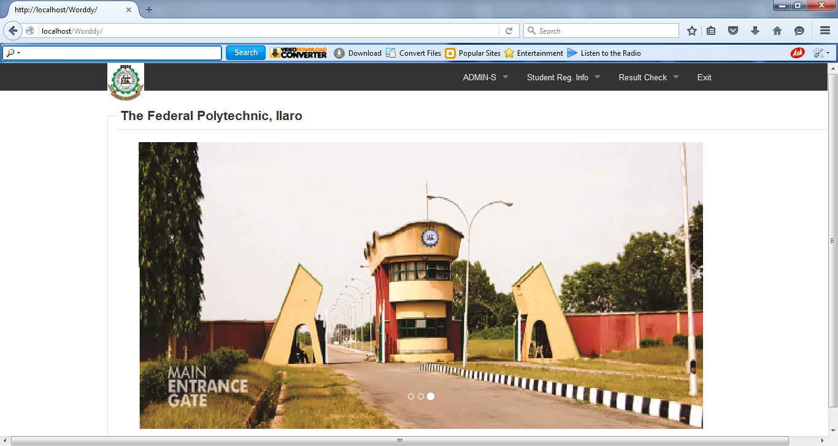
Figure 4.1: Snapshot of index menu

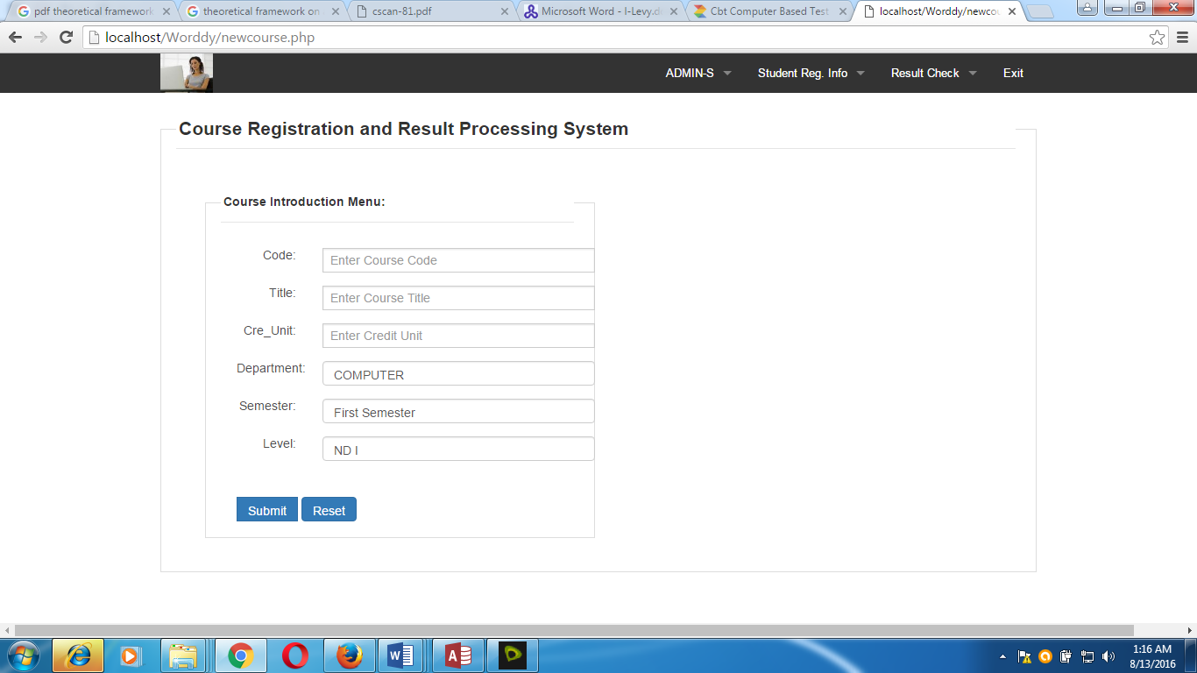

Figure 4.2: Snapshot of course introduction menu
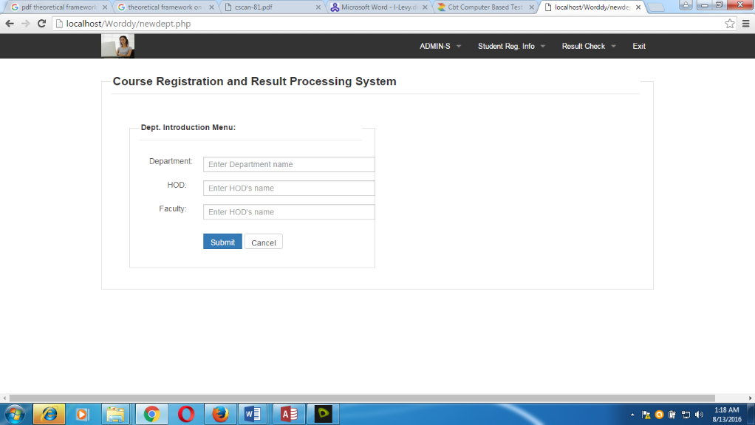

Figure 4.3: Snapshot for department introduction menu

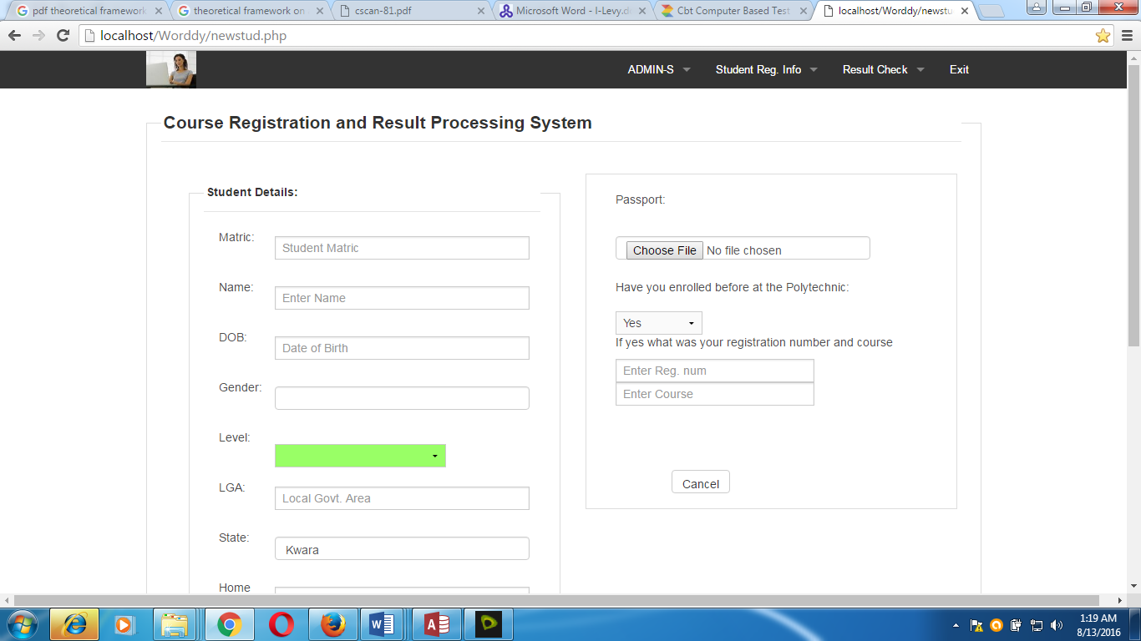

Figure 4.4: Snapshot student profile registration menu
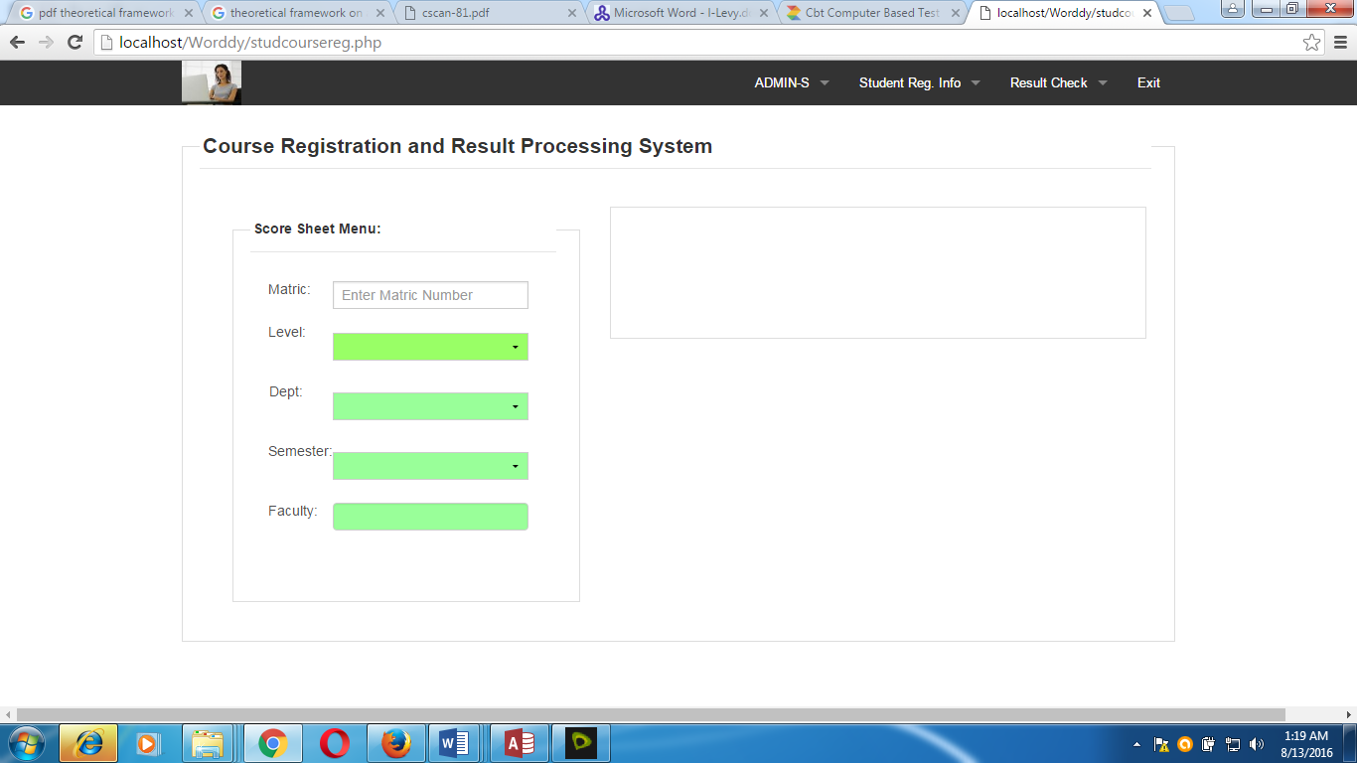
Figure 4.5: Snapshot for student course registration menu
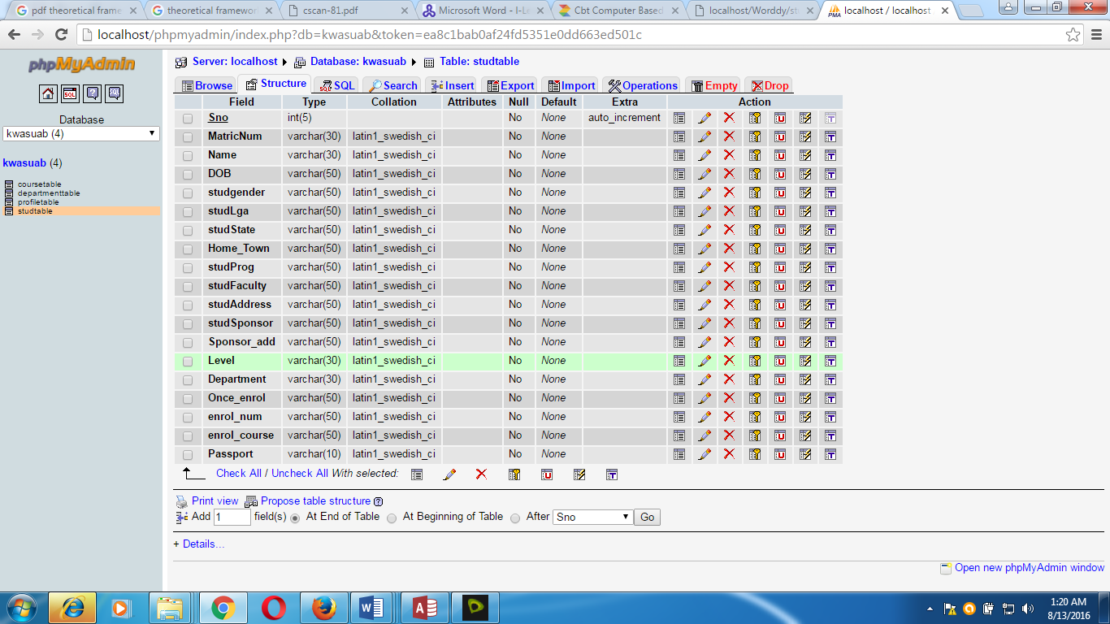
Figure 4.6: Question table

4.5 PROGRAM DESCRIPTION

Every stage of the system modification should meet the requirement that arise. The areas to be affected are the software aspect to cover new changes in software versions. Hardware like the hard disk capacity needs to be modified as the system continues, large hard disk space will be required for storing information.
In carrying out the maintenance of the system the procedure and function that has take place before installation must be accomplished according to procedure for making changes to the system the staff handling the new system should cultivate the attitude of maintenance for the hardware and software that makes up the system. At times staff needs to be retained in the area where major changes are made either to the system (PC) or the software.

4.5 PROGRAM DESCRIPTION
Every stage of the system modification should meet the requirement that arise. The areas to be affected are the software aspect to cover new changes in software versions. Hardware like the hard disk capacity needs to be modified as the system continues, large hard disk space will be required for storing information.
In carrying out the maintenance of the system the procedure and function that has take place before installation must be accomplished according to procedure for making changes to the system the staff handling the new system should cultivate the attitude of maintenance for the hardware and software that makes up the system. At times staff needs to be retained in the area where major changes are made either to the system (PC) or the software.

SYSTEM FLOWCHART
START
MAIN MENU
ADMIN
Registration
Result Check
Exit
STOP
Course Introduction
Dept Introduction
Score Entry
Profile Registration
Course Registration
COURSE INTRODUCTION FLOWCHART
START
Enter course Details
Is Correct
Save to Database
Any more?
Close Database
Return
Open Database
No
Yes
Yes
No
ADMIN LOGIN FLOWCHART
Start
Enter Logins
Correct?
Course
Dept
Score
Return

DEPT INTRODUCTION FLOWCHART
START
Enter Dept Details
Is Correct
Save to Database
Any more?
Close Database
Return
Open Database
No
Yes
Yes
No
PROFILE REGISTRATION FLOWCHART
START
Enter profile detail
Is Correct
Save to Database
Any more?
Close Database
Return
Open Database
No
Yes
Yes
No
COURSE REGISTRATION FLOWCHART
START
Enter Course Details
Is Correct
Save to Database
Any more?
Close Database
Return
Open Database
Yes
No
Yes
Result View flowchart
No
START
Open Database
Enter Student number
Valid?
Close Database
Return
Display Info.
PROCESS RESULT
Yes
No

4.5.1 OPERATING THE SYSTEM

To operate the system, the engineer is expected to give the tutorial to the user of the application in other to be familiar with the system develop. The modules have to be iron out one after the other to the users. Below are the following steps to operate the system;
Step 1: Insert CD into the CD ROM
Step 2: Click on CourseRegresultPro
Step 3: The index page is display
Then navigate through the menu, for more information about the modules read again the procedures in this project work.

4.5.2 MAINTENANCE OF THE SYSTEM

Maintenance this program can be done in HTML environment. Any future modification can be done by re-compiling the source program in development environment making necessary changes versions of the existing version of the mini word processing applications.

CHAPTER FIVE

5.0 CONCLUSION AND RECOMMENDATIONS

5.1 CONCLUSION

This research work focuses on the use of computer system with reference to course registration, result processing in the Polytechnic system. The work covers the manual system of opertions as regards the problems identified, stating the aims of the new system, stating the various specifications and then implementing the programs. The work was successufully developed using php, javascript scripting languagesin an HTML environment, a user- friendly programming language, and the package was tested and improved upon which yields an automated course registration, result processing and result view..
The project work cannot be said to be perfect, but however, its benefits cannot be overemphasized. It has led to the improvement in the speed of processing operation, efficiency, accuracy and improved storage of data.

Realizing a project of this nature is very exciting. However, the students encounter a lot a problem which I believe if looked into, will go a long way toward reducing the tension associated with the design implementation and construction of the project. In spite of the constraints encountered during the implementation of this project, the aim of my project is well accomplished.
Moreover, an attempt to accomplish this project has taken care of the delay between examination and result processing with minimum mistakes. This has also forced me to learn, practically, what is involved in the design and implementation or computerization of project (existing or non-existing). Finally, I wish to commend the polytechnic system and indeed the department of computer science for this project inclusion as a course that must be taken by graduating students it is a step in the right direction to withstand the future challenges in computing in companies, industries, institutions and the world at large.

5.2 RECOMMENDATIONS

Based on the achieved objective of this project and the experiences gained during its designed and implementation, I wish to make the following recommendations for future improvement. Students should be exposed to serious practical exercise during the course of their studies. In this regard, the students of Computer Science & Information Technology should be made to write at least a working program with veritable results before graduating. This could be accomplished by providing more computers qualified lecturers in the department.

Tertiary institutions should computerize their result processing system for greater efficiency, neatness, and reliability. This will go a long way to save the student all the trouble they go through trying to get their results in one form or the other. Finally, the students’ project should be closely supervised and monitored to achieve more success.

