title: “project” author: “Musya matheka” date: “2024-02-29” output: pdf_document: default html_document: default —

library(ggplot2)  
library(dplyr)

## Warning: package 'dplyr' was built under R version 4.1.3

##   
## Attaching package: 'dplyr'

## The following objects are masked from 'package:stats':  
##   
## filter, lag

## The following objects are masked from 'package:base':  
##   
## intersect, setdiff, setequal, union

library(tidyr)

## Warning: package 'tidyr' was built under R version 4.1.3

library(readxl)

## Warning: package 'readxl' was built under R version 4.1.3

data<- read_xlsx('C:/Users/mannuh/Desktop/memory.xlsx', sheet = 'in')  
head(data)

## # A tibble: 6 x 28  
## Gender Age TotalTime T1RH T1RM T1WH T1WM T1ADI T2RH T2RM T2WH T2WM  
## <chr> <dbl> <dbl> <dbl> <dbl> <dbl> <dbl> <dbl> <dbl> <dbl> <dbl> <dbl>  
## 1 Male 18 322. 6 7 6 8 0.5 12 5 8 2  
## 2 Female 18 282. 5 10 3 9 0.63 10 5 8 4  
## 3 Female 18 346. 5 10 3 9 0.63 9 9 4 5  
## 4 Female 18 375. 9 10 3 5 0.794 17 10 3 -3  
## 5 Female 18 373. 1 12 1 13 0.5 5 11 2 9  
## 6 Female 19 302. 5 10 3 9 0.63 7 10 3 7  
## # i 16 more variables: T2ADI <dbl>, T3RH <dbl>, T3RM <dbl>, T3WH <dbl>,  
## # T3WM <dbl>, T3ADI <dbl>, T4RH <dbl>, T4RM <dbl>, T4WH <dbl>, T4WM <dbl>,  
## # T4ADI <dbl>, T5RH <dbl>, T5RM <dbl>, T5WH <dbl>, T5WM <dbl>, T5ADI <dbl>

CleanData<- mutate(data,   
 'AVGTRM'= (T1RM+T2RM+T3RM+T4RM+T5RM)/5,   
 'AVGTRH'= (T1RH+T2RH+T3RH+T4RH+T5RH)/5,  
 'AVGTWH'= (T1WH+T2WH+T3WH+T4WH+T5WH)/5,  
 'AVGTADI'= (T1ADI+T2ADI+T3ADI+T4ADI+T5ADI)/5,  
 'AVGTWM'= (T1WM+T2WM+T3WM+T4WM+T5WM)/5)  
anova_A <- lm(AVGTRH ~ AVGTRM + AVGTWH + AVGTADI, data = CleanData)  
 regres<- lm(AVGTRH~Gender+Age, data=CleanData)  
 regression <- lm(AVGTADI~ Age+Gender, data=CleanData)

View(CleanData)  
CleanDat <- select(CleanData, Gender, Age, AVGTRM, AVGTRH, AVGTWH, AVGTWM, AVGTADI)  
View(CleanDat)  
anova_AVGTRM <- lm(AVGTRM ~ Gender + Age, data = CleanData)  
anova_AVGTRH <- lm(AVGTRH ~ Gender + Age, data = CleanData)  
anova_AVGTWH <- lm(AVGTWH ~ Gender + Age, data = CleanData)  
anova_AVGTADI <- lm(AVGTADI ~ Gender + Age, data = CleanData)  
summary(anova_AVGTADI)

##   
## Call:  
## lm(formula = AVGTADI ~ Gender + Age, data = CleanData)  
##   
## Residuals:  
## Min 1Q Median 3Q Max   
## -0.75143 -0.23908 -0.03363 0.18355 2.67023   
##   
## Coefficients:  
## Estimate Std. Error t value Pr(>|t|)  
## (Intercept) 0.55954 0.73141 0.765 0.449  
## GenderMale -0.15612 0.16981 -0.919 0.364  
## Age 0.03152 0.03739 0.843 0.405  
##   
## Residual standard error: 0.5228 on 38 degrees of freedom  
## Multiple R-squared: 0.03388, Adjusted R-squared: -0.01697   
## F-statistic: 0.6662 on 2 and 38 DF, p-value: 0.5195

summary(anova_AVGTRH)

##   
## Call:  
## lm(formula = AVGTRH ~ Gender + Age, data = CleanData)  
##   
## Residuals:  
## Min 1Q Median 3Q Max   
## -15.6129 -7.2322 -0.3327 6.3871 17.3871   
##   
## Coefficients:  
## Estimate Std. Error t value Pr(>|t|)   
## (Intercept) 27.6548 12.3043 2.248 0.0305 *  
## GenderMale -0.4802 2.8567 -0.168 0.8674   
## Age -0.3801 0.6290 -0.604 0.5493   
## ---  
## Signif. codes: 0 '***' 0.001 '**' 0.01 '*' 0.05 '.' 0.1 ' ' 1  
##   
## Residual standard error: 8.795 on 38 degrees of freedom  
## Multiple R-squared: 0.01145, Adjusted R-squared: -0.04058   
## F-statistic: 0.2201 on 2 and 38 DF, p-value: 0.8035

summary(anova_AVGTRM)

##   
## Call:  
## lm(formula = AVGTRM ~ Gender + Age, data = CleanData)  
##   
## Residuals:  
## Min 1Q Median 3Q Max   
## -7.4801 -1.4897 0.1199 1.7199 4.8340   
##   
## Coefficients:  
## Estimate Std. Error t value Pr(>|t|)   
## (Intercept) 9.981280 3.605950 2.768 0.00867 **  
## GenderMale -1.709314 0.837196 -2.042 0.04817 *   
## Age -0.004818 0.184345 -0.026 0.97929   
## ---  
## Signif. codes: 0 '***' 0.001 '**' 0.01 '*' 0.05 '.' 0.1 ' ' 1  
##   
## Residual standard error: 2.578 on 38 degrees of freedom  
## Multiple R-squared: 0.1019, Adjusted R-squared: 0.05459   
## F-statistic: 2.155 on 2 and 38 DF, p-value: 0.1299

summary(anova_AVGTWH)

##   
## Call:  
## lm(formula = AVGTWH ~ Gender + Age, data = CleanData)  
##   
## Residuals:  
## Min 1Q Median 3Q Max   
## -4.8340 -1.7199 -0.1199 1.4897 7.4801   
##   
## Coefficients:  
## Estimate Std. Error t value Pr(>|t|)   
## (Intercept) 3.018720 3.605950 0.837 0.4077   
## GenderMale 1.709314 0.837196 2.042 0.0482 *  
## Age 0.004818 0.184345 0.026 0.9793   
## ---  
## Signif. codes: 0 '***' 0.001 '**' 0.01 '*' 0.05 '.' 0.1 ' ' 1  
##   
## Residual standard error: 2.578 on 38 degrees of freedom  
## Multiple R-squared: 0.1019, Adjusted R-squared: 0.05459   
## F-statistic: 2.155 on 2 and 38 DF, p-value: 0.1299

summary(anova_A)

##   
## Call:  
## lm(formula = AVGTRH ~ AVGTRM + AVGTWH + AVGTADI, data = CleanData)  
##   
## Residuals:  
## Min 1Q Median 3Q Max   
## -11.322 -4.199 -1.469 3.828 24.098   
##   
## Coefficients: (1 not defined because of singularities)  
## Estimate Std. Error t value Pr(>|t|)   
## (Intercept) 2.5206 5.2833 0.477 0.636026   
## AVGTRM 0.8629 0.4477 1.927 0.061450 .   
## AVGTWH NA NA NA NA   
## AVGTADI 8.5133 2.2893 3.719 0.000644 ***  
## ---  
## Signif. codes: 0 '***' 0.001 '**' 0.01 '*' 0.05 '.' 0.1 ' ' 1  
##   
## Residual standard error: 7.432 on 38 degrees of freedom  
## Multiple R-squared: 0.2942, Adjusted R-squared: 0.257   
## F-statistic: 7.92 on 2 and 38 DF, p-value: 0.001334

summary(regression)

##   
## Call:  
## lm(formula = AVGTADI ~ Age + Gender, data = CleanData)  
##   
## Residuals:  
## Min 1Q Median 3Q Max   
## -0.75143 -0.23908 -0.03363 0.18355 2.67023   
##   
## Coefficients:  
## Estimate Std. Error t value Pr(>|t|)  
## (Intercept) 0.55954 0.73141 0.765 0.449  
## Age 0.03152 0.03739 0.843 0.405  
## GenderMale -0.15612 0.16981 -0.919 0.364  
##   
## Residual standard error: 0.5228 on 38 degrees of freedom  
## Multiple R-squared: 0.03388, Adjusted R-squared: -0.01697   
## F-statistic: 0.6662 on 2 and 38 DF, p-value: 0.5195

t<- t.test(CleanDat$AVGTRH,CleanDat$AVGTWM)  
print(t)

##   
## Welch Two Sample t-test  
##   
## data: CleanDat$AVGTRH and CleanDat$AVGTWM  
## t = 13.648, df = 80, p-value < 2.2e-16  
## alternative hypothesis: true difference in means is not equal to 0  
## 95 percent confidence interval:  
## 22.20055 29.77994  
## sample estimates:  
## mean of x mean of y   
## 19.995122 -5.995122

summary(regres)

##   
## Call:  
## lm(formula = AVGTRH ~ Gender + Age, data = CleanData)  
##   
## Residuals:  
## Min 1Q Median 3Q Max   
## -15.6129 -7.2322 -0.3327 6.3871 17.3871   
##   
## Coefficients:  
## Estimate Std. Error t value Pr(>|t|)   
## (Intercept) 27.6548 12.3043 2.248 0.0305 *  
## GenderMale -0.4802 2.8567 -0.168 0.8674   
## Age -0.3801 0.6290 -0.604 0.5493   
## ---  
## Signif. codes: 0 '***' 0.001 '**' 0.01 '*' 0.05 '.' 0.1 ' ' 1  
##   
## Residual standard error: 8.795 on 38 degrees of freedom  
## Multiple R-squared: 0.01145, Adjusted R-squared: -0.04058   
## F-statistic: 0.2201 on 2 and 38 DF, p-value: 0.8035

summary(CleanDat$AVGTADI)

## Min. 1st Qu. Median Mean 3rd Qu. Max.   
## 0.3754 0.8930 1.0932 1.1182 1.2698 3.8916

FData<- subset(CleanDat, Age <= 24)  
boxplot(FData$Age, main = "Boxplot of AVGNTP")

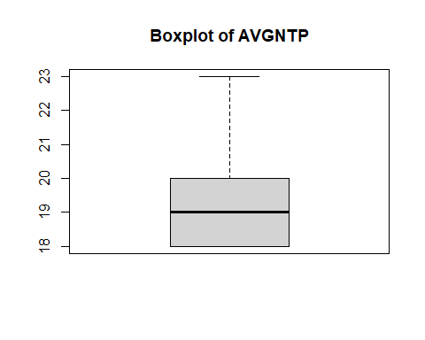

boxplot(FData$AVGTADI, main = "Boxplot of AVGNTP")

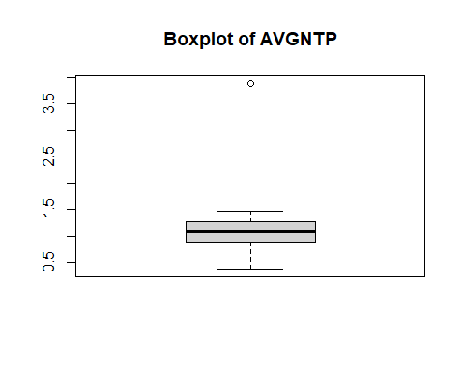

regres<- lm(AVGTRH~Gender+Age, data=FData)  
summary(regres)

##   
## Call:  
## lm(formula = AVGTRH ~ Gender + Age, data = FData)  
##   
## Residuals:  
## Min 1Q Median 3Q Max   
## -15.3583 -6.8398 0.0737 5.9803 17.6417   
##   
## Coefficients:  
## Estimate Std. Error t value Pr(>|t|)  
## (Intercept) 20.06724 19.15902 1.047 0.302  
## GenderMale -1.09130 3.11450 -0.350 0.728  
## Age 0.02728 1.00827 0.027 0.979  
##   
## Residual standard error: 8.881 on 37 degrees of freedom  
## Multiple R-squared: 0.003691, Adjusted R-squared: -0.05016   
## F-statistic: 0.06853 on 2 and 37 DF, p-value: 0.9339

ggplot(FData,mapping =aes(x=Gender,fill=Gender))+  
 geom_bar() +  
 labs(title = "bar graph of gender",  
 x = "gender",  
 y = "count")+  
 theme_minimal()

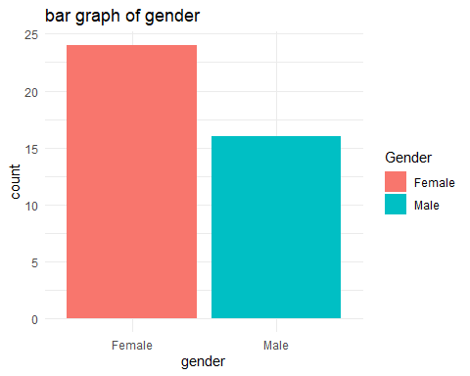

boxplot(CleanDat$AVGTADI, main = "Boxplot of AVGNTP")



ggplot(FData,mapping =aes(x=AVGTRH, y=Age))+  
 geom_point() +  
 labs(title = "Scatter Plot of Average TADI Vs Age ",  
 x = " Age",  
 y = "average TADI")+  
 theme_minimal()

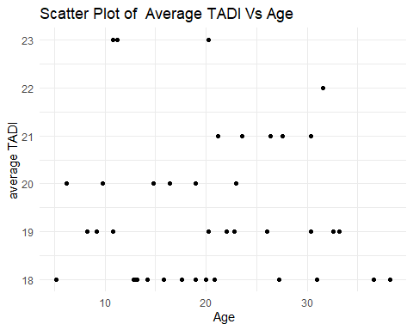

corre<-cor(FData[,c('AVGTRH','AVGTRM')])  
print(corre)

## AVGTRH AVGTRM  
## AVGTRH 1.0000000 0.1835295  
## AVGTRM 0.1835295 1.0000000