AFROBIZFIND APP

This is technical spec to build the AFROBIZFIND APP. The AFROBIZFIND APP is an app that customers can find company details. The customer can view a company profile.

The company profile activity

ADD CONPANY TO FAVOURITE LIST

BACK PAGE

The company profile will look like this

BECOME A CUSTOMER

OPENS GOOGLE MAP FOR DIRECTION

|  |  |  |  |
| --- | --- | --- | --- |
| Pictures  Scroll through picture  Company pictures | | | |
| Company name | | | |
| Address and opening times | | Small map of company location | |
| DIRECTIONS | CALL COMPANY  (OPENS PHONE CALL APP) | | ADD TO CONTACTS  (ADD NUMBER TO CONTACT LIST) |
| COMPANY ETHOS | | | |
| OFFERS  CUSTOMER OFFERS ONLY | | | |
| PRODUCT LIST | | | |

When you click the a dialog box will open to show

|  |  |
| --- | --- |
| Do you want to become a customer | |
| Allow company access to your mobile number | |
| Yes | no |
|  | |

When you click the a dialog box will open to show

|  |
| --- |
| Do you want to be a customer |
| I want to stay a customer |
|  |

If the customer is not a customer of the company then no dialog box will show.

The app will have a drawer layout

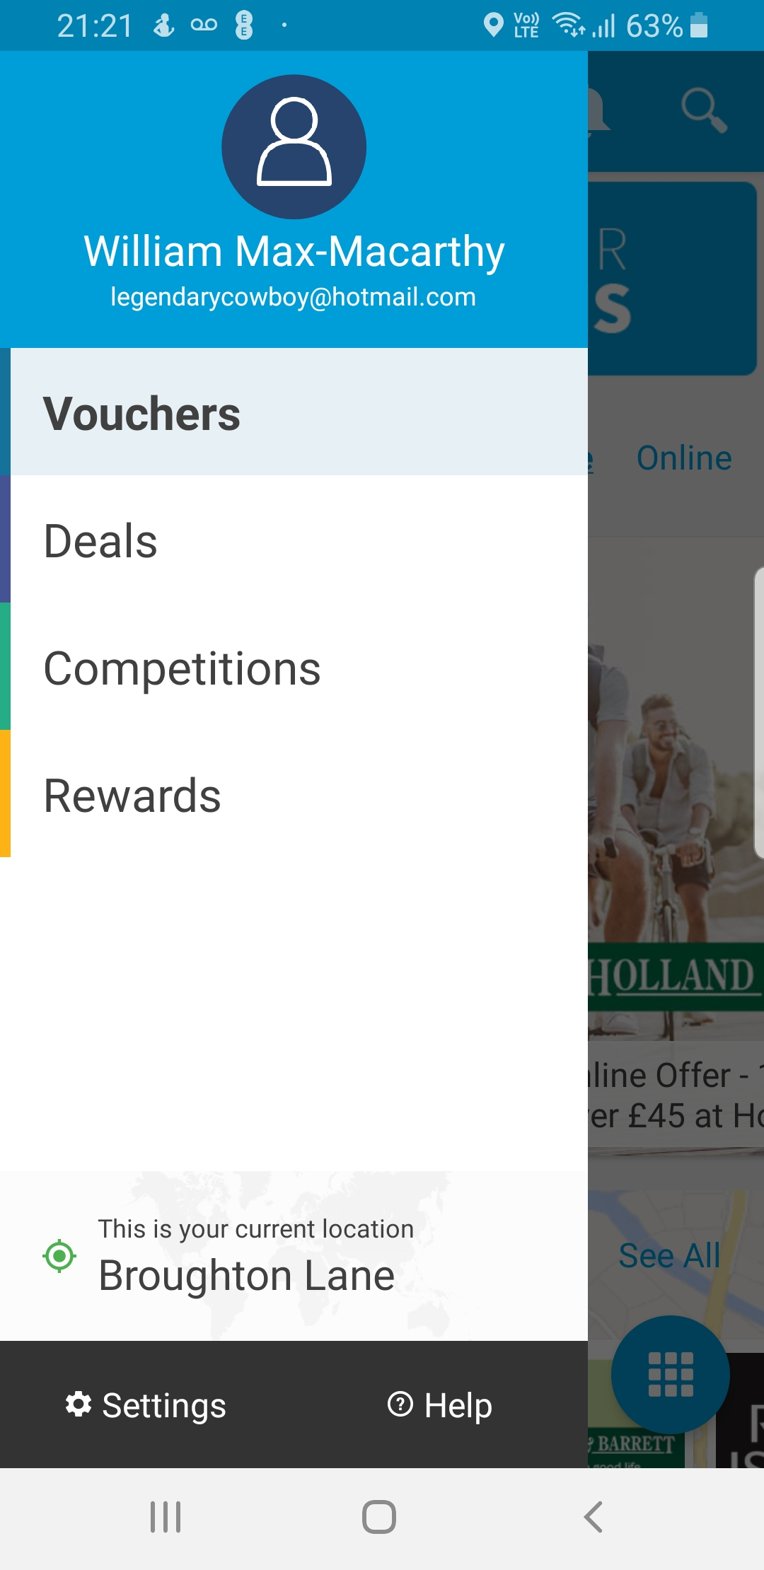

|  |  |
| --- | --- |
| Afrobizfind | |
|  | |
|  | |
| LOGIN | |
| PERSONAL DETAILS | |
| ADD A COMPANY | |
| SIGN UP | |
|  | |
| This is your current location | |
|  | |
| SETTINGS | Help |

When login is selected

|  |  |
| --- | --- |
| Afrobizfind | |
|  | |
|  | |
| LOGIN | |
| USERNAME | |
| EDIT TEXT BOX (datatype varchar(50)) | |
| PASSWORD | |
| EDIT TEXT BOX (datatype varchar(50)) | |
| FORGOT DETAILS | |
| PERSONAL DETAILS | |
| ADD A COMPANY | |
| SIGN UP | |
|  | |
| This is your current location | |
|  | |
| SETTINGS | Help |

When customer is logged in

|  |  |
| --- | --- |
| Afrobizfind | |
| username | |
| (datatype varchar(50)) | |
| Customer number | |
| (datatype varchar(50)) | |
| LOGIN | |
| PERSONAL DETAILS | |
| ADD A COMPANY | |
| SIGN UP | |
|  | |
| This is your current location | |
|  | |
| SETTINGS | Help |

Main activity page

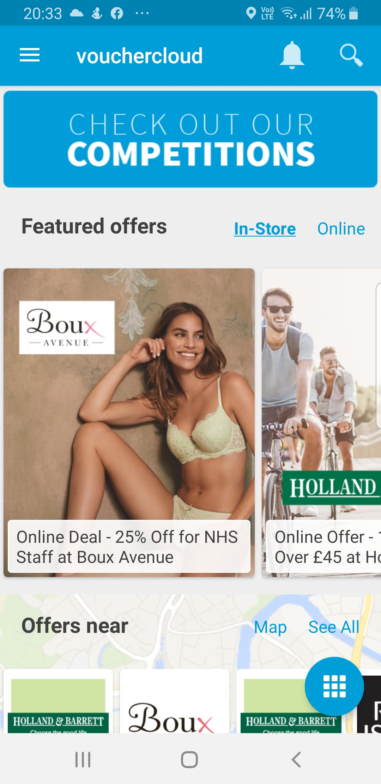

I want to main page to look like this with the map of local area as the background, with a row of thumbnails ofthe companies scrolling horizontally. Each row of company would be from one category. There will be one row of company for each category. Under the first row of companies there will be a link to see the map called ‘map’ and ‘nearest companies’ to companies nearest to phones location.

I want a search function on the top banner. The search function with search for company name, city and postcode.

Sign up

When customer select sign up it will take customer to the sign up activity

Sign up activity

|  |  |
| --- | --- |
| AFROBIZFIND | |
| Please fill in all boxes | |
| FIRST NAME | |
| EDIT TEXT BOX (datatype varchar(50)) | |
| SURNAME | |
| EDIT TEXT BOX (datatype varchar(50)) | |
| EMAIL | |
| EDIT TEXT BOX (datatype varchar(50)) | |
| MOBILE PHONE NUMBER | |
| EDIT TEXT BOX (datatype varchar(50)) | |
| HOME NO. OR NAME | |
| EDIT TEXT BOX (datatype varchar(50)) | |
| 1ST LINE OF ADDRESS | |
| EDIT TEXT BOX (datatype varchar(50)) | |
| CITY | |
| EDIT TEXT BOX (datatype varchar(50)) | |
| POSTCODE | |
| EDIT TEXT BOX (datatype varchar(50)) | |
| USERNAME | |
| EDIT TEXT BOX (datatype varchar(50)) | |
| PASSWORD | |
| EDIT TEXT BOX (datatype varchar(50)) | |
| Data protection disclaimer: AFROBIZFIND will NOT pass your details to any third party under any circumstances. You have to choose to become a customer of a company for that company to get your details. If you choose to stop being a customer of the company then your details will be removedfrom their records. | |
| SAVE | CANCEL |

The details entered will go to the main database. At this stage, the database will create a customer number. The customer number will be show on the drawer menu.

When personal details is selected

Personal details activity

|  |  |  |
| --- | --- | --- |
| AFROBIZFIND | | |
| CUSTOMER NUMBER | | |
| TEXT BOX(datatype varchar(50)) | | |
| FIRST NAME | | |
| TEXT BOX(datatype varchar(50)) | | |
| SURNAME | | |
| TEXT BOX(datatype varchar(50)) | | |
| MOBILE PHONE NUMBER | | |
| TEXT BOX (datatype varchar(50)) | | |
| EMAIL | | |
| TEXT BOX(datatype varchar(50)) | | |
| HOME NO. OR NAME | | |
| TEXT BOX(datatype varchar(50)) | | |
| 1ST LINE OF ADDRESS | | |
| TEXT BOX(datatype varchar(50)) | | |
| CITY | | |
| TEXT BOX(datatype varchar(50)) | | |
| POSTCODE | | |
| TEXT BOX (datatype varchar(50)) | | |
| USERNAME | | |
| TEXT BOX (datatype varchar(50)) | | |
| PASSWORD | | |
| TEXT BOX (datatype varchar(50)) | | |
| FAVOURITE COMPANIES | EDIT DETAILS | DELETE ACCOUNT |

GOES TO DELETE ACCOUNT ACTIVITY DIALOG

GOES TO SIGN UP ACTIVITY

OPENS FAVOURITES ACTIVITY

FAVOURITES ACTIVITY

|  |  |  |  |
| --- | --- | --- | --- |
| AFROBIZFIND | | | |
| FAVOURITE COMPANIES | | | |
|  | | | |
| COMPANY PICTURE  CLICK HERE TO SEE COMPANY PROFILE | | COMPANY NAME  COMPANY ADDRESS  CONTACT TELEPHONE NUMBER | |
| COMPANY CATEGORY | I AM A CUSTOMER Y OR N | | DELETE COMPANY FROM FAVOURITES |
|  | | | |
| COMPANY PICTURE  CLICK HERE TO SEE COMPANY PROFILE | | COMPANY NAME  COMPANY ADDRESS  CONTACT TELEPHONE NUMBER | |
| COMPANY CATEGORY | I AM A CUSTOMER Y OR N | | DELETE COMPANY FROM FAVOURITES |
| COMPANY PICTURE  CLICK HERE TO SEE COMPANY PROFILE | | COMPANY NAME  COMPANY ADDRESS  CONTACT TELEPHONE NUMBER | |
| COMPANY CATEGORY | I AM A CUSTOMER Y OR N  (Y or N will show) | | DELETE COMPANY FROM FAVOURITES |

DELETE ACCOUNT ACTIVITY DIALOG

When customer selects ‘DELETE ACCOUNT’ on the Personal details activity a small dialog box will appear looking like this.

|  |  |
| --- | --- |
| DO YOU WANT TO DELETE YOUR ACCOUNT? | |
| ENTER YOU PASSWORD TO DELETE ACCOUNT | |
| zxEDIT TEXT BOX (datatype varchar(50)) | |
| CANCEL | DELETE ACCOUNT |

YOUR ACCOUNT HAS BEEN DELETED

|  |  |
| --- | --- |
| PASSWORD INCORRECT | |
| ENTER YOU PASSWORD TO DELETE ACCOUNT | |
| EDIT TEXT BOX (datatype varchar(50)) | |
| CANCEL | DELETE ACCOUNT |

Once the account is deleted, the app will go to the main activity page.

Add a company activity

This activity will only open after a customer has logged in. if the customer has not logged in then a dialog box will open.

|  |
| --- |
| ADD A COMPANY OPTION IS ONLY AVAILABLE |
| AFTER YOU HAVE LOGGED IN. |
| PLEASE SELECT LOGIN TO LOGIN AND SIGN UP |

After the customer has logged in then the add a company activity will open.

|  |  |  |  |
| --- | --- | --- | --- |
| AFROBIZFIND | | | |
| ADD A COMPANY | | VIEW LIST OF MY COMPANIES | |
| COMPANY NAME | | | |
| EDIT TEXT BOX (datatype varchar(50)) | | | |
| BUILDING NO/ NAME | | | |
| EDIT TEXT BOX (datatype varchar(50)) | | | |
| FIRST LINE OF ADDRESS | | | |
| EDIT TEXT BOX (datatype varchar(50)) | | | |
| CITY | | | |
| EDIT TEXT BOX (datatype varchar(50)) | | | |
| POSTCODE | | | |
| EDIT TEXT BOX (datatype varchar(50)) | | | |
| OPENING TIME | | | |
| MONDAY | EDIT TEXT BOX (datatype time) | | EDIT TEXT BOX (datatype time) |
| TUESDAY | EDIT TEXT BOX (datatype time) | | EDIT TEXT BOX (datatype time) |
| WEDNESDAY | EDIT TEXT BOX (datatype time) | | EDIT TEXT BOX (datatype time) |
| THURSDAY | EDIT TEXT BOX (datatype time) | | EDIT TEXT BOX (datatype time) |
| FRIDAY | EDIT TEXT BOX (datatype time) | | EDIT TEXT BOX (datatype time) |
| SATURDAY | EDIT TEXT BOX (datatype time) | | EDIT TEXT BOX (datatype time) |
| SUNDAY | EDIT TEXT BOX (datatype time) | | EDIT TEXT BOX (datatype time) |
| EMAIL | | | |
| EDIT TEXT BOX (datatype varchar(50)) | | | |
| CONTACT TELEPHONE NUMBER | | | |
| EDIT TEXT BOX (datatype varchar(50)) | | | |
| WEBSITE | | | |
| EDIT TEXT BOX (datatype varchar(50)) | | | |
| COMPANY CATEGORY | | | |
| DROP DOWN SELECTION | | | |
| COMPANY ETHOS | | | |
| EDIT TEXT BOX (datatype varchar(255)) | | | |
| CUSTOMER NUMBER | | | |
| TEXT BOX (datatype varchar(50)) | | | |
| USERNAME | | | |
| TEXT BOX (datatype varchar(50)) | | | |
| SAVE COMPANY DETAILS | | CANCEL | |

The customer number and username will automatically be population from the customer is logged in.

When the company’s details are saved, the details will be stored in a database called company.db. The customer will be directed to SAVED COMPANY DETAILS ACTIVITY.

COMPANY CATEGORY DROP DOWN

BEAUTY/STYLIST

BARBERS

FOOD & DRINK

SUPERMARKET

EDUCATION/TUTOR

FASHION

PROFESSIONALS SERVICES

AUTOMOTIVE

SAVED COMPANY DETAILS ACTIVITY

|  |  |  |  |
| --- | --- | --- | --- |
| AFROBIZFIND | | | |
| EDIT COMPANY DETAILS | | VIEW LIST OF MY CUSTOMERS | |
| COMPANY’S PRODUCT LIST | | COMPANY’S OFFER LIST | |
| COMPANY NAME | | | |
| TEXT BOX (datatype varchar(50)) | | | |
| BUILDING NO/ NAME | | | |
| TEXT BOX (datatype varchar(50)) | | | |
| ADDRESS_LINE_1 | | | |
| TEXT BOX (datatype varchar(50)) | | | |
| CITY | | | |
| TEXT BOX (datatype varchar(50)) | | | |
| POSTCODE | | | |
| TEXT BOX (datatype varchar(50)) | | | |
| OPENING TIME | | | |
| MONDAY | TEXT BOX (datatype time) | | TEXT BOX (datatype time) |
| TUESDAY | TEXT BOX (datatype time) | | TEXT BOX (datatype time) |
| WEDNESDAY | TEXT BOX (datatype time) | | TEXT BOX (datatype time) |
| THURSDAY | TEXT BOX (datatype time) | | TEXT BOX (datatype time) |
| FRIDAY | TEXT BOX (datatype time) | | TEXT BOX (datatype time) |
| SATURDAY | TEXT BOX (datatype time) | | TEXT BOX (datatype time) |
| SUNDAY | TEXT BOX (datatype time) | | TEXT BOX (datatype time) |
| EMAIL | | | |
| TEXT BOX (datatype varchar(50)) | | | |
| CONTACT TELEPHONE NUMBER | | | |
| TEXT BOX (datatype varchar(50)) | | | |
| WEBSITE | | | |
| TEXT BOX (datatype varchar(50)) | | | |
| COMPANY CATEGORY | | | |
| TEXT BOX (datatype varchar(50)) | | | |
| CUSTOMER NUMBER | | | |
| TEXT BOX (datatype varchar(50)) | | | |
| USERNAME | | | |
| TEXT BOX (datatype varchar(50)) | | | |
|  | |  | |

The SAVED COMPANY DETAILS ACTIVITY will have fourlinks at the top.

EDIT COMPANY DETAILS will send customer back to the add a company activity.

VIEW LIST OF MY CUSTOMERS will send customer to LIST OF MY CUSTOMERS ACTIVITY.

COMPANY’S PRODUCT LIST will send the customer to the COMPANY’S PRODUCT LIST ACTIVITY.

COMPANY’S OFFER LIST will send customer to the COMPANY’S OFFER LIST ACTIVITY.

LIST OF MY CUSTOMERS ACTIVITY

This activity will show a list of all customers who has chosen to become a customer of the company.

|  |  |  |
| --- | --- | --- |
| AFROBIZFIND | | |
| LIST OF MY CUSTOMERS | | |
| Search (search for customer username) | No of Customers | 12(datatype int) |
| Customer’s username (datatype varchar(50)) | Mobile number(datatype varchar(50)) | |
| Customer’s username |  | |
| Customer’s username | Mobile number | |
| Customer’s username |  | |
| Customer’s username |  | |
| Customer’s username |  | |
| Customer’s username | Mobile number | |
| Customer’s username |  | |
| Customer’s username |  | |

The data will from the favourite db

COMPANY’S PRODUCT LIST ACTIVITY

This activity will show the company’s product list.

|  |  |  |
| --- | --- | --- |
| AFROBIZFIND | | |
| PRODUCT LIST | ADD A PRODUCT | EDIT/DELETE EXISTING PRODUCT |
| Search (search for Product List) | No of PRODUCT | 10(TEXT BOX)(datatype int) |
| (Product NameTEXT BOX) (datatype varchar(50)) | (priceTEXT BOX)(datatype MONEY) | |
| (Product Picture) | (Product description TEXT BOX)( (datatype varchar(100)) | |
| EDIT | DELETE | |
| (Product Name TEXT BOX) (datatype varchar(50)) | (priceTEXT BOX)(datatype int) | |
| Product Picture) | (Product description TEXT BOX)( (datatype varchar(100)) | |
| EDIT | DELETE | |

When ADD A PRODUCT is selected four new rows will appear where the new product details can be entered.

|  |  |
| --- | --- |
| AFROBIZFIND | |
| PRODUCT LIST | SAVE PRODUCT |
| PRODUCT NAME | PRICE |
| EDIT TEXT BOX (datatype varchar(50)) | EDIT TEXT BOX (datatype MONEY)) |
| PRODUCT DESCRIPTION | ADD PICTURE |
| EDIT TEXT BOX (datatype varchar(100)) | |
| EXISTING PRODUCTS | |
| (Product Name TEXT BOX) (datatype varchar(50)) | (priceTEXT BOX)(datatype MONEY) |
| (Product Picture) | (Product description TEXT BOX)( (datatype varchar(100)) |
| (Product Name TEXT BOX) (datatype varchar(50)) | (priceTEXT BOX)(datatype int) |
| Product Picture) | (Product description TEXT BOX)( (datatype varchar(100)) |

ADD PICTURE OPEN THE PHONES GALLEY TO BRING IN A PHOTO AND RESIZE THEPHOTO TO FIX A CERTAIN SIZE.

CLICKING ON SAVE PRODUCT will close the extra four rows and the new product will appear in the product list.

Database

The AFROBIZFIND app will run by five databases

Customer db

|  |  |  |  |  |
| --- | --- | --- | --- | --- |
| Field_Name | Data Type | Primary key | input | Allows Null |
| FIRST_NAME | Varchar (50) |  | By customer | no |
| SURNAME | Varchar (50) |  | By customer | no |
| EMAIL | Varchar (50) | yes | By customer | no |
| HOME_NUMBER | Varchar (50) |  | By customer | yes |
| ADDRESS_LINE_1 | Varchar (50) |  | By customer | yes |
| CITY | Varchar (50) |  | By customer | yes |
| POSTCODE | Varchar (50) |  | By customer | yes |
| USERNAME | Varchar (50) | yes | By customer | no |
| PASSWORD | Varchar (50) |  | By customer | no |
| MOBILE_NUMBER | Varchar (50) |  | By customer | no |
| CUSTOMER_NUMBER | Char(9) | yes | Auto generated | no |
| CREATED_DATE | DATETIME |  | Auto generated | no |
| LAST_MORDIFY_DATE | DATETIME |  | Auto generated | NO |

Company db

|  |  |  |  |  |
| --- | --- | --- | --- | --- |
| FIELD_NAME | Data Type | Primary key | input | Allows Null |
| COMPANY_NAME | Varchar (50) | yes | By customer | no |
| BUILDING_NUMBER | Varchar (50) |  | By customer | no |
| ADDRESS_LINE_1 | Varchar (50) |  | By customer | no |
| CITY | Varchar (50) |  | By customer | no |
| POSTCODE | Varchar (50) |  | By customer | no |
| MONDAY_OPENING | TIME |  | By customer | yes |
| MONDAY_CLOSING | TIME |  | By customer | yes |
| TUESDAY_OPENING | TIME |  | By customer | yes |
| TUESDAY_CLOSING | TIME |  | By customer | yes |
| WEDNESDAY_OPENING | TIME |  | By customer | yes |
| WEDNESDAY_CLOSING | TIME |  | By customer | yes |
| THURSDAY_OPENING | TIME |  | By customer | yes |
| THURSDAY_CLOSING | TIME |  | By customer | yes |
| FRIDAY_OPENING | TIME |  | By customer | yes |
| FRIDAY_CLOSING | TIME |  | By customer | yes |
| SATURDAY_OPENING | TIME |  | By customer | yes |
| SATURDAY_CLOSING | TIME |  | By customer | yes |
| SUNDAY_OPENING | TIME |  | By customer | yes |
| SUNDAY_CLOSING | TIME |  | By customer | yes |
| EMAIL | Varchar (50) |  | By customer | no |
| TELEPHONE | Varchar (50) |  | By customer | no |
| COMPANY_NUMBER | Char(6) | yes | Auto generated | no |
| WEBSITE | Varchar (50) |  | By customer | no |
| CUSTOMER_NUMBER | Char(9) |  | By sql code | no |
| USERNAME | Varchar (50) |  | By sql code | no |
| FIRST_NAME | Varchar (50) |  | By sql code | no |
| SURNAME | Varchar (50) |  | By sql code | no |
| CREATED_DATE | DATETIME |  | Auto generated | no |
| LAST_MORDIFY_DATE | DATETIME |  | By sql code | no |

Offersdb

|  |  |  |  |  |
| --- | --- | --- | --- | --- |
| FIELD_NAME | Data Type | Primary key | input | Allows Null |
| COMPANY_NAME | Varchar (50) |  | By sql code | no |
| COMPANY_NUMBER | Varchar (50) | yes | By sql code | no |
| OFFER_DETAILS | Varchar (50) |  | By customer | no |
| DISCOUNT | Varchar (50) |  | By customer | no |
| START_DATE | DATE |  | By customer | no |
| END_DATE | DATE |  | By customer | no |
| CUSTOMER_ONLY | Varchar (50) |  | By customer | no |
| OFFER_CODE | Varchar (6) | yes | By customer | no |
| OFFER_ID | Varchar (50) | yes | Auto generated | no |
| MOBILE_NUMBER | Varchar (50) |  | By customer | no |
| ACTIVE | Char(1) |  | Auto generated | no |
| CREATED_DATE | DATETIME |  | Auto generated | no |
| LAST_MORDIFY_DATE | DATETIME |  | Auto generated | no |
| MANUALLY_DE`ACTIVED | Char(1) |  | By sql code | no |

Products db

|  |  |  |  |  |
| --- | --- | --- | --- | --- |
| FIELD_NAME | Data Type | Primary key | input | Allows Null |
| COMPANY_NAME | Varchar (50) |  | By customer | no |
| COMPANY_NUMBER | Varchar (6) | yes | By customer | no |
| PRODUCT_NAME | Varchar (50) |  | By customer | no |
| PRODUCT_NUMBER | Varchar (9) | yes | Auto generated | no |
| PRODUCT DESCRIPTION | Varchar (255) |  | By customer | no |
| PRICE | MONEY |  | By customer | no |
| CREATED_DATE | DATETIME |  | Auto generated | no |
| LAST_MORDIFY_DATE | DATETIME |  | By sql code | no |

Favourite db

|  |  |  |  |  |
| --- | --- | --- | --- | --- |
| FIELD_NAME | Data Type | Primary key | input | Allows Null |
| COMPANY_NAME | Varchar (50) |  | By customer | no |
| COMPANY_NUMBER | Varchar (50) | yes | By customer | no |
| CUSTOMER_NUMBER | Varchar (50) | Yes | By customer | no |
| USERNAME | Varchar (50) | Yes | By customer | no |
| FAVOURITE_ID | CHAR(8) |  | Auto generated | no |
| END_DATE | DATE |  | By customer | no |
| MOBILE_NUMBER | Varchar (50) |  | By customer | no |
| CREATED_DATE | DATETIME |  | Auto generated | no |
| LAST_MORDIFY_DATE | DATETIME |  | By sql code | no |