Blog 2: Building a Future-Ready GenAI Centre of Excellence (CoE) for Large Enterprises
In our first blog on The AI-First CEO/CXO, we argued why AI must be a board-level mandate—not just a technical upgrade, but a strategic transformation. As CEOs commit to an AI-first vision, the next critical question emerges:
How can large enterprises operationalize this vision with scale, speed, and safety?
The answer lies in creating a Generative AI Centre of Excellence (GenAI CoE)—not as a side-project or innovation lab, but as a cross-functional operating system embedded into the core of enterprise execution.
Based on the CoE organizational blueprint by AISwitch.org, this blog outlines how to design a scalable and future-ready GenAI CoE—spanning strategy, execution, governance, and external collaboration.
1. The Executive Board: Setting the Strategic Lattice
At the top of the structure sits the GenAI Executive Board of Governance, which acts as the strategic core of the CoE. This board is more than just oversight it defines the prioritization logic for use cases, aligns them with enterprise-wide KPIs (cost reduction, CX, revenue streams), and ensures that all AI efforts are tied to business value.
But this isn’t a standalone entity. It feeds directly into the CoE Leader (VP), who is tasked with operationalizing these goals. The handoff isn’t just top-down it’s cyclical. The CoE Leader sends progress, risk, and ROI feedback to the board, closing the loop and enabling continuous recalibration of AI priorities.
Key Outcomes: Strategic alignment, prioritization logic, closed-loop governance
2. CoE Leader (VP): The Nerve Center
The CoE Leader (typically a VP) is the functional integrator who ensures that GenAI isn’t trapped in POC purgatory. Reporting into the Executive Board, this role manages:
- Implementation of GenAI projects, ranging from document summarization to customer support chatbots to GenAI-powered ERP assistants.
- Regular engagement with Legal, Finance, and HR, not just for compliance but to forecast the people and process impact of AI.
- Cross-functional orchestration with engineering, data science, design, and training leaders.
This role also anchors the GRC (Governance, Risk, and Compliance) layer, which is woven throughout the CoE—not siloed.
Key Outcomes: Prevents model sprawl, accelerates time-to-value, orchestrates cross-functional AI delivery
3. Legal & GRC Director: Trust by Design
As generative models produce dynamic outputs, risk boundaries become harder to define. That’s why the Legal & GRC Director sits within the CoE framework, not outside it.
This function directly supports the CoE Leader by:
- Reviewing regulatory exposure (e.g., IP, hallucinations, data leakage).
- Setting compliance guardrails on model usage (e.g., RAG with redacted documents, content moderation filters).
- Working with the engineering team to embed explainability and traceability into model pipelines.
Their output also feeds into training design ensuring that AI literacy isn’t just technical but ethical.
Key Outcomes: Reduces regulatory, reputational, and ethical risks; supports responsible AI deployment
4. Talent & Skill Leader: Upskilling the Org-Wide AI Quotient
Generative AI without human adaptation = value leakage. That’s where the Talent/Training Leader becomes critical.
This role collaborates with the Legal Director to ensure that training programs reflect governance guidelines, and with the CoE Leader to prioritize up skilling based on active use cases.
Examples include:
- Prompt engineering bootcamps for marketing teams.
- LLMOps training for IT and DevOps.
- Risk-aware AI literacy for legal and compliance teams.
Training is also tailored to insights from project retrospectives—shared back from engineering and design teams.
Key Outcomes: Builds GenAI fluency, aligns learning with real use cases, accelerates adoption
5. Engineering + Data Science + Design: The AI Product Triad
At the technical core of the CoE are three interlinked units—Engineering, Data Science, and Design. Together, they transform ideas into enterprise-grade AI products.
a) Engineering Director
- Leads solution architecture.
- Works with data engineers to build RAG pipelines, orchestration layers, and API gateways.
- Aligns infrastructure decisions (GPU clusters, model hosting) with usage volume forecasts from business teams.
b) Data Science Leader
- Designs model evaluation metrics in sync with business KPIs.
- Partners with Engineering to build fine-tuned models and retrieval-enhanced generation (RAG) stacks.
- Works with the Design Leader to fine-tune model prompts based on UX feedback.
c) Design Leader
- Not just about UI. This role bridges the human-AI interaction loop.
- Works on use-case specific prompt templates, chatbot flows, and GenAI interaction modalities.
- Feeds back user friction points to Engineering for latency, reliability, or UX fixes.
Together, this triad ensures that AI solutions are usable, scalable, and explainable—not just technically elegant.
Key Outcomes: Scalable, usable, and explainable GenAI products
6. Partner Ecosystem VP: Scaling Through Collaboration
The Partner Ecosystem Leader stitches together the external threads:
- AI research labs for co-development of fine-tuning strategies.
- Hyperscalers for access to APIs (OpenAI, Claude, Gemini, etc.).
- Startups for specialized plugins or domain-tuned models.
- Academia for workforce development and responsible AI frameworks.
Their work directly informs the Engineering stack and enables the Training Leader to roll out certified learning paths (e.g., via Google Cloud or AWS AI certification).
Key Outcomes: Speeds up innovation, brings in domain depth, enables global-grade scale
GenAI Maturity Milestones:
To help enterprises benchmark their progress, here’s a simplified maturity model:
Stage | Description
1. Awareness | POCs and experimentation
2. CoE Formation | Governance and cross-functional alignment
3. Enablement | Role-based training and use-case onboarding
4. Productization | In-house GenAI IP and frameworks
5. Business Model Shift | GenAI as a core differentiator

Feedback Loops: The Hidden Superpower:
Each node of this CoE structure is not just connected it’s in constant feedback with others. Legal insights influence training. Design feedback improves engineering pipelines. Executive goals inform model evaluation metrics. This recursive structure creates a flywheel effect for GenAI growth.
Change Management Consideration:
Establishing a GenAI CoE also requires strong change management:
- Re-skilling at scale
- Redefining performance metrics
- Breaking silos between data, tech, and business units
This is where leadership sponsorship and transparent communication make or break success.
Conclusion: An Operating System, Not a Side Project
A GenAI CoE when structured like this isn’t just a taskforce. It’s an operating system that spans vision, talent, data, design, compliance, and external engagement. Every function feeds into the other, creating a closed feedback loop that enables:
- Faster time to market
- Lower model risk
- Higher adoption across business units
In short, it turns GenAI into a core competency, not a one-off experiment.

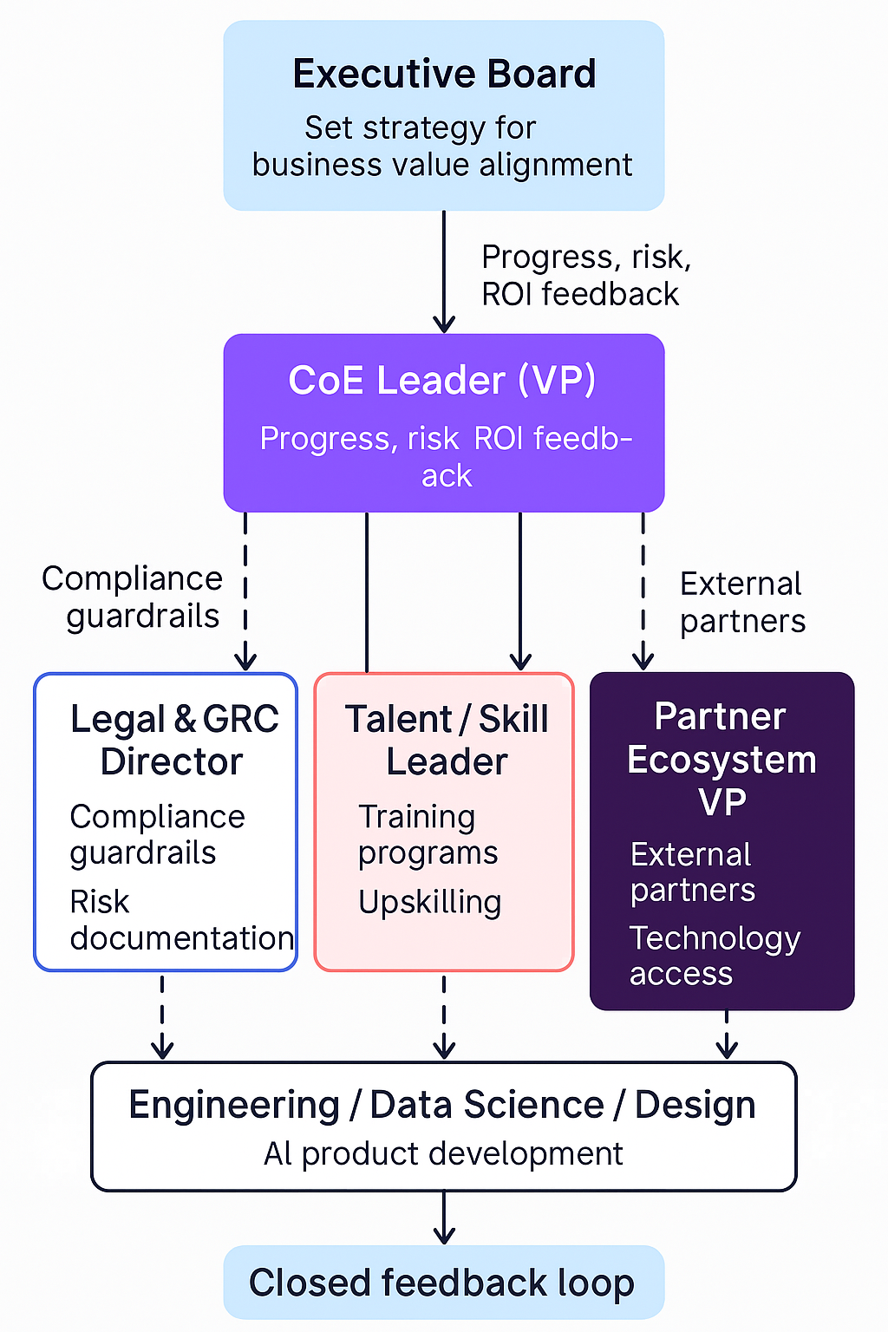
As Generative AI shifts from exploration to enterprise deployment, large organizations (>$1B revenue) are faced with a critical question:
👉 How do you embed GenAI capabilities across your value chain while maintaining governance, scalability, and speed?
The answer lies in building a Generative AI Centre of Excellence (CoE)—not just as a support function, but as an integrated operating system that aligns strategy, execution, and enablement under one roof.
This post explores a future-ready GenAI CoE model based on AISwitch.org’s framework, enhanced with strategic roles, technical workflows, governance models, and the AI Innovation Fund (AISWITCH Steps) for prioritization and acceleration.

💡 1. Executive Board: The Strategic Lattice
At the top sits the GenAI Executive Board of Governance—the strategic core of the CoE. This board is responsible for:
- Prioritizing GenAI use cases across the organization.
- Aligning AI programs with key KPIs: cost reduction, revenue uplift, operational efficiency, and CX improvement.
- Ensuring all AI initiatives have business outcome clarity.
More than oversight, this board operates as the AI command center. It also connects directly to the CEO/CXO, translating the AI-First leadership vision into action—as highlighted in our earlier post.

🔄 Closed Feedback Loop:
The CoE Leader reports back with impact dashboards, risk signals, and ROI trends—enabling dynamic recalibration of AI initiatives.

🧠 2. The AI Innovation Fund – AISWITCH Steps (NEW SECTION)
AISwitch.org emphasizes a strategic funding approach through the AI Innovation Fund, structured around the AISWITCH steps:
- Assess: Evaluate readiness, risk, and opportunity.
- Initiate: Launch priority pilots aligned with business goals.
- Scale: Operationalize successful use cases via the CoE.
- Workflow: Embed AI into daily operational processes.
- Integrate: Ensure AI works across legacy and modern tech stacks.
- Train: Enable teams through skill-building programs.
- Comply: Implement trust, risk, and compliance frameworks.
- Harmonize: Align AI, data, and people functions holistically.
💡 This fund is owned jointly by the Executive Board and CoE Leader, ensuring funding decisions follow governance-backed strategic priorities, not siloed innovation labs.

🧩 3. CoE Leader (VP): The Nerve Center
The CoE Leader (typically a VP) is the integrator who prevents GenAI from getting stuck in "POC purgatory."
Key responsibilities:
- Manage implementation of GenAI projects across functions: customer service, operations, finance, etc.
- Work with Legal, HR, and Finance to assess people/process impacts.
- Anchor the GRC (Governance, Risk, Compliance) framework inside CoE.
The CoE Leader also acts as the interface for external innovation, connecting with ecosystem partners, tech vendors, and research bodies.

⚖️ 4. Legal & GRC Director: Trust by Design
Given the evolving risks with generative outputs (hallucination, data privacy, IP), GRC isn’t optional—it must be embedded.
Key functions:
- Define regulatory and compliance guardrails for model deployment.
- Collaborate with Engineering to build explainability + auditability into model pipelines.
- Co-design AI Literacy training with the Talent Leader to ensure risk-aware upskilling.
Trust and transparency are designed into the system, not bolted on.

📈 5. Talent & Skill Leader: Raising the Org-Wide AI Quotient
A GenAI CoE cannot succeed without equipping the organization to engage with it. The Talent/Training Leader drives org-wide AI adaptation.
- Tailored training for each function: Prompting, GenAI UX, AI-augmented workflows.
- Collaborate with CoE & GRC to ensure ethical and compliant literacy.
- Build certified learning pathways in partnership with ecosystem partners (e.g., AWS, Google, Microsoft).
📘 Example Programs:
- Prompt Engineering for Sales & Marketing.
- LLMOps for IT & DevOps.
- Risk-Aware AI Use for Legal & Compliance.

🧪 6. The AI Product Triad: Engineering + Data Science + Design
At the technical core of the CoE are three deeply interconnected units:

a. Engineering Director
- Lead architecture of RAG stacks, vector DBs, and pipelines.
- Interface with infra teams for GPU/TPU workloads.
- Collaborate with business teams for scalable solution design.

b. Data Science Leader
- Define model evaluation metrics tied to KPIs.
- Experiment with fine-tuning and prompt tuning approaches.
- Align outputs with business goals and user context.

c. Design Leader
- Human-AI interaction lead: from UX to prompt templates.
- Create AI agent flows and chatbot personas.
- Feed usability friction data back to Engineering and DS for improvements.
💡 Their cross-functional synergy ensures AI is usable, scalable, and explainable, not just technically elegant.

🤝 7. Partner Ecosystem VP: Scaling Through Collaboration
This leader connects the CoE to the external AI ecosystem:
- Partner with AI research labs for cutting-edge models and safety.
- Engage with hyperscalers (AWS, Azure, GCP) for foundation model access.
- Co-innovate with startups and domain experts.
- Establish academic alliances for talent and governance frameworks.
The insights and tooling from this arm flow back into the AI product stack and training modules.

🔄 Continuous Feedback Loop
What makes this CoE truly resilient is its closed feedback system:
- Every function (Design, DS, Training, Legal) feeds into the other.
- Learnings from deployed use cases flow back into training, prompting, compliance, and roadmap prioritization.
- The CoE is built to evolve with use-case maturity, business conditions, and regulatory shifts.

🧭 Conclusion: An Operating System—Not a Side Project
A GenAI CoE structured this way isn’t just a “taskforce.”
It’s an AI Operating System that brings together:
- Vision (Executive Board + Innovation Fund)
- Enablement (Training, Design, Legal)
- Execution (Engineering, DS, GTM)
- External Leverage (Partners & Certifications)
✅ Benefits:
- Faster time to market
- Lower model risk
- Scalable deployment
- Higher internal adoption
This model turns GenAI into a core enterprise competency, not a one-off pilot.

