Blog 3: Why CEOs Must Select the Right AI-Cloud Partners to Power Enterprise GenAI Transformation
In Blog 1 and Blog 2, we explored how a CEO’s vision and a well-structured GenAI Centre of Excellence (CoE) can ignite enterprise-wide transformation. But even the most ambitious AI strategy can be derailed by one silent saboteur: the wrong technology partners. Selecting the right AI-Cloud service providers (AISPs) isn’t just a technical call—it’s a strategic imperative that can define your enterprise’s GenAI maturity for years to come.
According to our research, “70% of GenAI failures in large enterprises result from poor partner integration decisions.” In such a fast-moving landscape filled with hyperscalers, foundation model providers, and AI tooling startups, the CEO must make partner selection a board-level conversation.
As highlighted by the AISwitch.org guide, this decision is not about choosing what’s popular—it’s about choosing what fits. The right partners will enable scale, innovation, and governance. The wrong ones may lead to cost overruns, compliance breaches, or inflexible architectures.
Recap: Why Partner Selection Is a CEO-Level Decision
Your GenAI CoE may drive execution, but the success of every use case, from document summarization to AI copilots, hinges on your partner stack.
Risks of the wrong AISP include:
- Vendor lock-in with poor interoperability
- Inability to switch models (e.g., GPT-4 vs Claude vs Gemini)
- Non-compliance with evolving AI regulations
- Unmonitored token usage and spiraling costs
- Performance or reliability mismatches for enterprise workloads
To mitigate these, let’s bring in the structured selection approach outlined by AISwitch.org.
How to Choose the Right AI-Cloud SPs First Time (via AISwitch.org)
AISwitch.org defines four essential steps for CEOs and CTOs to get AI-Cloud SP selection right from Day One. Let’s unpack each step with actionable takeaways:

1. Define the Operating Model First (Not Just Use Cases)
Before choosing any GenAI SP, define how your organization plans to operate AI:
- Will the CoE orchestrate model access and guardrails centrally?
- Will business units own and execute their use cases?
- Are you building proprietary LLM pipelines or consuming APIs?
This ties directly into Blog 2’s GenAI CoE architecture. You need clarity on your operating model to understand which capabilities you need from your SPs.
2. Demand Composability in the AISP Stack
Avoid platforms that trap you into a rigid model or infrastructure stack. CEOs should look for:
- Multi-model support (OpenAI, Claude, LLaMA, Gemini, etc.)
- RAG pipelines with flexible orchestration
- Open-source compatibility (LangChain, Haystack, etc.)
- BYO-Data Infrastructure (connect your own vector DBs, cloud storage)
This supports the CEO’s role as a long-term ecosystem architect, as emphasized in Blog 1.

3. Score SPs Based on Capability Match
Every SP brings something different to the table. Instead of a one-size-fits-all RFP, score SPs on their alignment across 5 pillars:
Capability Pillar | Questions to Ask
Model Flexibility | Can you switch or fine-tune multiple LLMs?
Orchestration & Pipelines | Can the SP support scalable RAG, prompt chaining, fallback?
Governance & Security | Is compliance, redaction, and audit logging built-in?
Infra Compatibility | Can it run on your preferred cloud or on-prem?
Cost Transparency | Can you track token-level spend per app/team/use case?
The GenAI CoE’s Partner VP (Blog 2) can use this exact scorecard to shortlist vendors.

4. Pilot Fast, Fail Fast — Then Commit
Don’t sign multi-year licenses on day one. Instead:
- Run low-risk, high-frequency use cases as pilots (e.g., summarizing PDFs)
- Benchmark SPs on cost, latency, token spend, and support
- Involve both CoE and business users in the evaluation loop
This is where the AI Innovation Fund from Blog 1 can play a vital role in supporting experimentation.

The AISP Stack (Layered View from AISwitch.org)
Let’s revisit the AISP stack view, which helps visualize where in the architecture different AI-Cloud SPs play:
Layer | What It Covers | Example Partners
Foundation Models (FM) | Open-source, proprietary, fine-tuned LLMs | OpenAI, Anthropic, Cohere, LLaMA
Middleware + APIs | RAG frameworks, chaining, vector search | LangChain, Pinecone, Weaviate
Data Infra & Pipelines | Vector DBs, data governance, transformation | Databricks, MongoDB, Azure ML
UX & GenAI Interfaces | Chatbot frameworks, Copilots, UX tooling | Zapier AI, Streamlit, Retool
Security & Compliance | Content filters, watermarking, traceability | CalypsoAI, Credo AI, Holistic AI
Your CoE must be designed to plug and play across these layers, and your partner strategy must ensure no layer becomes a single point of failure.

CEO’s Role in AI-Cloud Partner Strategy
A visionary CEO should:
- Set clear guardrails for SP selection (multi-cloud, multi-model, secure-by-default)
- Encourage cross-functional evaluation with CIO, CFO, CISO, and Head of AI CoE
- Fund an innovation sandbox to test high-potential SPs
- Embed partner metrics in quarterly AI strategy reviews
As Blog 1 argued, AI-First CEOs don’t just approve budgets—they drive architectural decisions that scale responsibly.
Common Pitfalls to Avoid
Pitfall | Mitigation Strategy
Choosing based on brand, not architecture | Use structured scorecards with CoE and business input
Locking into a single ecosystem early | Demand multi-model and BYO-data capabilities
Ignoring security/compliance early on | Involve legal/CISO from day one
Not tracking cost-per-output | Demand token-level cost visibility from SPs

CEO Checklist – Ready to Use:

Strategic Checklist for Evaluating GenAI Partners

- Do they support multi-model, multi-cloud architecture?
- Is there open-source and BYO-data compatibility?
- Are orchestration and RAG pipelines customizable?
- Is there transparency in cost and model usage?
- Can we pilot and exit easily before full-scale rollout?

Final Thoughts: Interlinking Strategy, Execution, and Ecosystem
This blog completes the strategic foundation laid in the first two posts:
- Blog 1: AI-First CEO → Vision, budget, ecosystem stewardship
- Blog 2: GenAI CoE → Operating model, roles, use case pipeline
- Blog 3: AI-Cloud Partners → Platform stack, selection framework, governance fit
Coming up next, we’ll dive into “Top 5 Strategic Priorities for AI-First CEOs”—a high-impact checklist every leader should track to maximize GenAI ROI in 2025 and beyond.

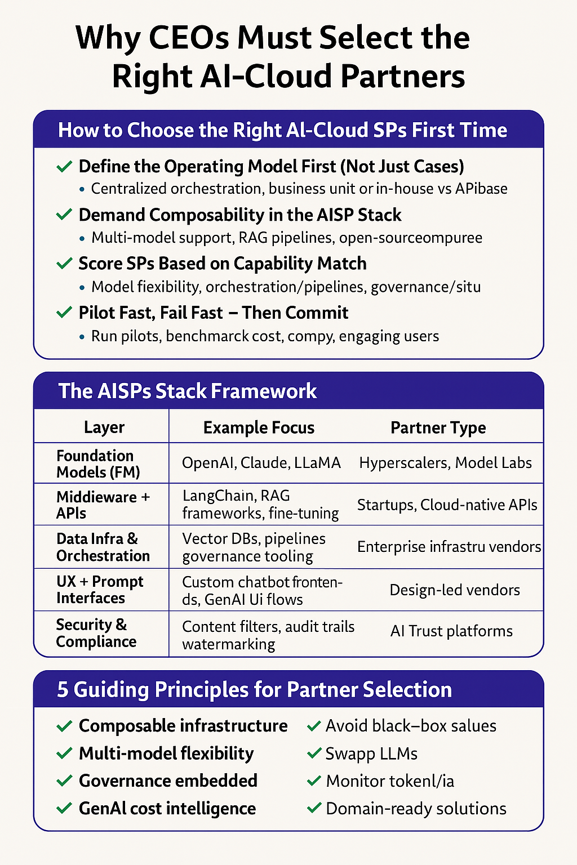
Define the operating model:
Define the Operating Model First Before Selecting AI-Cloud SPs



