

Region: Global

Focus Area: AI
Document Type: Knowledge Article
Why You Need an AI Story and Why 3 Minutes is All You’ve Got
www.digitalfabric.group

Introduction
“You walk into a boardroom with the next big AI innovation. You have 180 seconds before attention drifts. What you say next can make or break your vision.”
In today's rapidly evolving technological landscape, artificial intelligence (AI) is no longer a futuristic concept it's a present-day reality reshaping industries, economies, and daily life. As AI continues to permeate various sectors, the ability to articulate its value succinctly becomes paramount. Whether you're a startup founder pitching to investors, a corporate leader aligning teams, or a marketer communicating with customers, crafting a compelling AI narrative is essential.
But why is a 3-minute story the golden standard? Let's delve into the significance of concise AI storytelling and how it can be a game-changer for your organization.

The Imperative of AI Storytelling
1. Bridging the Knowledge Gap
AI technologies, while powerful, are often complex and abstract. For stakeholders not deeply entrenched in tech, understanding AI's capabilities and implications can be challenging. A well-crafted story demystifies AI, translating technical jargon into relatable narratives that highlight tangible benefits.
"Storytelling is the bridge – it unifies employees, reassures stakeholders and makes complex transitions not just understandable but inspiring." -World Economic Forum
Moreover, business leaders are increasingly resistant to overused buzzwords or algorithm-centric explanations. They seek clarity, context, and confidence not code. A concise story helps sidestep unnecessary AI evangelism and focuses the discussion on outcomes and relevance.
2. Driving Organizational Alignment
A clear AI narrative ensures that all departments from R&D to marketing are aligned in their understanding and objectives. This cohesion fosters collaboration, streamlines decision-making, and accelerates AI integration across the organization.
Internally, a consistent story becomes a unifying reference point. Externally, it becomes a competitive asset that reflects the maturity and clarity of your AI strategy
3. Enhancing Stakeholder Engagement
Investors, partners, and customers are more likely to engage with a story than a data dump. Narratives evoke emotions, making the AI journey relatable and the envisioned future tangible. This emotional connection can be pivotal in securing buy-in and support.
Did you know? Organizations that clearly communicate their AI vision are 2.5x more likely to succeed in scaling their AI initiatives, according to McKinsey.
Additionally, when framed correctly, a story can signal strategic clarity, innovation mindset, and market foresight all of which are critical for CXO buy-in.
The Power of the 3-Minute Narrative
1. Catering to Short Attention Spans
In an age of information overload, attention spans are dwindling. Research indicates that individuals form impressions about a speaker's trustworthiness and competence within just 30 seconds. A concise, 3-minute story respects the audience's time while delivering maximum impact.
2. Focusing on Core Messages
Condensing your AI narrative into three minutes forces clarity. It compels you to distill your message to its essence, highlighting the most critical aspects without unnecessary fluff.
"It really forces you to hone in on all of the important aspects of your business while doing away with anything that's less relevant." -Danny Yaroslavski on Medium
Importantly, for top leadership, the 3-minute story should anchor on 2–3 top-priority business problems. Anything more dilutes focus and reduces retention.
3. Facilitating Repetition and Recall
Short, impactful stories are easier to remember and repeat. This virality ensures that your AI narrative can be shared across networks, amplifying its reach and influence.
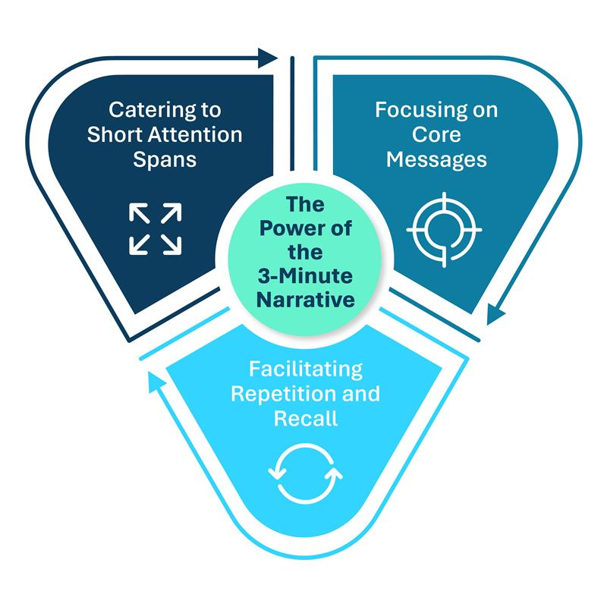
Why 3-Minute AI Stories Work Best at the Top
The C-suite does not have the time or appetite for long-form AI explanations filled with data charts or algorithmic details. What they value is clarity, strategic alignment, and measurable impact.
Here are five reasons why 3-minute stories are the most effective way to engage senior leadership:
- Immediate Focus on Critical Business Problems: They surface the top 2–3 strategic priorities that AI is meant to address no distractions, no detours.
- Removes Unnecessary AI Evangelism: Leadership doesn’t want to hear about neural networks or edge computing unless it ties directly to KPIs. A good story strips out technical clutter and speaks the language of the business.
- Translates Tech into Tangible Impact: Instead of listing features or use-case templates, the story articulates what outcomes will be achieved—cost savings, risk mitigation, process acceleration, customer insights.
- Elevates the Conversation to Strategic Advantage: The story links AI initiatives to broader enterprise shifts: improving competitiveness, enabling agility, or transforming business models not just automating minor tasks.
- Enables External Market Positioning: A clear AI narrative becomes a tool for leadership to communicate the organization's innovation edge to the external world. It showcases AI maturity, capability, adaptability, and scalability—enhancing brand value, ecosystem partnerships, and talent attraction.
In short, the 3-minute AI story becomes a critical success factor (CSF) for both internal AI teams and external technology partners. It’s not a communication tactic it’s a strategic enabler.
Mini Case Study: When one of the vendor pitched their automation platform, they didn’t lead with technology they said, "Imagine every employee having a digital assistant." This simple phrase framed their AI value prop powerfully and helped them connect with early investors.
Crafting Your 3-Minute AI Story
To build an effective 3-minute AI narrative, consider the following structure:
- Problem Statement: Begin by highlighting a pressing issue or opportunity in your industry.
- AI Solution: Introduce your AI-driven approach, emphasizing how it addresses the problem uniquely.
- Impact: Showcase the tangible benefits be it increased efficiency, cost savings, or enhanced user experience.
- Call to Action: Conclude with a clear next step, whether it's a product demo, partnership proposal, or investment opportunity.
This structure ensures a logical flow, guiding the audience through the journey from problem to solution seamlessly.
Conclusion
Incorporating AI into your operations is no longer optional it's imperative. However, the success of AI integration hinges not just on the technology itself but on how effectively its story is told. A concise, 3-minute narrative can be the linchpin in securing stakeholder buy-in, driving organizational alignment, and positioning your brand as a forward-thinking leader in the AI era.
A short, emotionally resonant, and strategically aligned AI story doesn’t just simplify your offering it elevates it. It becomes your enterprise’s communication blueprint and innovation signal to the market.
In a world where attention is the scarcest currency, your AI story could be the most valuable asset you share.
Reference: https://aiswitch.org/why-u-must-build-ai-story






Reach out to us
Tap into expert insights and transformative strategies to lead your enterprise into the age of AI, Cloud, and Intelligent Automation. Connect with us to accelerate growth, optimize operations, and unlock new value at scale.
Email ID: info@digitalfabric.in

Learn more about DIGITALFABRIC® for more insights:
https://digitalfabric.in/
Connect with DIGITALFABRIC®
Copyright © 2025 Digitalfabric® AISwitch. All rights reserved.

