

Region: Global

Focus Area: AI
Document Type: Knowledge Article
How to Build a 3-Minute AI Story: A Step-by-Step Framework
www.digitalfabric.group

Introduction
In today’s enterprise landscape, AI initiatives are no longer just proof-of-concepts they’re strategic drivers of operational efficiency, innovation, and competitive advantage. However, translating a complex AI solution into a clear, concise, and persuasive narrative is often a major challenge for technical teams. Whether you're pitching to executives, clients, or cross-functional stakeholders, a well-structured 3-minute story can bridge the gap between technical depth and strategic impact.
This blog introduces a step-by-step framework to help you craft such a story using the AISWITCH model an approach designed to align AI initiatives with business goals, communicate value clearly, and drive informed action. Built on proven storytelling techniques and strategic alignment principles, this guide helps ensure your AI narrative is both technically grounded and business-ready.

The AISWITCH Framework: A Strategic Approach
The AISWITCH framework offers a strategic approach to AI storytelling, ensuring that your narrative aligns with business objectives and resonates with your audience. Here's how you can apply it:
1. A – Alignment with Business Strategy
Start by aligning your AI initiative with your organization's overarching business strategy. Clearly articulate how the AI solution addresses a specific business challenge or opportunity. This alignment ensures that your story is relevant and compelling to stakeholders.
“An AI narrative that doesn't tie back to business strategy is just noise.” – AISwitch.org
2. I – Insight into the Problem
Provide a deep insight into the problem your AI solution aims to solve. Use data, benchmarks, and real-world examples to illustrate the magnitude and impact of the problem. This helps in establishing the urgency and necessity of the AI solution.
3. S – Solution Overview
Present your AI solution succinctly. Highlight its unique features and capabilities, emphasizing how it stands out from existing solutions. Ensure that the solution is presented in a way that is easily understandable to a non-technical audience.
4. W – Why It Matters
Explain why your AI solution matters. Discuss the tangible benefits it brings to the organization, such as cost savings, efficiency improvements, or enhanced customer experiences. Use metrics and technical outcomes (e.g., processing time reduction, throughput improvement) to substantiate your claims.
5. I – Implementation Strategy
Outline the implementation strategy for your AI solution. Detail the phases of deployment, integration with existing systems, and necessary resources. Provide a timeline for key milestones and the expected technical outputs at each stage. This demonstrates that the solution is feasible and that the project is well-planned.
6. T – Team Expertise
Highlight the expertise of the team behind the AI solution. Showcase the skills and experience of key team members, emphasizing their ability to deliver the solution successfully.
7. C – Call to Action
Conclude your story with a clear call to action. Whether it's scheduling a demo, initiating a pilot project, or seeking approval for further investment, ensure that the next steps are well-defined and actionable.
8. H – Human Element
Incorporate the human element into your story. Discuss how the AI solution impacts employees, customers, and other stakeholders. This human touch makes the story more relatable and emotionally engaging.
9. S – Storytelling Techniques
Utilize storytelling techniques to make your narrative more compelling. Structure your story with a clear beginning, middle, and end. Use anecdotes, metaphors, and visuals to enhance engagement.
“People don't buy AI, they buy better futures. Show them what that looks like.” – Paul Roetzer, MAICON
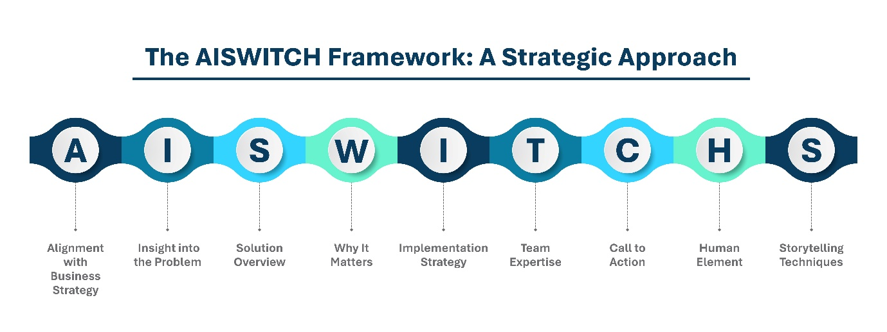
Structuring Your 3-Minute AI Story
To ensure that your story fits within the 3-minute timeframe, consider the following structure:
- Introduction (30 seconds): Introduce the problem and highlight its significance, emphasizing the urgency.
- Body (2 minutes): Present the AI solution, explain its technical benefits, provide the implementation strategy, and showcase the expertise of the team.
- Conclusion (30 seconds): Summarize the key points and present the call to action.
Remember: Simplicity ≠ shallowness. Say less, mean more.
By following this structure, your story will remain concise, focused, and impactful, ensuring that every minute is used effectively.
Tips for Effective Delivery
- Practice: Rehearse your story multiple times to ensure smooth delivery.
- Clarity: Avoid jargon and technical terms. Aim for simplicity and clarity.
- Engagement: Maintain eye contact, use appropriate gestures, and modulate your voice to keep the audience engaged.
- Feedback: Seek feedback from colleagues or mentors to refine your story.
- Visual Aid: Consider a simple 1-pager or infographic to reinforce your narrative.
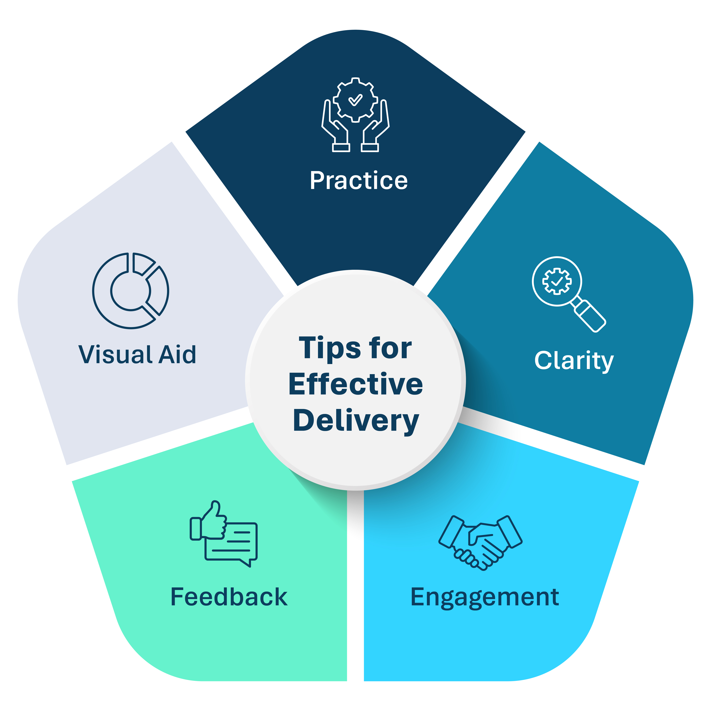
Example: Real-World AI Pitch Using AISWITCH
Problem: Hospitals waste hours on manual patient discharge processing.
Solution: “Our AI scans and auto-fills discharge documents in under 5 seconds.”
Impact: Reduced processing time by 80%, increased patient turnover by 2 beds/day.
Call to Action: “Join our pilot to unlock faster patient discharge workflows.”
(Team includes ex-Mayo Clinic and former AWS ML engineers.)
Conclusion
Building a compelling 3-minute AI story requires a combination of strategic alignment, technical clarity, and impactful delivery. By following the AISWITCH framework and adhering to the suggested structure, you can craft a powerful narrative that resonates with your audience and drives meaningful action. Focus on simplicity, but ensure that each part of the story is rich in technical depth, relevance, and clear outcomes.
Reference: https://aiswitch.org/how-to-build-3-mnt-story






Reach out to us
Tap into expert insights and transformative strategies to lead your enterprise into the age of AI, Cloud, and Intelligent Automation. Connect with us to accelerate growth, optimize operations, and unlock new value at scale.
Email ID: info@digitalfabric.in

Learn more about DIGITALFABRIC® for more insights:
https://digitalfabric.in/
Connect with DIGITALFABRIC®
Copyright © 2025 Digitalfabric® AISwitch. All rights reserved.

