

Region: Global

Focus Area: AI
Document Type: Knowledge Article
Declutter Your AI Storytelling Applying the Power of 3
www.digitalfabric.group

Introduction
In AI adoption journeys, the success of any pilot, proof of value (PoV), or even scaled deployment often hinges on one overlooked capability storytelling. Not the generic kind, but precise, strategic storytelling that moves decision-makers. This is where the Power of 3 plays a foundational role.
We naturally group things in threes. It’s a cognitive science principle that helps structure information in a way our brain processes and retains more efficiently. Applied to AI storytelling, this concept helps reduce complexity, amplify signal, and sharpen stakeholder focus.

The Challenge: AI Stories Are Often Cluttered
AI and analytics solutions generate high volumes of insights from model performance metrics and error distributions to unstructured data transformations and multi-modal outputs. In the rush to cover everything, the result is a high cognitive load on the audience.
What starts as a business narrative often derails into:
- Complex architecture diagrams
- Fragmented use-case slides
- Dense performance charts
- Parallel plotlines with minimal alignment
This clutter makes it harder for stakeholders to extract the strategic value of the solution.
The Solution: Use the Power of 3
To reduce narrative noise and improve impact, structure your AI story around three high-value messages or outcomes. This helps:
- Optimize signal-to-noise ratio: Strip peripheral narratives that dilute your message
- Improve data-to-ink (or data-to-pixel) ratio: Focus on visuals that reinforce the message, not distract
- Reduce decision fatigue: Help leadership retain and act on core takeaways
Think of it like a feature selection step in ML. You don’t just throw in all possible inputs. You identify and retain those with the highest predictive power.
5-Step Guide to Applying the Power of 3
1. Identify 3 Outcomes That Matter Most: Focus on business or operational outcomes not tech specs. Ask:
- What measurable changes did this AI solution bring?
- Can we demonstrate impact in time, cost, accuracy, or experience?
2. Merge Related Narratives Into One Core Theme: When you have multiple related initiatives, build one cohesive narrative. Similar to ensemble learning, you’re combining weak and strong signals to form a more powerful unified storyline.
3. Eliminate Threads One by One to Assess Impact Loss: Use a narrative sensitivity analysis: Remove each sub-narrative and observe whether overall impact diminishes. If it doesn’t its noise.
4. Choose 3 Clean Visuals: Visuals must support not overwhelm the story. Avoid UI screenshots, pipeline diagrams, or confusion matrices unless the audience demands it. Instead, opt for outcome-oriented visuals:
- Before vs. after performance comparisons
- Simplified user journey impact
- Business KPI shift maps
5. Test It with a Non-Technical Stakeholder: If a non-technical process owner can relay the core story back in 60 seconds, your story has clarity.
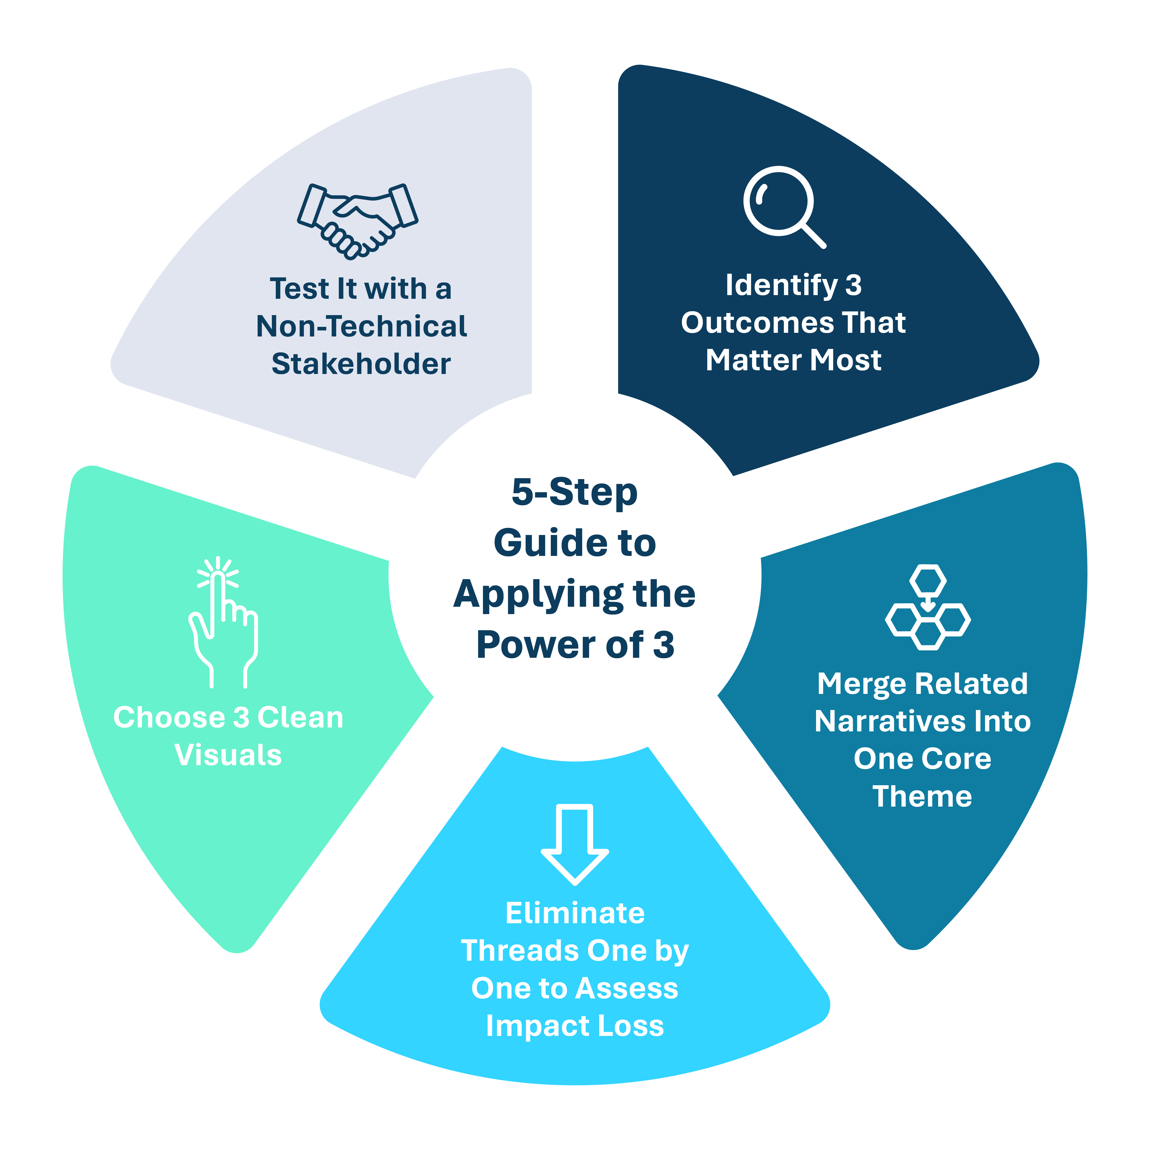

Example: Decluttering a Chatbot AI Story
A conversational AI team wanted to showcase the evolution of their chatbot system. Their original deck included:
- Training datasets and augmentation techniques
- Model pipeline and fine-tuning details
- NLU vs. rule-based resolution accuracy
- A/B testing performance metrics across intents
But the actual business owner was only interested in:
- Reduction in average call handling time (AHT)
- Percentage drop in unresolved queries
- Improvement in customer satisfaction post-chat
Power of 3 Version:
- 45% reduction in AHT across top 5 support queries
- Unresolved query rate dropped from 22% to 5%
- Customer satisfaction (CSAT) improved by 27%
Everything else tech stack, data sources, model diagnostics are execution-layer details. Important for internal teams, but not for a boardroom-level narrative.
Another Example: E-KYC AI Story (Abstracted)
In most AI-powered KYC automation initiatives, the discussion quickly devolves into tech-level problems such as:
- Issues with web data crawling and document parsing
- NLP-based sentiment classification challenges
- OCR noise due to document blur and formatting variability
- Semantic entity recognition errors in unstructured inputs
While these are all valid engineering challenges, they contribute to narrative clutter if not tied back to the business impact.
Decluttered E-KYC Story – Power of 3 Signals:
- Reduced average KYC processing time from 8+ hours to under 10 minutes
- Lowered manual data capture errors by 80%
- Improved onboarding experience scores by 25%
This shift focuses attention on outcomes that matter, not the technology hurdles behind them.
Think Like a Model Builder, Communicate Like a Strategist
Just as we engineer ML models by removing low-importance features or regularizing overfit models, we must do the same with our AI stories. Too many narratives = noise. Too much architecture = cognitive overload.
Instead, let your audience walk away remembering just 3 things the right 3 signals and you’ve done your job as an AI storyteller.
Conclusion
This storytelling principle is inspired by frameworks that emphasize cognitive load reduction, ensemble thinking, and narrative engineering as applied in AI-first organizations. By adopting the Power of 3, AI and analytics teams can communicate more clearly, align stakeholders faster, and accelerate adoption with confidence.
Reference: https://aiswitch.org/declutter-ai%3A-power-of-3






Reach out to us
Tap into expert insights and transformative strategies to lead your enterprise into the age of AI, Cloud, and Intelligent Automation. Connect with us to accelerate growth, optimize operations, and unlock new value at scale.
Email ID: info@digitalfabric.in

Learn more about DIGITALFABRIC® for more insights:
https://digitalfabric.in/
Connect with DIGITALFABRIC®
Copyright © 2025 Digitalfabric® AISwitch. All rights reserved.

