

Region: Global

Focus Area: AI
Document Type: Knowledge Article
Pivot Your AI Strategy: The Cloud-AI-Data Leverage
www.digitalfabric.group

Introduction
Take a Leap of Faith-Trust the Cloud. Now.
The global business landscape particularly across India and the Asia-Pacific is at a decisive inflection point. Over the past decade, technological supply-side capabilities in cloud computing, big data analytics, and AI/ML have matured and become readily available. But what differentiates this era from previous incremental transitions is the drastic demand-side shift triggered by recent global disruptions.
The pandemic has reshaped workforce behaviors, accelerating a permanent shift to virtual, secure, and autonomous work environments. The ability to operate with agility, remotely, and with scalable infrastructure is no longer a luxury it is an imperative. In this new digital normal, elastic, AI-powered cloud infrastructure is not just a technical upgrade it is a strategic enabler.

The Four Pillars of Digital Infrastructure for the Post-Pandemic Enterprise
To meet today's demands, modern digital infrastructure must evolve across four mandatory vectors:
- Elastic and Scalable: Infrastructure must support horizontal, vertical, and diagonal scaling—automatically adjusting to traffic spikes, compute loads, and service-level variability.
- Cost-Energy-Performance Optimization: Smart orchestration of workloads should prioritize compute efficiency, data movement, and sustainability across high-performance cores and storage tiers.
- Resilience and Reliability: High availability, container-native orchestration, service mesh architectures, and automated failover ensure that platforms remain "always-on" and fault-tolerant.
- Governance-Assured AI-Data Integration: Secure, governed, and policy-driven data pipelines must be tightly coupled with AI layers to accelerate use-case delivery while complying with data lineage and privacy norms.
These four layers form the technical backbone for new enterprise operating models, from real-time logistics to predictive maintenance and fraud prevention.
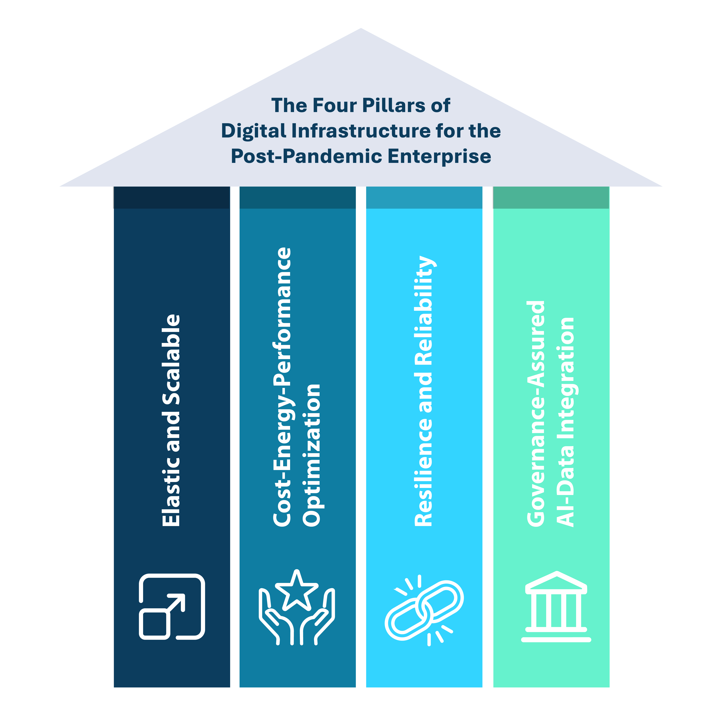
A Blueprint for AI-First Transformation: The 7-Lens Framework
Enterprises that have successfully transitioned into AI-augmented digital-native operations typically follow a common pattern. Here's a distilled 7-lens framework to analyze and replicate their success:
1. Problem Definition
Start by identifying the core business frictions that can be eliminated with automation and intelligence. Typical examples include:
- Reducing order-to-delivery time through dynamic route optimization.
- Balancing multi-stakeholder performance trade-offs (cost, time, quality).
2. Strategy: Minimum Viable Systems (MVS)
Design and implement Minimum Viable Systems that interlink cloud, AI, and data platforms:
- MVS-1: Real-time service orchestration across geo-distributed assets (e.g., logistics, field ops).
- MVS-2: Hyperlocal discovery engines with context-aware recommendation layers.
- MVS-3: Cognitive personalization via AI graphs—enabling "perfect-fit" discovery experiences for users.
Each MVS delivers quantifiable outcomes (e.g., delivery within 32 minutes, optimized resource allocation) and scales horizontally across new use-cases (e.g., last-mile delivery of OTC goods, utility services).
3. Talent: Minimum Viable Talent (MVT)
To operationalize MVSs, organizations must build or partner for cross-functional AI-cloud-data teams, including:
- Data engineers (for cleansing, integration, pipeline management)
- OR experts (for constraint-based modeling like linear/integer programming)
- Machine learning engineers (for predictive models, NLP, CV, graph-based AI)
4. Information: Data Foundations
Effective AI requires high-quality, high-velocity, high-variety datasets. Challenges and resolutions include:
- Volume: Millions of user-event logs, partner transactions.
- Variety: Structured (tables), semi-structured (JSON), unstructured (images, audio).
- Velocity: Streaming telemetry for real-time inference and decision-making.
Sophisticated pre-processing pipelines, schema harmonization, and continuous data quality monitoring are essential components of robust data architectures.
5. Technology: Hybrid AI-Cloud Stack
AI systems must operate seamlessly across structured/unstructured data, requiring:
- Time-series forecasting for demand prediction
- Constraint solvers for resource optimization
- Deep learning models for perception tasks (CV, NLP)
- Graph databases for semantic understanding (e.g., food graphs, fraud graphs)
The orchestration layer must manage 400K+ combinatorial scenarios in milliseconds. Agile deployment pipelines (CI/CD/CT), model observability, and feedback loops ensure the stack is future-proof.
6. Culture: Organizational Change & Trust
Technology alone doesn’t drive transformation organizational culture must shift, too.
- Fraud detection systems improve transparency but require stakeholder trust.
- AI-driven feedback loops challenge traditional hierarchies and human biases.
- Ops teams must embrace data-first decision-making, supported by AI insights.
Behavioral nudges like fraud prevention via speech analysis, image recognition, and anomaly detection promote a culture of accountability.
7. Human-AI Augmentation: Business Impact Metrics
AI augmentation must translate to measurable outcomes, such as:
- Average delivery time reduced to sub-35 minutes
- Order fulfillment accuracy improved under traffic/weather constraints
- Reduced customer churn via personalization
- Lower fraud rates through AI-driven behavioral analytics
These outcomes are not aspirational they are being delivered by enterprises that embrace technical agility over legacy inertia.
Conclusion
India as the Living Lab of AI-Cloud Transformation
India with its high-dimensional diversity, fragmented supply chains, and cost sensitivity has become a prototype lab for full-stack digital transformation. If scalable, resilient, and governed AI-cloud-data systems work here, they are likely to succeed anywhere.
The path forward is clear: Businesses must pivot fast, build integrated capabilities, and deliver value at scale. From edge-to-core, chip-to-API, inference-to-outcome, the blueprint for intelligent enterprises is already here.
The future isn’t cloud-first or AI-first. Its cloud-AI-data integrated, with agility at its core.
Reference: https://aiswitch.org/aws%3A-cloud-ai-data-pivots






Reach out to us
Tap into expert insights and transformative strategies to lead your enterprise into the age of AI, Cloud, and Intelligent Automation. Connect with us to accelerate growth, optimize operations, and unlock new value at scale.
Email ID: info@digitalfabric.in

Learn more about DIGITALFABRIC® for more insights:
https://digitalfabric.in/
Connect with DIGITALFABRIC®
Copyright © 2025 Digitalfabric® AISwitch. All rights reserved.

