

Region: Global

Focus Area: AI
Document Type: Knowledge Article
Your 3-Minute AI Story from Template to Transformation
www.digitalfabric.group

Introduction
In today’s fast-paced business landscape, the ability to explain your AI initiative clearly and quickly is a competitive advantage. Stakeholders don’t have time for dense whitepapers or overly technical presentations. What they need is a crisp, compelling story that distills the essence of your AI project into something they can understand, remember, and act on. That’s where the 3-minute AI story comes in. More than a pitch, it’s a strategic narrative that connects purpose with impact, turning complex solutions into persuasive moments. This blog guides you through the process of moving from a generic storytelling template to a high-impact narrative that resonates across audiences from boardrooms to demo rooms.

The Essence of a 3-Minute AI Story
A 3-minute AI story isn't just about brevity; it's about impact. It's a strategic narrative that encapsulates your AI initiative's purpose, process, and potential in a digestible format. Whether you’re speaking to customers, investors, internal teams, or the media this approach ensures your message is clear, engaging, and memorable.
From Template to Transformation
Transitioning from a generic template to a transformative story involves several key steps:
1. Identify the Core Message
Begin by pinpointing the central theme of your AI initiative.
- What problem does it solve?
- Why does it matter now?
- Who benefits the most?
This core message becomes the anchor for your entire narrative.
2. Structure Your Story
Organize your narrative into a clear and familiar storytelling structure:
- Introduction: Present the problem or opportunity.
- Development: Describe the AI solution and its implementation.
- Conclusion: Highlight the outcomes and future implications.
Framework Callout: This mirrors the classic "setup–confrontation–resolution" arc used in powerful storytelling.
This structure aligns with the classic storytelling arc, ensuring a logical flow.
3. Incorporate the 'Power of 3'
Use the Power of 3 principle, a proven storytelling technique that enhances memorability. Identify three key benefits or innovations that make your AI solution valuable.
4. Use Clear and Concise Language
Avoid technical jargon unless speaking to a highly specialized audience. Focus on clarity and simplicity, making sure your audience can grasp complex concepts with ease. When explaining intricate processes, such as AI model selection or algorithm tuning, analogies can help non-technical stakeholders understand.
Use analogies when explaining technical concepts to non-technical stakeholders.
5. Engage Emotionally
Facts tell, but stories sell. Share real-life examples of user reactions or tangible outcomes that emphasize human value. Highlight the business transformation resulting from AI implementation, and how it drives operational efficiency, stakeholder trust, and overall company growth.

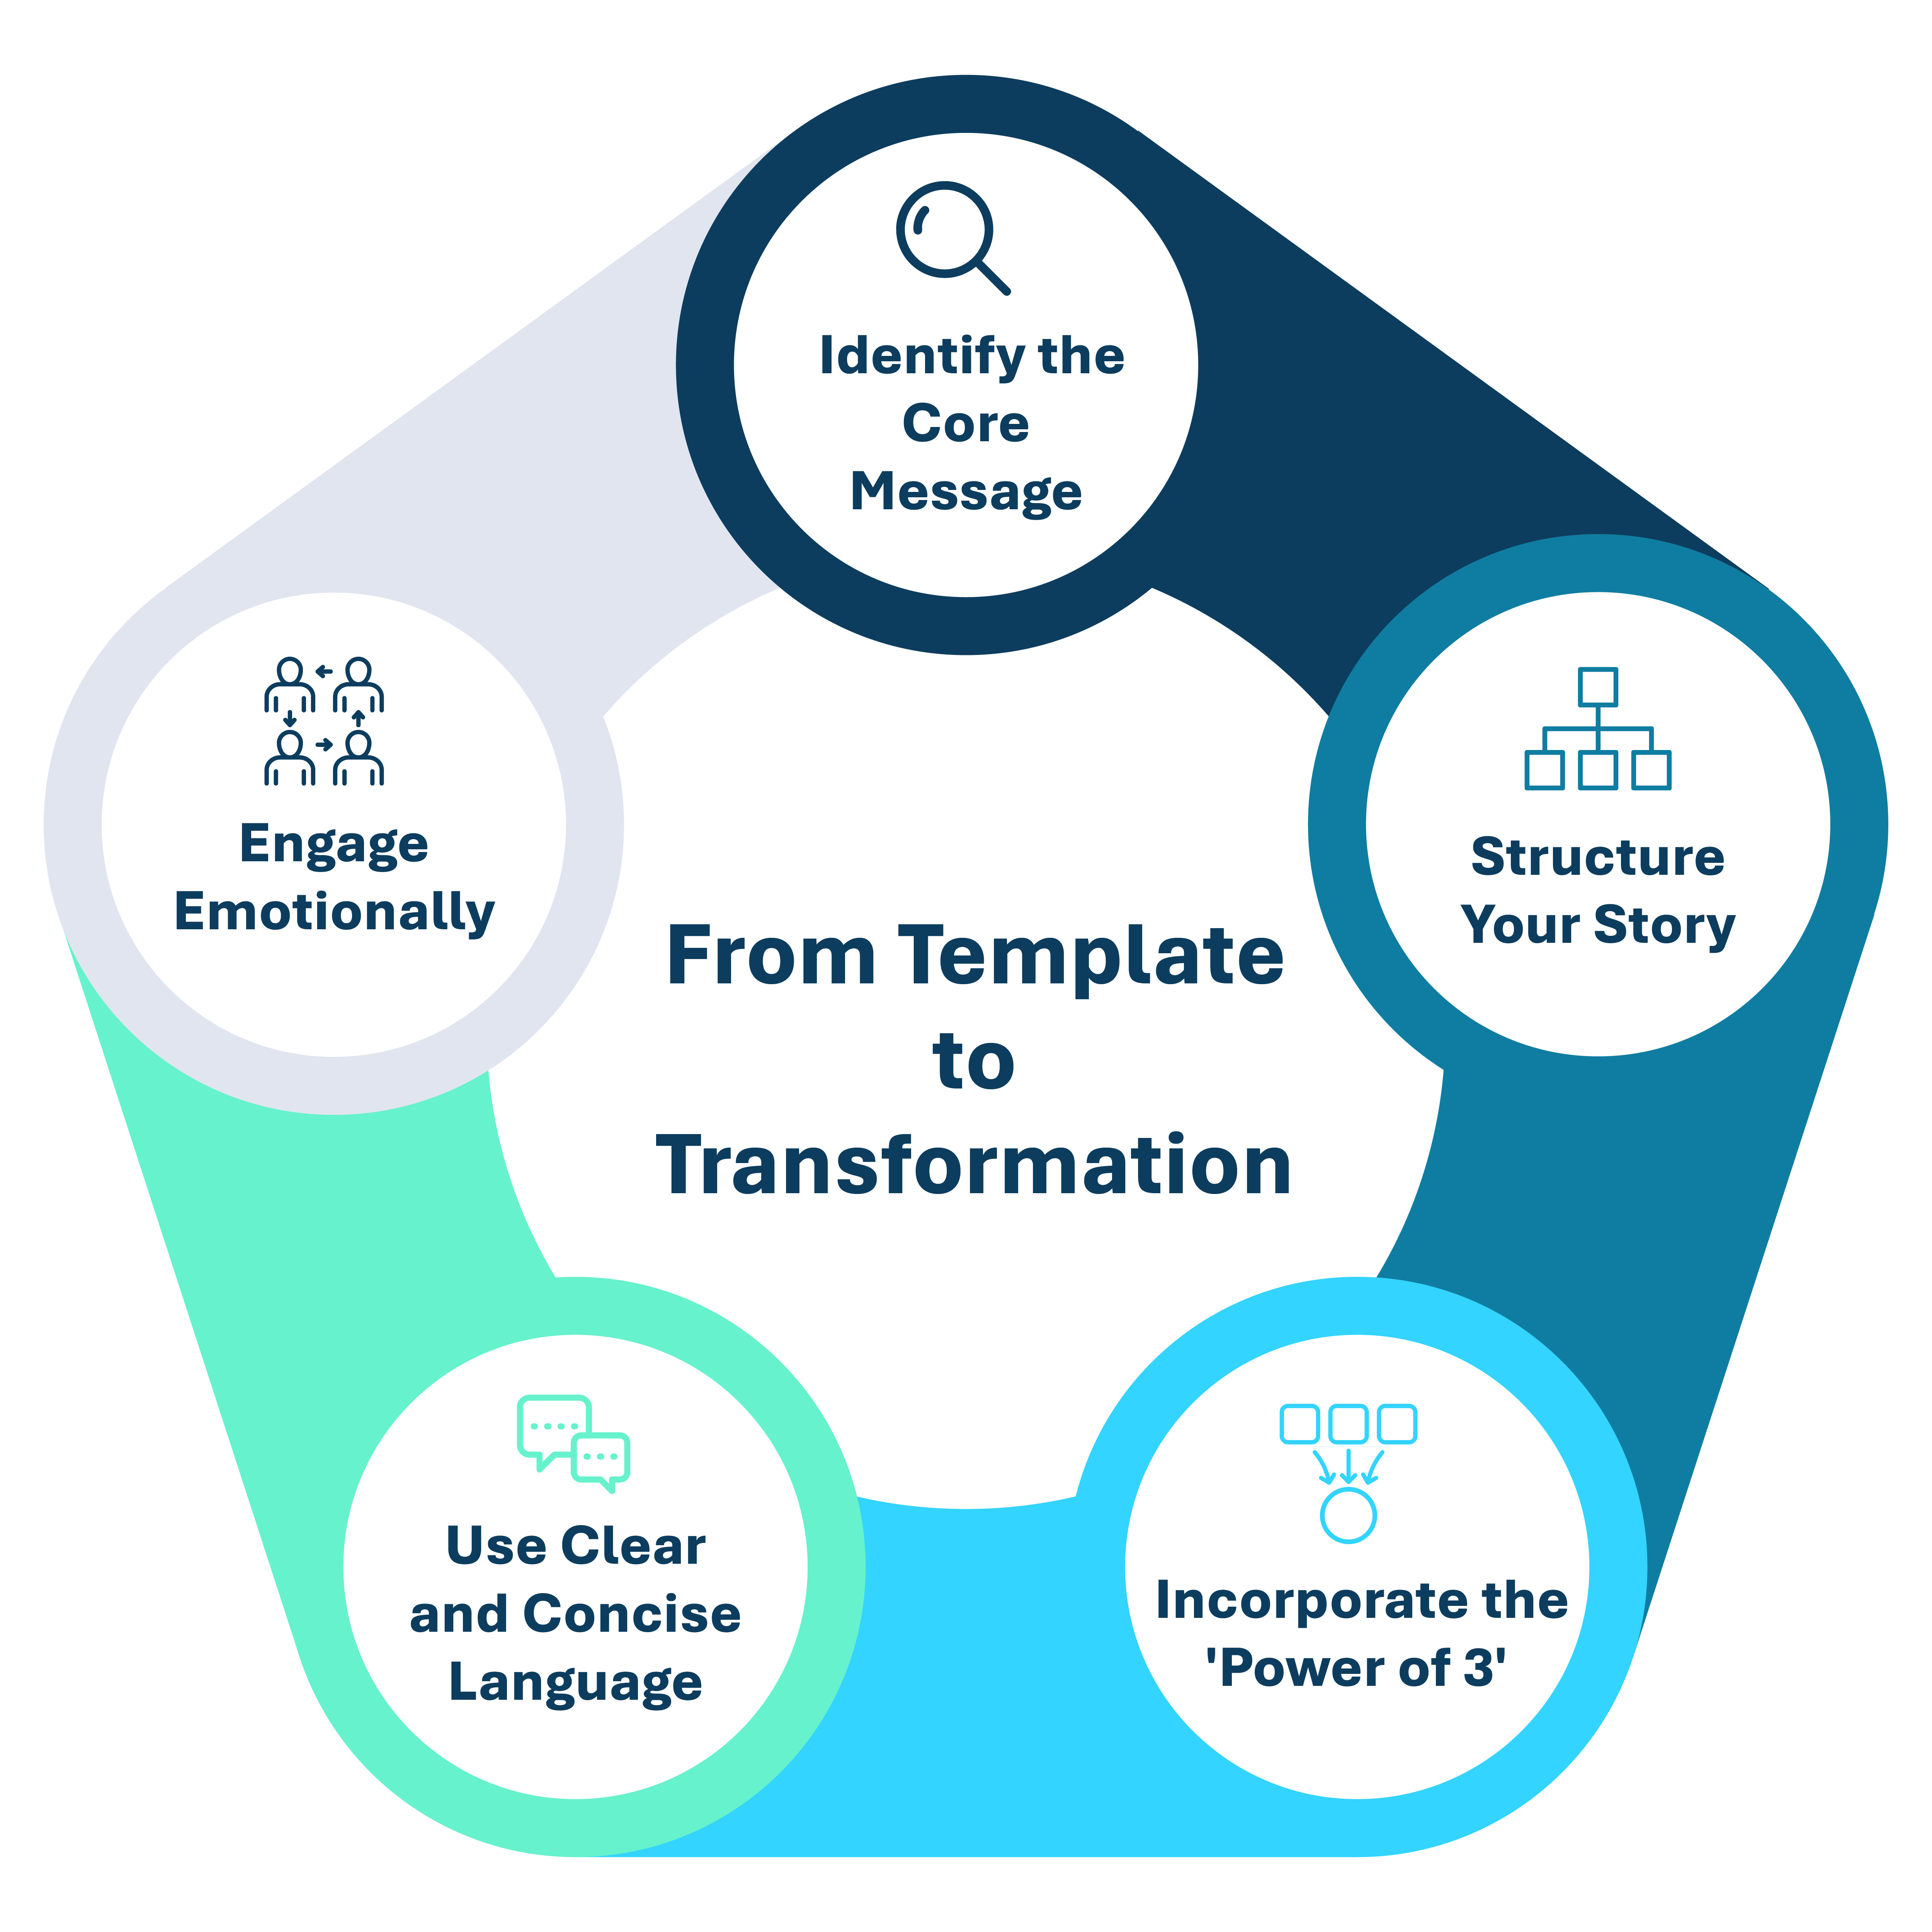
Practical Example
Consider a company facing challenges with revenue forecasting. Over the past five years, their projections have been inaccurate, affecting key stakeholders such as investors, employees, and clients. As a result, their Net Promoter Score (NPS) has steadily declined, now sitting at 30%.
Core Message: Improve the accuracy of revenue projections to over 90%, leading to a significant increase in NPS.
Structured Story:
Introduction: The company struggles with inaccurate revenue projections, creating frustration among key stakeholders.
Development: The company sets up a dedicated AI team, deploying machine learning (ML) algorithms to improve forecasting accuracy using historical financial data.
Conclusion: The AI solution achieves 92-94% accuracy in projections, with early feedback from stakeholders showing improved satisfaction. The company expects their NPS to exceed 80% within the next few quarters.
Power of 3:
- Increases forecast accuracy to 92-94%.
- Reduces stakeholder frustration and improves strategic planning.
- Enhances credibility and satisfaction among investors and clients.
Where It Works: Pitch Scenarios
A 3-minute AI story is particularly effective in:
- Investor pitches (VCs value concise, clear narratives).
- CXO briefings (executives need fast, high-level insights).
- Sales meetings (quickly grabbing attention and sparking interest).
- Conference talks and demos (where storytelling often trumps traditional slides).

Conclusion
Transforming a template into a compelling 3-minute AI story requires clarity, structure, and emotional engagement. By focusing on a central message, organizing your narrative effectively, and emphasizing key benefits, you can craft a story that not only informs but also inspires.
Reference: https://aiswitch.org/output%3A-a-3-mnt-ai-story-1






Reach out to us
Tap into expert insights and transformative strategies to lead your enterprise into the age of AI, Cloud, and Intelligent Automation. Connect with us to accelerate growth, optimize operations, and unlock new value at scale.
Email ID: info@digitalfabric.in

Learn more about DIGITALFABRIC® for more insights:
https://digitalfabric.in/
Connect with DIGITALFABRIC®
Copyright © 2025 Digitalfabric® AISwitch. All rights reserved.

