



Series: 5- WHAT'S DATA STORYTELLING
Focus Area: AI
Document Type: Knowledge Article
Transforming Data into Decisions- 5 Proven Data Storytelling Techniques
www.digitalfabric.group
Without these techniques, just tools/ platforms won't ever deliver any value
Just the availability and access to mature data storytelling tools with advanced features do NOT guarantee their leverage.
What are the techniques that efficient and effective data storytellers must hone and embrace, to be able to justify the investments in the data visualization tools and platforms?
Here are the top 5 techniques to build effective data-stories that will resonate with senior business leaders and will add demonstrable value in their decisions and actions:
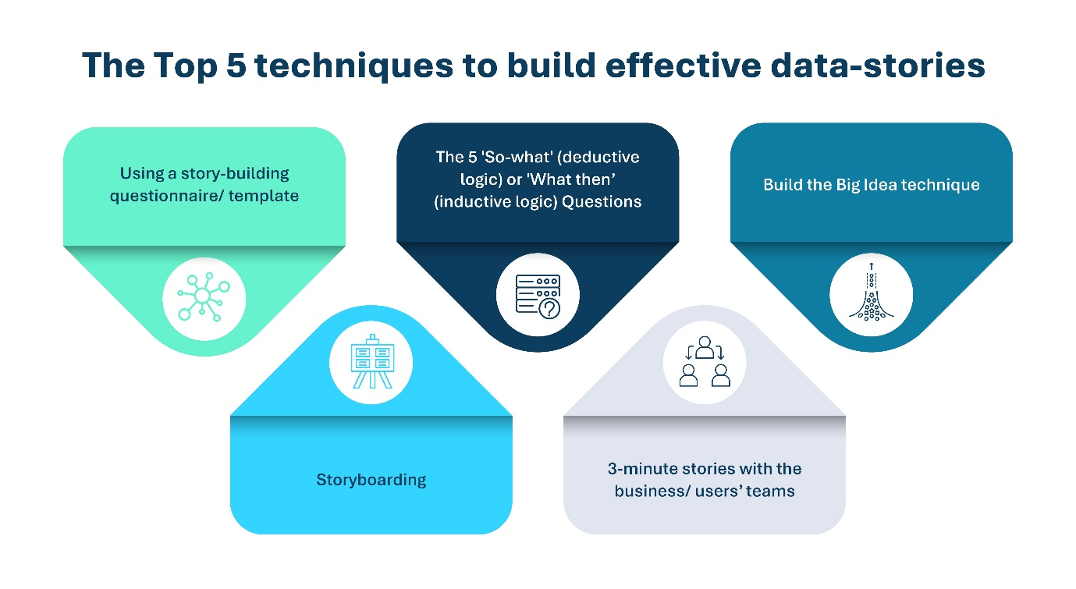
- Using a story-building questionnaire/ template
- The 5 'So-what' (deductive logic) or 'What then’ (inductive logic) Questions
- Build the Big Idea technique
- Storyboarding
- 3-minute stories with the business/ users’ teams
Exploratory vs. explanatory data storytelling techniques:
Techniques 1 & 2 are exploratory, QnA based data storytelling techniques. As the category-name suggests, they are applicable in scenarios where the data storytellers don't already have a clearcut picture of the business problems and users' targeted outcomes and expectations.
- These scenarios and hence the techniques are similar to the DevOps/ agile methodologies in software/ solutions development and delivery.
- Here, the users/ customers' feedback is sought at every stage starting from requirements elicitation to design to code-build to test-cases and UAT.
- In these methods, the customers and users should be able to relate to the questions as relevant and useful in their specific problems, decisions and actions context.
Techniques 3 to 5 are more explanatory and applicable to scenarios where the data storytellers already have a pretty good idea and confidence about what stories and answers the business stakeholders and customers/ user groups want to hear.
1- How to use a Data-story development questionnaire/ template
A good data-story ALWAYS start from the right questions, that the story will provide answers for. So, the first and foremost technique for effective data storytelling lies in the story developers' ability to ask the right questions. Here is an example data-story building questionnaire:
- Who are the targeted audience/ persona for this data-story? What are their expectations from the data science programs/ projects?
- What decisions are these targeted persona's going to need support for, from the data-stories?
- What metrics for the target persona/ role will be most impacted by the accuracy and quality of insights presented in the data stories?
- What are the risks and constraints that the target persona/ roles experience / envisage, that must be covered as critical dimensions of the data stories built for them?
- What could be the potential sources of decision biases that the target persona/ roles may have, which may raise their concerns?
- What are the data sources that data story builders need, to construct the data stories in a 360 manner?
- What's the priority, in terms of data criticality and ranking of insights visualization?
- What will success look like, in a data-story?
2- The 'So-What' / 'What Then' questions technique
Many of us are familiar with the '5 Why's framework. In similar lines, for data story-telling, the questions can span across multiple levels, a reasonable no. of steps being at least 5.
The key decision here is:
- Whether the questions will be 'So what' i.e. deductive/ backward chaining based, e.g. the story aimed to explain an insight post-facto and deduce the learnings from it, or
- The questions will be 'What then', i.e. the story extrapolating/ predicting a forward chaining-based future view/ simulation, based on the patterns and insights analyzed and presented in the visualization and analytics tools and the ML platforms (specifically for predictive models)
3- Build the Big Idea
Explained by Nancy Duarte in 'Resonate', the Big Idea being summarized into a key sentence, describing:
- A unique viewpoint that's the key highlight of the data story
- Focusing on the key outcomes/ targets at stake
- Explained in a syntactically valid narrative, in complete sentences and not just bulleted statistical observations and statements
For the previous example on COVID - planning for the third wave, the Big Idea covering the 4 key dimensions as stated above, can be expressed as:
Based on the analysis of the first and second wave of COVID in India, it has been seen that the mass vaccination drives are the most effective ways to prevent community spread of the contagion across all age-groups, hence the vaccine production, distribution cold chains and execution infrastructure should be funded on an emergency basis, to prevent the third wave.
4- Storyboarding
Storyboarding focuses on first building a structural Strawman of the story. It's like the flowchart that we design, before developing the program/ algorithm and writing the code. It shows how the data story will flow, cascading the narrative from scenarios to scenarios, in a visual form or in the targeted textual content structure.

5- The 3-minute story
This is a time-boxed technique so that the priority filters and key messages are articulated first, and also to reduce unnecessary noises and story 'clutters', e.g. without too many dashboards and data elements eventually proving similar insights and viewpoints.
Among these example data story-telling technique options (explained further in follow-through practice notes), choice of the most apt story-telling technique will obviously depend on:
- The time and priorities of the targeted persona/ audience for the data story
- Complexity and availability and accessibility and quality of the underlying data
- What questions do the data story need to address as top priority?







Reach out to us
Tap into expert insights and transformative strategies to lead your enterprise into the age of AI, Cloud, and Intelligent Automation. Connect with us to accelerate growth, optimize operations, and unlock new value at scale.
Email ID: info@prosight-AISM.com

Learn more about DIGITALFABRIC® for more insights:
https://digitalfabric.group
Connect with DIGITALFABRIC®
COPYRIGHT © 2025 DIGITALFABRIC® AISWITCH™. ALL RIGHTS RESERVED.

