



Series: 5- WHAT'S DATA STORYTELLING
Focus Area: AI
Document Type: Knowledge Article
HOW TO USE STORYBOARDING TECH FOR BUILDING DATA STORIES
www.digitalfabric.group
Storyboarding produces structural Strawman of the target data story
It's like the flowchart that we design, before developing the program/ algorithm and writing the code. It shows how the data story will flow, cascading the narrative from scenarios to scenarios, in a visual form or in the targeted textual content structure.
For example, suppose we are building the data-story of a business case for new social-media-based marketing campaigns for a series of product launches, using trends and patterns from past successful campaigns data.
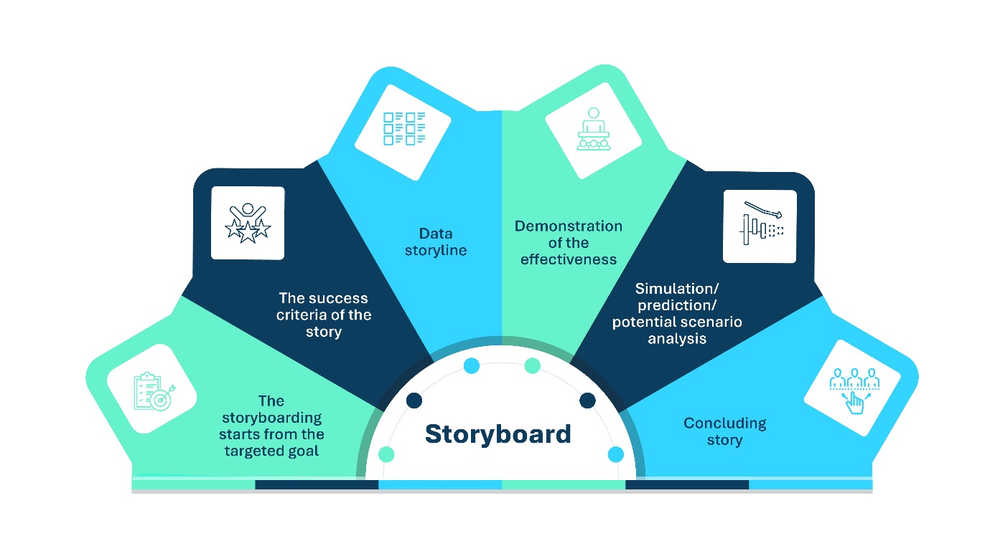
- The storyboarding starts from the targeted goal: To design a new social-media based marketing campaign for new product launches targeted towards millennial customers, with a high assurance of success.
- The success criteria of the story: Getting the resources in terms of skills and infrastructure, and funds, that are necessary for designing and delivering a new type of marketing campaign, focused on social media.
- Data storyline: Analysis of success of previous campaigns - on social media vs. traditional media, for a specific targeted set of customers
- Demonstration of the effectiveness: e.g. of social media campaigns over traditional campaigns, for the targeted customer groups
- Simulation/ prediction/ potential scenario analysis: of alternative social media campaign design alternatives, basis the demonstrated results of previous campaigns' effectiveness analysis
- Concluding story: Happily ever after!- Summarizing the previous analyses and simulations and presenting the business case for the new campaign
For more explanations on other techniques and applications, go to:
https://aiswitch.org/5-datastory-techniques







Reach out to us
Tap into expert insights and transformative strategies to lead your enterprise into the age of AI, Cloud, and Intelligent Automation. Connect with us to accelerate growth, optimize operations, and unlock new value at scale.
Email ID: info@prosight-AISM.com

Learn more about DIGITALFABRIC® for more insights:
https://digitalfabric.group
Connect with DIGITALFABRIC®
COPYRIGHT © 2025 DIGITALFABRIC® AISWITCH™. ALL RIGHTS RESERVED.

