



Series: 5- WHAT'S DATA STORYTELLING
Focus Area: AI
Document Type: Knowledge Article
WHAT ARE TOP 5 FEATURES OF DATA STORY-TELLING TOOLS?
www.digitalfabric.group
Data storytelling & Data visualization tools & platforms: 5 key features
Data story-telling is already a well-practiced activity in many of the digital business enterprises. Extrapolating the current-state of data story-telling and correlating it with Gartner 2025 predictions on the same, data storytelling will grow manifold, in terms of capability building investments and practice growth, and the tools and techniques investments in it is slated to expand into multi-billion dollars, in next 3-5 years.
Although the volume-wise growth in this space seems poised for exponential growth, the value-curve is still not well proven with trustworthy evidences from top business leaders and decision makers. This is partially because of the fact that, like most other technology-related practice interventions, data storytelling as a practice has also started with the typical Cart Before the Horse syndrome in most enterprises, where the availability of a data visualization platform has been equated to existence of a data storytelling practice. This scoping gap and it's consequent capability gaps are again failing to show value and make a visible, measurable impact, in the eyes of top enterprise leaders.
As a result, there's no dearth of mature data visualization tools, already applied and adopted in some form ranging from full-platform to siloed tool-stacks, across the mid to large enterprises. Most popular tools in this context are:
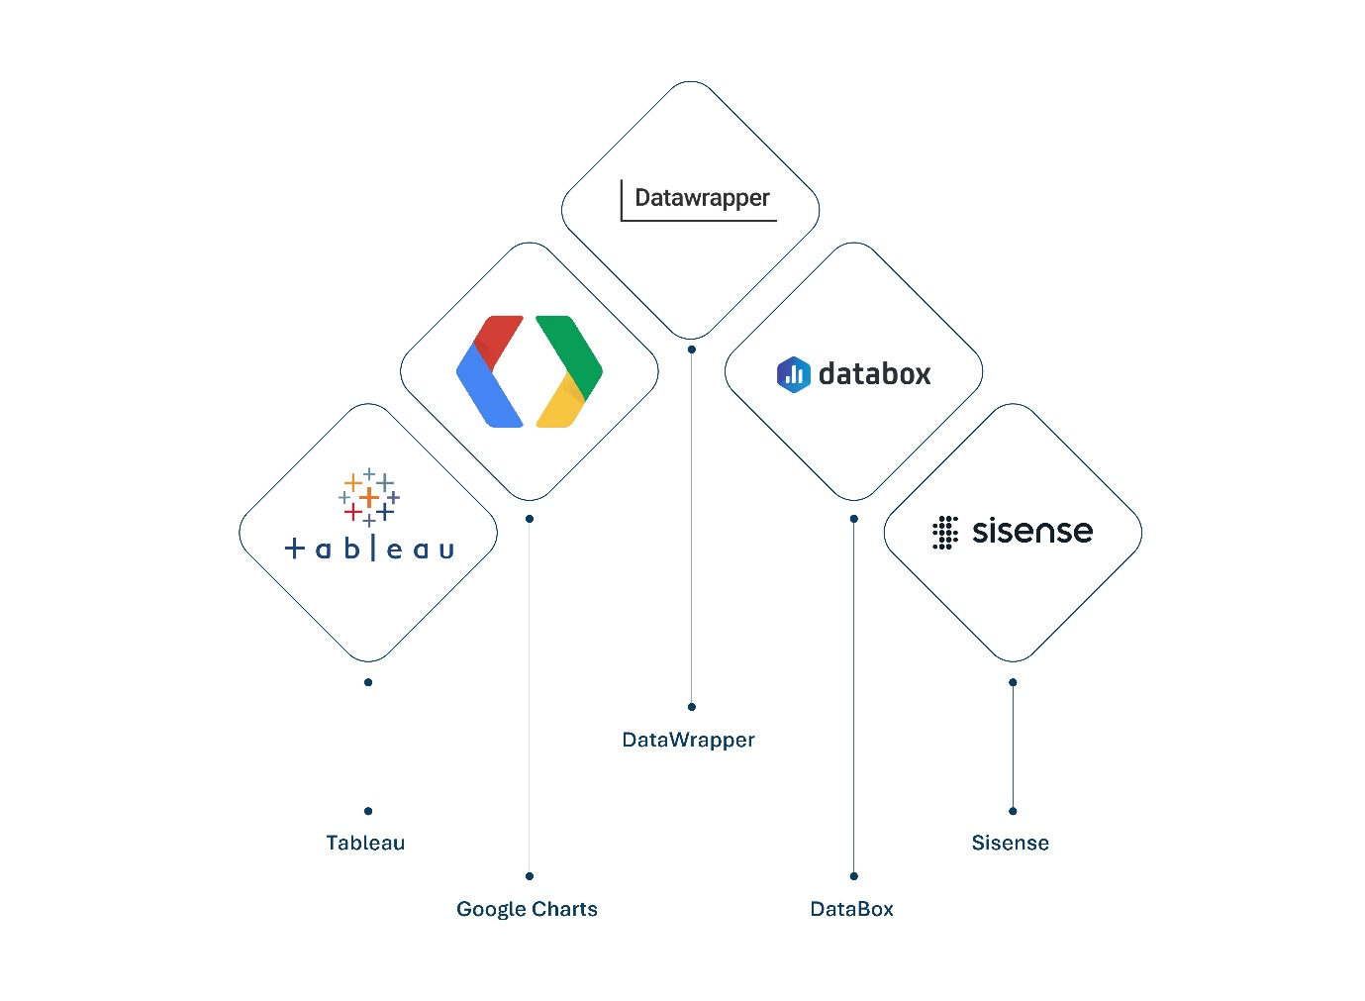
- Tableau (preferred by enterprise citizen data science practitioners due to high level of familiarity with the interface & ease-of-use, quick learning curves, with varying degree of access controls, basic versions available at zero to low costs but enterprise-wide adoption of the tool is costly)
- Google Charts (Developers' favorite: fast learning curves for techies but not for starter citizen developers/ business team-members, needs basic coding knowledge of JavaScript, for example)
- DataWrapper (good for citizen developers moderate learning curves, technical capabilities above average in mapping visualization, no coding skills prerequisite)
- DataBox (preferred and optimized for mobile data visualization, flexible form factors)
- Sisense (increasingly popular in hoistic, 360 data story development and support, leads in social media-based analytics and visualization, provides easy industry insights-based pre-built dashboards that can be quickly populated with specific enterprise data).
Most of these tools facilitates data visualization with a large portfolio of capabilities, including:
- Portability of reports and model visualizations across form factors e.g. mobile to virtual presentation platforms
- Volumes of datasets e.g. structured to unstructured to short texts to mixed data, ranging from social media to web crawlers-collected data dumps and documents
- Data latency e.g. from near real-time to static / time-boxed trending reports
- Algorithmic efficacy e.g. analytics and ML-based predictive capabilities available, and
- Pre-integrated capabilities for multiple types of data pipelines, storages, databases, data sources and other analytics and visualization tools.
While this can well serve as a checklist for current data story-telling practitioners across enterprises, the key point to keep in mind for analytics, data science and AI application leaders is that: Just having the tools/ platform capabilities at your teams' disposal DOES NOT ENSURE that the teams have the right training, techniques, skills and most importantly, the core ability to ask the right questions in specific business contexts, that these tools and features can provide answers for, IF USED WELL.
For more explanations, other techniques and applications, go to:
https://aiswitch.org/5-datastory-techniques
https://aiswitch.org/data-storyboarding-tech
https://aiswitch.org/3-minute-data-stories
https://aiswitch.org/so-what-story-building
https://aiswitch.org/data-story-qna-templating







Reach out to us
Tap into expert insights and transformative strategies to lead your enterprise into the age of AI, Cloud, and Intelligent Automation. Connect with us to accelerate growth, optimize operations, and unlock new value at scale.
Email ID: info@prosight-AISM.com

Learn more about DIGITALFABRIC® for more insights:
https://digitalfabric.group
Connect with DIGITALFABRIC®
COPYRIGHT © 2025 DIGITALFABRIC® AISWITCH™. ALL RIGHTS RESERVED.

