



Series: 5- WHAT'S DATA STORYTELLING
Focus Area: AI
Document Type: Knowledge Article
HOW TO BUILD 3-MINUTE DATA STORIES FOR CXO ATTENTION SPAN
www.digitalfabric.group
Senior leaders, influencers and decision makers won't listen longer...
The 3-minute story:
This is a time-boxed technique so that the priority filters and key messages are articulated first, and also to reduce unnecessary noises and story 'clutters', e.g. without too many dashboards and data elements eventually proving similar insights and viewpoints.
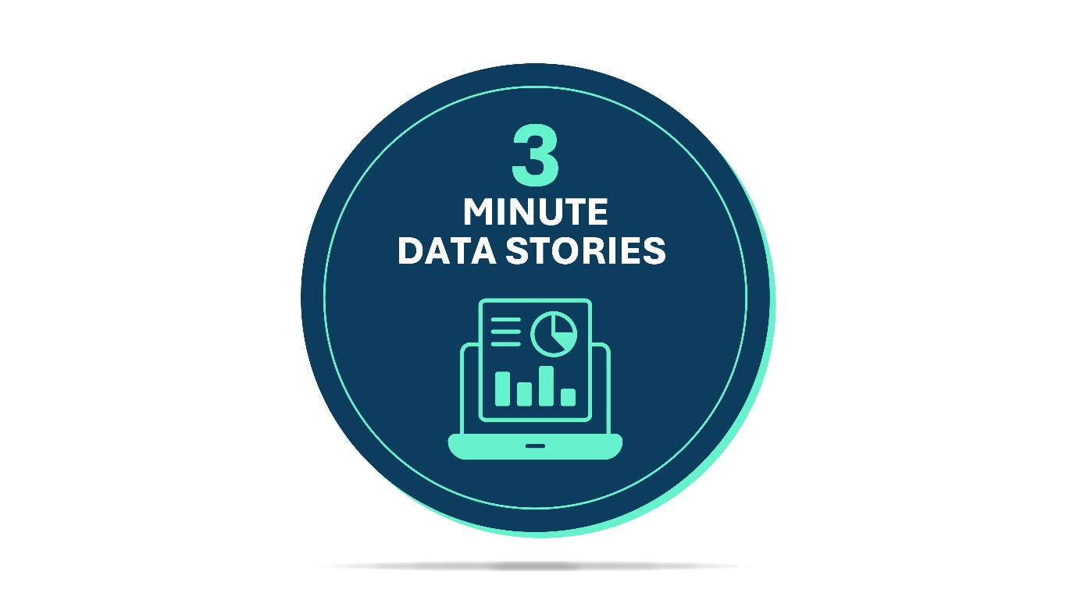
For example, for the COVID third wave prevention plan data-story, a 3-minute story-telling version will include visual storylines plus narratives, as below:
The spread of the virus during the first and second waves of COVID-19 has shown that - in countries where mass vaccination programs got delayed, due to population and logistics and access problems, both the rate of spread and the severity of illness indicators have increased from 2X to 30X, across a few critical parameters in some regions [ref. Visual graphs/ trend charts]. ......
Shortage of health infrastructure and basic healthcare materials like oxygen and critical care medicines resulted in rapid deterioration in cases of elderly patients (first wave) as well as youngsters (20's and 30's)..... [with data visuals]....The effectiveness of vaccines were proven in multiple studies ...... [visuals]... These immunity indicators prove that vaccination rates above 30-40% can help prevent rampant proliferation of COVID in a potential third wave that the medical experts are predicting in the next few quarters.
Based on these observations, the private sector hospitals have to join hands with public sector health infrastructure, to provide vaccine production-distribution-execution support at an emergency scale, especially across regions where the rate of spread has been very high in the first and second waves.
The 3-minute story-boxes are one of the most powerful messaging techniques focused on the attention span of the target audience, which in most cases are the top leaders and decision makers.
The key features of 3-minute stories are:
- It starts with the top 1-2 (max) pain-points and/ or priorities and stays focussed on that strongest story-thread. That way, the story doesn't attempt to cover too much ground but only tells the key message. This reduces possible clutter in the audience minds and lets them to focus on the key message as well.
- It uses the 'Black Swan- -like data story elements like sudden shifts in trends and absolute numbers and exponential spikes in patterns, to drive leadership audience attention to the IMPACT factors and not just input factors.
- This technique represents respect and value for senior leadership audience time and efforts. That way, the satisfaction scores of the targeted audience, with this technique, is the highest.
For more explanations, other techniques and applications, go to:
https://aiswitch.org/5-datastory-techniques
https://aiswitch.org/data-storyboarding-tech
https://aiswitch.org/so-what-story-building
https://aiswitch.org/data-story-qna-templating







Reach out to us
Tap into expert insights and transformative strategies to lead your enterprise into the age of AI, Cloud, and Intelligent Automation. Connect with us to accelerate growth, optimize operations, and unlock new value at scale.
Email ID: info@prosight-AISM.com

Learn more about DIGITALFABRIC® for more insights:
https://digitalfabric.group
Connect with DIGITALFABRIC®
COPYRIGHT © 2025 DIGITALFABRIC® AISWITCH™. ALL RIGHTS RESERVED.

