



Series: 5- WHAT'S DATA STORYTELLING
Focus Area: AI
Document Type: Knowledge Article
HOW TO USE THE SO-WHAT AND WHAT-THEN DATA STORY-TELLING TECH
www.digitalfabric.group
So-what and What-then: Critical questions to build good data-story plots
For effective 'depth-first' data story-telling, the So-What and What-Then questions give sufficient probing opportunities to the data story builders, to gain a deep understanding of the plot (the business problem in question). Questions can span across multiple levels, a reasonable no. of steps being at least 5.
- 'So what' questions: i.e. deductive/ backward chaining based, e.g. the story aimed to explain an insight post-facto and deduce the learnings from it,
- 'What then' questions: i.e. the story extrapolating/ predicting a forward chaining-based future view/ simulation, based on the patterns and insights analyzed and presented in the visualization and analytics tools and the ML platforms (specifically for predictive models)
For example, in a data story concerning insurance claim projections post-COVID potential third wave, the 'What then' questions at multiple levels of analysis granularity will be:
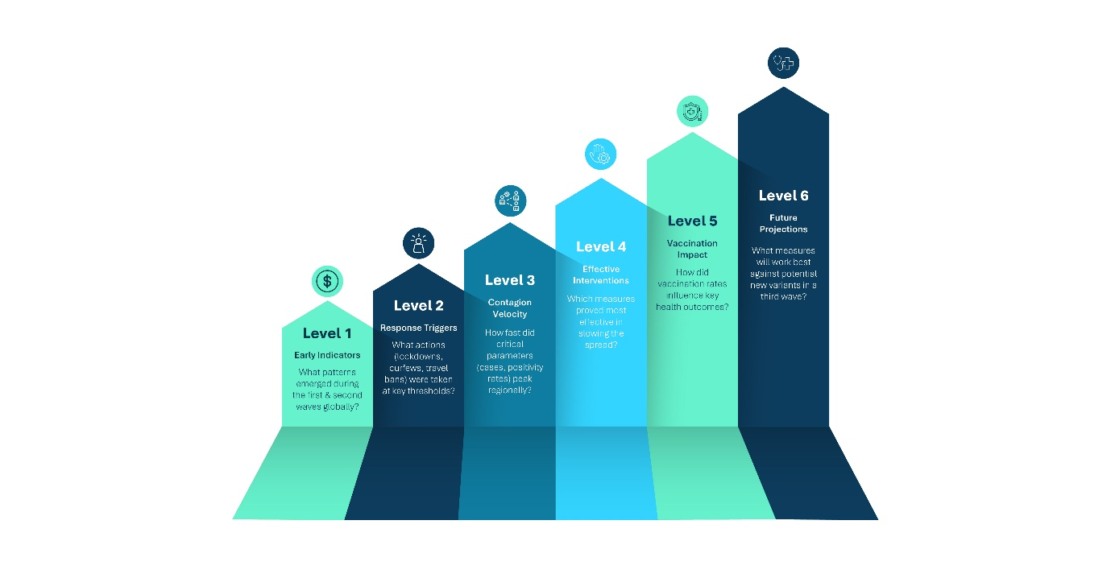
Level 1: What have been the early indicators of community spreads that have been seen around the world in the first and second waves and what have the most successful countries done then in tackling and reversing the contagion trends?
Level 2: What measures (e.g. complete/ partial lock-down, curfew, stoppage of inter-state people movements) were taken then, in first and second waves, at different thresholds of the critical contagion severity indicators (e.g. positivity rates, mortality rates, ICU occupancy)?
Level 3: What were the peaking rates/ speed of the critical parameters during the first and second waves (e.g. total cases doubling/ crossing 1000-2000-3000 thresholds by regions and percentage of population?
Level 4: What measures were proven to be most effective in controlling the rates then?
Level 5: What impact have vaccination rates had, on the critical parameters?
Level 6: What measures will most likely benefit the different regions, based on dominant mutations of the contagion, if and when the third wave of COVID hits certain regions or the country as a whole?
For more explanations, other techniques and applications, go to:
https://aiswitch.org/5-datastory-techniques
https://aiswitch.org/data-storyboarding-tech
https://aiswitch.org/3-minute-data-stories
https://aiswitch.org/data-story-qna-templating







Reach out to us
Tap into expert insights and transformative strategies to lead your enterprise into the age of AI, Cloud, and Intelligent Automation. Connect with us to accelerate growth, optimize operations, and unlock new value at scale.
Email ID: info@prosight-AISM.com

Learn more about DIGITALFABRIC® for more insights:
https://digitalfabric.group
Connect with DIGITALFABRIC®
COPYRIGHT © 2025 DIGITALFABRIC® AISWITCH™. ALL RIGHTS RESERVED.

