



Series: 5- WHAT'S DATA STORYTELLING
Focus Area: AI
Document Type: Knowledge Article
DATA STORYTELLING TECHNIQUE: QUESTIONNAIRE TEMPLATING
www.digitalfabric.group
How to use a Data-story development questionnaire/ template
As Peter Drucker- the forever green management Guru said- the previous century was about finding the Right Answers. But this century 2000 is all about ASKING THE RIGHT QUESTION.
Data storytelling is no exception to this rule that it has to start from the right questions that the target enterprise teams- business / IT/ functions- have.
Obviously, the most important technique for effective data storytelling starts from building the right data story questionnaire. In terms of coverage/ scope of a big data science project, across all the dimensions of the enterprise data landscape:
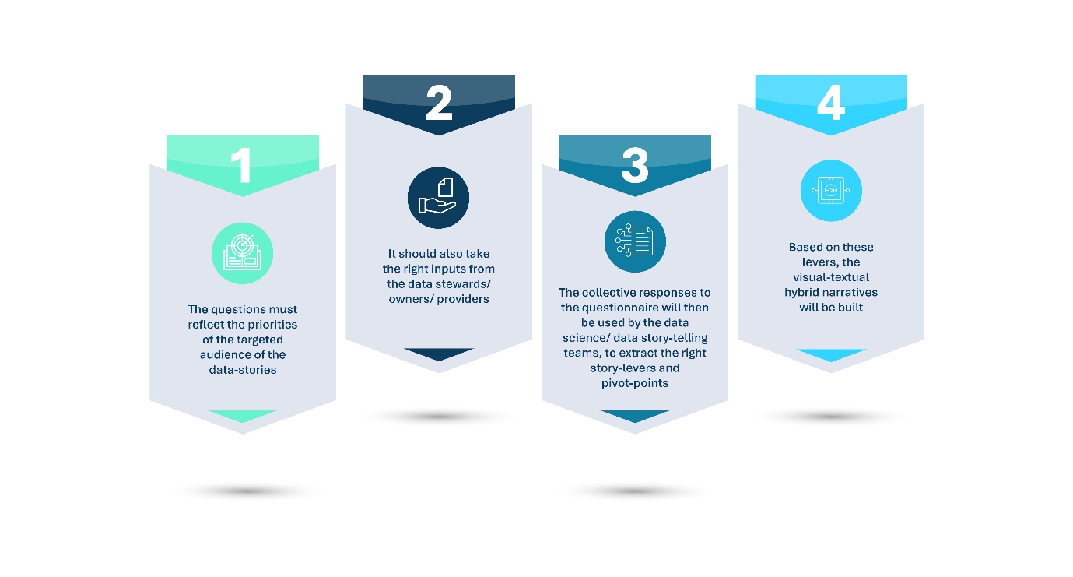
- The questions must reflect the priorities of the targeted audience of the data-stories.
- It should also take the right inputs from the data stewards/ owners/ providers
- The collective responses to the questionnaire will then be used by the data science/ data story-telling teams, to extract the right story-levers and pivot-points.
- Based on these levers, the visual-textual hybrid narratives will be built.
A sample data-story building questionnaire template is presented below:
- Who are the targeted audience/ persona for this data-story? What are their levels of seniority in the organization? What level of detail/ granularity might they expect?
- What decisions are these targeted persona's going to need support for, from the data-stories?
- What metrics for the target persona/ role will be most impacted by the accuracy and quality of insights presented in the data stories?
e.g. productivity/ sales/ growth targets; marketing campaign design/ campaign efficacy predictions; team KPI definitions & benchmarking; process cost metrics & reduction targets; service quality targets; new business growth targets vs. predictions, etc.) - Good visibility into these WIIFM metrics for each target role/ persona will help the audience relate to the stories at a personal level, which is a key requirement of any effective story-telling practice.
- What are the risks and constraints that the target persona/ roles experience / envisage, that must be covered as critical dimensions of the data stories built for them?
Use of measurable metrics like VaR (Value-at-Risk) can be useful in enhancing value of data stories for target persona.
- What could be the potential sources of decision biases that the target persona/ roles may have, which may raise their concerns, change resistance and conflict levels and potentially hindering their ability to leverage the story insights and learnings, without personally biased views and intrinsic judgements?
This is by far the toughest task for data storytellers. Indirect/ implicit bias measurement tools can be leveraged here.
- What are the data sources that you as the data storyteller need, to build the data stories in a fair, 360 manner covering critical viewpoints of all key stakeholders/ audience persona?
These data sources need to be analyzed in terms of Portability, Accessibility, Integrability, Usability, Quality, Security, Regulatory Liability and technology infrastructure requirements (in terms of cost, speed, latency tolerance).
- What's the priority, in terms of data criticality and ranking of insights visualization?
e.g. if there are severe resource and time constraints, what are the top 3-5 data sources you MUST have and use? What storylines MUST be covered and presented, and in what ORDER?
- What's the end-game? How should the story conclude? What will success of a data-story look like?
What will be the targeted post-story improvements in targeted decision outcomes/ process metrics/ persona performance targets and goals?
Once this questionnaire is completed as results of multiple focus groups and interviews with the targeted audience/ business users/ customer teams, the answers will be collated and the storyboarding phase will start.
For more explanations, other techniques and applications, go to:
https://aiswitch.org/5-datastory-techniques
https://aiswitch.org/data-storyboarding-tech
https://aiswitch.org/3-minute-data-stories
https://aiswitch.org/so-what-story-building







Reach out to us
Tap into expert insights and transformative strategies to lead your enterprise into the age of AI, Cloud, and Intelligent Automation. Connect with us to accelerate growth, optimize operations, and unlock new value at scale.
Email ID: info@prosight-AISM.com

Learn more about DIGITALFABRIC® for more insights:
https://digitalfabric.group
Connect with DIGITALFABRIC®
COPYRIGHT © 2025 DIGITALFABRIC® AISWITCH™. ALL RIGHTS RESERVED.

