



Focus Area: AI & Automation (End User)
Document Type: Knowledge Article
Series: Strategy Management of AI-automation
AISWITCH_2020_AI STRATEGY HOW TO USE MCKINSEY 7S
www.digitalfabric.group
AISWITCH AI PRACTICE COOKBOOK: HOW TO USE MCKINSEY 7S FRAMEWORK FOR AI STRATEGIC PLANNING
Who should read this: Enterprise AI CoE leaders, CDO, CIO, CEO (for strategic AI initiatives), AI Business User Leaders, AI Solution Architects, AI Solutions & Service Providers
Why is the McKinsey 7S framework highly useful & relevant for enterprise AI-automation strategic planning & execution?
From a 2020 AI-automation planning & adoption survey of 300+ directors, VP’s and CXOs, the following trends were visible:
- More than 1/3rd [35%] of senior leadership across global enterprises are looking at AI & automation to accelerate revenue growth and create net new revenue streams and businesses.
- Nearly 2/3rd [66%] respondent leaders, however, mentioned that the strategic impact of AI & automation on revenue growth has only been partial.
Based on what we hear from several client leaders and also as experienced first-hand in the AI-automation practitioners’ communities, success of AI-automation strategies depends very little on the technologies themselves. AI-automation initiatives are different from tradition software deployment projects. In case of AI-automation projects, any system going live/ green, with all glitches fixed, cannot be immediately declared a ‘success’. The impact realization depends much more on softer strategic levers like structure, skills, staff and style, than just the systems in themselves. This is why- a multidimensional framework like the McKinsey 7S framework [Figure 1 below] is far more apt for AI-automation strategic planning and successful execution.
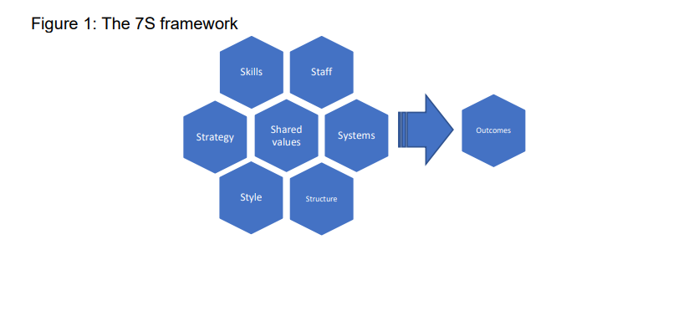
What are the steps in using the 7S framework, for AI-automation strategic planning?
As per the quick definition from Wikipedia as a refresher: “The McKinsey 7S Framework is a management model developed by business consultants Robert H. Waterman, Jr. and Tom Peters in the 1980s. This was a strategic vision for groups, to include businesses, business units, and teams. The 7S’s are structure, strategy, systems, skills, style, staff and shared values.”
What's the objective to build the 7S framework representation of Enterprise AIautomation strategy?
- To analyze how well an organization is positioned to achieve its strategic goals, using AI & intelligent automation
- To build specific positions of strengths across seven internal aspects of an enterprise that need to be aligned if it has to be successful in optimally leveraging AI & automation to drive strategic transformations
Following steps need to be taken, to leverage this well-used framework, to build and articulate the key/ essential elements of an enterprise's AI-automation strategy.
- Identify and prioritize areas where AI & automation can be leveraged to improve performance, e.g. In terms of top-line growth: revenue, profitability, market share, new markets, TTM/ TTV of new business models- through better service/ product quality, new/ improved customer experiences etc.
In terms of bottom-line: to reduce customer service costs, service delivery costs, service/ product generation costs, supply chain cost, overhead costs etc.
- Analyze, predict and prepare readiness & action plans for the competitions' moves specifically with strategic tech disruptions like technical advancements in AI algorithms & automation tool-stacks. Potential/ resultant future changes in sector/ region-specific competitive & regulatory landscapes within which the enterprise operates
- Identify/ evaluate/ sync up with potential technology partners & M&A candidates
- Identify and measure the constraints to implement the AI strategy and subsequent plans to mitigate them
How will this approach benefit an enterprise that's embarking on an AI & automation journey?
McKinsey 7S frameworks consist of the seven interdependent elements, divided into hard elements and soft elements:
Hard Elements
1. Strategy for AI-automation leverage for business:
- Purpose of the business in using AI [e.g. to drive cost / focus/ differentiation strategies]
- The ways the enterprise aims to achieve sustainable competitive
- advantage through long-term value-adding applications of AI & automation
2. Structure of the organizational activities on AI capability-building:
- Division of activities; integration and coordination mechanisms,
- Operating models e.g. federated engineering model/ AI solutions building
- CoE/ a consolidated captive shared services model to provide AI capabilities to all business lines and service lines
3. Systems in AI strategy execution:
- Formal procedures & systems for measurement & governance, risks & controls, data security, audit & internal/ external compliance systems
- Orchestration and technology and human resource allocation systems for AI & automation programs,
- Partner evaluation, negotiation and selection system,
- Use-case identification, prioritization and program management systems,
- Systems for monitoring of AI & automation project executions, tracking outcomes, continuous improvements
- Systems for AI-automation life-cycle management, asset management & version control,
- Training systems for capability augmentation
Soft Elements
1. Shared Values for AI & automation: In sync with overall AI strategy, structure and targeted outcomes. Considerations must factor in dimensions like-
- AI and ethics,
- Strategic focus in cost reduction through human replacements or
- productivity augmentation, workforce rationalization or re-purposing,
- Impact of the targeted and deployed AI solutions on consumer behavior and public value system & society at large
2. Skills: Programs to upskill and reskill workforce and stakeholders, to build organization's core competencies and distinctive capabilities in AI leverage.
3. Staff: to organize talent for AI-
- Technical [algorithms experts, UX designers, solution architects, experience designers, data scientists, machine trainers, modelers]
- Domain experts- requires close working relationship between human
- resources & talent management functions and functional & business units
- Coverage of AI resources across demographic, educational and attitudinal parameters.
4. Style- of communication, culture, responsibility management:
- Delivery responsibilities,
- Culture of 'how things actually work on the ground', policies and work practices - formal and informal
- Across all phases of AI-automation solutions e.g. ideation, design, deployment, run-time monitoring and enhancements.
- Collaborative attitude among teams, open vs. closed systems, communication pattern and behavior patterns of key groups, such as managers, tech professionals and domain experts.
One application example of the 7S framework is briefly shown herein, just to illustrate how it’s used, first to build a practicable AI strategy considering all constraints and priorities, and then to work out an effective execution plan to implement the AI strategy [This is just an indicative and specific example for a company, not a generic one.]
Shared Values for AI (Central node) | AI to drive human augmentation not replacement: Employee contributions & satisfaction, higher productivity and effectiveness, differentiated skills- more customer focussed relationship & soft skills= Higher customer satisfaction
Strategy to leverage AI | Differentiation- To use AI to create and deliver uniquely differentiated services to provide digital business moments to customers
Structure to leverage AI | An AI capability hub- a CoE that will drive AI & automation programs across multiple business/service lines, to deliver the newly built & uniquely differentiated value propositions
Systems for managing AI | HR systems for AI talent management, AI assets & security management, data LC management, AI development platforms/ tools- lifecycle management, sprint management - DevOps tools, code management, open-source management, quality management, project and program management
Skills to leverage AI | Focus on reskilling workforce across all delivery and service lines to understand the changes brought in by AI, the Art of the possible, and the practicalities of implementation
Staff for AI | Tech: Data scientists, ML experts, AI algorithms and solutions developers, architects, designers, UX experts, security experts, partner tech experts; Non-tech/ domains- business/ functional- from businesses or functional/ support lines
Style of functioning | Encourage collaborative and open systems behaviour by highly differentiated an visible RnR, experimentation attitude, fall fast-learn-try new/different, DevOps

1-2-3 Action items Monday Morning
Key Actions | Key Actors
An executive leadership and business leadership level team needs to be formed, first to decide on the overarching AI-automation strategy of the company, in alignment with the business strategy and the shared values. | Board members, CXOs, BU leaders
Based on the strategic directives from leadership, the AI-automation CoE heads, CXOs and the AI governance council/ steering committee will build a 2- 3-year strategic plan for enterprise AI-automation, factoring in the 7S dimensions. | AI CoE & BU leaders, CXO’s
The AI-automation CoE leaders and program heads will iteratively review the AI-automation strategic plan, with regular inputs from critical functional leaders, on the 7S dimensions, e.g. the CHRO function (for staff, skills), the engg/ tech functions- data & analytics/ CIO/ CTO (for systems), operations & marketing (style), finance, risk & compliance (strategy-RoI, risk). | AI CoE leaders







Reach out to us
Tap into expert insights and transformative strategies to lead your enterprise into the age of AI, Cloud, and Intelligent Automation. Connect with us to accelerate growth, optimize operations, and unlock new value at scale.
Email ID: info@prosight-AISM.com

Learn more about DIGITALFABRIC® for more insights:
https://digitalfabric.group
Connect with DIGITALFABRIC®
COPYRIGHT © 2025 DIGITALFABRIC® AISWITCH™. ALL RIGHTS RESERVED.

