



Focus Area: AI & Automation (End User)
Document Type: Knowledge Article
Series: Strategy Management of AI-automation
AISWITCH_2025_How to Evaluate AI implementation Partners Objectively with 5 Next Practices
www.digitalfabric.group
AISWITCH AI Service Provider Evaluation Cookbook: 5 Critical Capabilities
Who should read this: End-user Leaders- AI users/ strategists/ digital business leaders/ service provider client partners/ SP AI-powered SL leaders
Enterprise AI-automation leaders and end-users/ service providers/ business leaders/ solution architects/ presales leaders & teams mandated to choose the best-fit service providers as their AI-automation implementation partners.
Why is the selection of right partner critical for success of enterprise AI-automation initiatives?
Choice of the best-fit AI implementation partners can make a world of difference in success, scale-up and adoption rates in enterprise AI-automation initiatives. As per a 2020 survey on AI-automation implementation best practices, 72% enterprise leaders considered that the choice of consulting partners and system integrator partners are extremely important decisions, to ensure success in their strategic initiatives.
While choosing the right journey partner for any of these echnologies, evaluating the journey partner only in terms of no. of certified headcounts and depth of technical competencies are necessary conditions but are not sufficient. This holds especially true for AI, given that its implementation challenges are unique, and value realization, RoI & break-even periods are much longer-term than most other systems-related projects. AI implementation journeys are also quite different from other large-scale software projects and technology implementation or migration programs, given that:
- AI use cases require extensive training on the domain and business processes. These have different fitment complexities in terms of choice of data, domain, models, algorithms, success metrics. AI projects don’t get over just like other software projects e.g. when a software goes live. AO solutions have to be embedded into the processes that are targeted for AI-powered transformations, given these are mostly new ways of doing business.
- POC, pilot, training for production and inferencing in production – these phases of AI programs often pose very different challenges, compared to other software project challenges. These AI-automation initiatives often differ from regular software projects in terms of data requirements- quantity & quality, infrastructure requirements, runtime behavior, model output quality in POC vs. in-prod, feasibility & fitment of usage in-prod, accuracy metrics and relevance & acceptance of output.
- Consequently, the maintenance and operational risks and governance models for enterprise AI-automation solutions are significantly different from typical post-production tech support that’s required for most other enterprise software implementation projects.

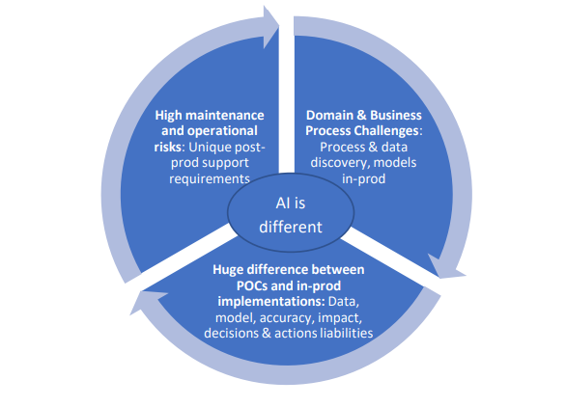
What are the 5 critical capabilities that AI implementation partners must be evaluated on?
Keeping the unique aspects of AI implementations in mind, an analysis of successful early adopter companies reveals five critical capabilities that have been most commonly used, in evaluating and choosing their AI partners. These five capabilities are given in table 1.
5 Critical Capabilities of AI Implementation Partners | Description
Ability & attitude to align project goals and success criteria to clients’ targeted critical business outcomes, beyond just successful ‘golive’ of a solution | The partners must be evaluated on the basis of the maturity of their committed metrics on clients’ key target outcomes. Client outcome-orientation gets best manifested in the attitude & quality of metrics that the AI implementation partners measure, own, manage and  report.
Ability to use crowdsourcing, machine-sourcing (like AutoML & GPT’s for NLG) & man-machine combined talent from gig economy | Ability of your partners to leverage internal or external talent platforms like Kaggle or Topcoder, innovative hybrid talent platforms in AMT, Epistema etc. Sourcing right & relevant talent is the biggest problem in AI that can be tackled by providers with innovative crowdsourcing or hybrid talent models.
Depth of domain consulting capabilities | Service providers who prioritize domain-intensive, consultative approach rather than just a tech project implementation approach, must be preferred. This is especially relevant for large, strategic AI projects, even at the cost of higher overall project expenses- for better quality of a diverse, domain-tech combined talent pools.
Ability to utilize innovative design methods | Partners with demonstrated design thinking capabilities typically integrated with their digital service offerings, should be prioritized. This is highly relevant given emerging techs like AI cannot be adopted effectively using old methods. To leverage AI for drastic differentiations, speculative design & scenario planning capabilities can be key expectations from providers.
Ability to build de facto agility | Partner consultants must demonstrate a long-term view on the use cases implemented, so as not to create new hard-to-change and hard-to-migrate systems resulting into new technical and process debts for clients, while replacing the old ones.

Storyboard: How wrong choices on AI partners bring in wrong talents with wrong priorities and derail client success
As a senior client leader in a global institute of higher education explained: While the technical know-how and quality of resources provided by their AI implementation partners were commendable, the consultants had a typical attitude problem: They always focused only on the low-hanging fruits- prioritizing the easiest-to-implement AI use cases. The consultants came across being extremely risk-averse and always attempting to brush under the carpet the challenges that were hard-to-solve but were critical for the clients.
Given that such scenarios are very common, enterprise AI leaders must take a long-term view while evaluating their AI journey partners, as the journey is a long one. Typical gestation periods of productionizing complex AI projects on critical business processes can range between 1 to 3 years. Keeping this in mind, take up the following actions.
How to ensure that AI partners have demonstrable capabilities in 5 aspects
Action items for next Monday morning
Actions | Descriptions/ steps
Evaluate the strength of domain consulting of partners: When it comes to AI, especially for business process related usecases like AI applications- common examples being in CRM, vendor management, legal & contract management, domain is the king. | - Assess capabilities demonstrated in past projects especially in large-scale tech-driven process transformation projects.  - If possible, demand to speak directly with other clients from same or similar domains, who have walked this journey with the partner under evaluation.
Assess the attitude of the consultants: Technical competencies and experiences are more commonly available now. What makes a difference is the attitude that the journey partners take, towards client problems and priorities. | - Ask them to choose from a list of problems that you want them to solve using AI  - Assess whether they are just stuck to the easy-to-solve ones or are willing to take on bigger challenges depending on what matters to clients the most and makes the biggest impact for the clients.
Plan to directly interview the consultants proposed by the implementation partners. | - Assess how much they are aligned to the client company’s targeted outcomes  - Check how well they understand the criticality of those outcomes in clients’ specific business and organizational context and reality

Enterprise AI leaders must evaluate the domain depths and attitude demonstrated by their AI implementation partners, beyond just tech competencies. While technical competencies and availability of resources are standard evaluation criteria, enterprise AI leaders also must plan to assess the implementation journey partners in terms of domain experience, outcomes orientation and the right attitude & priority.







Reach out to us
Tap into expert insights and transformative strategies to lead your enterprise into the age of AI, Cloud, and Intelligent Automation. Connect with us to accelerate growth, optimize operations, and unlock new value at scale.
Email ID: info@prosight-AISM.com

Learn more about DIGITALFABRIC® for more insights:
https://digitalfabric.group
Connect with DIGITALFABRIC®
COPYRIGHT © 2025 DIGITALFABRIC® AISWITCH™. ALL RIGHTS RESERVED.

