



Focus Area: AI & Automation (End User)
Document Type: Knowledge Article
Series: Workforce Management for AI-automation
AISWITCH_2025 REVERSE MENTORING MUST FOR AI RESKILLING
www.digitalfabric.group
AISWITCH AI PRACTICE COOKBOOK: 7 STEPS TO ESTABLISH REVERSE MENTORING FOR AI RESKILLING
Who should read this: Enterprise AI CoE leaders, CHRO, CDO, CIO, CEO (for strategic AI initiatives), AI Business User Leaders, AI Change Coaches, AI Solution Architects, AI Service Providers.
Why the need for reverse mentoring systems for enterprise AI-reskilling programs?
AI has become the latest priority for more than 80% Fortune 1000 organizations in next 3-5 years. But availability of relevant skill, knowledge and experience is emerging as the biggest bottleneck.
- As per a 2020 Survey of 300+ senior leaders (Directors and above) in AI end-user companies, ~60% leaders mentioned that shortage of talent and full-stack coding skills is a major reason why AI is failing in their enterprises.
- More than 50% leaders think that lack of basic awareness about key AI technologies and concepts, amongst the senior user-groups, is another key reason for AI deployments not delivering targeted outcomes in production.
These problems got nothing to do with AI tech-stacks per se. The HR partners need to work with the BU teams, leaders, and the AI CoE teams, to resolve these burning issues on ground. Reverse mentoring is a tried and tested approach that can provide a much needed weapon to face the AI skill and awareness shortage challenges.
What is reverse mentoring?
Reverse mentoring involves junior, young staff-members mentoring/ guiding/ coaching senior leaders and team-members, on specific skills/ technologies/ applications etc. This is especially relevant for new, digital-native technologies and platforms.

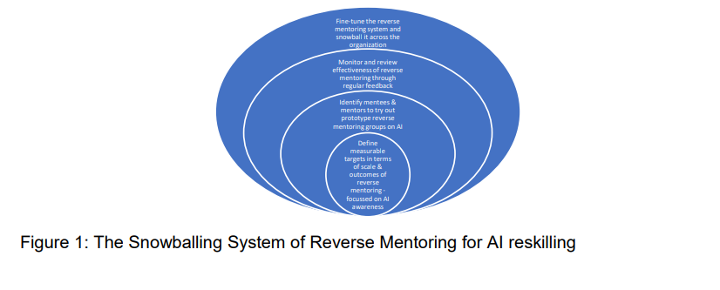
Although AI technologies and platforms have existed for 70 years now, mainstream uptake of AI at enterprise-level has been a relatively recent phenomenon. Adding the skill scarcity problems, reverse mentoring is highly applicable in the context of AI reskilling and adoption.
It started in late 1990’s, with exemplary leaders like Jack Welch trying it out at GE, with 500 employees, expecting the organization to tip ‘upside down’, with the youngest and brightest teaching the most experienced staff, on new technologies. Global companies like CISCO, Fidelity, P&G and Target, that were eager to take relevant technological advances in their strides, have been running reverse mentoring programs for years.
These systems have helped them in
- spreading changes faster, across hierarchies and generations,
- reducing the internal digital knowledge divides,
- encouraging diversity of thinking (a Forbes survey says 85% leaders believed diversity/ inclusivity is most crucial for innovation),
- increasing visibility, recognition & resultant retention of young talents (a survey showed 96% millennials participating in reverse mentoring, didn’t attrite),
- and most importantly, a much faster progress of knowledge about latest technology applications.
Estee Lauder used reverse mentoring as a culture-change lever, in the wake of a key change in the marketing landscape and customer behaviour- due to increasing importance of social media influencers. Young mentors built a knowledge-sharing portal ‘Dreamspace’- to spread knowledge on social media marketing and tech platforms.
Storyboard: How a reverse mentoring program helped senior leaders in a traditional IT SP company reinvent themselves with ‘transfer learning’, NOT of AI, but ON AI
Most of the senior leaders in the global IT SP company were great businesspeople with strong foundations and years of service delivery experience, in IT. But most of them were not familiar with AI or data sciences. Some AI SMEs planned with their HR support teams, to try out the idea of reverse mentoring, to transfer the basic knowledge of AI to these senior leaders.
Few proactive AI-ML engineers from the CTO teams were identified. Their key incentive was to have real facetime with these senior CXO level leaders who they wouldn’t have otherwise met in years. Coming from premier institutions, they could freely talk about latest algorithms and techniques and the current problems being solved at world-class institutions. They learnt a lot about the practical challenges in making these wonderful algorithms work in client contexts, e.g. issues about data availability, security, quality of data,
infrastructure availability, the ‘cloud-averse’ mindsets of senior leadership in traditional BFSI sector clients, change resistance from targeted user groups in client landscapes- to use AI, and so on. Shadowing these leaders on some of their typical days at work, the young geeks also learnt about professional nuances e.g. how to handle senior client leaders, how to explain deep-tech stuff like AI algorithms without throwing jargons, how to speak the language of business and clients. The senior leaders also became far more confident and energized about AI, now armed with all the geek-terms and knowing what they mean at least till the first level, even if not learning how to code. They started sounding more grounded and hence convincing, to the client teams, in presentations and meetings. Knowing both sides of the AI spectrum- basics of tech-stacks as well as their business applications domains, the senior leaders from the IT SP company started making a lot more sense, to their external partners and end-user client teams, across the table.

How to build effective reverse mentoring systems in 7 steps, to reskill/ upskill experienced staff-members, on AI?
Just having the reverse mentoring system established isn’t good enough, like any other good systems. Following 7 CSF’s are to be clearly implemented, communicated and monitored, to ensure success of these initiatives and systems:
1. Identify an executive sponsor/ senior evangelist for reverse mentoring on AI, ideally a CXO, e.g. from the CEO/ CDO/ CTO/ COO groups, or from the BU leaders who are the biggest user-groups for AI use cases.
2. Mandate the senior leaders and the CHRO office to define measurable outcomes metrics- to monitor and report the success of AI reverse mentoring initiatives.
3. Get the BU leaders’ HR partner teams to take regular feedback from both sides and act upon them, fine-tuning the modus operandi of the sessions, programs and the overall system.
4. Establish a formal system to track progress of reverse mentoring programs on AI. Build a knowledge sharing and reverse-mentoring Q&A and feedback portal, also with value dashboards and ‘Star’ boards, to recognize best mentor mentee combinations where significant knowledge transfer and learning outcomes have been achieved.
5. Ensure proactive participation from both sides: Participation in reverse mentoring should be an optional rather than mandatory initiative, and a rewarding experience, both for the young mentors and their experienced mentees.
6. Let the HR partners facilitate first few sessions, to initiate ice-breaking conversations which should eventually lead to both formal and informal knowledge sharing, experience sharing and transfer learning of specific skills.
7. Have systematic, traceable interactions, follow formal plans monitored by a program management system, considering the time and efforts constraints.
Action items Monday Morning
Key Actions | Kay Actors
Establish enterprise-level/ corporate-level reverse mentoring policies and systems for AI reskilling and knowledge building programs, both for tech teams as well as business process/ functional teams as user groups. | CXOs, BU HR partners
Identify and train the potential reverse mentors from the youngster groups e.g. 2-5 years’ experience bracket, with hands-on knowledge / experience in AI-ML project that are currently running. | AI CoE leaders
Communicate to the BU leaders about availability of mentors for this program and mandate them to communicate to their teams and encourage participation especially of senior members who will benefit from the handholding from a recently skilled, applied AI-ML engineer/data scientist. | AI CoE leaders, BU leaders & senior team-members







Reach out to us
Tap into expert insights and transformative strategies to lead your enterprise into the age of AI, Cloud, and Intelligent Automation. Connect with us to accelerate growth, optimize operations, and unlock new value at scale.
Email ID: info@prosight-AISM.com

Learn more about DIGITALFABRIC® for more insights:
https://digitalfabric.group
Connect with DIGITALFABRIC®
COPYRIGHT © 2025 DIGITALFABRIC® AISWITCH™. ALL RIGHTS RESERVED.

