



Focus Area: AI & Automation (End User)
Document Type: Knowledge Article
Series: Workforce Management for AI-automation
AISWITCH_2025_AI and Design Think- The winning techniques combo
www.digitalfabric.group
AISWITCH Practice Cookbook: How to use Design Thinking in AI
Who should read this: End-user Leaders- AI users/ strategists/ digital business leaders/ service provider client partners/ AI-automation solutioning & pre-sales Enterprise AI-automation leaders and end-users/ service providers/ business leaders/ solution architects/ presales leaders & teams mandated to improve design efficacy of AI-automation solutions.
Why are design thinking techniques most apt for AI-automation solutions?
As a number of tech leaders of early adopters of AI-automation shared their challenges and learnings, lack of empathy in designing deep-tech AI-automation solutions is a key reason why users often feel disconnected with these expensive and complex techstacks.
As per a 2020 survey involving 1000+ global leaders, 44% leaders think siloed culture is the biggest barrier against making digital business happen, through scaling up digital tech. Design thinking techniques are best applicable in breaking these siloes and making business process teams and tech functions in IT and data sciences speak with each other and understand each other’s language.
Use design thinking techniques to build AI solutions to achieve strategic business goals
A 2020 survey on end-user enterprise AI-automation practices show that
- the largest numbers of enterprise leaders (23%) are planning to leverage these technologies to drive revenue growth.
- 31% (16% and 15% combined, respectively) leaders want to use to these technologies and leverage data in a better way, to improve business process performance.
- nearly 80% enterprise leaders trust these transformational technologies to deliver their strategic goals by accelerating organizational abilities to leverage data and make better strategic decisions & transformational actions.
Driving revenue growth and improving business performance are complex strategic objectives, and require extensive lateral thinking, trying and testing various new ideas and solutions, new usecases and product concepts, new ways of generating and expanding revenues. Design thinking techniques focus on generating and evaluating alternatives and new ideas, and hence are the most suitable approaches towards achieving these objectives.
Which design thinking techniques are relevant for solving strategic business problems with AI?
Design thinking techniques for idea generation and prototyping, are very apt for solving complex and strategic business problems with AI.
Examples of design thinking techniques for idea generation include:
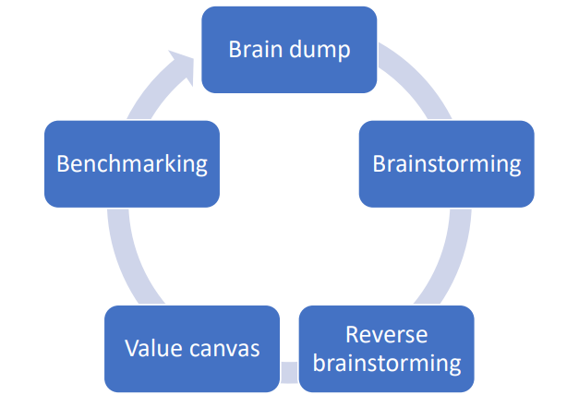
- Brain dump: If the brainstorming participants aren’t comfortable openly communicating ideas verbally among themselves, then they are asked to present their solution ideas in sticky notes in writing
- Brainstorming: Involving all key stakeholders, using ice-breaking techniques if required, going over key design challenges & constraints e.g. lack of availability of adequate good-quality training data [in case of a complex AI use-case that doesn’t have a pre-existing example], encourage participants to think in divergent, OOTB ways, whiteboarding of ideas without judgements or evaluation of feasibility, at initial stages
- Reverse brainstorming: Starting with problem analysis, e.g. instead of asking for solution ideas, ask the brainstorming participants for ideas to cause/ create the target problem, then do a root cause analysis of all the problem inputs
- Value proposition canvas technique: Complementary to the empathy map technique, it shows how target customers can benefit from various features of the proposed alternative solutions/ new products, getting the expected gains and relief from pains that are listed in the empathy maps.
- Benchmarking: e.g. once the solution ideas are generated in brainstorming, benchmark and compare them with competitors’ solutions available in the market
Examples of design thinking techniques using prototyping include:
- Low fidelity prototyping: e.g. use small representational datasets from client provided training data samples for POC, to rapidly build, train and test features and accuracy of AI classification and inferencing models for new AI use cases, and choose ones that offer higher precision & recall and discard others.
This way, the solutioning teams can quickly learn from failures, while experimenting with all potential alternatives. Prototyping tools often allow quick project monitoring, progress recording, performance management and interactive user actions, to support this type of prototyping.
- Storyboarding: appropriate if the targeted solution is a service or a business/ operating model or a new process and not a product/ technology solution, e.g. in designing marketing ad campaigns
Storyboard: How Design Thinking techniques helped AI-automation pre-sales/ solutioning team of a global SP, for a huge Pharma client
Here is a real-life example on how prototyping helped achieve optimal AI solutions design for a strategic problem in the (currently most happening, due to COVID) Pharma sector.
The presales solutions architects were mandated by a large pharma client to build strategically important, revenue-impacting AI use cases for a highly complex process in the pharma sector- pharmacovigilance. This process impacts revenue as well as regulatory compliance, where customers/ users of the new and existing products of the company post their feedback and experiences post usage of the medicines, and this information is mined for patterns for further research on medicine effectiveness & side-effects, and also for regulatory requirements.
The solutioning teams thought of deploying design thinking techniques as the most relevant approach here. For most of strategic AI solutions, the use cases are multidimensional in all perspectives, e.g. from data, algorithms, tech stack selection – development or run-time, and from process standpoints.
These complex use cases also requires multiple practice perspectives. For example, the stakeholders for the pharmacovigilance solution included the clients- the pharma company themselves, their strategic, business & regulatory leaders, customers of the pharma company- doctors and patients.
Then there were the health regulators and federal regulators of pharma, and health and life insurance companies – e.g. to monitor impact & potential side-effects of new drugs, and so on.
Then the customer experience design folks also needed to get involved, to ensure that their proposed solution was highly usable, transparent, explainable and easily interpretable in terms of data visualization and results, hence proving a good user experience.

In terms of technologies, the use-case involved handling a complex mix of structured & unstructured, scientific data e.g. drug trials, clinical trials, to customer feedback sentiment analysis - positive negative polarity of words, even video analysis. So, many domain specific inputs & lexicons were needed. Different technologies ranging from predictive ML algorithms, to NoSQL platforms, Hadoop, MongoDB etc. were to be considered in the design.
Prototyping was found to be the best fit method, to arrive at an optimal solution design, in this complex context involving too many unknowns. Taking sample data-cuts from the training & testing POC data provided by the client team, the solutioning team rapidly tried out multiple solution designs, with all stakeholders’ inputs and client-provided valuation criteria. Then they chose the high accuracy ones i.e. solution options offering highest precision and recall, given the pharmacovigilance use cases are human-life impacting and hence highly regulated.
This very high-risk but high-value, complex & strategic AI use-case also required experimentation with multiple deep learning techniques. It couldn’t have been done well without design thinking.
Design thinking techniques for prototyping and idea generation helped enterprise leaders to leverage AI to achieve strategic goals and solve large-scale, complex business problems.
Apply five design thinking best practices to leverage AI for strategic business outcomes
Exponential gains in strategic business outcomes, through pragmatic leverage of AI automation-analytics, can come from new products and revenue streams enabled by these technology applications, and by improved efficiencies and effectiveness of strategic decisions and actions. Both these strategic value realization scenarios can happen only when the application of these technologies are designed in an integrated manner, using multi-disciplinary teams, factoring in all key stakeholders’ viewpoints. Design thinking best practices help enterprise leaders foster this culture of collaborative innovation, which helps an organization to achieve strategic outcomes using these exponential technologies like AI & automation.
Five design thinking best practices are seen as most relevant, in organizations that have been able to realize strategic gains in business outcomes leveraging transformational technologies like AI:
- Design thinking to foster the culture of positivity- harnessing an optimist organizational mindset: Delivery of strategic outcomes isn’t possible without a ‘cando’ attitude across an organization. Design thinking practiced within an organization encourages the stakeholders to think beyond the obvious, to question the status quo and look out for and try out alternative opportunities, expecting them to work. This mindset change is a key hidden benefit of design thinking that enables enterprises to achieve exponential gains and wins, with existing or new offerings.
- Encouraging multi-disciplinary teams: Group creativity is a mandatory ingredient for success in strategic transformation programs. No large-scale strategic initiative can be delivered single-handedly by one functional team or BU alone, without support from adjacent and relevant functions and stakeholders.
- Focusing on conflict management not avoidance: Taking conflicts as obvious occurrences in any multi-disciplinary initiative where different stakeholders can have completely divergent worldviews and objectives, is a key best practice in design thinking. Here, conflicts are often actually encouraged instead of avoided or being brushed under the carpet, so that every perspective is hard and analyzed, every risk is considered and understood.
- Use of Allegory: Design thinking actively encourages usage of allegories, e.g. to explain complex deep technical solution alternatives like AI use cases, to the target groups involving diverse non-technical, business stakeholders. Speaking a jargon free language that’s interpretable and understandable by most stakeholders is essential for fostering open team communication, which in turn empowers people to put forth their ideas without any constraints.
- Leveraging avant-garde mindset: Creating new products or services also involve an adventurous mindset, ability to deal with too many unknowns and uncharted territories loaded with uncertainties. Design thinking techniques such as customer journey mapping and empathy mapping help the new product or service design teams to imagine and experience the customer journeys and empathize with them and simulate the new experiences e.g. how a target customer persona such as a millennial geek, would like to visualize and consume a new digital banking service offering. In absence of adequate historical evidence, data or feedback, which is a common scenario for net new products/ offerings, design thinking helps enterprises leverage the avant-garde mindset, and then the SMEs can complement it with their domain knowledge and relevant operational perspectives.
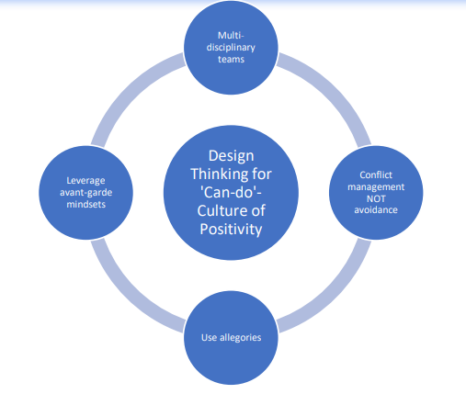

Storyboard: How allegories helped explain complex AI algorithms in a new cognitive search solution for an oil exploration company
A senior technology leader in an oil and gas company was sharing how the use of commonly experienced concepts like libraries helped their team to make the business process teams understand how a complex AI solution was going to ease their lives.
Oil exploration is known to be a data-intensive and expensive exercise that deploy significant amount of time and efforts of SMEs with years of field experience and scientific know-how. The company was trying to create an AI-powered solution that would help them query those large mixed databases of structured and unstructured, scientific exploration and objects and image data, faster and better. This way, using advanced AI techniques like deep learning, machine learning based predictions on scientific data, and image classification using CNNs, complex queries can be automated, and the time and efforts of the expensive SMEs can be better utilized.
Ultimately, from business outcomes perspective, when the exploration process gets faster, high-yield fields can be found and mined sooner, thereby impacting the company toplines significantly.
The solutions design team, to get the ideas from the SMEs, used the allegory of a manually maintained library vs. a digital library, to explain to them how the new AI-based solution will speed up their analysis and ease up their lives. Instead of explaining and expecting the oil SMEs to understand the deep mathematical concepts of tensors and CNNs, use of allegories of libraries to explain the benefits of unstructured cognitive search, made the concept simple for the SMEs and they gave highly valuable and constructive inputs into the design of the solution that ultimately improved their team productivity and business contributions significantly.
Action items Next Monday Morning
To leverage design thinking techniques in achieving strategic goals and solving complex strategic problems, the enterprise leaders can take the following actions:
Actions | Actors
Identify AI initiatives that have strategic goals/ impact: AI applications to large & complex, strategic business problems and/ or new product/ new revenue opportunities | CSO office, Client business leaders & SP partners
Identify the key stakeholders involved in each initiative: Look at the choice of stakeholders from a holistic standpoint and not just technology or business teams, e.g. consider legal, security, compliance, customer relationship team’s viewpoints also to be represented. | AI-automation solutioning teams, trained on design thinking techniques
Identify the best-fit design thinking technique to solve the problem: Analyze the degree of complexity and uncertainty and strategic relevance of the problem or opportunity and identify & use the chosen technique to build the strategic AI solution. | Business teams, client leaders, SP solutioning partners, design thinking experts
Identify potential AI application opportunities that can deliver strategic value but are relatively less understood and newer. | All business leaders & key process leaders
Analyze & find the best-fit design thinking best practices or their hybrid versions, that will likely work best in the specific opportunity scenarios. | Design thinking consultants, Business and process leaders and teams
Apply the best-fit design thinking practices and combinations, to achieve the optimal solution designs. | Solution designers. SMEs.

Design thinking best practices work perfectly in contexts of multi-disciplinary teams, to promote lateral thinking, unique perspectives and also for conflict management. These techniques encourage avant-garde mindset that can help organizations achieve unprecedented new revenue streams and business opportunities.







Reach out to us
Tap into expert insights and transformative strategies to lead your enterprise into the age of AI, Cloud, and Intelligent Automation. Connect with us to accelerate growth, optimize operations, and unlock new value at scale.
Email ID: info@prosight-AISM.com

Learn more about DIGITALFABRIC® for more insights:
https://digitalfabric.group
Connect with DIGITALFABRIC®
COPYRIGHT © 2025 DIGITALFABRIC® AISWITCH™. ALL RIGHTS RESERVED.

