



Focus Area: AI & Automation (End User)
Document Type: Knowledge Article
Series: Technology Management for AI-automation
Pivot Your AI Story the AWS Way with integrated cloud-AI data leverage: AISWITCH 3-minute AI Story Boilerplate
www.digitalfabric.group
Research blog post on AWS India Summit 2021: Go Digital India and APAC!
The world, and our space in it- India and APAC, are at an unprecedented business inflection point. The supply-side tech capabilities for cloud, big data analytics and AI-ML have become available and mainstream over the entire past decade. But what have set these times apart from those incremental trends-based extrapolations, are the drastic demand shifts and business disruptions caused by the pandemic over the past 1.5 years.
The contagion has changed citizens’ and gig workers’ behaviors alike, for good. Constantly being on road or in a plane, seems like work-patterns that are blasts from remote pasts. And not just for the digital-native workforce but even for traditional businesses both in tech and end-user sectors, ability to work remotely in a virtual, autonomously secure and orchestrated tech environment, is the neo-normal expectation- almost like a new fundamental right beyond the data privacy rights.
Obviously, these demand-side levers have necessitated unprecedented supply-side agility in 4 mandatory dimensions of core business infrastructures. The digital business underbelly- the underlying storage, data and algorithmic infrastructures, need to be:
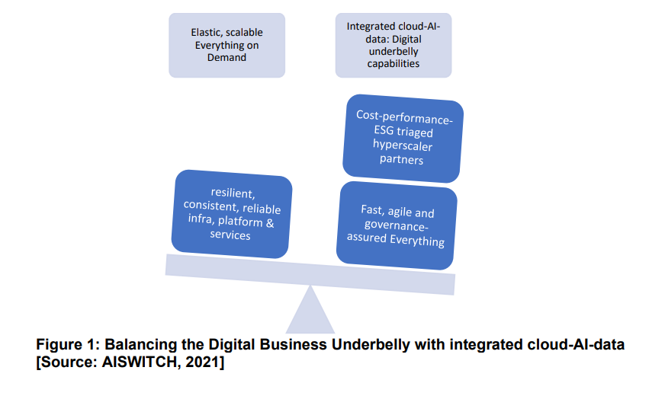
The 4 input dimensions are:
- Elastic, scalable (up/ down/ out- horizontal/ vertical/ diagonal) infra & platforms
- Cost-performance-energy triaged by green hyperscaler partners
- Resilient, consistent & reliable, always on infra & containers & microservices platforms
- fast & agile, governance-assured integrated cloud-AI-data services
These aspects have become the must-have requirement specifications for most of the large-deal RFPs of mature and agile post-COVID businesses- digital or otherwise, across all key regions of the world. By way of sheer numbers, India has emerged as a successful global prototype incubator, on how these rapid digital transformations are done. This, precisely, has been the crux of the AWS story that unfolded in the AWS India Summit 2021, shared aptly by the leadership team of Puneet, Guru, Anupam, James and also by the customer leaders from industry titans like Titan & Mahindra as well as new age winners like Swiggy!
Let’s take a sneak peek at some of their stories, built on the 3-minute AISWITCH story boilerplates that can be leveraged by other large enterprises in planning and articulating their cloud-AI-data journeys and outcomes.
AISWITCH Boilerplate of 3-minute cloud-AI-data story: Hot from the AWS India Summit!
The Exemplary Swiggy: The youngest one comes first, and so fast!
1. Problem definitions: What are the top 2 business problems that the cloud-AI data initiatives have solved?
The leadership from Swiggy explained how 1- speed (of the order fulfilment process) and 2- balance (optimizing cost & performance between customers, partners, associates and Swiggy) have been the key levers for them to deliver their targeted business outcome Customer Happiness.
2. Strategy: What integrated cloud-AI-data MVS (Minimum Viable Strategies) have been executed to complete these initiative successfully?
Firstly, the average delivery time has been just 32 minutes, factoring in restaurants’ & delivery associates’ partner performances as well as uncontrollable parameters like weather and traffic density fluctuations. This was made possible only through the minimum viable integrated cloud-AI-data strategies that have rapidly yielded high performance optimized use cases, enabling quick TTM.
The second MVS is the operationalization of a highly efficient Hyperlocal platform enabling hyperlocal discoveries and on-demand deliveries, built on AWS and partner ecosystems’ tech capabilities. Let’s just imagine the scale of the challenge of delivering Hyperlocal in India, given the operational diversity parameters like 500+ cities, 200000+ delivery associates and partners. The same platform can now be scaled in terms of scope, to cater to other quick demands too e.g., OTC meds, diapers, or to run errands for customers. The platform is performance-optimized too, e.g. to handle unpredictable spikes in order volumes.
The third and ultimate AI MVS of Swiggy, to fulfil its key target objective of Customer Happiness, is the ‘Perfect meal discovery’. This is delivered through a Food graph database built and run, on graph-based ML and DL algorithms stacks.
3. Workforce: What MVT (Minimum Viable Talent) strategies/ human capital have been leveraged/ is required, to work on these initiatives?
The tech teams of Swiggy and its partners from the AWS ecosystems ensured that the diverse cloud-AI-data science talent pools needed to succeed in the 3 key MVSs as depicted, are available when needed. All the targeted AI use cases in the 3 MVSs required skillsets ranging from big data- cleansing, wrangling & integration, statistical & OR techniques e.g. integer programming, to classical ML algorithms including graph databases and deep learning & computer vision.
4. Information: What datasets have been used/ are required, to implement these use cases? What were/ are the data quality, volume, speed, relevance challenges if any, and how were/ are they handled?
For the cloud-AI-data integrated MVSs to be successful, the data requirements were challenging in terms of all the 3 V’s of Volume, Velocity and Variety. For instance: the data and models on customer intelligence, including order histories and choice of cuisines. The Biriyani delivery story captured this challenge in the best possible way: Just one type of food that combines variations across all regions and restaurants, in terms of preparation styles, ultimately resulting into 18000+ distinctive categories!
5. Technology: What partner tech-stacks and tools have been used and how/ at what scale?
The targeted AI use cases for operational optimization as well as customer happiness, needed an integrated & hybrid approach towards algorithms and data infrastructures across the structured and unstructured types.
For example: forecasting, ML models and time-series predictions are used to predict time for travel, restaurant partners’ food prep time, and then a combination of all these model outcomes into multi-objective functions in terms of the constraints of time, order, driver availability etc. The models are agile enough to handle 400000+ such different combinations, leveraging linear Integer programming at scale. The AWS services and tech partner ecosystems have been used extensively, to scale and orchestrate compute and storage infrastructure cloud and managed services e.g. AWS forecast services, for prototyping & early experiments of these solutions. This resulted into the Relevance Layer functions evaluating 10000’s of restaurant-customer combinations at any point in time, for optimizing value for all stakeholders across the customers-partners-Swiggy ecosystems.
6. Culture: What culture changes were/ are required to scale up adoption in a business-relevant manner? How are these org change levers executed/ planned for success?
The cloud-AI-data use cases were themselves the most significant culture change levers, directly promoting positive behavioural switches in the entire ecosystem across partners and customers.
For instance: the use cases to detect, monitor and control abuse and fraud. In rare instances where some customers and drivers were trying to game the system, integrated use cases reduced such fraudulent activities, through increased monitoring, transparency and operational visibility. All types of AI tech stacks were used e.g. voice analysis to determine the authenticity and context of calls, NLP to analyse the customers’ feedback to the CS team, and CV to analyse delivery image uploads. The Swiggy fraud graph on the transaction platform have been highly successful in protecting customer experience without risk of abuse.
7. Human-AI augmentation: What % impact have been observed/ are expected out of the AI programs, on the key business metrics of the targeted problems (that were articulated at step 1)?
Agility- speed of delivery averaging at 32 minutes- is biggest business asset in terms of capability- Swiggy being an exemplary digital-native business. At the same time, access to talents as resources has been one of the biggest constraints, where the only way to succeed is to leverage partnerships to scale faster.
Integrated cloud-AI-data success stories are no longer just the prerogatives of extreme agile & customer-obsessed digital-native businesses like Swiggy. Traditional business stalwarts like Titan and Mahindra have also walked this new talk with demonstrated results achieved, e.g. Titan through their Prometheus platforms based on AWS SageMaker and other libraries, and Mahindra Connected Car platforms leveraging AWS IoT services.
In terms of integrated and agile capabilities, there’s absolutely no dearth of the right tools for the right jobs, from AWS and its partners, along with the third largest start-up ecosystems in the world being based in India. From chip to API to business outcomes, there are integrated services from Intel, AMD, NVIDIA, Mac to AWS graviton 2 ARM based processors delivering 40% better compute performance for various types of workloads in AI-ML-big data spaces. AWS Inferentia and Trainium are specifically designed for delivering high performance ML. The switch to digital is done aptly even by mammoth traditional businesses that have leveraged the AWS ecosystems for all tech heavy lifting backends, while focusing on their new business delivery capabilities.
Conclusion
Clearly, these success stories have delivered effectively in India- world’s most heterogeneous, high-dimensional and complex digital business environment. Hence, it’s predictable with high degrees of support and confidence, that these collaborative and integrated operating models WILL work everywhere else too! Key to this successful pivot will be the businesses' agility and ability to leverage the integrated tech-stacks, while optimizing the operational constraints.







Reach out to us
Tap into expert insights and transformative strategies to lead your enterprise into the age of AI, Cloud, and Intelligent Automation. Connect with us to accelerate growth, optimize operations, and unlock new value at scale.
Email ID: info@prosight-AISM.com

Learn more about DIGITALFABRIC® for more insights:
https://digitalfabric.group
Connect with DIGITALFABRIC®
COPYRIGHT © 2025 DIGITALFABRIC® AISWITCH™. ALL RIGHTS RESERVED.

