



Focus Area: AI & Automation (End User)
Document Type: Knowledge Article
Series: Technology Management for AI-automation
AISWITCH AI PRACTICE COOKBOOK: WHY ENTERPRISE AI MUSTN’T BE ONLY AN IT INITIATIVE
www.digitalfabric.group
Who should read this: Enterprise AI CoE leaders, CDO, CIO, CEO (for strategic AI initiatives), AI Business User Leaders, AI Solution Architects, AI Solutions & Service Providers
Why the enterprise AI-automation initiatives cannot be driven by IT alone
Several recent surveys show that:
- As per 45-48% enterprise respondents, AI is either viewed as or is started as an IT-driven practice.
- The same surveys also show that more than 70% enterprise leaders view AI as a key strategic lever, and more than 80% are increasing their investments in AI, expecting these emerging technologies to drive major gains in business outcomes and topline indicators.
- These two approaches indicate some intrinsic conflicts in lack of understanding of AI and what it can do for businesses, vs. what it requires in terms of tech infrastructure and application support etc.
Truth be told- in terms of proximity or adjacency to other enterprise functions or horizontal capabilities, AI is closer to business (for domain knowledge and right problem definitions) and analytics (for data science & algorithmic skills), than to IT. IT is a critical supplier of the underlying tech-stacks for AI, and a limited user of AI capabilities. But the impact and opportunities for businesses to leverage AI are far more significant.
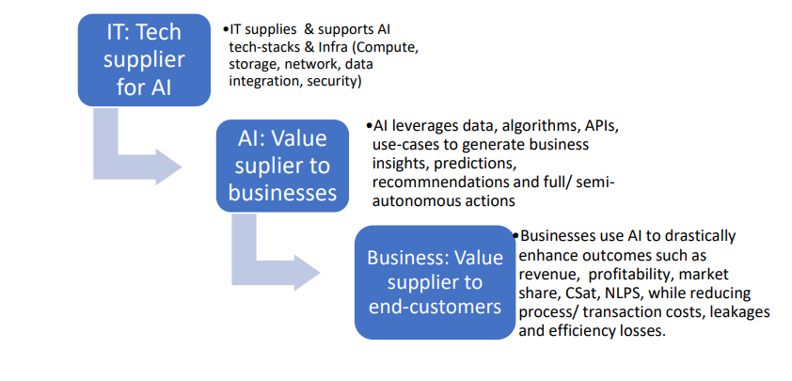
Unfortunately, given the infancy of this early-mainstream practice, only some of the relatively more mature organizations and digital-native ones get it right first time. This is true in terms of identifying the most high-impact use-cases with clear & measurable business outcomes.
What are the disadvantages of considering AI as purely tech-driven, IT-led initiatives?
Looking at AI as an IT initiative has the following limitations as an approach:
• The IT organization or the CIO organization, in most cases, don't have enough visibility into the resultant business outcomes of most of their existing IT investments and initiatives, leave alone AI.
- Given the maturity status of IT as measured by several analyst & advisory firms, still about 60% of IT-enabled organizations have IT running like a black-box, with very limited and fragmented feedback loop between IT and businesses.
- Many organizations still don't have strong internal SLA's [OLA's] between IT and BU's, which can establish a clear mutual understanding of business outcomes, criticalities, dependencies, and business priorities.
Under these circumstances, if a complex tech+business combined capability such as AI becomes part of IT's charter only, the black-box can only get more opaque.
• If AI becomes included primarily in CIO's charter, then
- IT teams confine themselves looking at IT-specific use-cases, given the focus of the IT organization being IT service delivery to internal stakeholders efficiently and effectively, e.g. using AI and ML in running DC's or delivering VDI etc.
- There are two main problems with this myopic approach:
- A lot of IT tools already had enough automation and intelligence built in them already, e.g. rule-based orchestrators and threshold-based auto-triggered scripts & workflows [RBA and RPA-equivalents in IT] etc. So, AI would just bring in some incremental benefits and not a potentially game-changing set of leaps in outcomes, that it is otherwise capable of.
- Given IT budgets are just about 2-8% [on average, 6-8% in case of BFSI, and 2-3% in case of governments & education sectors] of the total operational budget of most organizations, even if the impact of AI on IT-specific efficiency and effectiveness is >60%, the overall impact in the context of the whole enterprise, can be seen as quite negligible. It creates a false sense of satisfaction that 'we are also doing AI', while the real use-cases with the highest possible impact, remain left out.
• Machine learning is an integral part of AI solutions, which requires a lot of depth in maths and stats, data sciences skills and talents [e.g. R, MATLAB], beyond just coding skills [e.g. Python]. IT isn't the right place if we are looking for predominantly maths-stats skills
• IT is already siloed from the businesses it supports, in many cases, and AI within IT will make it kind of double-boxed.
Case in point: Unutilized AI platform strengths from IBM, Google, Azure, AWS tech-stacks, if AI applications are focussed on and led by IT
This approach of 'IT-centric' AI applications is also very clearly visible in several AI solution platforms esp. ones that come from service providers- be it traditional, global MNC's etc. Most of them have either completely IT-centric or predominantly IT-driven AI solutions, with major focus on test automation, IT operations, end-user IT etc.
For the real big AI capabilities like Watson, Google, Microsoft, using these algorithms primarily for IT use-cases alone is an overly expensive option, and bit of an overkill for most use-cases [making simple things unnecessarily complicated without adding much value].

How to make IT work effectively for AI that’s led primarily by businesses, for businesses
IT will remain a critical enabler to make AI work for the whole organization, e.g. in terms Of
- supplying the best-fit compute, storage, network
- for seamlessly running AI workloads- from training to model storage to updates in batch or continuous mode to search & retrieval and execution [e.g. across CPU, GPU, hybrid infra, cloud & on-prem hybrid models, massively parallel and quickly scalable infra- VMs, servers and storage; in-memory databases, secure data infrastructure, trusted AI platforms].
But AI initiatives should NEVER remain confined to IT's charter only. AI techniques are all about leveraging an enterprise's intelligence to better business outcomes drastically. This target cannot be achieved by IT alone. What should work then? Some best practices as seen in the usage landscape can be articulated as below:
Action items next Monday Morning
Key actions | Key actors
If an end-user organization already has a horizontal analytics practice running, which will most likely be aligned to the BU's and business functions already, then that organization is a good place to start AI strategies. This is because:  • ML requires lot of data engineers and data scientists.  • Alignment with businesses will already be there, so the use-cases with maximum potential business impact can be identified from those existing business relationships.  • Identifying low-hanging fruits and achieving early win's that are visible enterprise-wide, will be much easier, given the SoW's for AI can involve critical and measurable business outcomes. | AI/ analytics CoE leaders, organizational AI governance councils/ steering committee, CIO team for provisioning
If there is a digital business unit in the organization, that is another good option to  start AI, given:  • A high-performing digital business within a traditional enterprise is bound to have good ties with analytics,  • Digital demands speed and hence automation is a must-do, a mandatory step, the only option and not just one of many options.  So AI will be a natural extension of analytics and automation, for the digital organization. This way, AI can be driven as part of the CDO's [Chief Digital Officer] charter. | CDO, CEO, AI CoE leaders, CIO team
If there is a strategic directive from CEO's office to hone long-term, sustainable internal capabilities in AI [some very forward-looking, early adopter, and mature end-user companies are taking this approach], then it can be driven as a CoE setup initiative:  • This can draw in internal talent from analytics and automation practices from other BU's and functions, as well as domain experts from BU's  • Access to internal domain talent is a most critical success factor- given many AI programs fail due to lack of domain knowledge and not due to lack of coding or IT skills.  • This internal talent can be trained on AI solutions design and technical skills and can then work with BU's to identify best-fit and high-impact business cases and use-cases. They can then create a priority queue of use-cases by impact and feasibility, and co-build solutions with the BU teams. | CEO, CSO offices, AI CoE leaders, business leaders, CIO team







Reach out to us
Tap into expert insights and transformative strategies to lead your enterprise into the age of AI, Cloud, and Intelligent Automation. Connect with us to accelerate growth, optimize operations, and unlock new value at scale.
Email ID: info@prosight-AISM.com

Learn more about DIGITALFABRIC® for more insights:
https://digitalfabric.group
Connect with DIGITALFABRIC®
COPYRIGHT © 2025 DIGITALFABRIC® AISWITCH™. ALL RIGHTS RESERVED.

