



Focus Area: AI & Automation (End User)
Document Type: Knowledge Article
Series: Culture Management for AI-automation
AISWITCH AI PRACTICE COOKBOOK: USE DfT- DESIGN FOR TRUST FRAMEWORK TO BUILD AI FOR FAST ADOPTION
www.digitalfabric.group
Who should read this: Enterprise AI CoE leaders, CDO, CIO, CEO (for strategic AI initiatives), AI Business User Leaders, AI Change Coaches, AI Solution Architects
Why the need for Design for Trust framework for AI solutions design?
Adoption@scale is the single biggest problem of enterprise AI, as reflected in all major surveys:
- As per a 2020 Survey of 300+ senior leaders (Directors and above) in AI end-user companies, only less than 20% leaders mentioned that they have been able to scale AI adoption at the enterprise levels, beyond siloed tasks and functions.
- More than 30% leaders think that lack of clarity in expectations is a big reason why AI adoption is not a success in their organizations.
One key question behind all questions related to AI adoption, is - WIIFM- What's in it for me? Without answering this question, for role-specific persona’s in an enterprise, trust on AI solutions cannot be built or just assumed to exist, by default.
What is the DfT (Design for Trust) framework for AI solutions design?
DfT is a simple framework for persona-based AI solutions design, centering around personal trust. Each individual in an enterprise context interacts with certain other entities in an ecosystem. This can be minimally depicted as below:
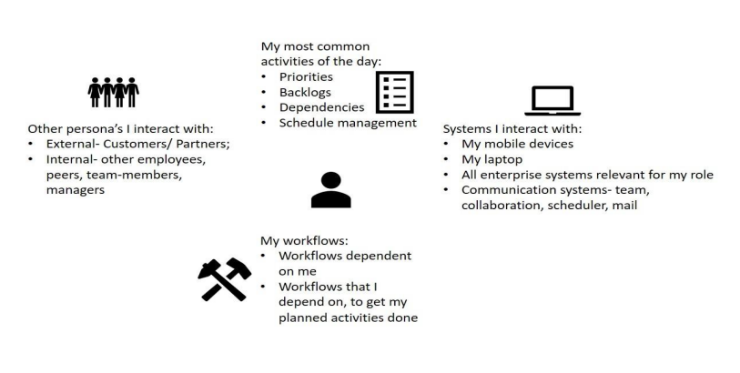
How to design an AI business case and use-case for an individual, using DfT?
Basis this minimalistic ontology of any generic individual in an organization, the following steps can be taken while designing a persona-centric trust-based AI solution, to show how AI can augment an individual's experience in an enterprise.
- STEP 1- Focus on what all activities an individual does, as an employee/ user/ customer, once s/he starts a day in office. Activities will include interactions with other entities within the enterprise boundaries: systems and people- external (customers, partners), internal (other employees, team members, bosses).
Say, when any typical employee enters his/her office space, there are certain common chain of activities that we all follow. This is like work study- micro-motion study, THERBLIGs. For example:
- Connect the laptop/ check on phone
- Check today's calendar. Set up reminders for meetings
- Check & read emails. Categorize emails basis actions required
- Respond to the top priority ones
- Take coffee breaks between meetings
- Take notes during meetings.
- Note down all action items from all meetings
- Prioritize action items
- Create/ update the checklist for Work of the Day
- Finish each action item and tick
- Go for lunch in between meetings
- Reconcile ticks in Work of the Day checklist
- Plan for backlogs if any
- Wind up
From this generic list of activities, the most usual AI-supported use cases for ‘Me’ as an individual in an enterprise, can be mapped onto almost all the activities, e.g. no. s 2,3,4, [possibly 5], 6,7,8, 9, 10, 12, 13; as shows in Table 1 below.
- STEP 2: Once the generic micro-motion study of any individual, irrespective of role/ position in the organization, is done, then there are 2 activities to achieve richer contextualization:
STEP 2A: Individual's people networks and dependencies: e.g.
- Identify the other key stakeholders that are directly linked with an individuals' daily ecosystem and activities. This will become bit more specific, for example, people who are in customer-facing roles will have different stakeholders, and people in back-offices or operations will have different other personas to interact with or to depend on/ work with. But still it can be fairly generic i.e. not tightly linked to hierarchy.
- Identify the most common mediums of interactions between the central personathe individual, and the other individuals/ personas identified in the previous step.
For example, we work f2f with some folks as much as possible, as we know they prefer that mode, then on phone/ email/video conferencing etc., with some others.
STEP 2B: The 'systems' in an individual's ecosystem, e.g.
- Identify the systems- IT/business systems, various tools, equipment, machineries that an individual needs to interact with for his/her day-to-day jobs
- Identify the workflows that have dependencies on the person, and the workflows that the person has to depend on

- STEP 3: Combining all the inputs from steps 1, 2A and 2B, the activities table is created as below:
Daily activities of an Individual in an enterprise | Intersection with other persona's | Intersection with systems | Workflow dependencies | AI has a role? If yes, What use case
Check today's calendar. Set up reminders for meetings | Customers/Managers/Peers | Email, Calendar, Scheduler | Availability of others | Yes. E.g. a Virtual Assistant- check meetings, calendar, cross-check with others calendars, Block, Monitor responses. Set up reminders. Update meeting status.
Check & read emails. Categorize email basis actions required | 'Me' | Email | Actions may involve other workflows | Yes. Semantics extraction of Intent/ action items from mail content/subject lines. Categorization by entities [e.g. escalation]
Respond to the top priority ones | 'Me' | Email | Actions may involve other workflows | Yes. NLP/NLG modules can be used to produce semi-canned responses to transaction-related/workflow-related/ rule-based/ query-response emails.
Take notes during meetings | 'Me' | My Device | - | Yes. I can have my virtual assistant to take notes for me in a meeting using voice to text, plus other.
Note down all action items from all meetings | 'Me' | My Device | - | Yes. Semi-assisted. A semantic analyser can extract all possible action items from the note. I choose apt ones.
Prioritize action items | 'Me' | My Device | Dependencies | Partial. E.g. Dependencies on other workflows analysed by AI. Importance, impact estimation, prioritization: Me
Create/update the actions checklist | 'Me' | My Device, scheduler | e.g. Project management | Yes, Reconciling basis dependencies and priorities, across project plans, program dashboards. Update.
Finish each action item and tick | Customers/Peers | Other systems to complete | Workflows for each action | Yes. The Virtual assistant can act as an action monitor, status consolidator, and can update my to-do list
Reconcile ticks in work of the day checklist | 'Me' | My Device, scheduler | - | Yes. Reconcile with consolidated status monitor-planned vs. actual
Plan for backlogs if any | 'Me' | My Device, scheduler | - | Yes. Cross-tabulating priorities, dependencies of actions, and status, AI can prioritize and plan pending actions
The table above captures some 'low-hanging fruit' AI use cases that are common-sensical for most typical knowledge workers or employees in an enterprise. The WIIFM story for an individual employee/ user can be captured this way-
- This will cover somewhere between 50-70% of the common activities of the workforce, in terms of percentage of people/ working population who can relate to these activities as 'their own', and
- It’s intuitive to see how the simple use-cases can save their time and efforts on repetitive tasks that are implicitly logical and hence the patterns can be discovered and learnt by supervised AI algorithms and can be autonomously taken care of.
STEP 4: Deeper and more advanced use cases will typically take
- a Persona, as a Process Owner: Requiring an end-to-end Process view i.e. one more dimensional complexity added on top of individual persona, and
- Requiring richer contextual information e.g. in terms of KRAs and KPI's of the individual Process Owner's role.
To identify and define use cases at this level 2, [level 1 is the common employee ‘Me’ persona], a detailed process model is usually built, and then individual roles are mapped on to them [like the makers and checkers of customer information verification in a KYC process].
The process modelling part is anyways already understood, analysed and practiced extensively in a lot of mature AI use-cases. But these have been mostly built with the target PROCESS at the core/ at the centre, whereas DfT as an approach requires to put Individuals first, at the centre, of any universal model. So, fundamentally, with DfT, the lens itself with which the AI solutions designers see the state-space of the problem, will flip. DfT will bring the persona at the center, first as an individual stakeholder in the system, then as a specific process owner. All the process models and workflows will have RACI’s involving these personas and will be modelled around them.
Summarily speaking, trust is an individualistic attribute, it is personal. Therefore, AI solutions designers and architects working on designing solutions with user personas and personal trust factors at the center, must start from this question of WIIFM. Not only for consumer-facing AI apps like AR/VR-based games or virtual avatar-based conversational AI, even for enterprise AI use cases, the messaging and positioning has to be completely personalized, in order to hike the Trust Quotient, and hence improve acceptance, reliance, dependence, and subsequently, adoption.
1-2-3 Action items Monday Morning
Key actions | Key actors
Establish a DfT framework for designing all major/ strategic AI use cases and solutions, to scale up adoption | AI CoE leaders, AI solution architects
Train the AI solution architects to build new AI solution prototypes using DfT as the standard solutions design best practice framework. Mandate them to first try out DfT applications in 3-5 major AI solutions design initiatives, involving their key target user personas. | AI solution architects, target users
Establish systems with senior management sponsorship, to monitor and check the user trust factors, factoring in their feedback and willingness/ challenges in adoption of the targeted AI solutions/ use cases. | AI CoE leaders, BU leaders & senior executive leadership driving strategic AI adoption initiatives

N.B. Therbligs are 18 kinds of elemental motions used in the study of motion economy in the workplace. A workplace task is analysed by recording each of the therblig units for a process, with the results used for optimization of manual labour by eliminating unneeded movements. [https://en.wikipedia.org/wiki/Therblig]







Reach out to us
Tap into expert insights and transformative strategies to lead your enterprise into the age of AI, Cloud, and Intelligent Automation. Connect with us to accelerate growth, optimize operations, and unlock new value at scale.
Email ID: info@prosight-AISM.com

Learn more about DIGITALFABRIC® for more insights:
https://digitalfabric.group
Connect with DIGITALFABRIC®
COPYRIGHT © 2025 DIGITALFABRIC® AISWITCH™. ALL RIGHTS RESERVED.

