



Focus Area: AI & Automation (Vendors & service providers)
Document Type: Knowledge Article
Series: AI-SWITCH PRACTICE RESEARCH FOR VENDORS & SERVICE PROVIDERS
How to best sell AI services: Use the Value-selling framework
www.digitalfabric.group
5 Why’s on Value-selling framework as imperative for effective sales of AI
- No consistent AI marketing framework available: Knowledge of AI services and capabilities are often deeply technical and sales teams often do not have the necessary deep tech know-how to be able to articulate their value proposition accurately. In that process loads of overselling and over-promising happen. Content training is a must. Use of the ValueSelling framework will bridge this gap.
- One common language between the AI service providers and buyers: The translation layer in Sales needs a common language. ValueSelling practice training enables sales teams to develop and use that common language.
- Predictability of success: Given AI has started mainstreaming only recently. Industry standard benchmarks aren’t readily available either on Risks or Benefits. Highly uncertain practices. In absence of consistent best practices, frameworks and benchmarks, AI services selling has become a ‘jump into the dark’ kind of random process. ValueSelling training will bring some methods into this madness.
- AI sales requires specialized training and best practice guidance: Not just because of the complexity of underlying technology but also because it’s not the same as selling IT services or products like IT products. AI capabilities and assets (solutions/ tools on sale) have specific but very high-impact value offerings depending on the problem context and industry/ domain/ function where it’s being applied.
Hence, pre and post value articulations and realizations require in-depth knowledge about the potential application of the tech and what impact it can create. Consistent processes are must for this articulation, messaging, positioning by buying center personas, verticals, functions, levels and so on. ValueSelling framework trains AI sales teams on these best practices.
- AI services in fast-track of innovations: Cost of errors is too High. If consistent messaging, positioning and selling is not done right first time, every time, every iteration, these innovations will go wasted. Businesses won’t be able to realize the potential value of these transformational technology stacks and services. ValueSelling practices will help AI sales teams to do it right from the beginning.
Why:
- No standard framework
- No common language between demand and supply sides of tech
- Predictability of success- Inaccurate, vague
- No specialized sales training
- No expertise in selling innovations

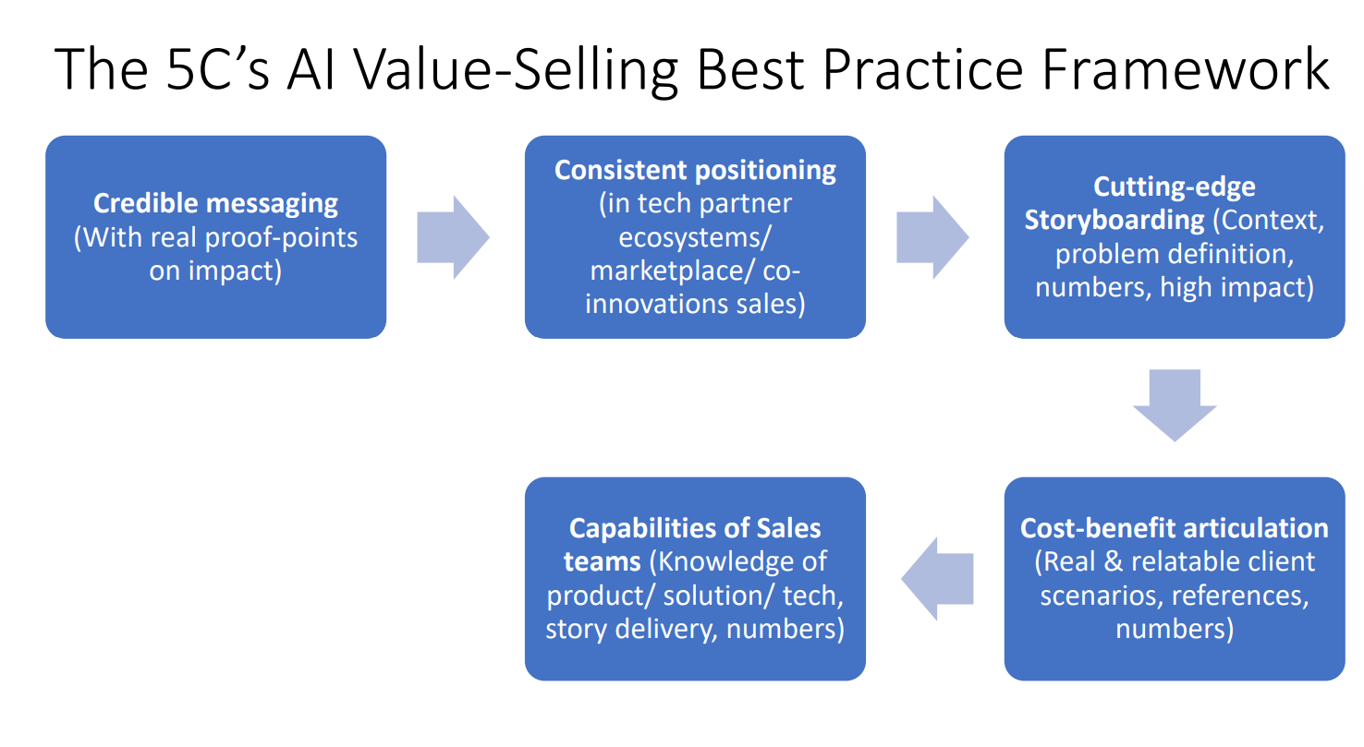
5 C’s as Targeted AI Selling Best Practices
- Credibility of messaging: Promises of impact and positioning storyboards & battlecard. Example case is in Meta offering metaverse. Great tech but enterprise view not cleanly articulated. Games don't work in enterprises with profitability objectives. Good Businesses don't play dice. Peer references usage for instance. Giving comparable benchmarks on use cases not on usages.
- Consistency of positioning in ecosystems: Avoiding value scope creeps- not overstepping constantly on partner territories
- Cutting edge storyboarding: Granularity of messaging of USPs e.g. AI differentiators linked to business strategy differentiators- Balancing between generalizability and unique specializations in tech algo wise or application wise or knowledge wise eg industry or practices n functions eg GRC n FinOps or hrops etc
- Cost- benefits articulation: Develop n use consistent n verifiable metrics
- Capabilities of sales teams: understanding of the offerings n the USPs claimed vs how to demonstrate n explain to different buying centre personas n knowledge maturity levels

5 C’s
- Credibility- provenness
- Consistency- no creep
- Cost-benefits
- Cutting edge storyboarding
- Capabilities of sales







Reach out to us
Tap into expert insights and transformative strategies to lead your enterprise into the age of AI, Cloud, and Intelligent Automation. Connect with us to accelerate growth, optimize operations, and unlock new value at scale.
Email ID: info@prosight-AISM.com

Learn more about DIGITALFABRIC® for more insights:
https://digitalfabric.group
Connect with DIGITALFABRIC®
COPYRIGHT © 2025 DIGITALFABRIC® AISWITCH™. ALL RIGHTS RESERVED.

