



Focus Area: AI & Automation (Vendors & service providers)
Document Type: Knowledge Article
Series: AI-SWITCH PRACTICE RESEARCH FOR VENDORS & SERVICE PROVIDERS
AISWITCH_2025_CALM3 LEADERSHIP AGILE AI STRATEGY
www.digitalfabric.group
Leaders must practice agility while building Minimum Viable Strategy for Agile Businesses & AI
Who should read this: Enterprise CEO (for strategic AI initiatives), Digital Strategy Office, digital business leaders, CDO, CIO, Digital Tech/ Service Providers
Enterprise business and AI leaders must build a minimum viable strategy, using the CALM framework
As per our 2020 survey on AI and digital business strategies, 90%+ of successful business leaders consider their businesses digital. The pandemic-triggered economic, workforce, and behavioral realities have shown enterprise leaders the value of AI & intelligent automation. The businesses that have survived and thrived have been those that were already virtualized or seized the opportunities of digitalized business.
A key prerequisite for a Minimum Viable Strategy for agile AI products and the digital enterprise, is agile leadership. This is delivered through the CALM framework.
What Leadership means in the context of CALM (Constraints-Assumptions-Leadership-Minimum Viable Strategy) framework
As a digital business leader, you cannot deliver the digital “moments” with slow & static strategies and systems that are completely outpaced by the real-time dynamics of the digital economy. Leaders must surpass the superfast technology supply curves, so that you can successfully anticipate and execute your agile business strategies, with an agile AI strategy.
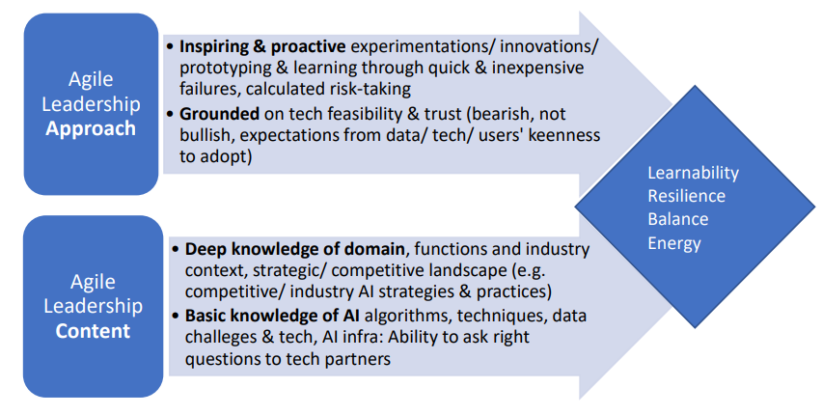
Use the CALM (Constraints- Assumptions/risks- Leadership->Minimum Viable Strategy) framework to build your agile AI strategy for a digital enterprise:
- Constraint optimization: Identification and classification of the constraints acting on your AI and digital businesses endeavors, e.g. business & financial constraints, hard and soft technology constraints, the softer people, culture & behavioral change constraints
- Assumptions rationalization: Expanding the risk factors and developing appropriate risk mitigation strategies, techniques & systems
- Leadership: Agile leadership models that are balanced between inspirational and practical aspects, synchronized between business & technology strategies
- Minimum Viable Strategy: As an agile leader, you must ensure that your Minimum Viable Strategy for your agile AI & businesses is documented, precise, specific, practical, and with measurable strategic objectives. This helps with the task of frequently communicating and re-evaluating the strategy, to ensure it provides day-to-day guidance for your AI & business teams.
The agile leadership challenge: Why Leadership is a critical pivot for successful practice of MVS
- Business-tech sync up: Agile leadership with business and tech sync is crucial for success. If agile AI tech strategy is out-of-sync e.g. too far ahead in terms of speed & objective functions, compared to the agility of your digital business strategy, you will fail to achieve target outcomes of the MVS. Worse, your teams morale will suffer.
- Speed of Change mismatch: For tech-native enterprises, AI & cloud tech capabilities may change way faster than business strategy. This may give rise to a new ‘speed of change’ mismatch. To avoid this trap of synchronicity, leaders must constantly remain focused on measuring targeted business outcomes of the MVS. DO NOT focused solely on tech/AI initiatives achieved e.g. use cases running successfully in production.
5-step action plan for leaders to put MVS into practice
To practice Minimum Viable Strategies, leaders- both in technology and business- must focus on the following actions:
- Identify major change triggers/ constraints/ risks: Identify the STEP (social, technical, economic, political) scenarios, competitor activity, from partners’ needs, from new start-ups and industry disruptors. This has to be a continuous activity and external SME partner ecosystems must be leveraged for outside-in practice views and ideas. Experienced agile leaders already know that it’s not possible for one person or one team, confined within one bound of reality (i.e. one organization), to keep track of all disruptions in our dynamic tech-business landscape.
- Leverage advisory/ tech partner ecosystems to evaluate the change triggers and prioritize the most significant and impactful ones for your AI-business initiatives. Modify your current MVS to reflect these top-priority changes. Use your research advisors as your extended team partners, to generate, evaluate new application ideas and brainstorm about the pro’s and con’s and nuances of new algorithms from
- interesting start-ups/ academia spin-off’s (e.g. Gamalon, Endgame, Affectiva)
- deep tech problem-solving focused companies e.g. Haystac in unsupervised document clustering, OpsRamp in lean AIOps
- global tech innovation powerhouses e.g. AWS, MS Azure, IBM Watson, Google Tensorflow based ecosystems
- Build the execution plan, milestones, RACI and target value metrics, for the modified MVS. Keep in mind that failure is a possible outcome of any of these changes but experimentation must be encouraged and practiced (If you haven’t tried, you won’t ever know). “Failure is good”.
- Communicate the plan and target metrics & timelines to all stakeholder teams mentioned in the RACI.
- Monitor continuously and regularly how the teams responsible for the initiatives in the modified MVS are progressing, not just in terms of efforts put in, but in terms of realization of targeted outcomes within planned timelines and cost-points.
- Go to step 1.

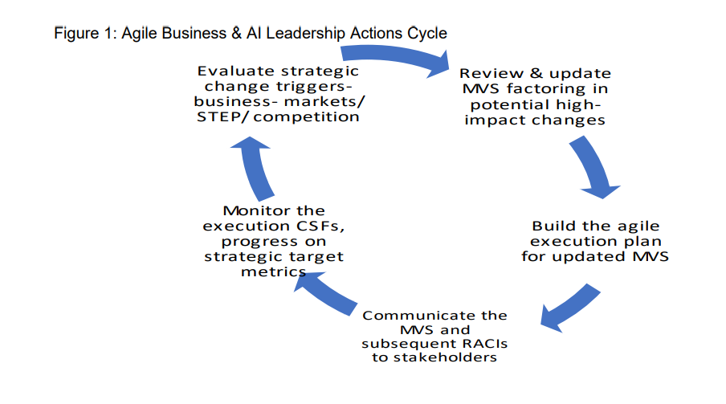







Reach out to us
Tap into expert insights and transformative strategies to lead your enterprise into the age of AI, Cloud, and Intelligent Automation. Connect with us to accelerate growth, optimize operations, and unlock new value at scale.
Email ID: info@prosight-AISM.com

Learn more about DIGITALFABRIC® for more insights:
https://digitalfabric.group
Connect with DIGITALFABRIC®
COPYRIGHT © 2025 DIGITALFABRIC® AISWITCH™. ALL RIGHTS RESERVED.

