



Focus Area: AI & Automation (Vendors & service providers)
Document Type: Knowledge Article
Series: AI-SWITCH PRACTICE RESEARCH FOR VENDORS & SERVICE PROVIDERS
AISWITCH_2025_CALM1 AI MVS AGILE STRATEGY
www.digitalfabric.group
AISWITCH AI PRACTICE COOKBOOK: Agile Organizations Guide Product direction with a Minimum Viable Strategy
Who should read this: CEO, strategy office, CDO, CIO, TSP leaders
2021 onwards, End Users and TSPs focus on Minimum Viable Strategy to rapidly build & execute agile digital business & AI strategies
Frequent learning iterations and course corrections are the nature of agile products. Leaders should ensure their product strategy makes frequent small changes too, so as to match the changing environment. So it’s usually more appropriate to guide your programmes and endeavours using the concept of a Minimum Viable Strategy:
- Above all – have a current, relevant, and useful product strategy that includes key metrics.
- Create lean light Product Strategy documents that provide specific and concrete guiding principles to the team.
- Revisit the core items of strategy every 3 sprints or so. Fine-tune the strategy to deliver optimal results. But avoid frequent lurches in direction.
Figure 1: Keeping Product Strategy Minimal and Nimble
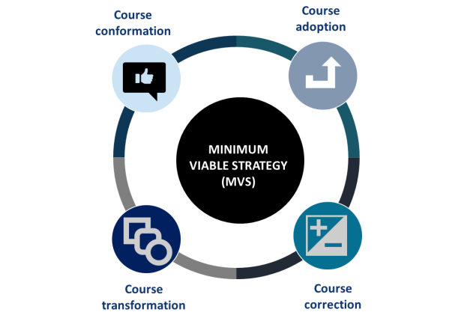
The Product Leader must ensure that the goals are the best possible options in light of all current information & assumptions. It is wise to stay close to the Agile Manifesto.
Therefore, the Product Strategy should be a small and practical document. This helps with the task of frequently communicating and re-evaluating the strategy, to ensure it is still guiding the business teams in the right direction.
Together with the team, the Product Leader should assess that the product strategy is still as good as it can be. This requires answering specific questions such as:
- Is customer satisfaction still rising?
- What priorities are our customers asking for?
- What do the product metrics tell us?
- Has anything significant changed in our Internal Analysis or External Analysis (SWOT) that warrants revisiting our product strategy?
- Do we need to revise the risk register or take risk-focused actions??
- Is the team still motivated and positive?
- Do we need to address any constraints such as skills or facilities or tools or information sources?
- Is our product strategy giving enough specific guidance to the team?
- Can everyone in the team articulate our product in less than 2 minutes?
- Are our processes at the right balance of control and simplicity?
Having acquired the information, the Product Leader must take wise decisions and make the required (hopefully small) changes to strategy to ensure best product delivery. This is not to encourage rapid and huge changes of product direction. MVS is about ensuring that the strategy is reviewed frequently and continually adjusted & fine-tuned to assure alignment with the changing needs of the market and customer base.
What are the key components of Strategy?
A Strategy can be summarised as Ends, Ways and Means:
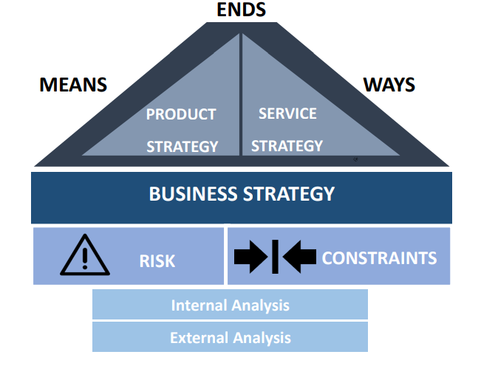
Ends, Product Vision or Product Objectives: The Overall goal or vision for the product.
Ways: How the available resources will work within the inevitable constraints to accomplish the Ends as described above.
Means or Resources: The Minimum Viable Strategy must look a few milestones ahead and state how the resources will be used to move towards the Ends.
It’s essential that all products move forward as part of an overall strategy, but when learning and iteration is such a fundamental part of a project, as it frequently is in the agile world, then we need leaders to avoid heavyweight, cumbersome strategies. A Minimum Viable Strategy allows a product team to be nimble, recognise new and changing conditions and seize opportunities as they arise.
A Universe of Possibilities
The hardest part of any strategy is deciding what NOT to do. A good approach is to start with a SWOT analysis:
- Internal Analysis: Identify the Strengths and Weaknesses of your organization and your team.
- External Analysis: Identify the Opportunities and Threats that the market environment, societal factors and your competitors are facing.
Using a SWOT analysis as a workshop seed, will typically throw up a range of possible ideas that would be attractive to pursue. Inevitably there will be many more ideas than resources to follow them up.
From the Universe of Viable Alternatives, to a Feasible Product (or a few)
First use a Risk Analysis to identify the risks associated with each product idea. Risk management techniques are for another discussion, but identifying the risks and threats associated with each product, and comparing these with the organization’s Risk Appetite is an essential paring-down technique.
Then, identify the inevitable constraints within which you must work. These will include financial (limited money), intellectual (skills you don’t have in quantity), time (maybe a window of opportunity), facilities such as space, equipment, licences, and many more. The constraints may well be the deciding factor that you can only pursue say 2 products at any one time. This helps you to ruthlessly cut out opportunities that seem attractive but don’t match your organization’s risk appetite or current constraints.
Of course, all risks and constraints can be adjusted in the medium and long term. But here and now, we must work with what we have and what we can cope with.
Evidence and Notes
- The Agile Manifesto https://agilemanifesto.org/
Appendix: Details on terms used in MVS approach
Ends, Product Vision or Product Objectives: The Overall goal or vision for the product. For example, what impact do you want to have on your users’ lives? Or how should the market perceive your product?
Ways: How the available resources will work within the inevitable constraints to accomplish the Ends as described above. The Ways must be written as a practical guide for those doing and managing the work. Include metrics for how to measure progress towards your goals.
Means or Resources: Look just a few milestones ahead. While a vision is essential, long range resource planning is fruitless in an agile project. Tangible resources include people, money, facilities, tools, intellectual property. Leading organizations recognize their intangible resources in their strategy, such as courage, a can-do culture, agility.







Reach out to us
Tap into expert insights and transformative strategies to lead your enterprise into the age of AI, Cloud, and Intelligent Automation. Connect with us to accelerate growth, optimize operations, and unlock new value at scale.
Email ID: info@prosight-AISM.com

Learn more about DIGITALFABRIC® for more insights:
https://digitalfabric.group
Connect with DIGITALFABRIC®
COPYRIGHT © 2025 DIGITALFABRIC® AISWITCH™. ALL RIGHTS RESERVED.

