



Focus Area: AI & Automation (Vendors & service providers)
Document Type: Knowledge Article
Series: AI-SWITCH PRACTICE RESEARCH FOR VENDORS & SERVICE PROVIDERS
AISWITCH_2025_TOP 10 NEXTGEN AI PLATFORM DIFFERENTIATORS FROM SERVICE PROVIDERS
www.digitalfabric.group
AISWITCH AI PRACTICE COOKBOOK: 2021 TSP AI PLATFORM TECH TRENDS: 10 NEXTGEN DIFFERENTIATORS
Who should read this: Enterprise AI CoE leaders, CDO, CIO, CEO (for strategic AI initiatives), AI Business User Leaders, AI Solution Architects, AI Solutions & Service Providers
Why, in 2021, the Technology Service Providers must focus on creating strong differentiators in their AI-automation solutions
Enterprises are increasingly investing in secure AI-automation solutions (market slated to grow @30%+ CAGR in the new reality), especially when Work-from-Anywhere has become a BAU practice ( “Going to Work” is moving into BCP-DR SOPs portfolio. Even traditional IT SPs like TCS are asking their mid-management to provide Business Case quantified & verifiable reasons for coming to office).
But, the rapid dynamics of typical work practices on the demand-side and the tech complexity dynamics on the supply-side are often out-of-sync:
End-user leaders are increasingly shifting their AI-automation goalposts from operational cost savings to strategic resilience, digital CX & value-enabling solutions that are 1 secure-by-design, 2-rapid-to-deploy, and 3-easy-to-learn (e.g. don’t require tech/ coding skills)
Every serious player in the technology service provider landscape has got a portfolio of AI solutions/ use cases/ platform assets, but 90% of the contents of their portfolios look the same. Only a few TSP companies are creating AI-automation use cases with sustainable value and competitive advantage for clients.
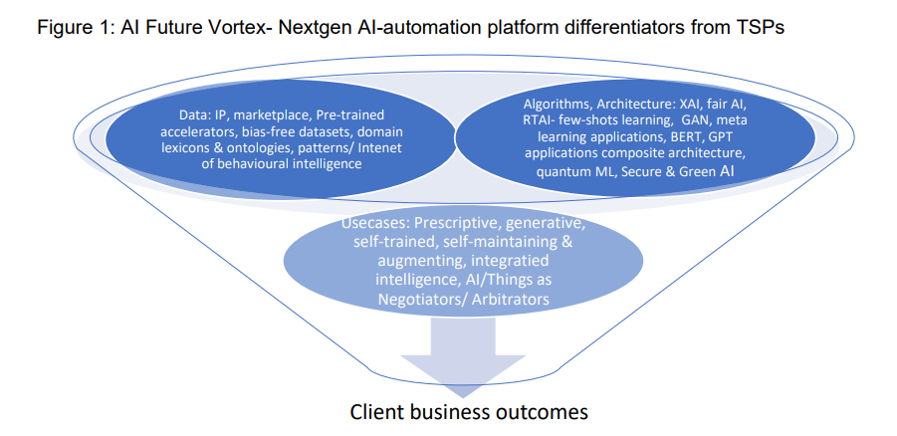
2020 differentiation in AI platforms/ solutions from TSPs: Near ZERO
If a cluster analysis is done on the AI-automation solutions offerings from TSPs, more similarities are obvious and visible, than strong differentiators. Few exceptions are seen in pockets or siloes, in IBM, Accenture, Capgemini, EY, Genpact etc., in way of thinking ahead of the curve and executing it too.
For most other ‘me-too’ runners, five most-seen AI tech applications and use-cases include:
- Chat and conversational AI for IT or business service desks: CRM- customer service- maturity of platforms range from structured and guided conversations to keyword-based chats to unstructured, cognitive Q&A
- Contract intelligence (Document/ content ML) and KYC (Know Your Customer: Web & document scrapping, OCR from source data, autonomous field capture semantic extractions & form-filling- Maker & Checker functions), increasingly generalized into KYX (Know Your Vendor/ Employee/ Supplier/ Provider/ Partner/ Contractor)
- Anomaly detection, fraud detection & prediction: In some cases, e.g. IBM Watson AML- logically integrated and evolved into broader capabilities of end-to-end AML
- Claims processing: Data extraction from mobile images and forms, form filling (work for RPA bots), partial automation of claims processing, with very few solutions actually leveraging the strengths of AI not just for rule-based or case based but for judgement-based decisions
- Predictive maintenance, field/remote servicing & predictions: Computer vision, image recognition & classification, video/ stream analytics, AR, VR, MR solutions; video analytics applications on sports and streaming media
Some of these, touted as integrated RPA-AI/ML/deep learning use cases, are there in every conceivable SP’s kitty, and are beaten to death in front of the end-user buying centre leaders.
What are the 2021 next-gen differentiators for TSP AI solutions?
Elaborating the differentiators in terms of the input dimensions of data and algorithms and the output dimension of use cases, potential differentiators are mentioned in table 1:
TSP AI solutions dimensions | Type of dimension | Potential next-gen differentiators
Data capabilities | Input-side/ platform dimensions | - Data as IP, Data marketplace, pre-curated bias-free datasets, curated IoT datasets, benchmark data, risk data  - Pre-trained accelerators (Domain/ function)  - Domain lexicons & ontologies as IP, ontologies as a service  - Business process data/ models libraries  - Data patterns/ models/ knowledgebases (e.g. in 2017 Amex, JPMC, BoA and Wells Fargo worked together on TruSight, to create a risk assessment service)  - Data models from Internet of behavioural intelligence, behavioural intelligence patterns
Algorithmic and architectural capabilities |  | - Explainable, transparent, interpretable, AI algorithms with fairness scores and assurance  - Real time AI, data approximation algorithms, synthetic data generation, less-data techniques, few-shots, one-shot, zero-shot  - Generative AI- new applications of GANs and BiGANs, formative AI for intuitive conversational AI, AutoML, self-writing code  - Supervised & unsupervised combined pretrained BERTs (e.g. multiple FinBERTs and PharmacoBERTs), low-code AI  - Hybrid, composite, modular architecture  - Quantum information processing algorithms, quantum ML  - Secure-by-default, zero-trust AI architecture, security-assured AI infrastructure e.g. Intel SGX, Green AI – energy efficient AI/ML algorithms requiring less data & compute- less carbon debt, acceptable accuracy
Use-case capabilities | Output side/ solutions dimension | - Predictive-> Prescriptive and autonomous decisions to actionse2e use cases  - Generative/ formative use-cases, self-trained, self-maintaining & augmenting  - Internet of Integrated intelligence usecases e.g. AIoT-> selfsecuring, self-managing Things, Grids, Transport, Infra  - Autonomous businesses- AI+ blockchain  - Use cases with AI/Smart Things as Negotiators/ Arbitrators

10 Early examples of next-gen differentiators from leading TSPs
- Guaranteed Business outcomes in hard dollar value: This is Accenture’s forte, with real-time dashboards for all values tangible, real-time business cases in production
- Pretrained accelerators: Ensuring speed to accuracy in production deployment (not just POCs) in days to weeks not months, e.g. Q&A engines- with pretrained conversational patterns and domain lexicons, achieving 90% + precision in 4-6 weeks. Genpact for example has shown industry-leading work on pretrained AI accelerators.
- Zero-trust, secure-by-default AI-automation solutions: Equipped with autonomous, self-learning, self-improving governance, compliance, risk monitors and orchestrators. Most TSPs are at different points in the maturity curves on this practice. Typically IT-heavy SPs like Wipro have created these capabilities in a limited way at an early start, given their experience in managing and provisioning dynamic infrastructure from cloud.
- XAI, ethical, fair, responsible AI modules integrated in AI solutions packages by default: For example, fair and transparent, explainable classifications and recognition, fair anomaly detection, fraud prediction, loan approval decisions- with transparent explanations on ‘Why this decision/action’. IBM, Accenture, and Wipro have done industry-leading work in these strongly differentiating practices which are also getting mandated by international AI regulatory bodies and government policies. Tech firms like Google and Microsoft also have built fairness-checker AI-ML modules.
- Persona/ role-based, user-centric AI: With minimal code maintenance and code change hassles. Solutions are not designed for data scientists or ML engineers but for business users, using low code platforms. Starting with RPA vendors such as Blue Prism and UIPath on low-code development for business user persona’s, digitally integrated service providers like Wipro have mapped AI solutions packages to function leaders’ persona’s and their teams.
- Machine-negotiated, interpretable and actionable outcomes: For example, if an anomaly is detected, an integrated NLG layer can compose potential solution paths combining different resolution paths from preexisting knowledge graphs and can then generate scripts for manual or autonomous approvals or actions
- Trust frameworks and trustworthy AI: Starting from hardware leaders like Intel, to end-to-end AI tech-stack providers like IBM, to AI consulting and implementation leaders like Deloitte, trust has become the pivotal anchor for AI solutions that can scale up across enterprise functions and partner ecosystems.
- Risk frameworks: EY for example has created a comprehensive AI risk assessment and management framework covering five key dimensions of AI risks. Risk assessment and mitigation are key requirements for AI governance and controls.
- Less data capabilities: As per a Harvard Business Review prediction on AI, less data scenarios and data approximation will become more important than data-volume management problems, for enterprises eager to use AI to gain strategic advantage. TSPs that have capabilities built to train AI solutions on bias free but rich synthetic data and using up-sampling to intentionally include more minority data points, will build more confidence and credibility in their models and AI capabilities.
- Maturity curves of process mining and discovery tools: Process discovery, blueprinting and mining are important and are quite effective ‘done deals’, thanks to tool-vendors such as CELONIS and Kryon. The next points in the maturity curves in this space must come from TSPs, e.g. GAN and RL-based based process reimagination, self-learning & self-improving, dynamically auto-optimizing business processes.







Reach out to us
Tap into expert insights and transformative strategies to lead your enterprise into the age of AI, Cloud, and Intelligent Automation. Connect with us to accelerate growth, optimize operations, and unlock new value at scale.
Email ID: info@prosight-AISM.com

Learn more about DIGITALFABRIC® for more insights:
https://digitalfabric.group
Connect with DIGITALFABRIC®
COPYRIGHT © 2025 DIGITALFABRIC® AISWITCH™. ALL RIGHTS RESERVED.

