



Focus Area: AI & Automation (Vendors & service providers)
Document Type: Knowledge Article
Series: AI-SWITCH PRACTICE RESEARCH FOR VENDORS & SERVICE PROVIDERS
AISWITCH_2025_ENTERPRISE AI STRATEGY EXAMPLES
www.digitalfabric.group
AISWITCH AI PRACTICE COOKBOOK: 2021 ENTERPRISE AIAUTOMATION STRATEGY – A SIMPLE EXAMPLE TEMPLATE
Who should read this: Enterprise AI CoE leaders, CDO, CIO, CEO (for strategic AI initiatives), AI Business User Leaders, AI Solutions & Service Providers
Why the need for a mature enterprise AI-automation strategy?
90%+ business organizations have either already implemented or are planning to implement and productionize several AI-automation solutions in their business processes and functions. Every business is becoming an AI business; hence every enterprise needs to frame an AI-automation strategy that’s in perfect sync with their business strategic priorities.
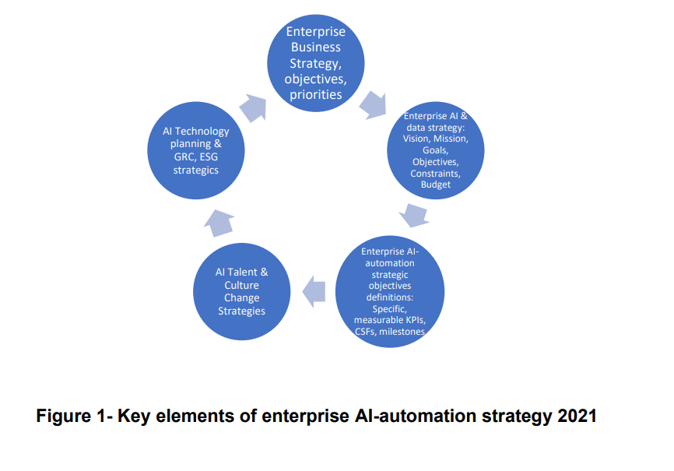
What should be the contents of a minimalistic yet comprehensive enterprise AI strategy, across the 3 horizons?
Most of the major AI-automation initiatives are strategic and transformational both in terms of scale and scope. Therefore, the AI-automation strategic horizons must span across the short-term to long-term strategic objectives and initiatives. 3 key strategic horizons for enterprise AI-automation are defined below:
- Horizon 0 (Ground Zero- NOW): 2021-22
- Horizon 1: 2-3 years – 2022-24
- Horizon 2: 3-5 years- 2024 onwards
AI Strategy Template: Horizons 012
Section 1: Enterprise business strategies and corporate strategic goals and priorities
- Horizon / Ground 0: Ongoing strategies on current digital+ legacy product/ service mixes/ bundles, current markets and competitive landscape, current partners and acquisition plans
- Horizon 1: New/ changed digital business strategies and priorities: New products/ services/ markets/ customer segments/ competitive landscape- tech/business/ innovation drivers and new players- competitors/ potential partners. Evaluation priorities
- Horizon 2: Self-disruptive & industry-changing, cannibalized solutions/services bundles, new disruptive offerings and business models, new operating models with mature partner ecosystems for tech and services
Section 2: Enterprise AI and data strategies- Vision, Mission, Goals, objectives, constraints, budget allocation strategy
- As-is Horizon/ Ground 0: <50% of total AI-automation budget (CoE, sponsored by business/ part of IT budget- all combined, total $s available for AI-automation projects across the enterprise) on “Run/ Grow” of these Current AI-RPA solutions what plans for scale-up, scope expansion.
Priority queues:
1- High-impact, moderate to low risk, provenly successful ones to scale first: Top 5-8 projects – 50%+ budgets allocated to scale up in terms of adoption and scope and leverage- for these tried and tested use cases
2- High-impact but struggling AI-automation projects, in terms of scale/ adoption/ value realization- 3-5 30%+ budget and efforts,
3- Low-impact low-risk (low hanging but less RoI fruits) – 15-20% budget and efforts, 3-5 projects.
Horizon 1:
- 30-40% of total AI-automation budget for 3-5 transformational AI-automation: End-to-end integrated, future-proofed & strategic (will not become irrelevant in 3-5 years at least)
- High returns-high-risk: Prioritized on Business Impact KPIs, even if the projects may be high-risk.
- Check/ estimate tech requirements in terms of data, algorithms, infra, partners, skills- check the constraints and allocate budgets
Horizon 2:
- 10-20% of total budget: Moonshot projects- completely new business/ revenue/ customer catchment (e.g., not just more of same in more Geo’s)
- Check with bleeding edge tech implemented by leading edge service partners for future-focussed talent.
Section 3: AI-automation strategic objectives
- Defined measurable, specific business-outcomes based lead indicators/ target-state view
- Major project milestones on critical success criteria for each project in Horizons 012.
- Inputs needed from consulting partners, external AI practice SME advisors e.g. to gather benchmark intelligence on what are feasible targets, what other competitors have achieved, what are achievable given current realities and constraints,
- Baselines and target 2-step benchmarks- for review every 6 months to 1 year.
Section 4: AI talent and organizational culture change strategies
- Culture change levers identified, baseline challenges assessed and quantified
- Talent acquisition strategies- crowdsourcing/ partnering/ internal dev CoE capabilities- in sync with sections 1 and 2 e.g. if your business strategy/ AI strategic vision is to become world’s top 3 in AI-automation leverage to disrupt/ transform your industry/sector, then building a strong internal CoE in long term is your target AI talent strategy, like what Capital One, JPMC did in banking, most good investment banks did as a competitive survival tactic.
Section 5: AI technology strategy
- Infra/ partner/ cloud strategies and AI lifecycle management strategies integrated, partner evaluation strategies and prioritization logic- for 012 projects these must be different
- For example: for Horizon 0- cost-prioritized, for Horizon1-current innovations prioritized, for Horizon 2 projects- start-up’s and disruptive, new, smaller, more agile partners prioritized, even likely for acquisitions
Section 6: AI GRC strategy
- Mitigating AI risks in sync with data and new regulatory standards kicking in
- For example: Ethical and explainable AI being mandatory for all customer-facing AI applications be it loan approval or insurance premium calculations or claims verification or medical diagnostics or employee performance appraisal
123 Action items for Monday Morning
Key actions | Key Actors
1-CEO, CXOs, BU heads, CSO and AI CoE leaders establish AI-business combined strategies for 3 horizons | AI CoE leaders, AI governance councils/ steering committee, CEO-CXO-CSOs
2- AI CoE leaders and CSO office build the AI & data strategy of the enterprise, factoring inputs from step 1 | AI CoE team, CISO, Chief risk/ compliance officer
3- Establish measurable AI strategic objectives, CSFs, KPIs | AI CoE tech+ BU teams, CRO/ CCO







Reach out to us
Tap into expert insights and transformative strategies to lead your enterprise into the age of AI, Cloud, and Intelligent Automation. Connect with us to accelerate growth, optimize operations, and unlock new value at scale.
Email ID: info@prosight-AISM.com

Learn more about DIGITALFABRIC® for more insights:
https://digitalfabric.group
Connect with DIGITALFABRIC®
COPYRIGHT © 2025 DIGITALFABRIC® AISWITCH™. ALL RIGHTS RESERVED.

