



Series: SEELING AI RIGHT
Focus Area: AI
Document Type: Knowledge Article
Why Value-Sell AI
www.digitalfabric.group
5 Why's on AI value Selling being imperative for AI success:

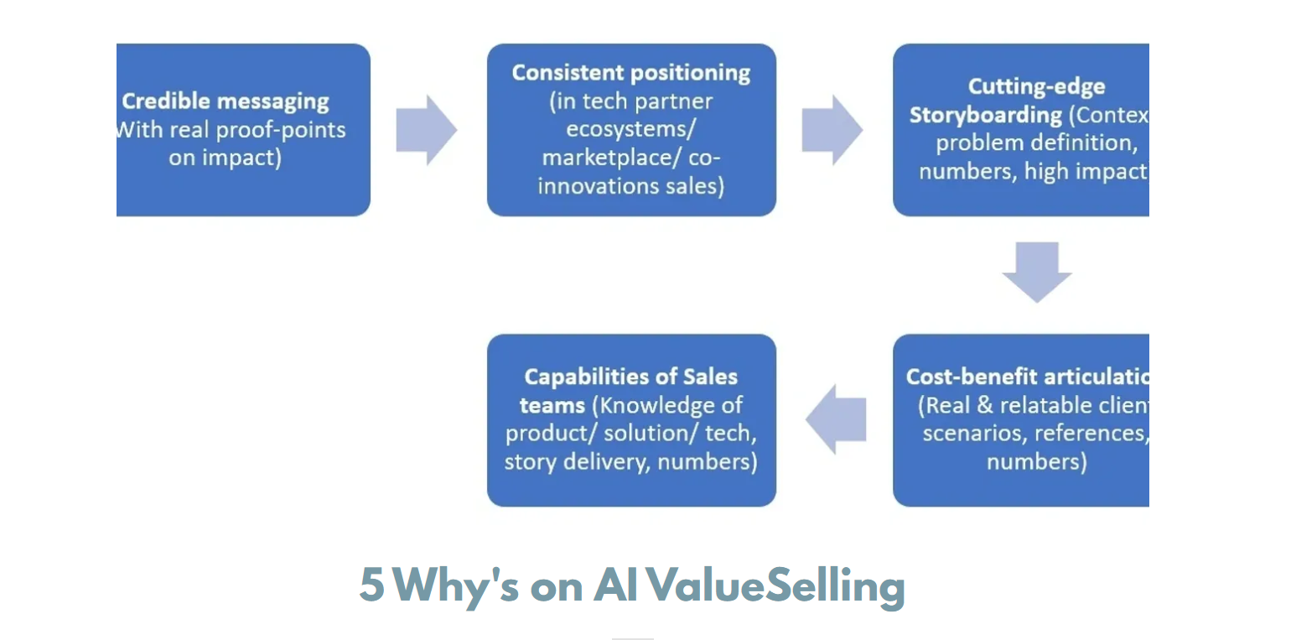
- No consistent AI marketing framework available: Knowledge of AI services and capabilities are often deeply technical, and sales teams often do not have the necessary deep tech know-how to be able to articulate their value proposition accurately. In that process loads of overselling and over-promising happen. Content training is a must. Use of the ValueSelling framework will bridge this gap.
- One common language between the AI service providers and buyers: The translation layer in Sales needs a common language. ValueSelling practice training enables sales teams to develop and use that common language.
- Predictability of success: Given AI has started mainstreaming only recently. Industry standard benchmarks aren’t readily available either on Risks or Benefits. Highly uncertain practices. In absence of consistent best practices, frameworks and benchmarks, AI services selling has become a ‘jump into the dark’ kind of random process. ValueSelling training will bring some methods into this madness. This is a long form text area designed for your content that you can fill up with as many words as your heart desires. You can write articles, long mission statements, company policies, executive profiles, company awards/distinctions, office locations, shareholder reports, whitepapers, media mentions and other pieces of content that don’t fit into a shorter, more succinct space.
- AI sales require specialized training and best practice guidance: Not just because of the complexity of underlying technology but also because it’s not the same as selling IT services or products like IT products. AI capabilities and assets (solutions/ tools on sale) have specific but very high-impact value offerings depending on the problem context and industry/ domain/ function where it’s being applied. Hence, pre and post value articulations and realizations require in-depth knowledge about the potential application of the tech and what impact it can create. Consistent processes are must for this articulation, messaging, positioning by buying centre personas, verticals, functions, levels and so on. ValueSelling framework trains AI sales teams on these best practices.
- AI services in fast-track of innovations: Cost of errors is too High. If consistent messaging, positioning and selling is not done right first time, every time, every iteration, these innovations will go wasted. Businesses won’t be able to realize the potential value of these transformational technology stacks and services. ValueSelling practices will help AI sales teams to do it right from the beginning.







Reach out to us
Tap into expert insights and transformative strategies to lead your enterprise into the age of AI, Cloud, and Intelligent Automation. Connect with us to accelerate growth, optimize operations, and unlock new value at scale.
Email ID: info@prosight-AISM.com

Learn more about DIGITALFABRIC® for more insights:
https://digitalfabric.group
Connect with DIGITALFABRIC®
COPYRIGHT © 2025 DIGITALFABRIC® AISWITCH™. ALL RIGHTS RESERVED.

