



Series: SEELING AI RIGHT
Focus Area: AI
Document Type: Knowledge Article
5 C's of ValueSelling AI
www.digitalfabric.group
Focus on 5C's for effective AI Value-Selling
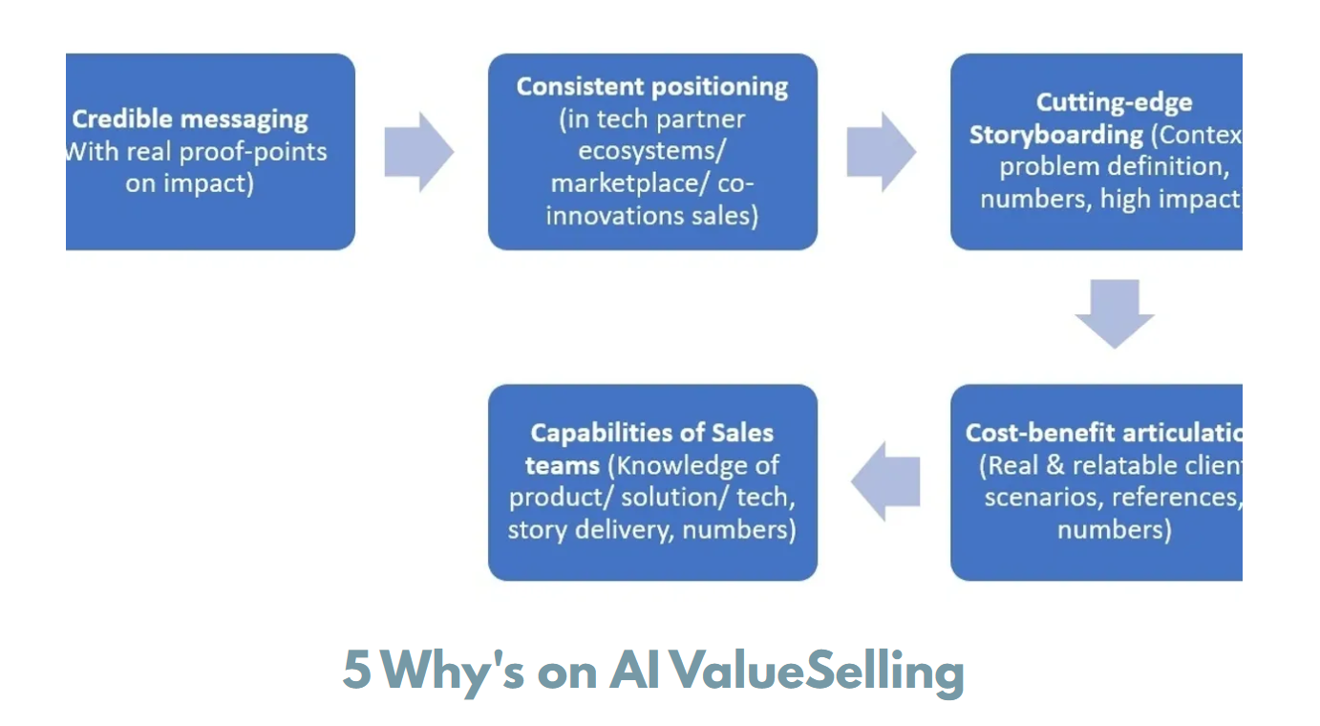

- Credibility of messaging: Promises of impact and positioning storyboards & battlecard. Example case is in Meta offering metaverse. Great tech but enterprise view not cleanly articulated. Games don't work in enterprises with profitability objectives. Good Businesses don't play dice. Use of Peer references is a must-do for building and reassuring credibility of messaging, for instance. Giving comparable benchmarks on proven use cases and not just on potential usages, is a must.
- Consistency of positioning in ecosystems: Avoiding value scope creeps-not overstepping constantly on partner territories and thereby creating unnecessary confusion and messy redundancy where the customers are conflicted on whether they are paying for similar features and services multiple times, or for tech partners who see constant overlaps and/ or completely avoidable and non-value-adding integration requirements.
- Cutting edge storyboarding: Granularity of messaging of USPs e.g. AI differentiators linked to business strategy differentiators. Balancing between generalizability and unique specializations is key in messaging, e.g. tech algo-wise or application wise or knowledge wise eg industry or practices and functions eg GRC, FinOps, HROps, legal, contract management use cases etc.
- Cost- benefits articulation: Develop and use consistent, benchmarked verifiable metrics in case studies beyond just technical story-points, e.g. proven and tangible impact metrics like cost savings, reduced rework/ errors/ false positives, increased profitability/ market share etc., by use cases/ applications, by industries, partners and peer references.
- Capabilities of sales teams: Understanding of the offerings n the USPs claimed vs how to demonstrate and explain to different buying centre personas, by the buyers' priorities and knowledge maturity levels.







Reach out to us
Tap into expert insights and transformative strategies to lead your enterprise into the age of AI, Cloud, and Intelligent Automation. Connect with us to accelerate growth, optimize operations, and unlock new value at scale.
Email ID: info@prosight-AISM.com

Learn more about DIGITALFABRIC® for more insights:
https://digitalfabric.group
Connect with DIGITALFABRIC®
COPYRIGHT © 2025 DIGITALFABRIC® AISWITCH™. ALL RIGHTS RESERVED.

