**Date:** 23th Nov ’20

Process Note – Seller or Retailer or Wholesaler or Service or Buyer Direct Communication Platform/ PWA Development

# Background:

At present various e-commerce company provide product to consumer. Product seller only option to provide product to consumer through e-commerce. Many sellers have individual APP also to take product requirement directly.

# Proposal:

Thus, to ensure Seller or Retailer or Wholesaler or Service or Buyer direct link through PWA, we propose following step to be adopted in that APP or pathway:

* 1. For Admin Main Page :

Upper Left corner Home icon with Hello, (Admin Name) on same line Chat box icon (For messaging with Employee directly), Upper Right corner Employee ID creation button or icon and refer option (1. For free membership 2. Normal referral)

1. Employee Wise Dashboard of performance (Export in excel)

1. Number of case done on daily basis, category name, video uploaded YES or NO (If YES video link)

2. Last month consolidated monthly report with successful conversion cases

1. Category Wise Dashboard with plan, payment detail if any one take the subscription plan (Export in excel)
   1. On click on Employee ID creation button :

Create employee account page: Fill detail of employee like Name, Mobile no., working cities or location, mail id, Designation etc.

Click SAVE button….Request generated…trigger system generated message of link or mail to employee

* 1. For Employee Start Process

On click of link send by admin, employee Login with mobile no. and set password with OTP verification

After that register their account as confirming the detail.

By this Employee page will reflect on which he can seen their job work on monthly quarterly or yearly basis

* 1. For Employee Main Page (Different for different designation):- Upper Left corner Home icon with Hello, (Employee Name) on same line Chat box icon (For messaging with Employee directly).

He can also use search option like buyer & view successfully uploaded video by seller and following things on his page:-

1. Job done by category

2. Notification (If any new video uploaded by seller as used by referred link)

3. Refer concept (same as seller or buyer way and earn rewards after successful conversion cases)

4. Reward (after successful conversion cases get XX in reward box)

5. Change password

7. His dashboard report Current, Last 3 months, Last year

Mobile no., Date wise, category, plan (Q/M/Y), name of citys, name of shop, Video Status

(YES/NO)

8. Logout

* 1. Employee refers his code to seller through mobile number. By this code or link seller will activate his account ID. For this process admin track employee performance through above admin dashboard
  2. For seller at the time of activation 1st Page is APP name page i.e. SEVA Swadesi E-Vikreta Aatmanirbharta APP



* 1. 2nd Page we need APP name with tagline (Upper Centre) i.e. Do SEVA Feel Aatmanirbhar and one tagline (Lower Centre) i.e. All Product & Service through SEVA:-

First time page: Create account – Name, email, Mobile no (must), set password, verification through OTP.

Terms & Condition with check box which is mandatory selection

After successful login welcome message (text) will goes to mail & mobile no.

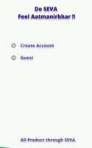 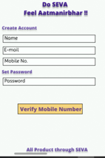

Second time page: Login, Password (Alphanumeric – 8 Digit), Submit button, or OTP login potion

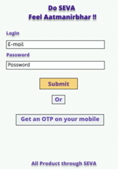

If user select guest it will directly jump on 3rd page (Those who will search product or service through website or portal)

* 1. 3rd Page we need APP name with tagline (Upper Centre) and one tagline (Lower Centre) :-

Always 5 Option selections will come Seller or Retailer or Wholesaler or Service or Buyer for guest otherwise registered user will jump on this page and go direct on next page of his registered selection

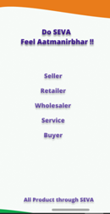

* 1. For sellers & buyer always come Upper Left corner Home icon with Hello, (Seller Name) and Upper Right corner Back button or icon

Seller or Retailer or Wholesaler or Service or Buyer fills following detail 1st time and update button:-

1. Name

2. Company/ Shop Name if Available

3. Address

4. City

5. Contact No.

6. GST no. (Not for Buyer)

7. Govt. ID

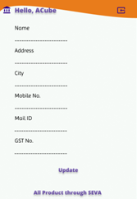

* 1. For Seller or Retailer or Wholesaler or Service provider Main Page

1. Upper Left corner Home icon with Hello, (Seller Name), on same line location will come through GEO location with icon set by him or default, Chat box icon and Upper Right corner list button or icon



1. Below Home icon-Language option or drop down: On click English, Hindi will come at present after that on the basis of language every text will convert

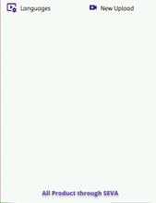 From the starting time our app guided video will be their.

1. A. On same line below location- New upload option will come with video icon: On click new page will come with two option first is Main Highlight & second is for Product Library where Seller or Retailer or Wholesaler or Service will upload image or product video.

B. For Main Highlight selection seller or other upload product video with product name as per product category drop down, contact number, City

After 1st time next time, 2 option will reflect

1st is Remove or New upload & 2nd is Other Product/Service option will reflect i.e NEW Upload if he want another Highlight option will reflect gradually for 2nd time, 3rd time and so on.

C. For Product Library selection seller or other uploads product video only (detail of product and other not required) up to 10 (1 min per video duration)

After 1st time next time, 2 option will reflect

1st is Remove or New upload & 2nd is Other Product/Service option will reflect i.e NEW Upload if he want another Highlight option will reflect gradually for 2nd time, 3rd time and so on.

After filling all detail as per already selected category & upload attachment through browse selection. This will also repeat when he want main highlight the some other product.

Select Terms & Condition with check box which is mandatory selection by all.

Ready to click upload button.

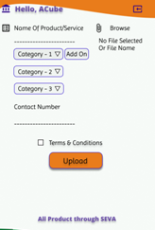

1. On bottom Line or where is suitable two TAB is required one is Subscription Plan & Product Library
2. After uploading separate acknowledge page for 3 month free subscription i.e for Main Highlight or Product Library will reflect based on city selections according to seller or other.

I agree or Select Accepted button

1. After completing of free subscription of 3 month: Auto Popup message of subscription renewal will send to seller 1 week before of completion date.
2. Seller or other will continue plan with choosing plan selection after that acknowledge page of charges i.e for Main Highlight or Product Library will reflect based on city selections according to seller or other will selected and plan duration selection Monthly, Quarterly & Yearly

I agree or Select Accepted button

1. After accepting of plan acknowledge page, Final charged page will come

For Main Highlight: Name of product i.e. key word, Time Duration of video (Not maximum of 3 min), reference no., plan duration (Monthly, Quarterly & Yearly) apply any redeem code (System generated) if applicable or provided by Ours. After that amount will be calculated.

For Product Library: Time Duration of video (Not maximum of 1 min), reference no., plan duration (Monthly, Quarterly & Yearly)

And then Proceed to pay xxxx/- (calculated amount) with payment integration

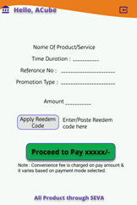 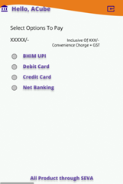

* 1. For Buyer Main or Guest Page

1. Upper Left corner Home icon with Hello, (Buyer Name) on same line location will come with icon through GEO location set by him or default, Chat box icon (Use chat with seller)and Upper Right corner list button or icon



1. Below Home icon-Language option or drop down: On click English, Hindi will come at present after that on the basis of language every text will convert
2. Below Language option- Select range location 1 to 5 km through GEO location set by him or by default search city or product (Name is Aaas Pass)
3. On same line range location search option is available for buyer (City or product both way to search)
   1. For Seller or Retailer or Wholesaler or Service Main Page

On click on home icon following option will come:-

1. Profile with icon

2. Sell by category with icon

3. Product Library with icon (As uploaded 1 or more)

4. Product Report Card with icon (As uploaded 1 or more)

5. Notification with icon (Recommended as searched previously items)

6. Setting with icon (Change language option, theme dark or light)

7. SEVA Service Support & Help with icon

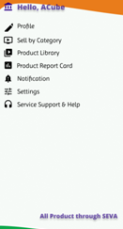

* 1. For Buyer Main Page

On click on home icon following option will come:-

1. Profile with icon

2. Shop by category with icon

3. My Wish List with icon (As searched)

4. Notification with icon (As per searched item or recommendation)

5. Setting with icon (Change language option, theme dark or light)

6. SEVA Service Support & Help with icon

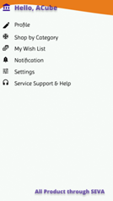

* 1. On click on Profile icon or text - Seller Buyer go to page 4 i.e point no.4
  2. On click on Sell by category icon or text - Seller go to point no.5 (iii) B & C
  3. On click on Buy by category icon or text - Buyer can select go to point no.6 (iii) & (iv)
  4. On click on Product Library icon or text - Seller past uploaded video i.e Main Highlight video or images & other video if upload in product library i.e. point no.5 (iii) B & C
  5. On click on Product Report Card icon or text – Seller can review their product Main Highlight video performance one by one if saved removed video also i.e. like, comment, seen, share to other count, rating etc
  6. On click on Notification icon or text for Seller – Buyer like, comment, chat box message (One to One with buyer), Plan renewal or any recommendation video etc
  7. On click Setting icon or text – Language, theme etc
  8. On click on Service Support & Help icon or text – Contact no APP team, Through message, Report video etc
  9. On click on My Wish List icon or text – Last seen product video etc
  10. For Seller or Retailer or Wholesaler or Service or Buyer Main page

On click on Upper Right corner list button or icon following option will come:-

1. Reward with icon

2. Payment Receipt with icon

3. Refer to Friend with icon

4. Change Type with icon

5. Change Password with icon

6. About Us with icon

7. Log Out with icon

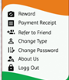

* 1. On click on Reward icon or text - Small page in which Redeem Point & Unique Code system generated for 9 dight which fix or assign to every registered account at the time starting format YYMMDD<AtoZ,a to z, 0to9><AtoZ,a to z, 0to9><AtoZ,a to z, 0to9>.

Also Transfer to Seller option i.e. registered mobile number

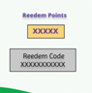

1. For buyer: For every view of any product video (one time) we will reward some 99point or 11paise in their account. Buyer can redeem through code with any seller on purchase through discount by transferring code option through registered mobile number of seller or directly take in account also.

After transferring point or paisa will be add on seller account reward.

1. For Seller: Received buyer rewards i.e points or paisa in their account. He will use this reward on next plan renewal (50% only) by using his Unique Code of 9 dights.
   1. On click on Refer to Friend icon or text - Small page in which Friend Name option & mobile no or mail ID option and share button or share multiple option like whatsup etc

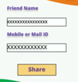

* 1. On click on Change Type icon or text – Seller or Retailer or Wholesaler or Service or Buyer go to page 3 i.e point no.3
  2. On click on Change Password icon or text - Small page in which Set New Password option, Confirm Password option and Submit button.

