The Computer Artist

Description
In this assignment, you will get the computer to draw a masterpiece using the Turtle library. The masterpiece will consist of at least 5 different objects. There will be one main object that is fairly complex. The other objects are used for decoration. For at least three of the remaining objects, the user can specify how many the user wants the computer to draw.

Example
In the example below, the boat is the main object. We have the water as another object. The three objects the user can decide how many to have is the clouds, the fish, and the jellyfish.

input:  # of clouds: 2  # of fish: 1  # of jellyfish: 3 | input:  # of clouds: 3  # of fish: 10  # of jellyfish: 1
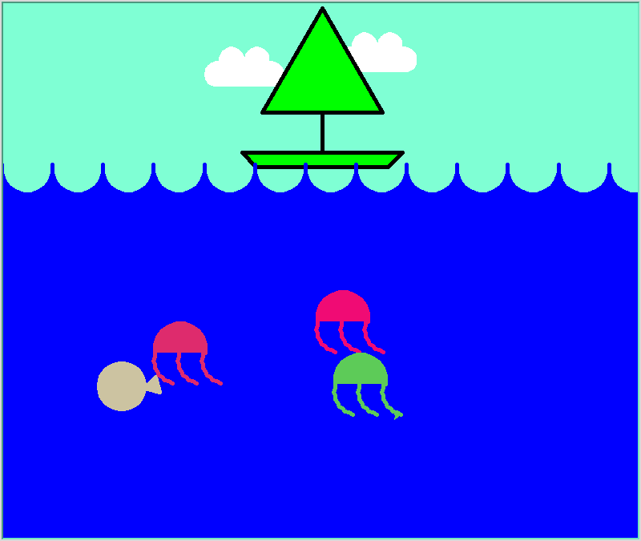 | 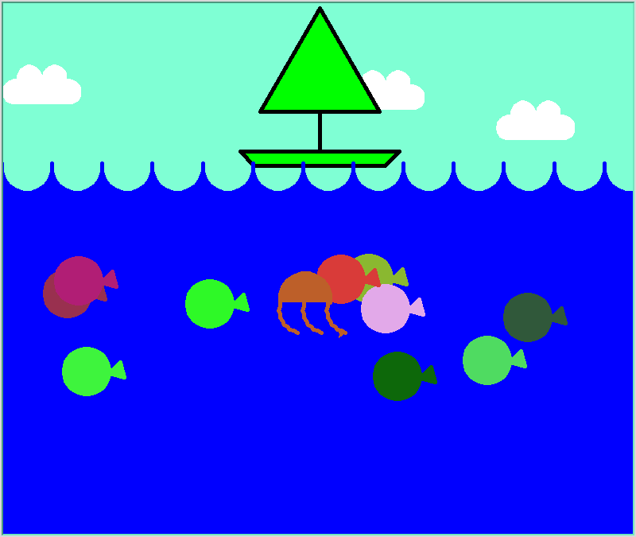

This is just an example. You are required to make your own picture with your own theme. Use your own creativity.

Technical Information
- use the random library in Python to generate random numbers
  - from random import *
  - randint(a,b) # computer picks a random integer from a to b inclusive
  - example: randint(1,5) will return an integer from 1 - 5
- to make the turtle window stay open, put an input() command at the end of your program
  - print("Press enter to exit")
input()
- Turtle Library Documentation
  - https://docs.python.org/3.3/library/turtle.html

Shape Complexity

Simple |  |  | Complex
 |   Source: https://openclipart.org/detail/244462/sunblackwhite | 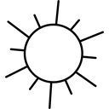  Source: https://www.shareicon.net/day-sunny-summertime-summer-weather-sunshine-731333 | 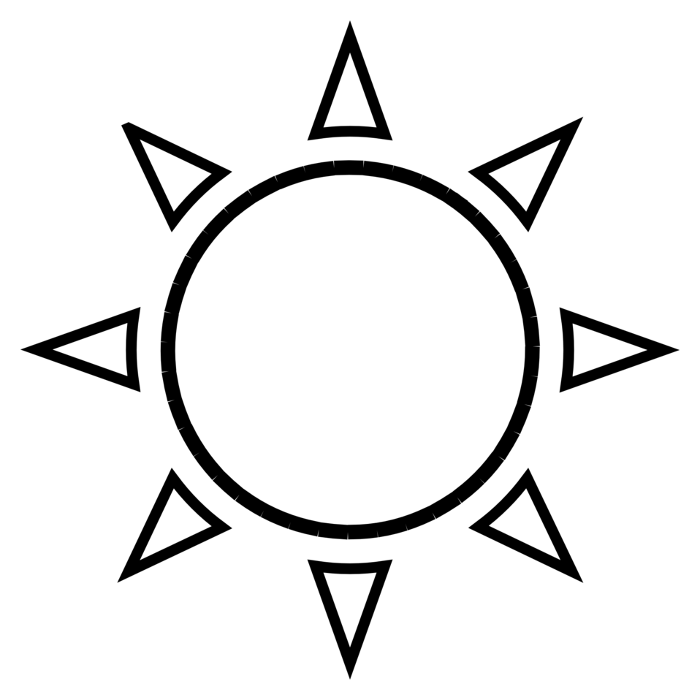  Source: http://www.publicdomainfiles.com/show_file.php?id=13920081617194

