Computer Graphics Lab

The graphics library we are using is name Doodlepad (https://doodlepad.org/)
It is contained in a file called doodlepad.jar
The website contains the API, documentation, and some example programs.

Compiling and running:
Place doodlepad.jar in the same directory as your java files.
To compile, we must add doodlepad.jar to our classpath as follows:
Windows | Mac and Linux
javac -cp .;doodlepad.jar MyJavaFile.java | javac -cp .:doodlepad.jar MyJavaFile.java

The period (.) means the current directory you are in your command line (which should be the same as the java file)

Similarily, to run, we also add doodlepad.jar to the classpath as follows:
Windows | Mac and Linux
java -cp .;doodlepad.jar MyJavaFile | java -cp .:doodlepad.jar MyJavaFile

If you’re compiling in an IDE, refer to your IDE documentation on how to add a jar file.

Part 1: Country Flags

Draw the following country flags

 |  |  | 
Germany | Faroe Islands | Tanzania | Burma

Part 2: Letter Distribution  Create a program that reads a text file and counts the number of occurrence of each letter. Create a bar graph like the one to to the right to show the letter distribution as pictured on the right.  Note that you should count both upper case and lower case occurrences.  Challenge:  Can you make the bar graph where the bars are vertical instead of horizontal? | 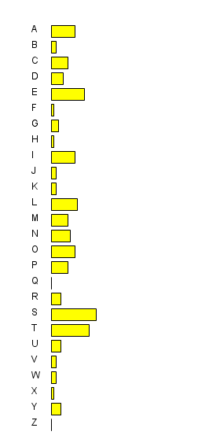

Part 3: Simple Maze
In this exercise, you will create a simple maze game. First, you will create a map in a text file as follows:
0 – empty block
1 – a wall
2 – the starting location
3 – the ending location
An example map is below:
11111211111111  10000000000001  11110111011101  11110000011101  11111110111001  11111010111011  11111000111003  11111111111111  In the map pictured to the right, the starting position is red, the end position is green, walls are gray, the path is white, and the player is purple. | 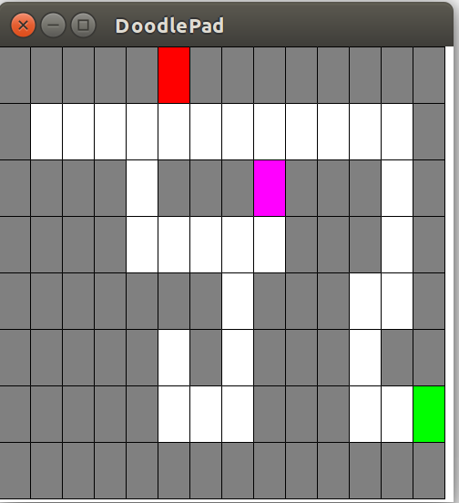

Load the map into your Java program.
To move your character, refer to this page: https://doodlepad.org/position_size.html

Hint: You should use a 2D array to model the map in your program.

