
HiveMind
Reading the market: a plain-English guide to the dashboard

What each number means, how the opportunities are scored, what backs them, how the forecast works, and how to use all of it to make decisions.
Written for business leaders. No technical background needed.
Figures and screenshots in this guide are taken from the live system on 28 October 2026, when it held three days of news history. Numbers will move as the history grows.

What is inside
1. The short version what HiveMind is, in one page
2. What makes it different six things most news tools do not do
3. How to use it: a ten-minute routine from the bell to a decision
4. The ideas behind the numbers attention share, momentum, acceleration, origins and the rest, in plain words
5. How an opportunity is built and scored the six ingredients, the weights and the action rules
6. What backs each opportunity the evidence you can check yourself
7. How the forecast works and how far to trust it
8. A walk through every screen with screenshots and how to read each one
9. A worked example one opportunity read from top to bottom
10. Limits and cautions what the system cannot tell you
11. Glossary every term on one page

1. The short version
HiveMind watches the Indian news so that you do not have to. Every hour it collects the stories published by 19 trusted sources (major newsrooms, business and trade papers, and official bodies such as the RBI, SEBI, PIB and the weather department). It reads each one from its headline and summary (which keeps running costs low), works out who is affected and how, and measures which subjects are gaining attention faster than normal.
It then asks a business question: for each client or business unit we serve, which of those rising subjects matters, and is now the right moment to act? The answer appears as a ranked list of opportunities, each with a score out of 100, a suggested action, and the evidence behind it.

What it tells you
- What is gaining attention in the news, and how fast.
- How solid the signal is: how many separate sources report it, whether an official source has confirmed it, how much history we have.
- Which of your sectors it touches, and a suggested angle or question to act on.
- When to move: a suggested window (for example, the next 24 to 72 hours).
- Whether past recommendations came true, once enough time has passed to check.

What it does not tell you
- It does not predict the future with certainty. The score ranks opportunities; it is not a probability.
- It does not see the whole market. It sees what 19 sources publish, which is a strong but partial picture.
- It does not replace judgement. It tells you where to look first and why; people decide what to do.

The one-sentence summary
HiveMind turns thousands of headlines into a short, ranked, evidence-backed list of what is heating up, what it means for each client, and when to act, and it keeps score on itself.

2. What makes it different
Plenty of tools count headlines. HiveMind is built around six ideas that change how the numbers should be read.
The idea | What it means for you
1. It measures share of attention, not counts | A busy news day makes every topic look bigger. HiveMind instead asks: what slice of all coverage does this topic take, compared with its normal slice? A topic only looks hot if it is growing faster than the news as a whole.  Think of market share, not sales volume.
2. It counts independent voices, not copies | Ten websites repeating one wire report are not ten confirmations. Outlets under the same owner count once; a wire agency (PTI, ANI) counts once however many sites reprint it. The dashboard shows independent origins, the number that actually tells you how widely a story is confirmed.
3. It reads for real-world impact, not keywords | Each story is read once by an AI model that records what happened, who is affected (for example, coastal fishing communities, auto makers, retail borrowers), how severe it is, and over what time frame. Topics are then tracked by what they mean, not by the words in the headline.
4. It connects the news to each client | The same rising topic matters differently to a bank, a carmaker and a retailer. Each client has its own sector lens, and every opportunity is a pairing of a client sector with a news topic, with a suggested angle.
5. Every number shows its working | Each score can be opened to see its six ingredients. Each stage (rising, crowded...) states the rule that put it there. Each action says what is missing. Each recommendation states what would make it wrong. Nothing is a black box. Data-quality checks run continuously and hold back "write now" if the data is unhealthy.
6. It is honest about uncertainty | Forecasts are labelled unvalidated until proven. Missing data is shown as missing, never as zero. Every recommendation is logged and checked 72 hours later, so the system keeps a public scoreboard of its own hit rate.

Why this matters
Most news dashboards answer "what is being talked about?" HiveMind answers "what is starting to be talked about, how sure are we, and what should we do about it?" The difference is in the measurement: share of attention, independent sources, and a standing check on its own accuracy.

3. How to use it: a ten-minute routine
You do not need to explore every screen. This routine covers what most leaders need.

Every morning (about ten minutes)
- Check the bell (top right). It lists what happened overnight: collections finished, anything that failed, and any service that needs attention such as a credit running out. A red dot means something to look at.
- Read the Overview. The six boxes at the top give the state of play. Under "Today's priorities" are the six best opportunities for your client.
- Open the top opportunity by clicking its row. Read "Why now", look at the score breakdown, and glance at the momentum chart.
- Check the evidence. Click the origins number to see which independent sources reported it, with links. If you would not trust those sources, do not trust the signal.
- Decide using the action label: "write now" means act; "investigate" means have someone close the gaps listed under "Signals still missing"; "monitor" means watch; "skip" means leave it.

Every week (about twenty minutes)
- Open Trends, then Sentiment to see which sectors are turning more positive or more negative.
- Open Trends, then Entities to see which companies, people or places are suddenly in the news more.
- Open Accuracy to see how past recommendations turned out. This is the page that tells you how much to trust the rest.
- Open Settings, then Usage to check that spending on outside services is within budget.

A rule of thumb
Treat the score as where to look first, and the evidence panel as whether to believe it. A high score with thin evidence (few origins, no confirmation) is a prompt to investigate, not to commit.

4. The ideas behind the numbers
Every metric on the dashboard comes from a handful of ideas. Once these are clear, every screen reads naturally. Each idea below has a plain definition, an everyday comparison and an example from the live system.

Story
A story is one real-world event, however many outlets report it. Near-identical headlines from different sites are merged. Example: the same Tata Motors and Amazon electric truck announcement appears in several papers; it counts as one story.

Independent origins
The number of separate reporting sources behind a topic. Outlets owned by the same group (for example, Times of India and The Economic Times are both the Times Group) count as one. Wire copy such as PTI or Bloomberg counts as one. Official bodies such as the RBI count as their own origin.
Why it matters: this is the closest thing to "how many people independently confirmed this". Example: the electric-vehicle topic is backed by 10 independent origins, including the Times Group, The Hindu Group, HT Media, NDTV and a Bloomberg wire story.

Coverage share
The slice of all collected stories that are about this topic, over a recent window (12 or 24 hours). Example: 0.8% means roughly 8 of every 1,000 stories are about it. Using share instead of a raw count means a day when the whole news volume doubles does not fake a trend.

Baseline
The topic's normal share, measured over the previous seven days. It answers "compared with what?". If the system has only 41 hours of history, it says so ("41h of 168h") and treats momentum as rough. The target is seven days; the longer the history, the better the baseline.

Momentum
Recent share divided by baseline share. It is the speedometer of attention. 1.0x is business as usual; 2x means the topic is getting twice its normal share; 0.5x means it has gone quiet.
Example: electric-vehicle manufacturing has a recent share of 0.8% against a baseline of 0.1%, so momentum is about x6.8. A small safeguard stops tiny numbers misleading: going from one story to three is not read as x3.

Acceleration
Is momentum itself speeding up or slowing down? It compares the current momentum with the previous step (12 hours earlier). It is shown on a doubling scale: +1 means momentum has doubled since the last step; -1 means it has halved; 0 means no change.
Example: momentum was x0.87 (a little below normal) and is now x6.84. That is roughly eight-fold in one step, which is an acceleration of +2.97. Momentum tells you where the topic is; acceleration tells you which way it is moving.
Speedometer and accelerator
Momentum is how fast attention is moving right now. Acceleration is whether it is pressing harder or easing off. A topic with high momentum and negative acceleration is a story that has peaked.

Stage (the lifecycle)
Each topic is placed in one of six stages by a written rule, so the label is never a matter of opinion.
Stage | The rule, in plain words
Watchlist | Too little to judge: under 3 stories, fewer than 2 independent origins, or too little history for a baseline.
Emerging | Momentum is 1.3x or more, but starting from a small share of coverage, and not yet sustained over two steps. Early, and the most interesting for getting ahead.
Rising | Momentum is 1.3x or more and has held for two steps, so it is a sustained increase, not a one-off spike.
Steady | Momentum between 0.8x and 1.3x. Normal, not changing.
Crowded | Already among the top quarter of topics by share and no longer accelerating. Everyone is writing about it, so a fresh angle is harder.
Declining | Momentum at 0.8x or less for two steps in a row, or 0.6x or less at once. Attention is fading.

Verified trigger
A recent story that counts as confirmed: it comes from an official source (such as the RBI, SEBI, PIB or the weather department), or it is reported by at least three independent origins. A trigger is the news event that gives you a reason to act now. Example: "Tata Motors, Amazon partner to deploy 3,000 electric trucks" is a verified trigger for the electric-vehicle topic.

Evidence strength
Level | What it requires
High | 5 or more independent origins and at least 72 hours of history.
Medium | 3 or more independent origins and at least 24 hours of history.
Low | Anything less. The topic may be real but is thinly supported.

Headline reading. To keep running costs low, each story is read from its headline and summary rather than the whole article. A headline is short, so the evidence rules lean on what can be checked independently: how many separate sources report it, whether an official source confirms it, and how much history exists. A second AI model double-checks the readings behind the top opportunities, and a person can spot-check a weekly sample.

Impact breadth
How many different areas of life the stories touch: markets, the economy, governance, people, and so on. A topic touching seven areas is spreading beyond one beat and is likely to matter to more clients than one touching a single area.

Sentiment
The tone of the coverage (positive, negative, neutral or mixed) and whether it treats the main actor as supportive or critical. Net sentiment is positive stories minus negative stories, as a share of all labelled stories: +1 is entirely positive, -1 entirely negative, 0 balanced. It measures how the press is writing, not how the public feels.

5. How an opportunity is built and scored

What an opportunity is
An opportunity is a pairing of a client sector with a news topic, for example "Industrial Goods x ev manufacturing". It comes with a suggested question or angle to act on. The same topic can appear against several sectors; by default the dashboard shows each topic once, with its best sector, and a "+9 more sectors" button for the rest.
The link between topic and sector is judged by an AI model that is given the client's sector descriptions and the topic's recent stories. For each sector it gives a relevance from 0 to 1, says whether the link is direct or indirect, and writes a suggested angle.
Each leading rising topic is judged directly, using that topic's own stories, so the angle is written for the topic and not borrowed from its broader area. A topic that has not been judged yet inherits the link of its broader area, and the dashboard labels it "Pairing inherited: hypothesis". A topic is only paired with a sector it genuinely belongs to: if its stories are spread across unrelated areas it is shown in Trends but not paired with any sector.

The six ingredients of the score
The score out of 100 is the sum of six parts. Each part is first rated 0 to 100 on its own, then weighted.
Ingredient | Weight | How it is rated
Momentum | 25 | How far above normal the topic's share is. Reaches full marks at about 4x its baseline; zero at 1x or below.
Acceleration | 15 | Whether momentum is speeding up. 50 means steady; full marks at +1.5 or more (momentum nearly tripling per step); lower if slowing.
Independent sources | 15 | How many separate origins report it. Full marks at 8 or more.
Sector evidence | 20 | How relevant the topic is to this client's sector (0 to 1), judged directly for the topic. A little lower when the link is only inherited from the broader category.
Trigger timing | 15 | How fresh the verified trigger is. Full marks within 24 hours, fading to 60 at 72 hours and to zero after a week. Halved if the trigger is not verified.
Editorial headroom | 10 | Room for a fresh angle: the less crowded the topic, the higher. Capped low for crowded and declining topics.

The weights (25, 15, 15, 20, 15, 10) are starting assumptions, not proven truths. The Accuracy screen tests them against real outcomes and can suggest changes, which are applied only when a person confirms them.

From score to action
The score ranks opportunities. A separate set of rules turns it into one of four actions, so that a high score alone never triggers "write now".
Action | When it applies
Write now | Every one of these is true: score of 65 or more; evidence at least medium; the topic is rising or emerging; headroom of 40 or more (room for a fresh angle); a verified trigger within the last 7 days; a supported sector link (judged for the topic, relevance 0.5 or more); at least 72 hours of history; at least 4 independent origins; and data quality not in the red.
Investigate | Score of 50 or more and promising, but at least one of the conditions above is missing. The dashboard lists exactly which ones, under "Signals still missing".
Monitor | Score of 35 or more, or too little evidence for a forecast: the topic stays on the watchlist.
Skip | Score below 35, or the topic is declining, or it is crowded with little headroom.

Why "write now" is rare, and why that is on purpose
At the time of writing the system shows 0 write now, 189 investigate, 87 monitor and 470 skip. The leading opportunity (score 87) is held back by two conditions: it has only 42 hours of history against the 72 required, and its headroom is about 11 against a required 40 because the topic already takes a large share of coverage. A strict "write now" label means you can act without a second look. It is meant to be uncommon.

6. What backs each opportunity
Every opportunity can be opened to show its support. These are the things to check before acting.

1. The sources
Only 19 approved sources are collected: the main national newsrooms, business and trade titles, and official sources (PIB, RBI, IMD and SEBI). Ownership groups and wire services are tracked so that copies are not mistaken for confirmation. Click any origins number to see who they are, how many stories each contributed, and links to the stories.

2. The independence of the coverage
The count of independent origins, not outlets. Eight outlets from one group is one origin. This is why a topic with ten origins is a much stronger signal than one with ten repeated headlines.

3. A verified trigger
An official source or three or more independent origins. The trigger is named on the opportunity ("Why now") with a link, so you can read it yourself.

4. A pairing judged for the topic
The sector link and the suggested angle for each leading topic are judged from that topic's own stories (relevance 0 to 1), not inherited. The chip on each row says whether the pairing was judged or inherited.

5. Enough history
The baseline is the yardstick for "normal". Right now the system holds about three days of news, against a seven-day target, and says so on every opportunity ("Short baseline: 41h of the 168h target"). This is the main reason to treat today's scores as indicative. Each day of collection makes them firmer.

6. The review condition
Each opportunity states what would make it wrong, for example: "Revise or withdraw if the trigger story is corrected or reversed, or if momentum falls below 1.0x for two consecutive 12-hour steps." This is your signal to stop acting on it.

7. A running scoreboard
Every recommendation is logged with its time and reasons. Seventy-two hours later it is checked against what actually happened. The Accuracy screen shows the hit rate. The first results arrive about three days after the first recommendation (around 30 October 2026).

8. A second opinion and a human check
A stronger AI model re-reads the stories behind the top opportunities and says whether it agrees with the first reading (for example, 8 of 10 agreed in the latest check). A person can also review a weekly sample on the Audit screen; the accuracy of those checks is shown against a 90% target.

9. Clean data
Repeated stories and template pages (topic landing pages, scoreboards) are found and left out of the analysis, never deleted. A set of data-quality checks watches for quiet sources, thin history, duplicates and unreliable readings, and holds "write now" back if the data falls below a safe threshold.

A quick credibility check in 60 seconds
Open the opportunity. (1) Click the origins number: are the sources ones you trust and are they genuinely different? (2) Read the "Why now" trigger. (3) Look at "Signals still missing". If all three look sound, the opportunity is well founded.

7. How the forecast works
There are two layers of looking forward, and it helps to keep them apart.

Layer 1: the stage tells you direction
The lifecycle stage (emerging, rising, steady, crowded, declining) says which direction a topic is moving and how far it has got, using the rules in Section 4. This is the main guide to timing.

Layer 2: the dashed forecast line tells you the likely level
On every momentum chart a dashed orange line extends the topic's coverage share into the near future, with a shaded band around it.
- How the line is drawn. The system takes the recent smoothed share, measures its direction and speed, and extends it forward. Because trends do not continue forever, it gradually flattens the line (each step carries 90% of the previous step's momentum). That is why the line curves toward a level instead of shooting upward.
- What the band means. The shaded area is an 80% range: based on how far the method has been off in the past, about four times in five the real value should land inside it. A wide band means the topic has been erratic.
- How far ahead. About 24 hours in the hourly view and 5 days in the daily view.
- When it switches on. Only when there is enough clean history (at least 24 hourly points). Otherwise the dashboard says why it is not shown.
- Below the chart a single sentence puts the numbers into words, for example: "Coverage is x6.8 its baseline and still accelerating; the forecast falls towards 0.1% share. Treat as unvalidated."

Why it says "unvalidated"
The method is a standard, well-understood way of extending a trend. But whether it predicts this particular news world well has to be proven with evidence, and three days of history is not enough to prove it. So the label stays until the scoreboard supports it.

How the system will prove (or disprove) itself
Check | What it does
Live hit rate | Each logged recommendation is checked 72 hours later. A hit means the topic's coverage share reached at least twice its previous seven-day level, with at least five independent origins. The hit rate is shown overall, by action type and by score band.
Backtest | Replays past days using only what was known at the time and checks the next 72 hours. Needs at least ten days of history.
Weight tuning | Tests alternative weightings of the six score ingredients against the recorded outcomes, and only suggests a change if it helps on both the older and the newer half of the history. Nothing changes until a person approves; the old weights are kept.
Forecast accuracy | Every few hours the system records what the dashed line says for the leading topics. Later it compares each with what actually happened: the 80% band should hold about 80% of outcomes, and the forecast should beat simply repeating the latest value. Both results are shown on the Accuracy screen.
Weekday adjustment | Some subjects are always bigger on certain days (sport at weekends, markets on weekdays). After four weeks of history the system learns each topic's usual weekday pattern, so an ordinary Monday peak is not mistaken for a rising topic.

Where things stand today
History: about 3 days (backtest needs 10; weekday adjustment needs 28). Recommendations logged: about 240, none yet old enough to judge. Forecast status: unvalidated. All of these improve automatically as the system collects hourly.

8. A walk through every screen
The left-hand menu has six main areas and two utilities. Some areas have tabs along the top. Small round "i" buttons throughout the dashboard open a plain-language explanation of the nearby number.
Menu item | What it is for
Overview | The one-page summary for leaders: state of play and today's best opportunities.
Opportunities | The full ranked list, with filters, and a detail panel for each opportunity.
Trends | Topics, Sectors, Entities and Sentiment: how coverage is changing over time.
Clients | Company lens (how the news reaches each sector) and client set-up.
Sources | Where the news comes from and how healthy collection is; the journalist directory.
Accuracy | How well past recommendations performed, and how every number is calculated.
Guide / Settings | Built-in system guide; keys, run logs, usage and system settings.

8.1 Overview
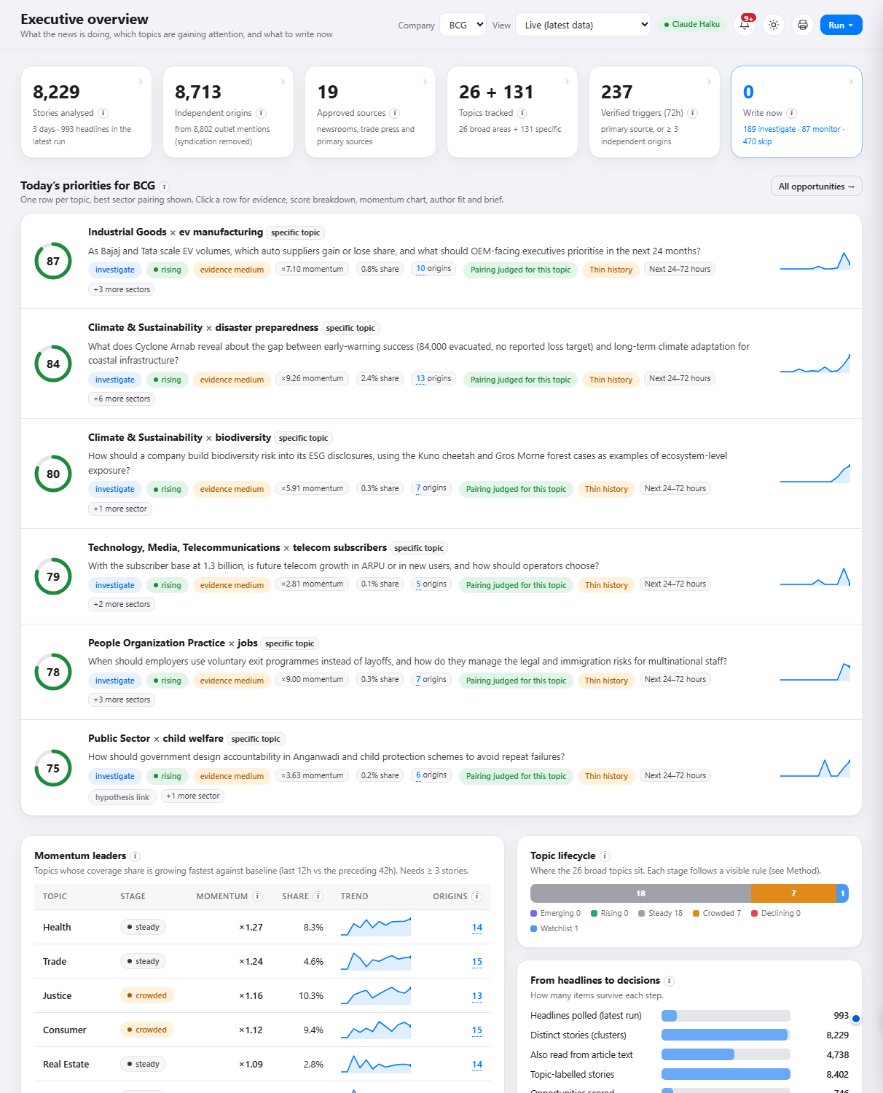
Figure 1. The Overview screen
The six boxes across the top, each clickable to jump to the detail behind it:
Box | Meaning
Stories analysed | Distinct stories in the database (8,229 over three days, with repeats and template pages removed). The small print shows headlines collected in the latest run.
Independent origins | Separate sources behind the coverage after removing copies (8,713 from about 8,800 outlet mentions).
Approved sources | The 19 sources the system is allowed to collect from.
Topics tracked | 26 broad areas plus 131 specific topics that have enough independent coverage to be judged.
Verified triggers (72h) | Recent stories confirmed by an official source or three or more origins. These are the events that give a reason to act.
Write now | How many opportunities meet every condition, with the investigate, monitor and skip counts beneath.

Today's priorities lists the best six opportunities. Each row shows the score ring, the action, the stage, momentum, share, number of independent origins, the evidence level, the suggested window, and a small trend line. Momentum leaders ranks broad areas by how fast their share is growing. Topic lifecycle shows how many areas sit in each stage. From headlines to decisions shows how many items survive each step, from raw headlines to "write now". Data confidence explains why to read scores with care (history depth, full-text share, collection timeliness).
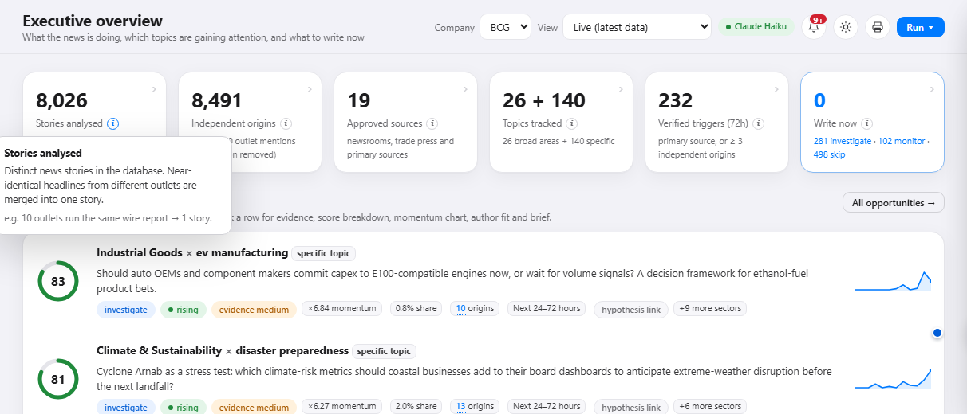
Figure 2. The round "i" button opens a plain-language explanation with an example

8.2 Opportunities
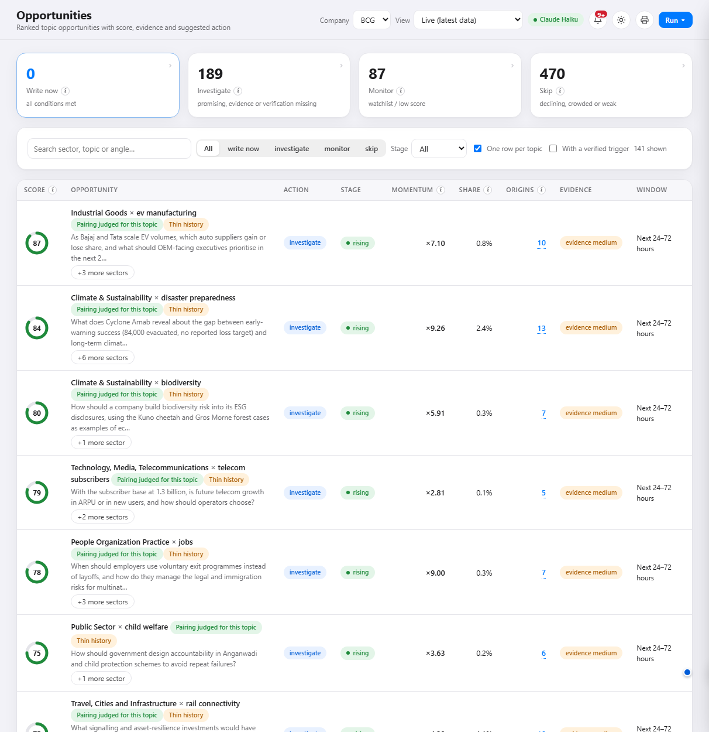
Figure 3. The ranked opportunity list

What you are looking at
The full ranked list of client-sector and topic pairings, best first. The four boxes at the top count the actions. Below them are a search box, action and stage filters, a "one row per topic" switch, and a "with a verified trigger" switch. The list is paged.

How to read it
- Score ring: 0 to 100, higher is more attractive. Not a probability.
- Action and stage: what to do and where the topic is in its lifecycle.
- Momentum and share: how far above normal, and how big a slice of coverage.
- Origins: independent sources; click the number to list them.
- Evidence: high, medium or low (Section 4).
- Window: when to act, such as "Next 24 to 72 hours".
- +N more sectors: the same topic also matters to other sectors.
- Pairing chip: green "Pairing judged for this topic" or grey "Pairing inherited: hypothesis".
- Amber flags: short warnings such as "Thin history" or "Few independent origins"; they explain why a promising row is not yet "write now".

How to use it
- Filter to "write now" and "investigate" for the shortlist.
- Search for a sector or subject you care about.
- Switch on "with a verified trigger" to see only opportunities with a confirmed reason to act.
- Click any row to open the detail panel.

The opportunity detail panel
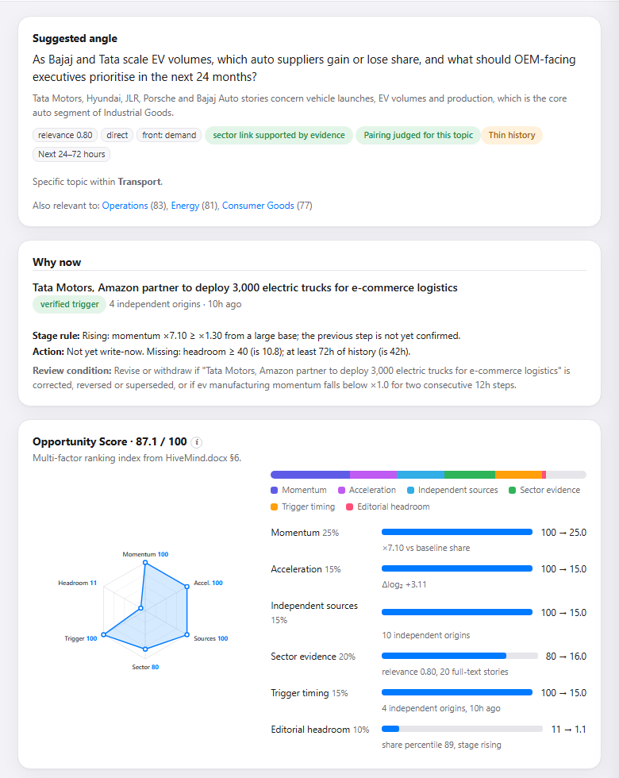
Figure 4. Detail panel, top half: suggested angle, why now, score breakdown
- Suggested angle: the question or decision to act on, written for the sector.
- Why now: the verified trigger story, how many origins confirm it, its age, the stage rule, and which action conditions are still missing. The review condition states what would make the opportunity obsolete.
- Opportunity score: the six ingredients as a radar chart and as bars, each showing its rating and the points it contributed. In this example: momentum 25.0, acceleration 15.0, sources 15.0, sector evidence 11.9, trigger timing 15.0, headroom 1.0, which add up to about 83.
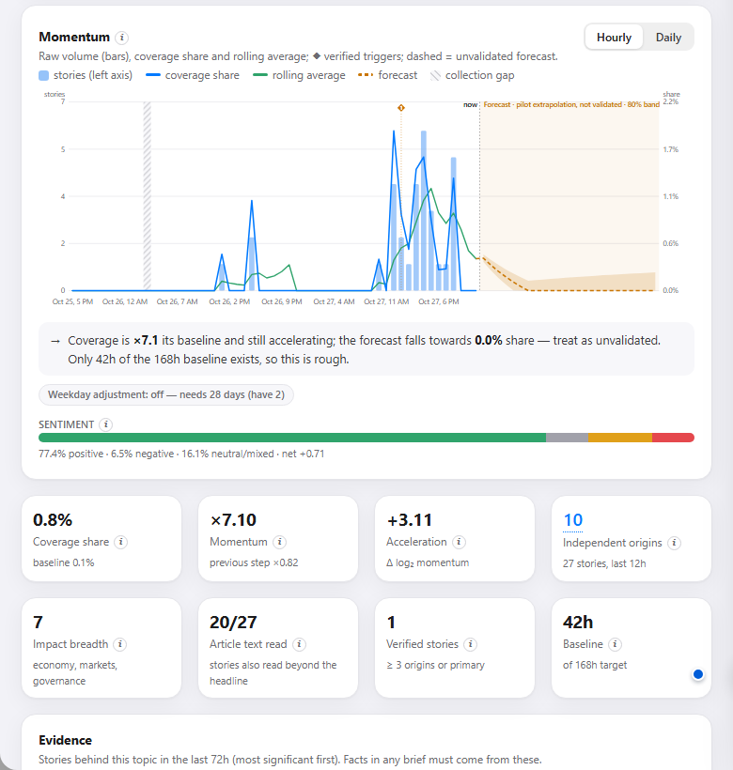
Figure 5. Detail panel, lower half: momentum chart, one-line reading, sentiment strip and metric cards
- Momentum chart: blue bars are story counts, the blue line is coverage share, the green line a smoothed average. Diamonds mark verified triggers; hatched bands mark gaps in collection; the dashed orange area is the unvalidated forecast.
- One-line reading underneath turns the numbers into a sentence.
- Sentiment strip: share of positive, neutral/mixed and negative stories. Here 77% positive and 6.5% negative (net +0.71).
- Metric cards: coverage share, momentum, acceleration, independent origins, impact breadth, full-text stories, verified stories and baseline depth.
Further down the panel are the evidence stories behind the topic, journalists whose beat fits, and a button to draft a brief (a short write-up for an editor to review before anything is used).
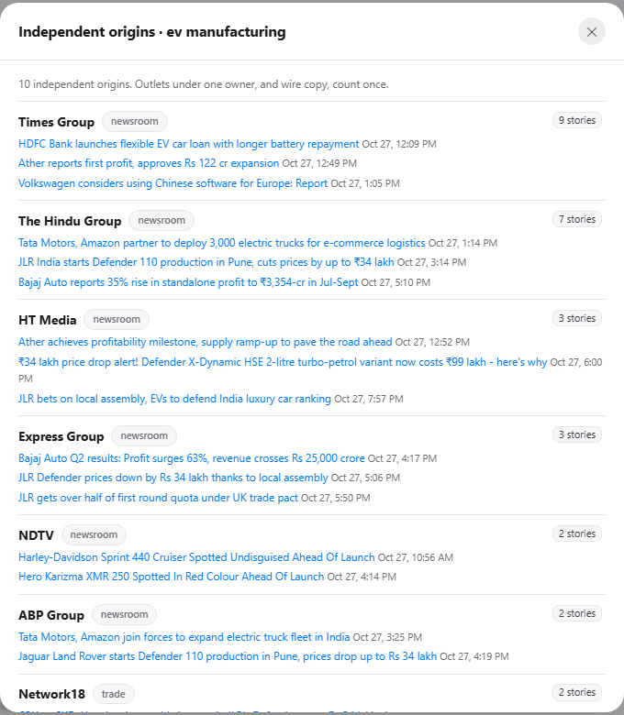
Figure 6. Clicking an origins number lists the independent sources and their stories

8.3 Trends

Topics
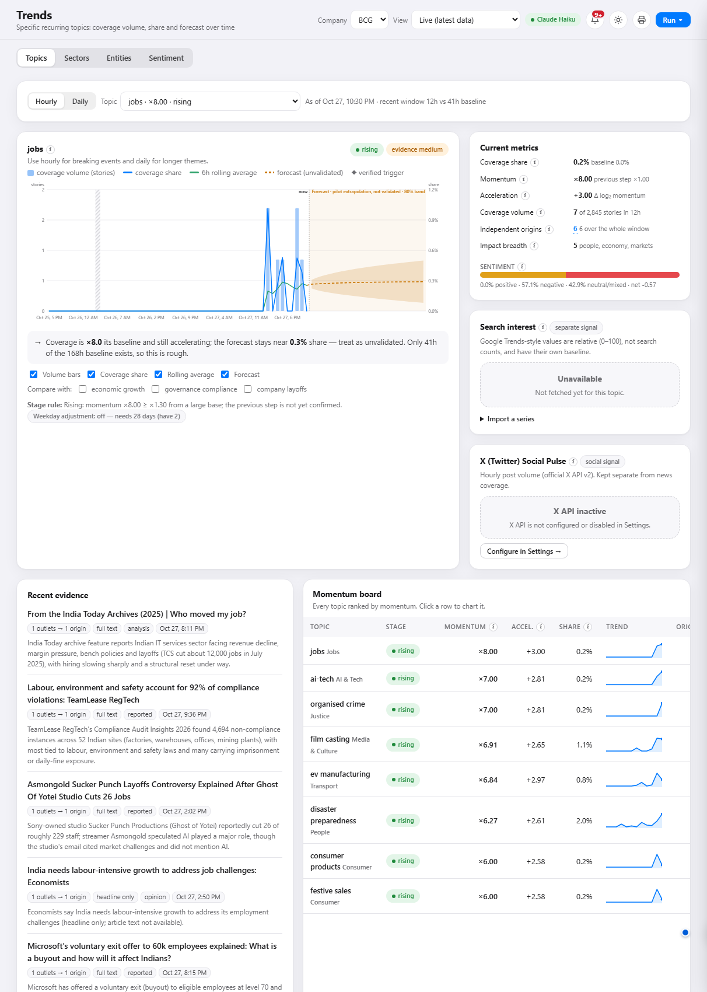
Figure 7. Trends, Topics: the momentum chart for one topic with the full metrics and a ranked board

What you are looking at
The same momentum chart as in the detail panel, for any topic you choose, with an hourly or daily view. Alongside are the current metrics, a search interest box and an X (Twitter) pulse box. Underneath are recent evidence stories and the momentum board that ranks every topic by momentum.

How to read it
- Use Hourly for breaking events and Daily for longer themes.
- The momentum board shows momentum, acceleration, share and a trend line for every topic; click a row to chart it.
- Search interest shows how much people are searching on Google (a relative 0 to 100 scale). It is kept separate from news coverage and is never filled with zeros: if it has not been fetched, it says "Unavailable".
- X pulse works the same way once an X access key is added in Settings.

How to use it
- Use it to understand the shape of a trend: a sudden spike, a slow build, or a fade.
- Tick "Compare with" to overlay related topics.

Sectors
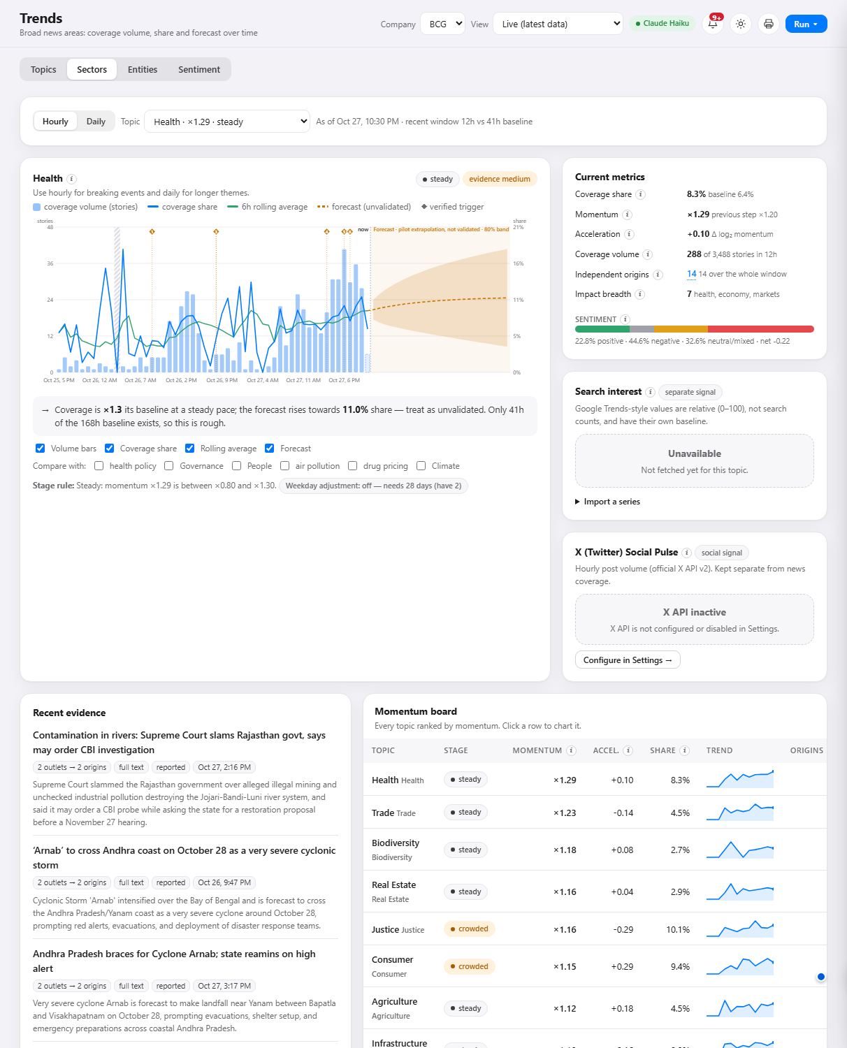
Figure 8. Trends, Sectors: the same view for the 26 broad news areas
The same screen at the level of broad areas such as Health, Trade, Energy or Finance. These are steadier and move more slowly than specific topics, so they show the big shifts.

Entities
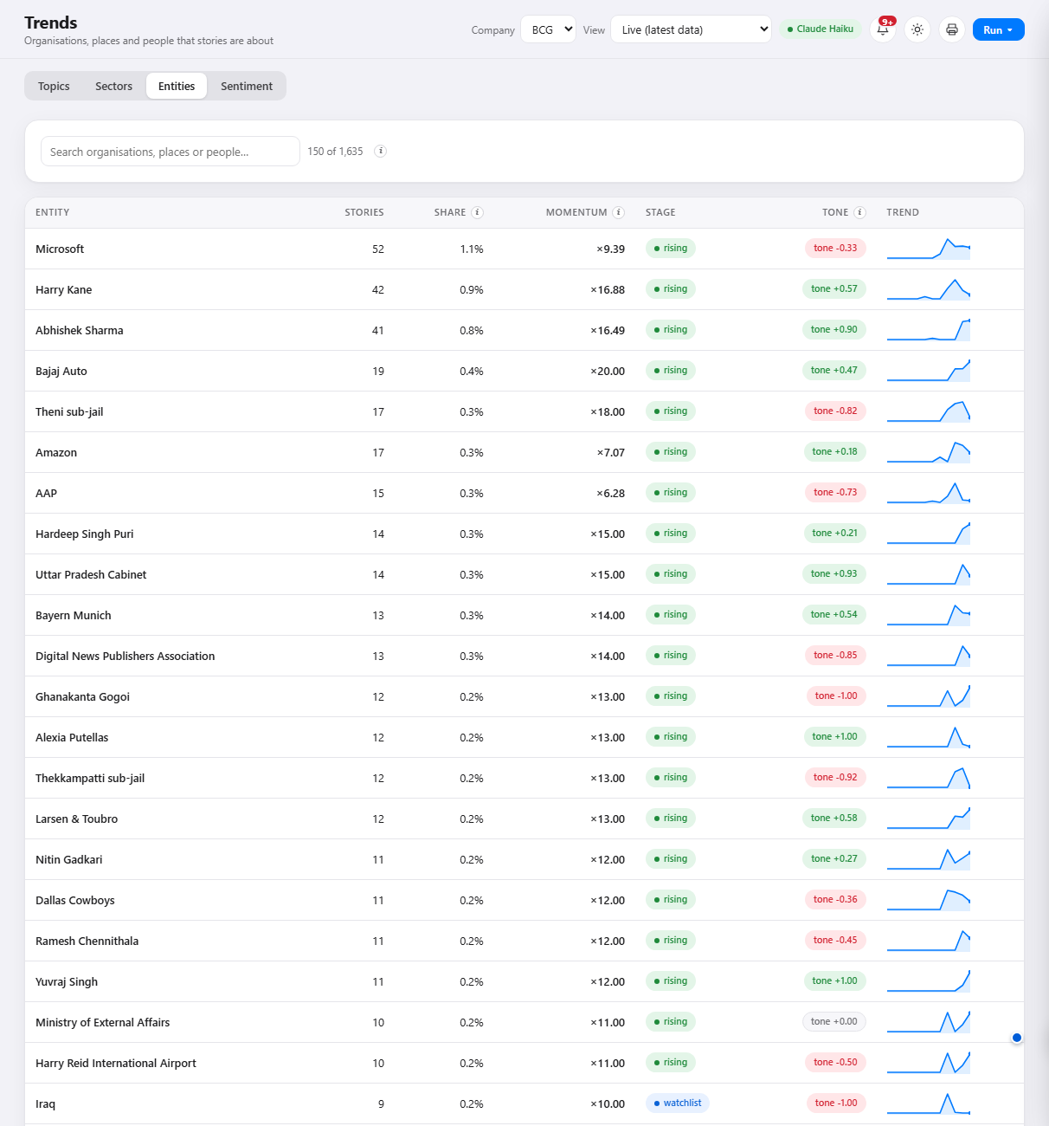
Figure 9. Trends, Entities: organisations, people and places in the news

What you are looking at
The organisations, people and places that stories are about, measured the same way as topics: share of coverage now against share over the previous week.

How to read it
- Momentum shows who is suddenly in the news more than usual.
- Stage uses the same watch, rising, steady and declining labels; an entity needs at least three independent origins before it can be called rising.
- Sentiment shows whether coverage about the entity is mostly positive or negative.

How to use it
- An entity surging often leads the topics around it. A company appearing in five times its usual number of stories is an early signal to look at what it is doing.
- Click an entity for its chart, topics and stories.

Sentiment
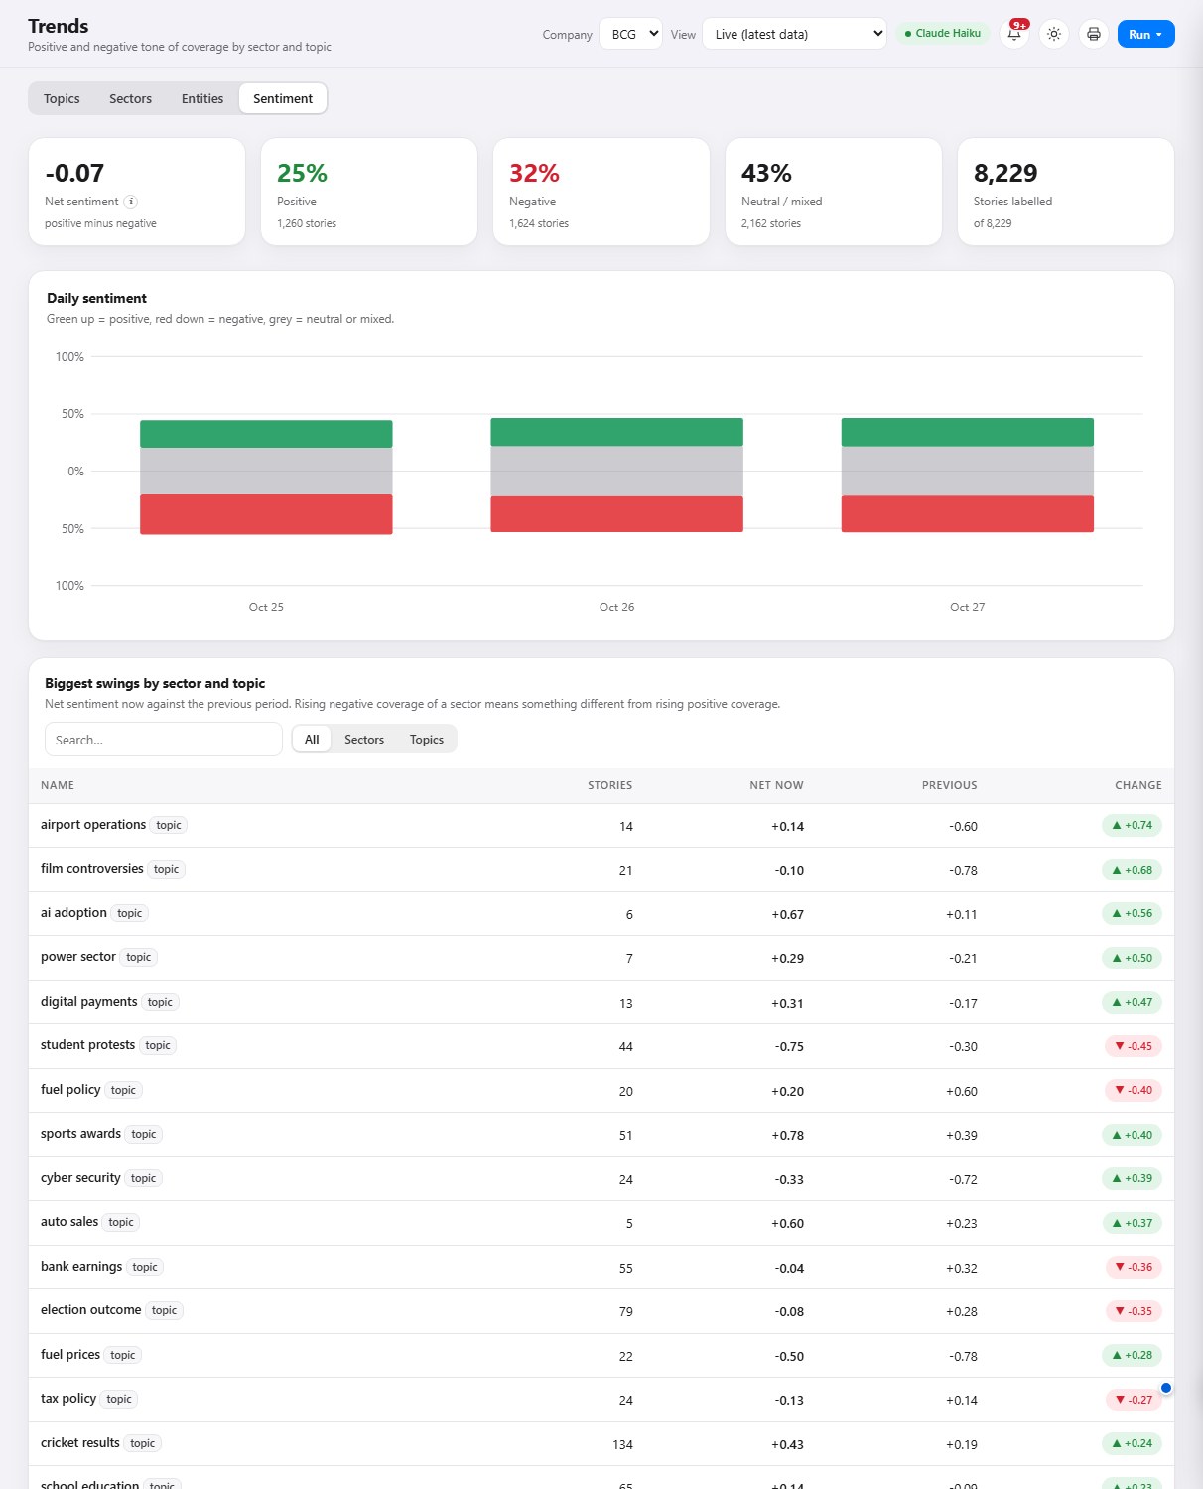
Figure 10. Trends, Sentiment: tone of coverage by day, sector and topic

What you are looking at
How positive or negative the coverage is. The four boxes give net sentiment, the positive and negative shares and how many stories have been labelled. The chart shows daily tone (green upward is positive, red downward negative, grey neutral or mixed). The table lists the biggest swings by sector and topic.

How to read it
- Net sentiment runs from -1 (all negative) to +1 (all positive).
- A change column compares the last 24 hours with the 24 hours before.

How to use it
- Rising negative coverage of a sector means something different from rising positive coverage. A topic gaining attention with a sharply negative tone usually points to risk or a problem to respond to; with a positive tone, to a launch, success or opening.
- Remember it measures the press, not the public.

8.4 Clients

Company lens
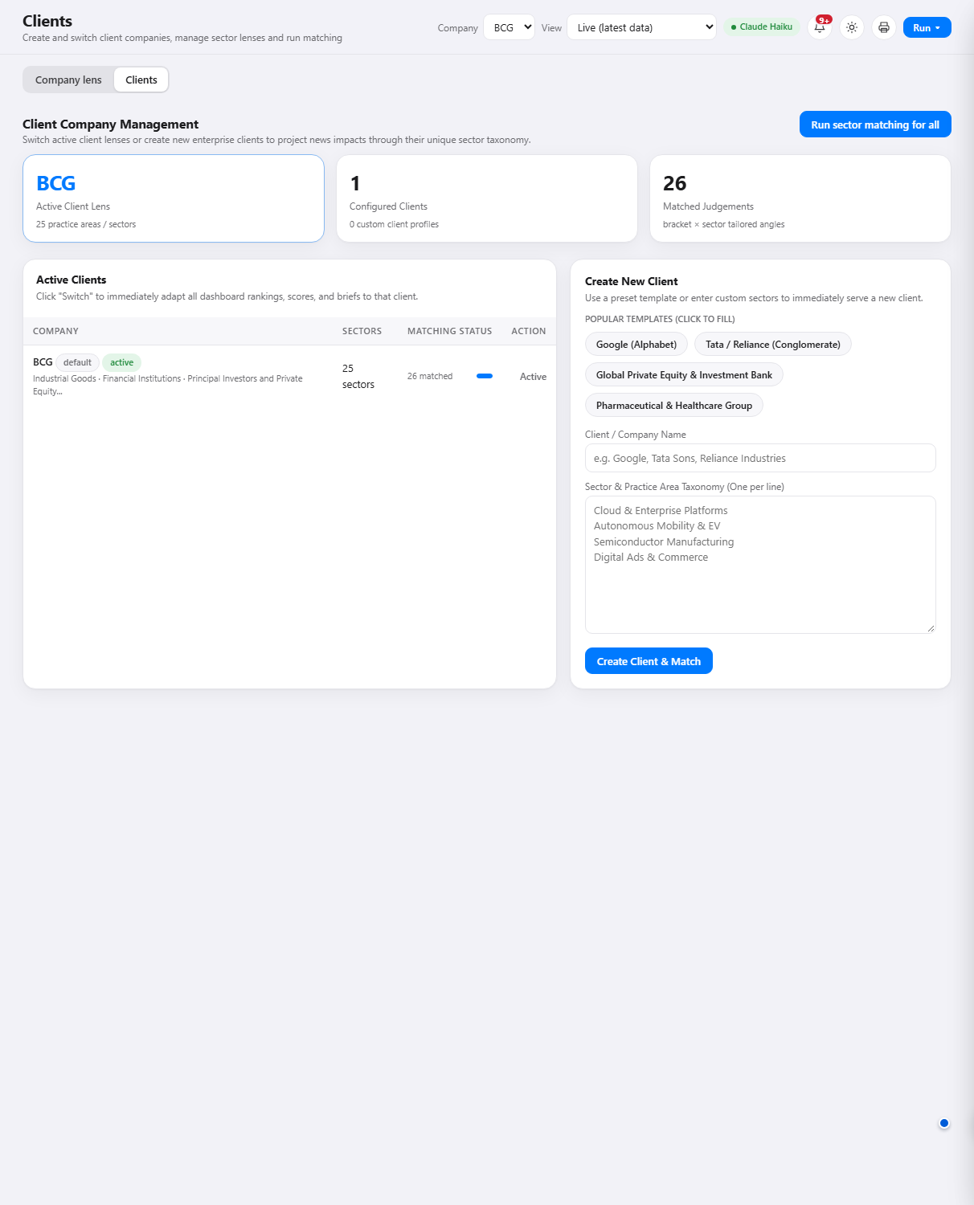
Figure 11. Clients, Company lens: how each news area reaches the client's sectors
For the selected client, this shows which news areas matter to which of its sectors, how directly, and the angle for each. It is what turns "this is trending" into "this is trending and here is why it matters to your Energy practice".

Client set-up
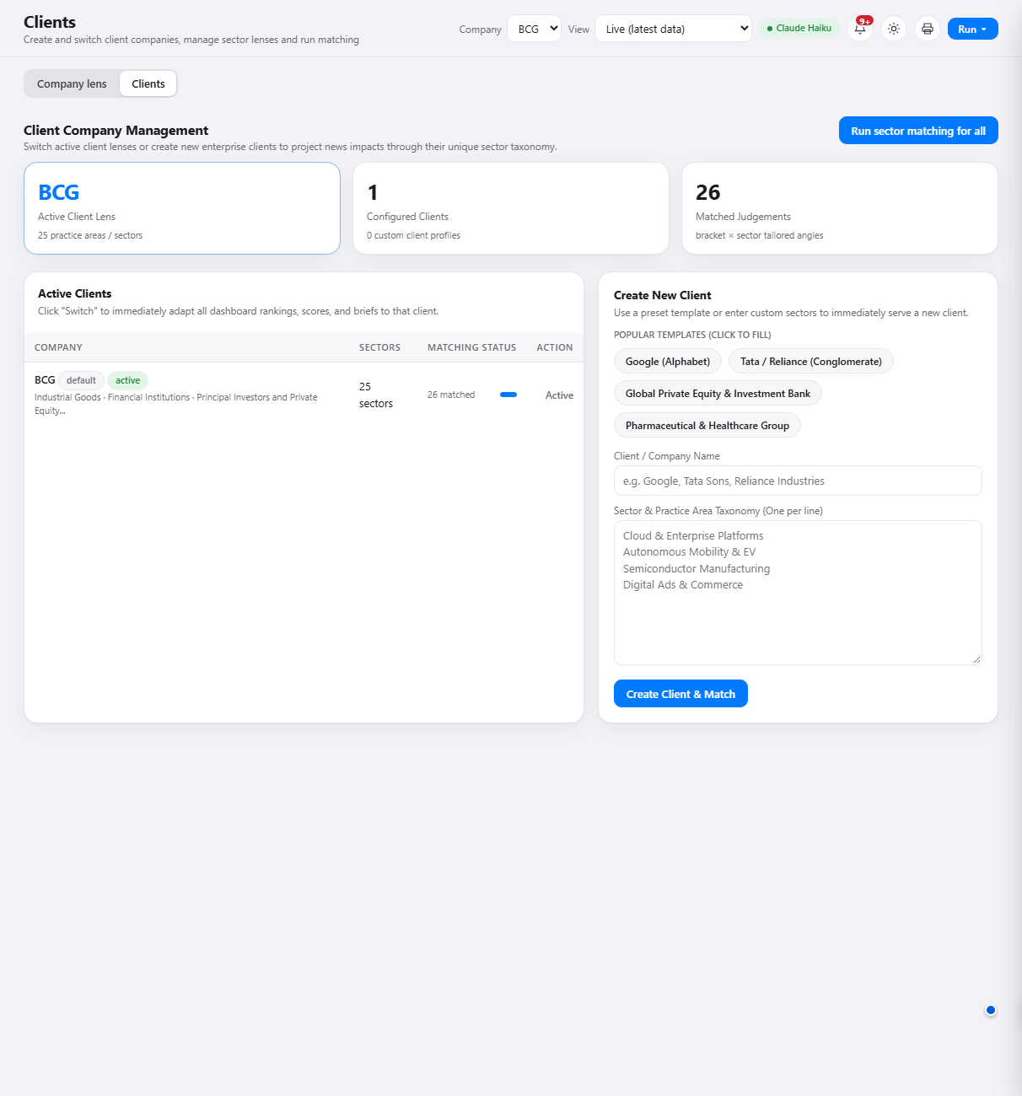
Figure 12. Clients: create and manage client companies
Add a new client by entering its name and its sectors (one per line, comma separated, or from a file). The system then matches every news area against the new client's sectors, so you can serve many clients from the same data. Use the Company selector in the top bar to switch between them.

8.5 Sources

Sources and collection
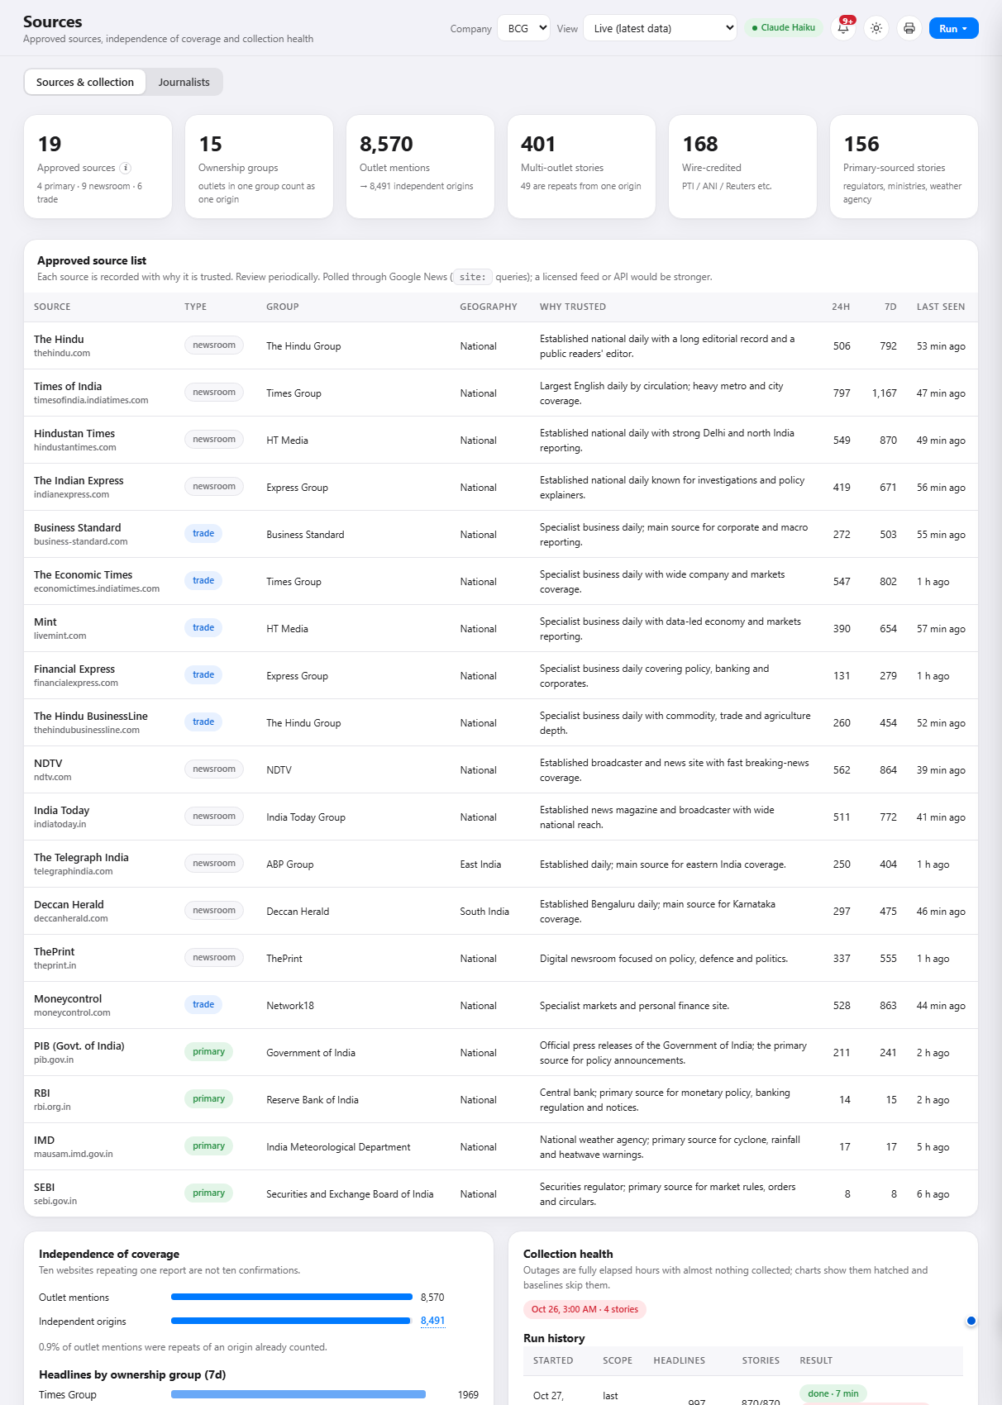
Figure 13. Sources: approved sources, independence of coverage and collection health

What you are looking at
Where the news comes from and how well collection is working: each approved source with its owner group and type, how many headlines it produced in the last day and week, and a table of recent collection runs. It also shows how much copying was removed to get from outlet mentions to independent origins.

How to read it
- A source that has gone quiet shows an old "last seen" time.
- "Collection gaps" mark periods when little was collected; charts treat these honestly instead of reading them as a drop in news.

How to use it
- Use it to check whether a surprising result might be a collection problem rather than a news event.
- Use the syndication figures to see how much of the coverage is repetition.

Journalists
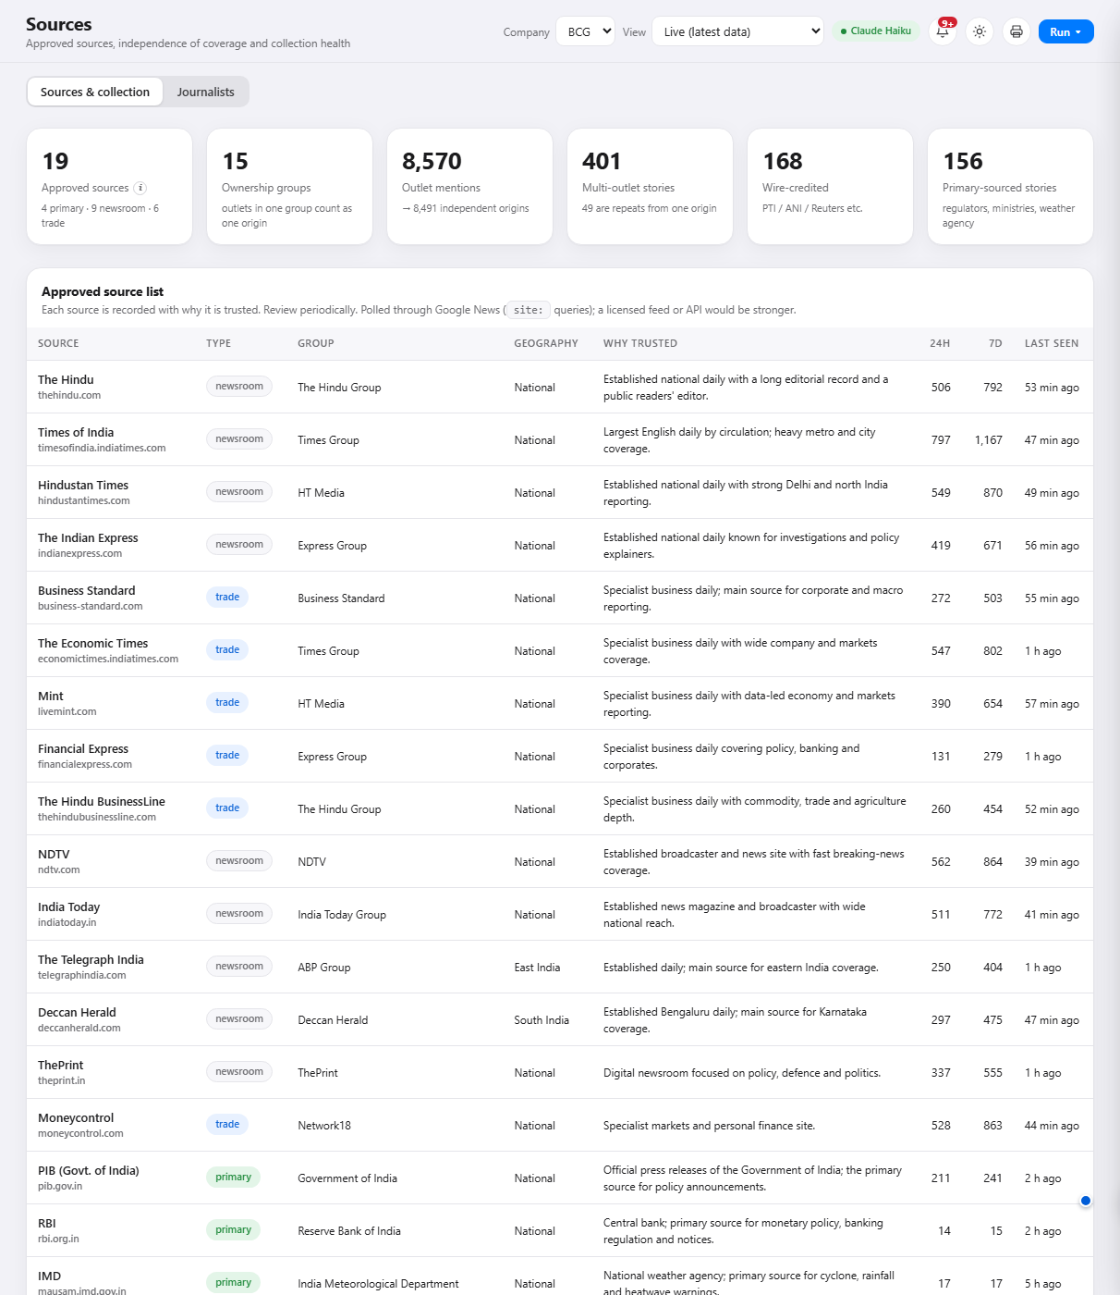
Figure 14. Sources, Journalists: the directory and best-fit journalists
A searchable directory of about 10,900 journalists, with their beats, outlets and recent articles. On each opportunity the system suggests the best-matching journalists, based only on their declared beat and what they have recently written. It never contacts anyone, and contact details are never sent to the AI model.

8.6 Accuracy
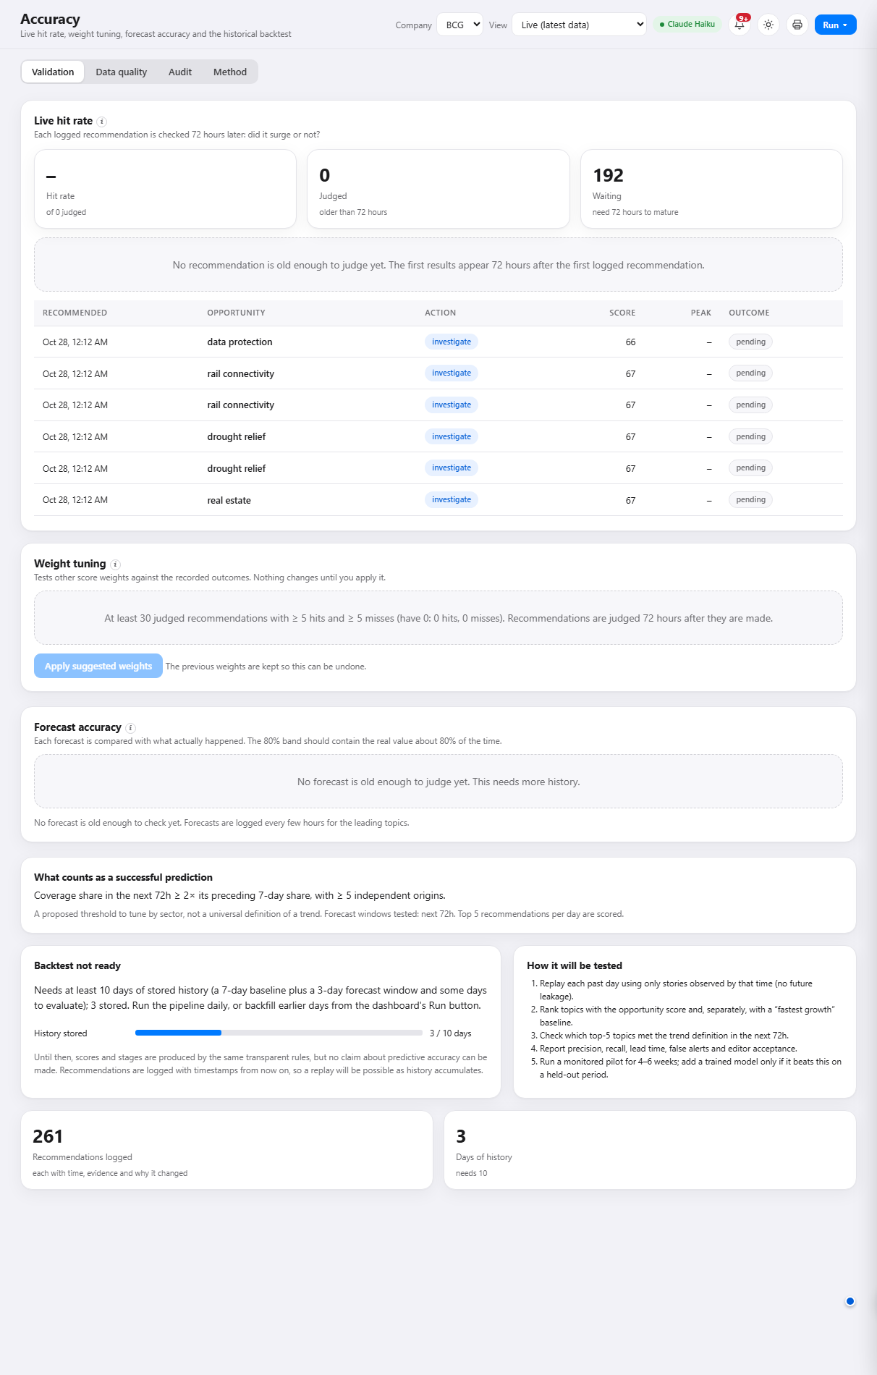
Figure 15. Accuracy: live hit rate, weight tuning and backtest

What you are looking at
The scoreboard. It shows whether the recommendations the system made came true.

How to read it
- Live hit rate: share of judged recommendations whose topic later met the definition of a trend. Currently empty: no recommendation is yet 72 hours old.
- Waiting: recommendations logged but not yet old enough to judge (234).
- Weight tuning: appears once there are at least 30 judged recommendations with a mix of hits and misses.
- Backtest: replays history once there are 10 days of data; currently 3 of 10.

How to use it
- This is the page that tells you how much weight to put on everything else. When the hit rate is established, it becomes your confidence level for the "write now" and "investigate" labels.
- A second tab, Method, documents how every number is calculated.

Data quality
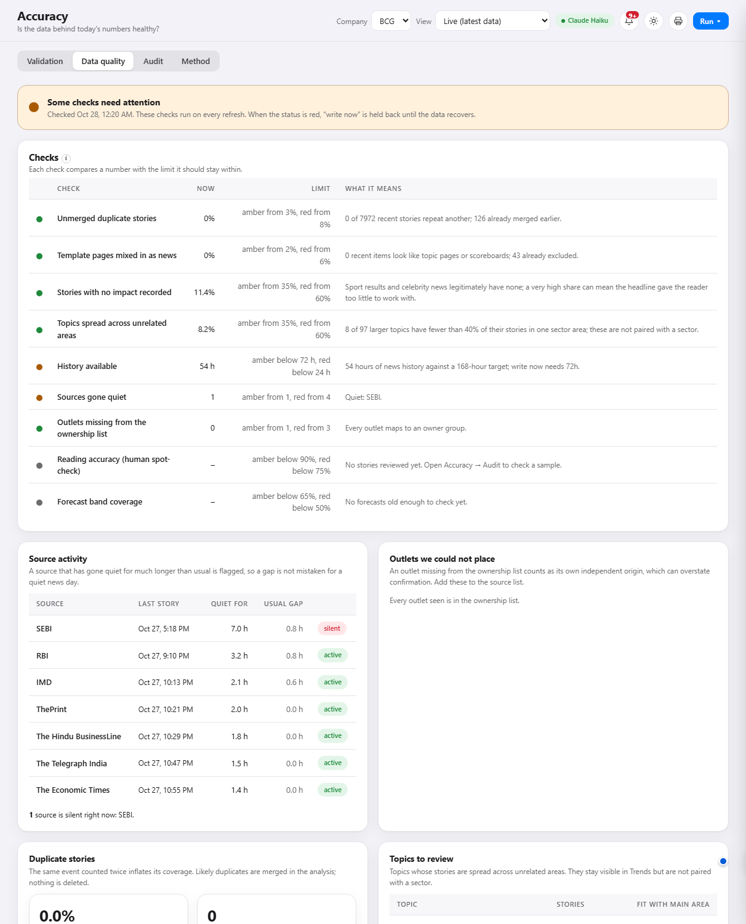
Figure 16. Accuracy, Data quality: is the data behind today's numbers healthy?
A set of checks, each with an amber and a red limit: repeated stories, template pages mixed in as news, stories with no impact recorded, topics spread across unrelated areas, history depth, sources that have gone quiet, outlets missing from the ownership list, reading accuracy from the human spot-check, and forecast accuracy. The banner at the top gives the overall status. When it is red, "write now" is held back until the data recovers. Below the checks are the quiet sources, any unplaced outlets and the topics that most need a review.

Audit
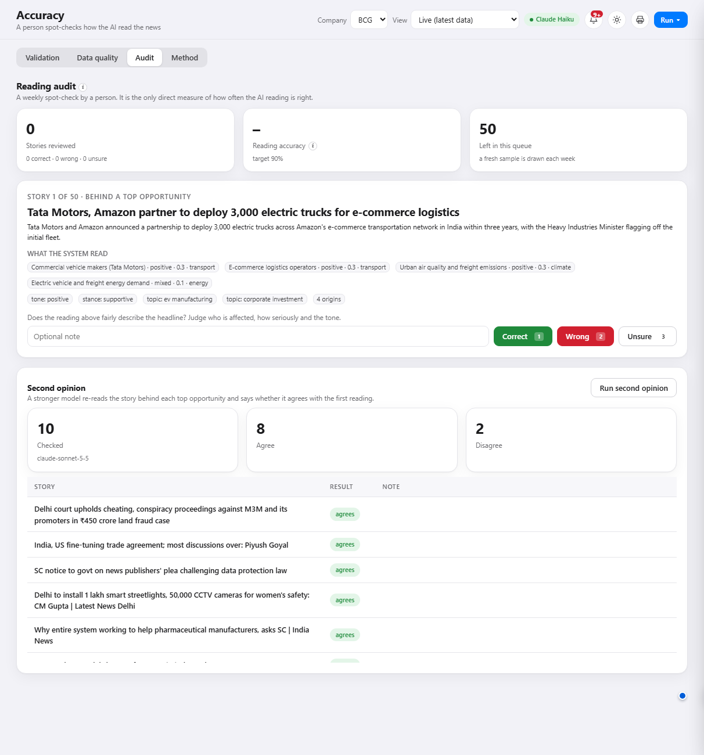
Figure 17. Accuracy, Audit: a person checks how the AI read a sample of stories
A weekly spot-check of about 50 stories, drawn mostly from those behind the top opportunities. Each card shows the headline, what the system read (who is affected, how, and the tone) and three buttons: correct, wrong or unsure. The accuracy is shown against a 90% target. Underneath, a stronger AI model's second opinion on the readings behind the top opportunities shows how many it agreed with.

8.7 Notifications, Settings and Guide
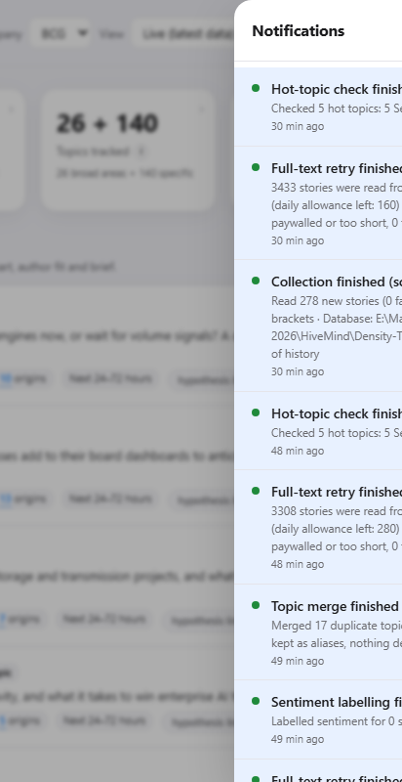
Figure 18. The bell: what happened recently, newest first
The bell lists every finished collection, labelling job and check, marked as scheduled (the hourly run), automatic (follow-up steps) or manual (someone pressed a button). Failures and credit problems appear here, so the main screens stay clean.

Settings: Integrations, System, Logs, Usage
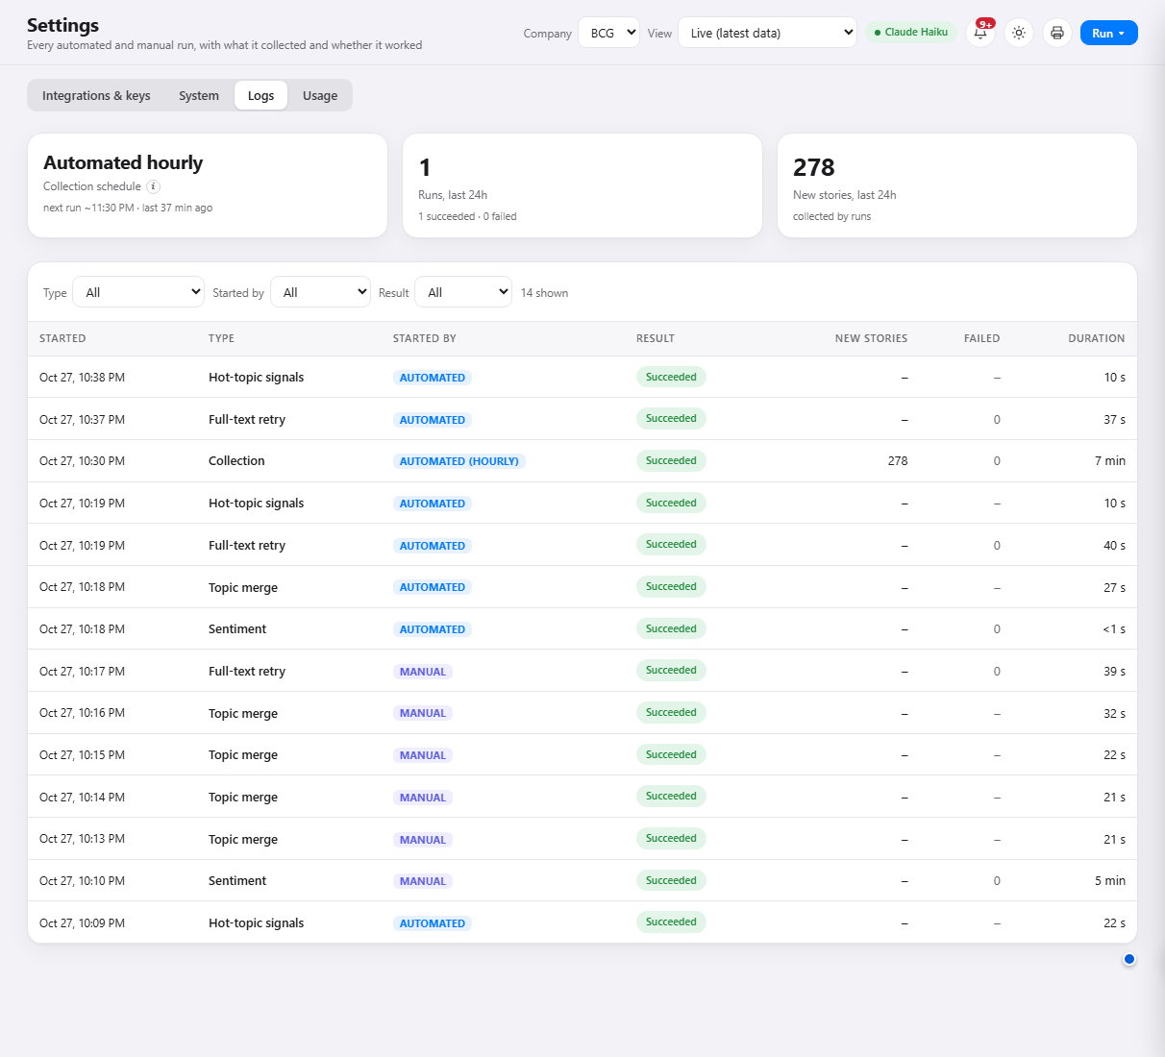
Figure 19. Settings, Logs: every run, what it collected and whether it worked
- Integrations and keys: the outside services the system uses (the AI model, web search, search-interest, X, the journalist directory, the proxy), each with an on/off switch, a status light and a connection test. Keys are stored locally and shown only in masked form.
- System: the computer the system runs on, and the optional local AI model that can stand in if the main one is unavailable.
- Logs: every collection and background job, with who started it (hourly schedule or a person), how many new stories it found, how many failed, how long it took, and the error if it failed.
- Usage: calls and tokens used today and this month for each service, the credit left where the provider reports it, and the daily limits that protect against overspending.
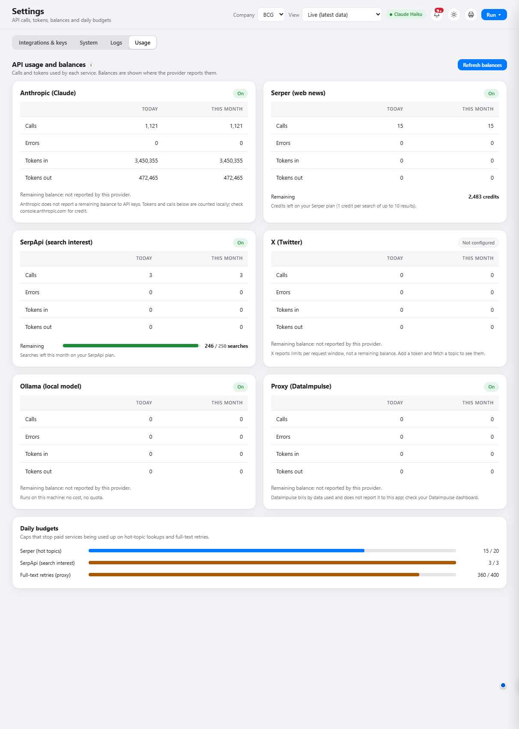
Figure 20. Settings, Usage: spend and remaining credit per service
The Guide (bottom of the menu) is a built-in manual covering the architecture, the formulas and the daily workflows, for anyone who wants more detail than this document.

9. A worked example
This reads one live opportunity from top to bottom, the way you would in the morning. All numbers are from 27 October 2026.
The opportunity
Industrial Goods x ev manufacturing, score 87, action investigate, stage rising, evidence medium, window next 24 to 72 hours.
Suggested angle: "As Bajaj and Tata scale EV volumes, which auto suppliers gain or lose share, and what should OEM-facing executives prioritise in the next 24 months?"

Step 1: what is happening?
Electric-vehicle manufacturing took 0.8% of all coverage against a normal 0.1%. Momentum is therefore x7.1. A step earlier it was x0.82, so acceleration is +3.11 (roughly an eight-fold jump). The topic has gone from quiet to prominent within about a day.

Step 2: is it real?
It is reported by 10 independent origins including the Times Group, The Hindu Group, HT Media, Express Group, NDTV and a Bloomberg wire story, so it is widely confirmed, not one report repeated. There is a verified trigger: the announcement of 3,000 electric trucks by Tata Motors and Amazon, confirmed by four independent origins ten hours ago.

Step 3: how is the 83 made up?
Ingredient | Points | Why
Momentum (max 25) | 25.0 | x7.1 is well above the x4 needed for full marks.
Acceleration (max 15) | 15.0 | +3.11 is above the +1.5 needed for full marks.
Independent sources (max 15) | 15.0 | 10 origins is above the 8 needed for full marks.
Sector evidence (max 20) | 16.0 | Judged directly for this topic: relevance 0.80 to Industrial Goods.
Trigger timing (max 15) | 15.0 | A verified trigger ten hours old.
Editorial headroom (max 10) | 1.1 | The topic already holds a large share of coverage (89th percentile), so there is little room for a fresh angle.
Total | 87.1 | Rounded to 87.

Step 4: why "investigate" and not "write now"?
Two conditions are not met: history is 42 hours against the 72 required, and headroom is about 11 against a required 40 (the topic is already crowded with coverage). The sector link, by contrast, is now judged and supported. The dashboard lists both gaps under "Not yet write-now. Missing...".

Step 5: what does a leader do with it?
- Do not publish on the strength of the score alone. Assign an analyst to find an angle the crowded coverage is not already taking.
- Note the window. The trigger is fresh, so a considered piece within 24 to 72 hours is realistic.
- Note the review condition. If momentum falls below 1.0x for two consecutive 12-hour steps, or the trigger story is corrected, drop it.
- Check the scoreboard later. In about three days the Accuracy screen will show whether opportunities like this one turned out to be real trends.

10. Limits and cautions
Using the system well includes knowing where it is weak. Please keep these in mind.
Limit | What it means in practice
Short history | Only about three days of news are stored, against a seven-day target for the baseline. Scores and stages are indicative until more history builds up. This improves every hour the system runs.
Unproven forecast | The forecast line and the score have not yet been checked against outcomes. The Accuracy screen will provide that evidence.
A partial view of the market | The system sees 19 sources. Stories only on social media, or in regional-language press outside the list, may be missed.
Headline reading | To keep costs low, stories are read from the headline and summary, not the whole article. Impact and tone judgements rest on short text. The safeguards are independent origins, a second-model check on the top opportunities, and a weekly human spot-check.
The score is a ranking, not a probability | A score of 83 does not mean an 83% chance of anything. It means the opportunity ranks highly on the six factors.
AI reading is not perfect | Each story is read by an AI model. It can misjudge sector, severity or tone. The evidence links exist so a person can check, and the Audit screen measures how often the reading is right.
Sentiment is the press, not the public | It measures how journalists write, not how customers feel.
Sector links start as hypotheses | The match between a topic and a client's sector is a judgement by the AI. It is labelled a hypothesis until it has been judged for the specific topic.
Search and social signals are optional | Search interest (Google Trends) and X posts add independent evidence when available, but are shown separately and are only fetched for the few rising topics, to control cost. X is not yet connected.

How to stay safe
Treat "write now" as a green light only after a quick look at the evidence. Treat "investigate" as an instruction to have someone close the gaps. Revisit the Accuracy screen weekly: it is the best indicator of how much to rely on the rest.

11. Glossary
Term | Meaning
Acceleration | Whether momentum is speeding up or slowing down. +1 means momentum doubled since the last step.
Action | The suggested next step: write now, investigate, monitor or skip.
Backtest | Replaying past days to check whether recommendations would have come true.
Baseline | A topic's normal share of coverage, measured over the previous seven days.
Coverage share | The slice of all collected stories that are about a topic.
Crowded | A topic already prominent in coverage and no longer accelerating, leaving little room for a fresh angle.
Entity | A named organisation, person or place that stories are about.
Evidence strength | High, medium or low, based on independent origins, full-text share and history.
Data quality | A set of health checks on the data (duplicates, quiet sources, history, reading accuracy). If it turns red, write now is held back.
Headline reading | Reading each story from its headline and summary rather than the whole article, to keep running costs low.
Judged pairing | A sector link and angle judged directly for one topic from its own stories, rather than inherited from its broader area.
Second opinion | A stronger AI model's check of whether the first reading of a story was fair.
Headroom | Room for a fresh editorial angle; low for crowded topics.
Hit rate | The share of past recommendations that came true within 72 hours.
Independent origins | The number of separate reporting sources, with owner groups and wire copy counted once.
Momentum | Recent coverage share divided by baseline share. 1.0x is normal.
Net sentiment | Positive minus negative stories as a share of labelled stories, from -1 to +1.
Opportunity | A pairing of a client sector with a news topic, with a score, action and suggested angle.
Review condition | What would make an opportunity wrong or out of date.
Score | A 0 to 100 ranking made of six weighted ingredients. Not a probability.
Search interest | How much people search Google for a topic (relative 0 to 100). Kept separate from news.
Stage | Where a topic is in its lifecycle: watchlist, emerging, rising, steady, crowded or declining.
Story | One real-world event, however many outlets report it.
Topic | A recurring subject (such as "fuel prices") tracked over time. Broad areas such as Energy are called sectors or areas.
Unvalidated | Not yet proven against real outcomes.
Verified trigger | A recent story confirmed by an official source or at least three independent origins.
Window | The suggested time frame for acting, such as the next 24 to 72 hours.

