

**Non adopted students working layout and details**

***NOTE: Details of each filed has been described below the pic***

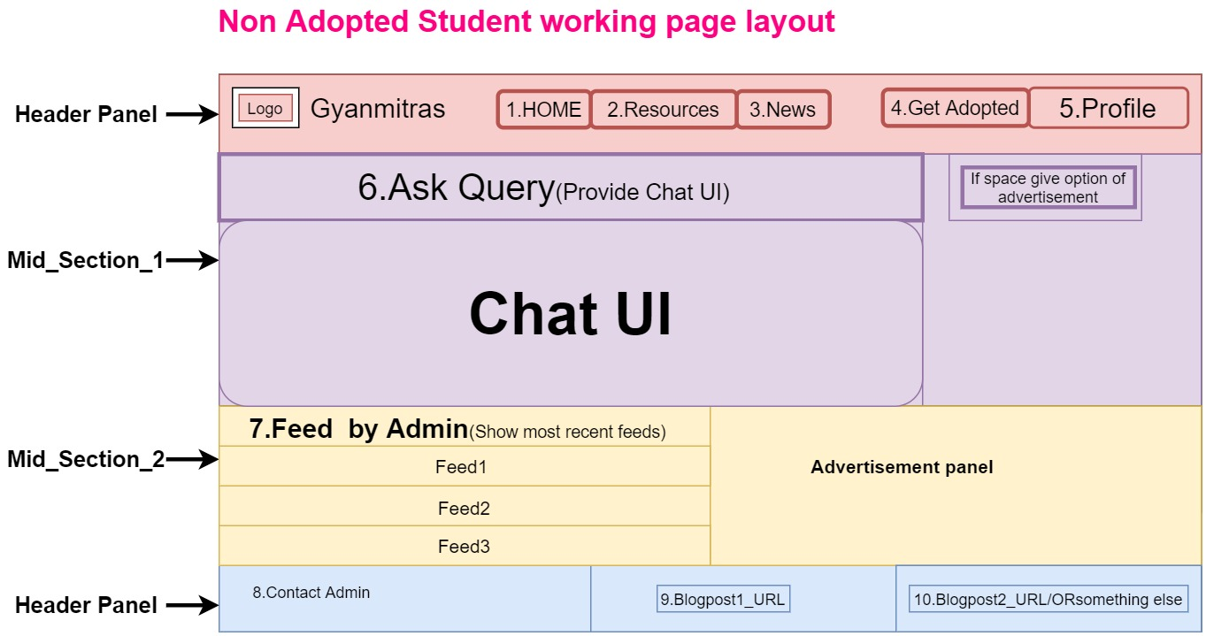

**Details of each fields (1-10)**

|  |
| --- |
| **1.Home**  **This will redirect to index page.** |
| **2.Resources**  **Should be redirected to Resource page.** |
| **3.News**  **Just a hyperlink of blog post should be provided which exact link will be updated after making an appropriate blog.** |
| **4.Get Adopted(Flash it in red color)**  **Provide the adoption form which fields are as below.**   |  |  | | --- | --- | | **Request for adoption(See more about adoption)** | **YES Confirm** | | **Terms and conditions** | I hereby declare that information’s provided by me is valid and I will be only liable to handle concerns evolved due to misleading information’s provided by me either now or at any subsequent stages. Refer Terms and conditions of academic adoption of students(Provide a hyperlink which data I will provide later ) | | **SUBMIT** | Generate a confirmation receipts after successful submit ,generate id of request | |
| **5.Profile**  **Profile should have following details and sub-details.**   |  |  | | --- | --- | | **His photo should be on top** |  | | **Name** |  | | **Address** | **Edit** | | **Mail id** | **Edit & Verify** | | **Contact** | **Edit** | | **Guardian Contact** | **Edit** | | **Logout** |  |   **6.Ask query**  ***Form field values with description***   |  | | --- | | **Provide a UI for query management ,where query of student should be replied by several counselors** |   **7.Feed by admin**  **Provide a table where feeds from admin will be shown to particular student on the behalf of his/her academic details and area of interest.**   |  |  | | --- | --- | | **Feeds** | **Update time** | | **Feed1** |  | | **Feed2** |  | | **Feed3** |  |   **8.Contact admin**  **A form should be provided to the volunteer to contact admin**   |  |  | | --- | --- | | **Form _Fields** | **Description** | | **Query on mail** | **Mail id of admin should be provided** | | **Get call** | **A call request to the admin should be generated** |   **9.Blogpost1_Url**  **Some URLs of some blog posts should be provided**  **10.Blogpost2_Url**  **Some URLs of some blog posts should be provided** |