**Adopted students working layout and details**

***NOTE: Details of each filed has been described below the pic***

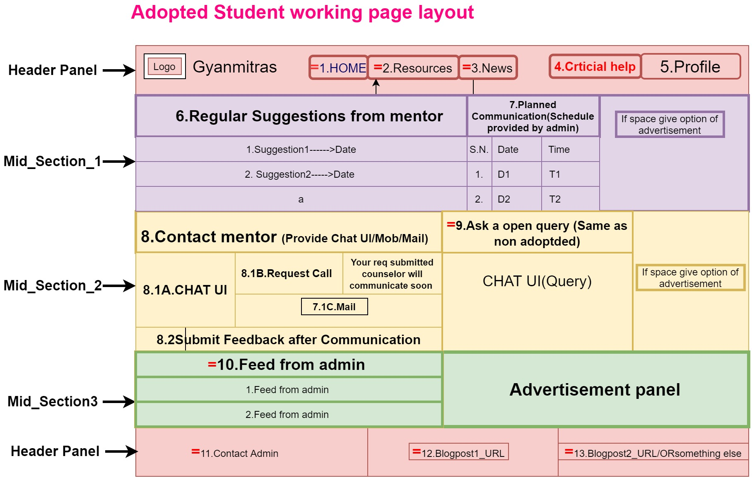

**Details of each fields (1-10)**

|  |
| --- |
| **1.Home *=Same as non-adopted student***  **This will redirect to index page.** |
| **2.Resources*=Same as non-adopted student***  **Should be redirected to Resource page.** |
| **3.News*=Same as non-adopted student***  **Just a hyperlink of blog post should be provided which exact link will be updated after making an appropriate blog.** |
| **4.Critical Help**  **This will open a separate page /popup where a form should be provided which will provide option to the adopted student to inform admin about their critical situations.**   |  |  | | --- | --- | | **Mention your concerns**  **(Provide dropdown)** | **Dropdown menus**  **1.Technical admission issues**  **2. Financial issues**  **3. Degree related issues**  **4.Neglegence by Govt. authorities causing academic concerns**  **5.Fraud**  **6.Others->Provide Text-area** | | **SUBMIT** | ***Acknowledgement popup->You will be contacted soon if your concerns are genuine*** | |
| **5.Profile**  **Profile should have following details and sub-details.**   |  |  | | --- | --- | | **His photo should be on top** |  | | **Name** |  | | **Address** | **Edit** | | **Mail id** | **Edit & Verify** | | **Contact** | **Edit** | | **Guardian Contact** | **Edit** | | **Counselor Name** |  | | **Counselor Contact** |  | | **Logout** |  |   **6.Regular suggestion from counselor**   |  |  |  |  |  |  |  |  |  |  |  | | --- | --- | --- | --- | --- | --- | --- | --- | --- | --- | --- | | **On the behalf of academic details, area of interest … counselor will give regular suggestions which should be displayed in tabular format .Three recent suggestions should be shown and remaining should be shown on request of students.**   |  |  | | --- | --- | | **Suggestion** | **Time/Date** | | **Suggestion1** | **D1/T1 (See More)->Hyperlink should be provided to see all Suggestions.** | | **Suggestion2** | **D2/T2** | | **Suggestion3** | **D3/T3** | | **Suggestion4** | **D4/T4** | |   **7.Planned communications**  **A schedule of communication between student and counselor should be provided here which will be planned by admin , most will use some simple function (Like Plan 4 -6times every month )**   |  |  | | --- | --- | | **Date** | **Time** | | **X-June** | **X-PM** | | **(X+7)-June** | **X-PM** | | **(X+14)-June** | **X-PM** | | **(X+21)-June/July** | **X-PM** |   **This plan should be synchronized with the available time slots of counselor, which concludes counselor time slots should be asked while counselor does adoption.**  **8.Contact counselor**  **Student should be given option to communicate with counselor.**  **There should be three means of communication.**  **8.1A.Chat UI**  **Chat UI-Chat UI should be provided for unplanned and planned communications.**  **8.1B.Get call**  **Request call-A request should be generated for counselor which should reflect on counselor end.**   |  |  | | --- | --- | | **Request Call** | **Request submitted** |   **8.1C.Mail**  **Mail Id of counselor should be provided (Keep it optional -> if problem arises in implementation of chat Method)**  **8.2Submit feedback**  **A feedback form should be flashed after every telephonic communication from student to counselor. This form should be for both requested and planned telephonic communication.**  **We can go for multiple tick boxes to take review which fields are following**     |  |  |  | | --- | --- | --- | | 1. **Was the communication useful?** | 1. **Did your counselor suggest any private institution?** | 1. **Were u asked to pay money for guidance.** | | 1. **Was your counselor in hurry?** | 1. **Were you asked for any other unregistered contact?** | 1. **Was your counselor on time?** | | 1. **Did your counselor lie?** | 1. **Was your counselor inefficient? If yes ->Explain** | 1. **Report Abuse ->**   **1.Explain your concern 2.Submit docs if any ,Related to abuse** |   **9.Ask query*=Same as non-adopted student***  ***Form field values with description***   |  | | --- | | **Provide a UI for query management ,where query of student should be replied by several counselors** |   **10.Feed by admin*=Same as non-adopted student***  **Provide a table where feeds from admin will be shown to particular student on the behalf of his/her academic details and area of interest.**   |  |  | | --- | --- | | **Feeds** | **Update time** | | **Feed1** |  | | **Feed2** |  | | **Feed3** |  |   **11.Contact admin**  **A form should be provided to the volunteer to contact admin**   |  |  | | --- | --- | | **Form _Fields** | **Description** | | **Query on mail** | **Mail id of admin should be provided** | | **Get call** | **A call request to the admin should be generated** |   **12.Blogpost1_Url**  **Some URLs of some blog posts should be provided**  **13.Blogpost2_Url**  **Some URLs of some blog posts should be provided** |