

**Non adopted Counselors working layout and details**

***NOTE: Details of each filed has been described below the pic***

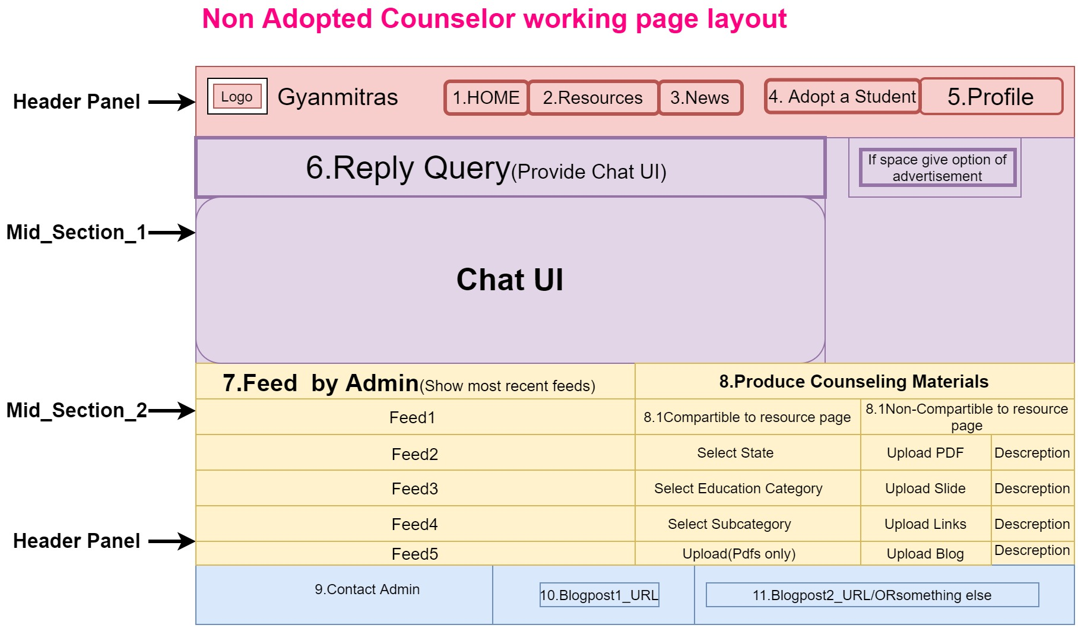

**Details of each fields (1-10)**

|  |
| --- |
| **1.Home**  **This will redirect to index page.** |
| **2.Resources**  **Should be redirected to Resource page.** |
| **3.News**  **Just a hyperlink of blog post should be provided which exact link will be updated after making an appropriate blog.** |
| **4.Adopt a Student (Flash it in red color)**  **Provide the adoption form which fields are as below.**   |  |  | | --- | --- | | **Request for adoption(See more about adoption)** | **YES Confirm** | | **Terms and conditions** | I hereby declare that information’s provided by me is valid and I will be only liable to handle concerns evolved due to misleading information’s provided by me either now or at any subsequent stages. Refer Terms and conditions of academic adoption of students (Provide a hyperlink which data I will provide later). | | **Choose Free time slots ->** | **Only weekends ->**   |  | | --- | | 9AM-10Am | | 10AM-11Am | | 11AM-12Am | | 12AM-1Pm | | 1PM-2PM | | 2PM-3PM | | 3PM-4PM | | 4AM-5PM | | 9AM-6PM | | 9PM-1PM | | 9PM-PM | | |  | **Non weekends also**  **Select Day->Mon/Tue/Wed/Thu/Fri/Sat/Sun**  **Select Time->**   |  | | --- | | 9AM-10Am | | 10AM-11Am | | 11AM-12Am | | 12AM-1Pm | | 1PM-2PM | | 2PM-3PM | | 3PM-4PM | | 4AM-5PM | | 9AM-6PM | | 9PM-1PM | | 9PM-PM | | | **Select Students**  ***(Suggested to redirect on other page )*** | |  |  |  |  |  |  |  |  | | --- | --- | --- | --- | --- | --- | --- | --- | | **Name** | **Location** | **Language** | **Academics** | **Aspiration** | **Have PC** | **Have Smartphone** |  | | **S1** |  |  |  |  |  |  | **Select** | | **S2** |  |  |  |  |  |  | **Select** | | **S3** |  |  |  |  |  |  | **Select** | | **S4** |  |  |  |  |  |  | **Select** | | **S5** |  |  |  |  |  |  | **Select** | | |  |  | | **SUBMIT** | Generate a confirmation receipts after successful submit, generate id of request. | |
| **5.Profile**  **Profile should have following details and sub-details.**   |  |  | | --- | --- | | **His photo should be on top** |  | |  |  | | **Name** |  | | **Address** | **Edit** | | **Mail id** | **Edit & Verify** | | **Contact** | **Edit** | | **Just show a message that u haven’t adopted any student** |  | | **Show number of produced counseling data and validated counseling data separately** | |  |  | | --- | --- | | **#Produced Counseling data** | **#Validated Counseling data** | |  |  | | | **Logout** |  |   **6.Reply query(Mechanism)**  ***A Query reply UI should be provided***   |  | | --- | | 1. **Students query will be filtered on the behalf of language and area of interest.** | | 1. **Query will be sent to all filtered counselors** | | 1. **Reply will be done on the basis of FCFS(First Come First Serve)->Whoever will reply first on this query their reply will be reflected on the student end and , query will be disabled for all other counselors** | | **NOTE: Prioritize non adopted counselors for open queries.** |   **7.Feed by admin**  **Provide a table where feeds from admin will be shown to particular counselor on the behalf of his/her**   1. **Academic details and area of interest -> If counselor is still studying** 2. **Expertise Details -> If counselor is working** 3. **Expertise details -> If counselor is retired.**  |  |  | | --- | --- | | **Feeds** | **Update time** | | **Feed1** |  | | **Feed2** |  | | **Feed3** |  |   **Move on next page :->>>>>**  **8.Produce Counseling materials**  **Counselors should be encouraged to produce counseling materials.**  **These counseling materials may be of two types**   * 1. **Compatible to resource page-> This means Counselor produces data of any category or subcategory of resource page.**   **Like Counselor produce data of**  **State : Bihar -> Category: Primary->Subcategory-> Available NGOs**  ***NOTE : THIS DATA WILL BE VALIDATED BY ADMINS MANUALLY AND IF FOUND RELAVENT , WILL BE UPLOADED TO RESOURCE PAGE***  **Working of design :**  **Use Layout of resource page for selecting data category -> Means as anyone select resource exactly in that manner provide the dropdown menus to the counselor and at end instead of fetching information give him upload option .**   * 1. **Counselor may simple upload a drive link /PDFs/Usable Links/Write articles which are non-compatible from Resources page**   ***NOTE: THIS DATA WILL BE VALIDATED BY ADMINS MANUALLY AND IF FOUND RELAVENT, WILL BE UPLOADED TO BLOGS AND WILL BE USED FOR RESEARCH PURPOSES.***    **Working of design :**     |  |  |  | | --- | --- | --- | | **Upload PDF** | **Description(Less than 100 words)** | **UPLOAD** | | **Upload PPT** | **Description(Less than 100 words)** | **UPLOAD** | | **Upload Blog (Only Doc file)** | **Description(Less than 100 words**  **Mention Title of blog in such layout [/TITLE/]** | **UPLOAD** | | **Upload YouTube URL** | **Description(Less than 100 words)** | **UPLOAD** |   **8.Contact admin**  **A form should be provided to the counselor to contact admin**   |  |  | | --- | --- | | **Form _Fields** | **Description** | | **Query on mail** | **Mail id of admin should be provided** | | **Get call** | **A call request to the admin should be generated** |   **9.Blogpost1_Url**  **Some URLs of some blog posts should be provided**  **10.Blogpost2_Url**  **Some URLs of some blog posts should be provided**  **10.Give more space for such links**  **Some URLs of some blog posts should be provided** |