

**Adopted Counselors working layout and details**

***NOTE: Details of each filed has been described below the pic***

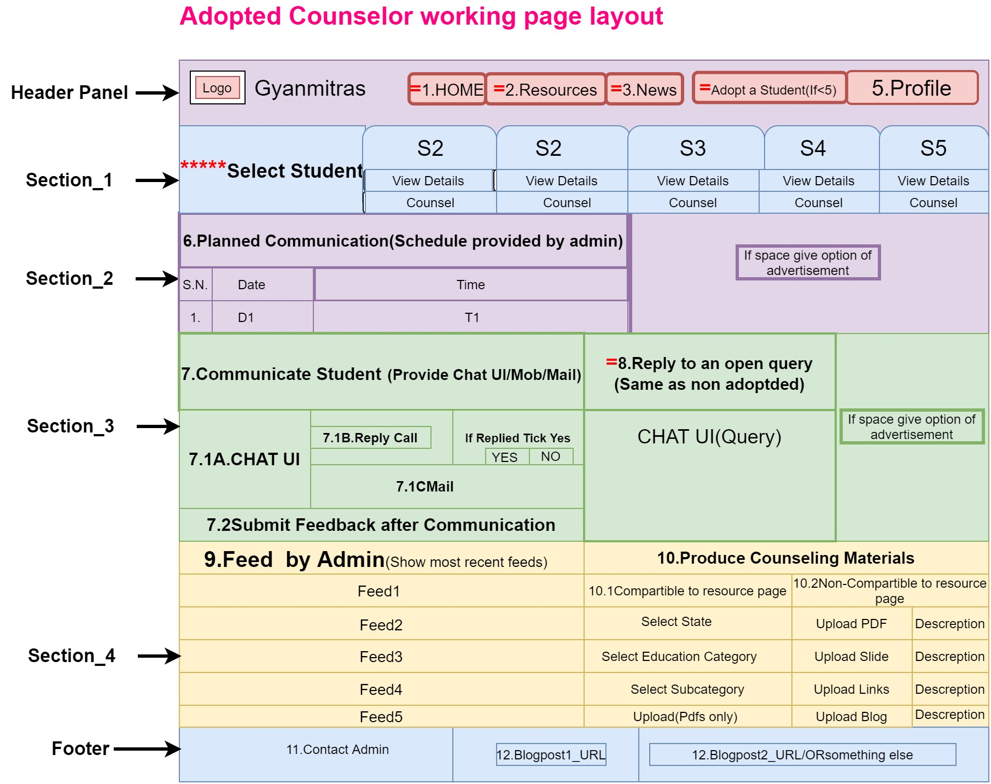

**Details of each fields (1-10)**

|  |
| --- |
| **1.Home**  **This will redirect to index page.** |
| **2.Resources**  **Should be redirected to Resource page.** |
| **3.News**  **Just a hyperlink of blog post should be provided which exact link will be updated after making an appropriate blog.** |
| **4.Adopt a Student (Flash it in red color)(Only if less than 5 students)**  **Provide the adoption form which fields are as below.**   |  |  | | --- | --- | | **Request for adoption(See more about adoption)** | **YES Confirm** | | **Terms and conditions** | I hereby declare that information’s provided by me is valid and I will be only liable to handle concerns evolved due to misleading information’s provided by me either now or at any subsequent stages. Refer Terms and conditions of academic adoption of students (Provide a hyperlink which data I will provide later). | | **Choose Free time slots ->** | **Only weekends ->**   |  | | --- | | 9AM-10Am | | 10AM-11Am | | 11AM-12Am | | 12AM-1Pm | | 1PM-2PM | | 2PM-3PM | | 3PM-4PM | | 4AM-5PM | | 9AM-6PM | | 9PM-1PM | | 9PM-PM | | |  | **Non weekends also**  **Select Day->Mon/Tue/Wed/Thu/Fri/Sat/Sun**  **Select Time->**   |  | | --- | | 9AM-10Am | | 10AM-11Am | | 11AM-12Am | | 12AM-1Pm | | 1PM-2PM | | 2PM-3PM | | 3PM-4PM | | 4AM-5PM | | 9AM-6PM | | 9PM-1PM | | 9PM-PM | | | **Select Students**  ***(Suggested to redirect on other page )*** | |  |  |  |  |  |  |  |  | | --- | --- | --- | --- | --- | --- | --- | --- | | **Name** | **Location** | **Language** | **Academics** | **Aspiration** | **Have PC** | **Have Smartphone** |  | | **S1** |  |  |  |  |  |  | **Select** | | **S2** |  |  |  |  |  |  | **Select** | | **S3** |  |  |  |  |  |  | **Select** | | **S4** |  |  |  |  |  |  | **Select** | | **S5** |  |  |  |  |  |  | **Select** | | | **SUBMIT** | Generate a confirmation receipts after successful submit, generate id of request. | |
| **5.Profile**  **Profile should have following details and sub-details.**   |  |  | | --- | --- | | **His photo should be on top** |  | | **Blink in RED color if he has adopted less than 5 students .** |  | | **Name** |  | | **Address** | **Edit** | | **Mail id** | **Edit & Verify** | | **Contact** | **Edit** | | **Just show a message that u haven’t adopted any student** |  | | **Show number of produced counseling data and validated counseling data separately** | |  |  | | --- | --- | | **#Produced Counseling data** | **#Validated Counseling data** | |  |  | | | **Logout** |  |   **\*\*\*\*\*.Select Student**  **A panel should be made on first section in the working page .On page open all adopted students by that particular faculty should be shown and two options should be provided.**   1. **View details of the student-> Show the detail of particular student on which click even has been made.** 2. **Counsel Student -> Show all functionalities of the page**   **6.Planned Communication**  **A schedule of communication between student and counselor should be provided here which will be planned by admin , most will use some simple function (Like Plan 4 -6times every month )**   |  |  | | --- | --- | | **Date** | **Time** | | **X-June** | **X-PM** | | **(X+7)-June** | **X-PM** | | **(X+14)-June** | **X-PM** | | **(X+21)-June/July** | **X-PM** |   **This plan should be synchronized with the available time slots of counselor, which concludes counselor time slots should be asked while counselor does adoption.**  **7.Communicate to Students**  **Counselor should be given option to communicate with counselor.**  **There should be three means of communication.**  **7.1A.Chat UI**  **Chat UI-Chat UI should be provided for unplanned and planned communications.**  **7.1B.Reply call**  **Reply call-Counselor should get a notice regarding call request and should be provided option to reply.**  **A button should be there by which reply should be acknowledged to the admin and after reply feedback form should be opened.**   |  |  | | --- | --- | | **Replied? YES NO** | **Feedback** |   **7.1C.Mail**  **Mail Id of counselor should be provided (Keep it optional -> if problem arises in implementation of chat Method)**  **7.2Submit feedback**  **A feedback form should be flashed after every telephonic communication for counselor. This form should be for both requested and planned telephonic communication.**  **We can go for multiple tick boxes to take review which fields are following**     |  |  |  | | --- | --- | --- | | 1. **Was the student capable to get you?** | 1. **Was there not a proper response?** | 1. **Were they requesting financial support?** | | 1. **Was the student in hurry?** | 1. **Were you asked for external communication?** | 1. **Was your student on time?** | | 1. **Did your student lie?** | 1. **Don’t Your student have sufficient infrastructure to continue his studies?** | 1. **Report Abuse ->**   **1.Explain your concern 2.Submit docs if any ,Related to abuse** |   **8.Reply an open query(Mechanism)**  ***A Query reply UI should be provided***   |  | | --- | | 1. **Students query will be filtered on the behalf of language and area of interest.** | | 1. **Query will be sent to all filtered counselors** | | 1. **Reply will be done on the basis of FCFS(First Come First Serve)->Whoever will reply first on this query their reply will be reflected on the student end and , query will be disabled for all other counselors** | | **NOTE: Prioritize non adopted counselors for open queries.** |   **9.Feed by admin**  **Provide a table where feeds from admin will be shown to particular counselor on the behalf of his/her**   1. **Academic details and area of interest -> If counselor is still studying** 2. **Expertise Details -> If counselor is working** 3. **Expertise details -> If counselor is retired.**  |  |  | | --- | --- | | **Feeds** | **Update time** | | **Feed1** |  | | **Feed2** |  | | **Feed3** |  |   **10.Produce Counseling materials**  **Counselors should be encouraged to produce counseling materials.**  **These counseling materials may be of two types**  **10.1. Compatible to resource page-> This means Counselor produces data of any category or subcategory of resource page.**  **Like Counselor produce data of**  **State : Bihar -> Category: Primary->Subcategory-> Available NGOs**  ***NOTE : THIS DATA WILL BE VALIDATED BY ADMINS MANUALLY AND IF FOUND RELAVENT , WILL BE UPLOADED TO RESOURCE PAGE***  **Working of design :**  **Use Layout of resource page for selecting data category -> Means as anyone select resource exactly in that manner provide the dropdown menus to the counselor and at end instead of fetching information give him upload option .**  **10.2Counselor may simple upload a drive link /PDFs/Usable Links/Write articles which are non-compatible from Resources page**  ***NOTE: THIS DATA WILL BE VALIDATED BY ADMINS MANUALLY AND IF FOUND RELAVENT, WILL BE UPLOADED TO BLOGS AND WILL BE USED FOR RESEARCH PURPOSES.***    **Working of design :**     |  |  |  | | --- | --- | --- | | **Upload PDF** | **Description(Less than 100 words)** | **UPLOAD** | | **Upload PPT** | **Description(Less than 100 words)** | **UPLOAD** | | **Upload Blog (Only Doc file)** | **Description(Less than 100 words**  **Mention Title of blog in such layout [/TITLE/]** | **UPLOAD** | | **Upload YouTube URL** | **Description(Less than 100 words)** | **UPLOAD** |   **11.Contact admin**  **A form should be provided to the counselor to contact admin**   |  |  | | --- | --- | | **Form _Fields** | **Description** | | **Query on mail** | **Mail id of admin should be provided** | | **Get call** | **A call request to the admin should be generated** |   **12.Blogpost1_Url**  **Some URLs of some blog posts should be provided**  **13.Blogpost2_Url**  **Some URLs of some blog posts should be provided**  **14.Give more space for such links**  **Some URLs of some blog posts should be provided** |