PROJECT:02
Exploratory Data Analysis (EDA) Report

DECODE LABS



Prepared By: Umm-e-Haniya | Role: DataAnalyst Intern |

EXECUTIVE SUMMARY
The primary goal of this project is to perform a comprehensive Exploratory Data Analysis (EDA) on the Decode Labs e-commerce dataset to uncover sales performance metrics, product trends, and extreme variations without modifying the raw data Dataset Overview: The dataset contains a total of 1,200 transactions (rows) and 14 analytical columns, tracking orders, categories, quantities, pricing, and customer groups.
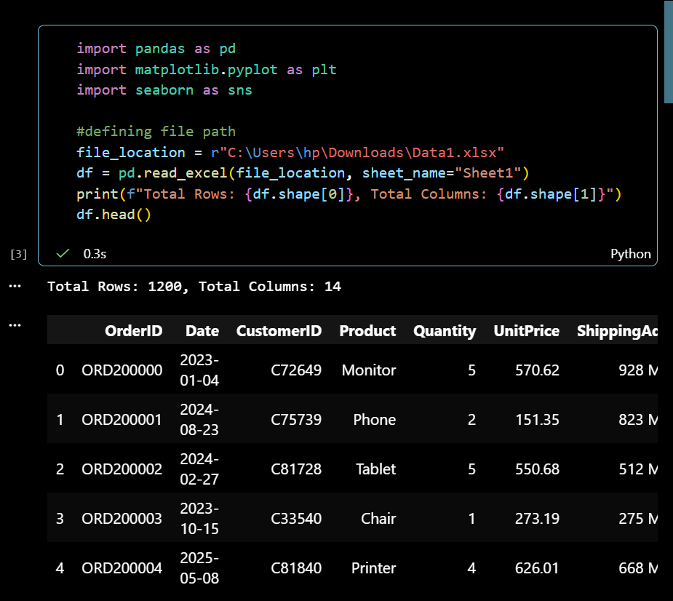
DESCRIPTIVE STATISTICS: (Mean vs. Median Analysis)
To understand the baseline distribution of the transaction sizes, a descriptive statistical scan was conducted on the Total Price column:

Average Mean | Median | Minimum Recorded Transaction | Maximum Recorded Transaction
- $1,053.97 | $823.62 | - $11.39 | $3,456.40

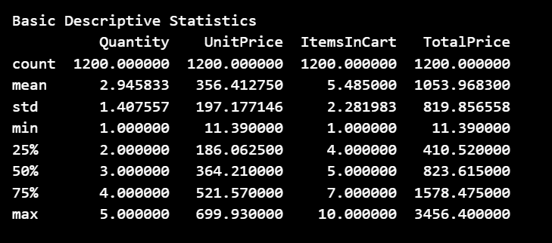
Analyst Insight :
The Mean ($1,053.97) is significantly higher than the Median ($823.62). This reveals that the dataset is heavily skewed to the right. In business terms, this proves that while the majority of customers make average-sized purchases, there is a distinct group of high-value, large-volume orders pulling the average upward.
Product Performance Portfolio (Revenue & Volume Rankings):
By aggregating data by product lines, the financial footprint of each category was calculated and sorted by total revenue generation:
- Chair
  - Total Quantity Sold: 518 units
  - Total Revenue Generated: $195,620.11
  - Average Unit Price: $388.94
- Printer
  - Total Quantity Sold: 477 units
  - Total Revenue Generated: $195,612.61
  - Average Unit Price: $407.34
- Laptop
  - Total Quantity Sold: 475 units
  - Total Revenue Generated: $192,126.56
  - Average Unit Price: $408.82
- Tablet
  - Total Quantity Sold: 498 units
  - Total Revenue Generated: $186,568.95
  - Average Unit Price: $391.24
- Monitor
  - Total Quantity Sold: 455 units
  - Total Revenue Generated: $175,651.41
  - Average Unit Price: $396.65
- Desk
  - Total Quantity Sold: 433 units
  - Total Revenue Generated: $167,459.93
  - Average Unit Price: $392.21
- Phone
  - Total Quantity Sold: 416 units
  - Total Revenue Generated: $151,722.39
  - Average Unit Price: $379.88
  - 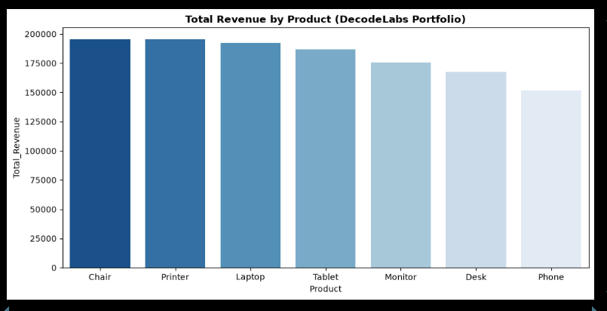
  - 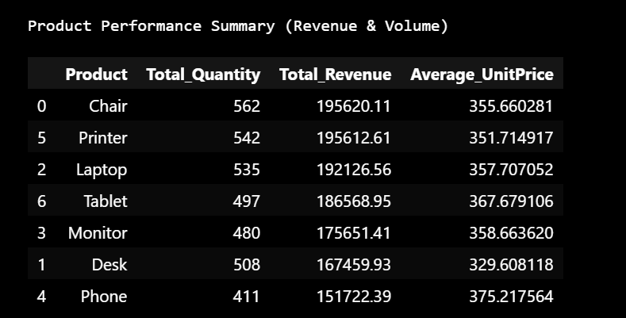
Product Takeaway:
Chairs stand as the leading revenue pillar for the business, closely followed by Printers with a negligible margin. Conversely, Phones underperformed compared to other categories, bringing in the lowest revenue portfolio
.
Forensic Outlier Detection (Interquartile Range Method)
Using the standard mathematical IQR method ($IQR = Q3 - Q1$), the upper safety threshold was calculated. The forensic scan successfully isolated exactly 8 extreme outlier transactions:
- ORD200107: Printer | Quantity: 5 | Unit Price: $670.75 | Total Price: $3,353.75
- ORD200326: Laptop | Quantity: 5 | Unit Price: $670.48 | Total Price: $3,352.40
- ORD200328: Tablet | Quantity: 5 | Unit Price: $674.04 | Total Price: $3,370.20
- ORD200469: Chair | Quantity: 5 | Unit Price: $676.98 | Total Price: $3,384.90
- ORD200632: Laptop | Quantity: 5 | Unit Price: $678.16 | Total Price: $3,390.80
- ORD200789: Tablet | Quantity: 5 | Unit Price: $691.28 | Total Price: $3,456.40 (Highest Overall Order)
- ORD201065: Printer | Quantity: 5 | Unit Price: $666.80 | Total Price: $3,334.00
- ORD201122: Monitor | Quantity: 5 | Unit Price: $678.19 | Total Price: $3,390.95
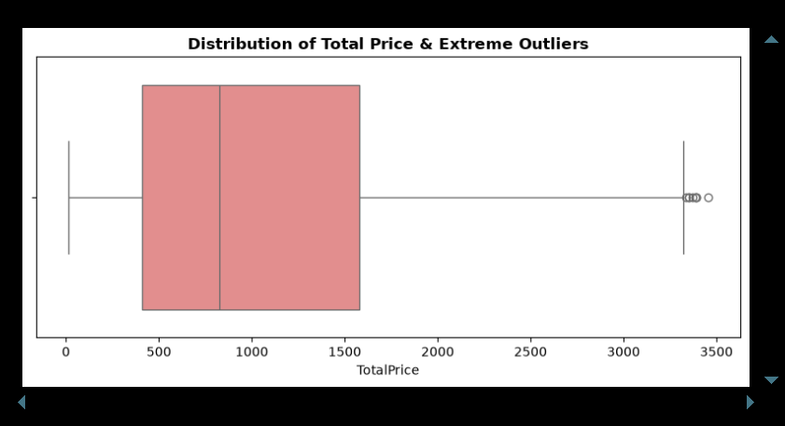
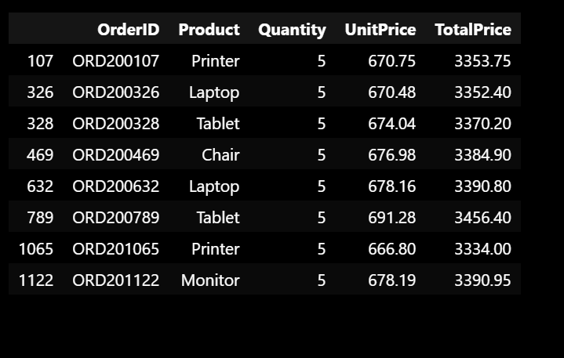
Signal vs. Noise Evaluation:
An inspection of these 8 anomalies confirms they do not represent typographical errors or system glitches (Noise). Instead, they are genuine, maximum-capacity wholesale transactions (5 units per order at high unit rates). Therefore, these represent VIP High-Net-Worth Customers (Signal) rather than errors.
Strategic Business Recommendations:
- VIP Engagement: Design exclusive corporate/loyalty packages tailored for customers matching the outlier profiles, as they drive substantial revenue spikes.
- Inventory Prioritization: Increase marketing allocation and stock stability for Chairs and Printers, which serve as the highest-grossing business pillars.
- Data Handling: Missing data structures (such as unapplied coupon fields) were safely bypassed during data loading to prevent skewing the standard descriptive statistics.

