INDUSTRIAL TRAINING PROJECT REPORT
Project Report

Decode Labs| By: Umm-e-Haniya


SQL DATA ANALYSIS:
Project Overview & Objective
In this project, we transitioned from basic spreadsheet viewing to systematic Relational Logic and Data Extraction. The primary objective was to act as a Data Analyst at Decode Labs and utilize structured SQL queries to filter, group, and aggregate raw business data. By executing these queries, we successfully transformed a massive unorganized dataset into highly actionable business intelligence

SQL Schema & Table Structure
The transactional dataset was loaded into a relational table named sales_table. The core attributes analyzed include:
- Order ID: Unique identifier for each order.
- CustomerID: Unique identifier for customers.:
- Product: The item sold (e.g., Monitor, Phone, Tablet, Chair, Printer, Desk).
- Quantity: Number of units ordered.
- Total Price: Total monetary value of the transaction.
- Order Status: Current state of delivery (Shipped, Delivered, Cancelled, Returned, Pending).
- Payment Method: Mode of payment (Credit Card, Debit Card, Online, Cash, Gift Card).

Core SQL Queries & Business Insights
Milestone 1: Basic Aggregations (Overall Performance):

Business Objective: To understand the high-level health of the business by calculating total volume, total revenue, and the average value per transaction.
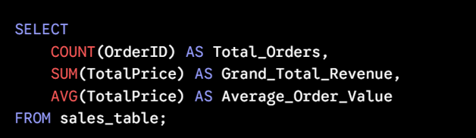
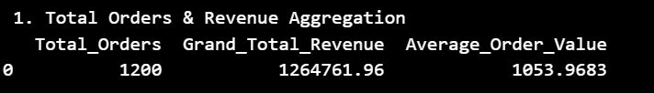
Milestone 2: Product Performance Portfolio:

Business Objective: To identify which products are driving the maximum sales volume and monetary revenue using categorical bucketing.
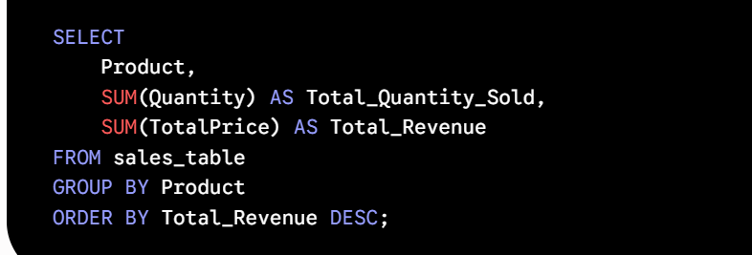

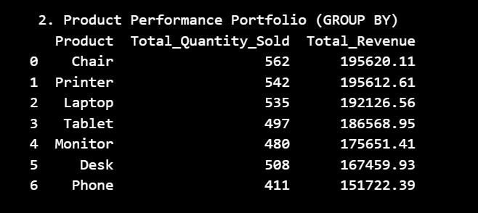

Milestone 3: Row-Level Filtering (Large Shipped Orders):
Business Objective: To isolate high-value operations by focusing strictly on successfully shipped orders containing bulk quantities (4 or more units).
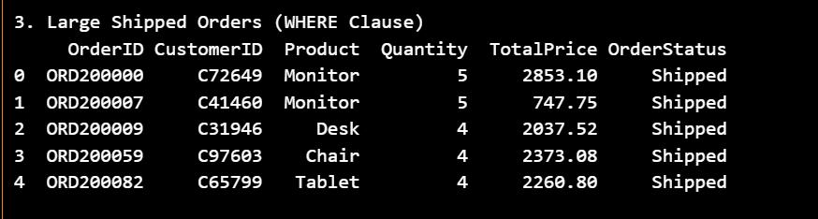
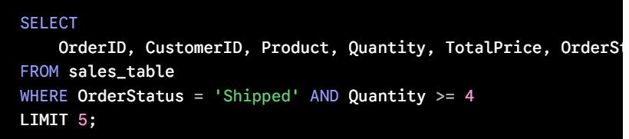

Milestone 4: Payment Method Analytics:
Business Objective: To analyze consumer behavior regarding payment choices and understand which channel contributes the most transactions and revenue.
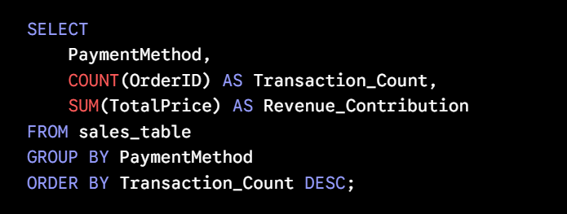
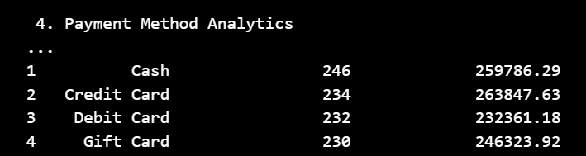
Technical Conclusion:By writing and executing these fundamental relational queries (SELECT, WHERE, GROUP BY, ORDER BY), we successfully bypassed manual inspection and extracted precise answers. This completes the Extraction Phase of the training, proving competency in managing structured databases and supplying leadership with data-backed truth.

