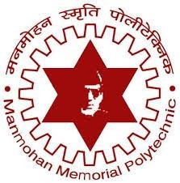
Manmohan Memorial Polytechnic
Department of Information Technology
Academic Year: 2080–2083
MINOR PROJECT PROPOSAL
Project Title:
Department Management System
Submitted By:
Reg.no : DIT-00160-023 Reg.no : DIT-00161-023
Prem Singh Priti Dev
Reg.no : DIT-00174-022 Reg.no : DIT-00163-023
Sital Mahato Rabin Sardar

Project Supervisor - Mohan Tabdar

Submitted To:
Department of Information Technology
Manmohan Memorial Polytechnic
[Budhiganga Rural Municipality – 04, Koshi Province]

Table of Contents
1. Introduction 1
2. Problem Statement 1
3. Objectives 1
4. Literature Review 2
5. Methodology 3
5.1 Development Methodology 3
5.2 Technology Stack 3
5.3 Feature Breakdown & User Flows 3
A. HOD Module (Full Administrative Access) 3
B. Teacher Module (Academic Access) 5
C. Student Module (Limited Access) 7
D. Parent Module (Limited Access) 8
5.4 Simplified Data Model 8
6. Expected Outcomes 8
7. Gantt Chart 9
8. Team Members 9
9. References 9

1. Introduction
The Department Management System is a web-based platform designed to digitalize and streamline all academic and administrative activities inside a department.
Many colleges still use paper registers, manual marksheets, handwritten notices, and scattered documents. This creates difficulties in communication, monitoring, and record-keeping.
This system provides role-based dashboards for HOD, teachers, students, and parents.
It manages attendance, marks, study materials, notices, student records, and communication all inside a single digital platform.
The primary aim is to make departmental operations faster, error-free, transparent, and easy to access for everyone. The system enhances efficiency, reduces workload, and supports a student-friendly digital environment.

2. Problem Statement
Departments face many challenges because most operations are still performed manually:
Attendance registers get lost or damaged.
Students cannot access their marks, notes, or notices in one place.
Teachers must manage attendance, marks, and materials separately.
Parents cannot easily track their child’s performance.
The HOD lacks real-time reports of academics and teacher activities.
Data becomes difficult to maintain and errors occur often.
Communication between teachers, students, and parents is inconsistent.
These issues reduce efficiency and create unnecessary workload.
A centralized system is needed to solve these problems.

3. Objectives
Main Objective:
To develop a centralized, digital, and user-friendly system that manages all major operations of the department.
Specific Objectives:
To manage attendance, marks, materials, and notices through a single platform.
To reduce manual work and avoid errors.
To provide dedicated dashboards for HOD, teachers, students, and parents.
To improve communication within the department.
To allow parents to monitor student progress easily.
To generate real-time reports for informed decision-making.
To keep departmental records secure and organized.

4. Literature Review
Many academic institutions worldwide are switching to digital management systems to reduce paperwork, improve communication, and maintain accurate records.
Digital departmental systems commonly include:
Automated attendance
Marks management
Document sharing
Notice management
Real-time dashboards
Global Case Studies
Countries like the US, UK, and Australia use departmental analytics dashboards that track student performance and attendance digitally.
Studies show that such systems reduce paperwork by up to 50% and improve academic transparency.
In India and Nepal, engineering colleges have recently begun implementing department-based systems.
Institutions using these systems report improved student engagement and reduced data loss.
Department Management Technologies
Modern systems include:
Online attendance modules
Digital marks entry
Materials sharing
Role-based dashboards
Automated notifications
Cloud-based secure storage
Modern Academic Information Systems
They focus on:
Real-time data
Mobile-friendly access
Analytics and reporting
Automated workflows
Better student interaction
These trends influenced the development of this system.

5. Methodology

5.1 Development Methodology
Follows the Agile Development Model
Work divided into weekly sprints
Regular feedback from faculty/students
Simple UI/UX for easy use
Modular and scalable structure

5.2 Technology Stack
Frontend: HTML5, CSS3, Bootstrap, JavaScript, React
Backend: Laravel
Database: MySQL
Server: Localhost
Version Control: Git & GitHub
Authentication: Role-based secure login

5.3 Feature Breakdown & User Flows
Below are the complete detailed features for each module, replacing the previous short descriptions.

A. HOD Module (Full Administrative Access)
The HOD has complete control over the entire department system.
Dashboard Overview
Total students, teachers, parents
Subjects offered
Average monthly attendance
Notices posted
Upcoming events
Recent activities
User Management
Add/Edit/Delete Students
Add/Edit/Delete Teachers
Add/Edit/Delete Parents
Assign students to semesters
Assign teachers to subjects
Attendance Monitoring
HOD can view:
Attendance of any date
Attendance of any student
Attendance of any subject
Monthly and semester reports
Low-attendance students
Teacher attendance activity
Marks Monitoring
HOD can access:
Marks of any student
Subject-wise marks
Internal exam and assignment marks
Highest/lowest marks
Class & semester comparison charts
Notice Management
Publish department notices
Edit or delete notices
View notice history
Teacher Activity Monitoring
Tracks:
Attendance taken
Marks uploaded
Study materials uploaded
Notices posted
Login activity
Pending tasks
Subject & Semester Management
Add/edit subjects
Assign teachers
Organize subjects based on semester
Reports & Analytics
Generate:
Attendance reports
Marks reports
Teacher performance summaries
Student progress reports
Full department statistics
Audit Log System
Records all actions:
Who did what
Exact time/date
Type of change
Ensures security and transparency.

B. Teacher Module (Academic Access)
Teachers handle academic operations only.
Teacher Dashboard
Displays:
Assigned subjects
Today's schedule
Class lists
Pending tasks
Recent activity
Attendance Management
Teachers can:
Take daily attendance
Edit attendance
View subject-wise attendance
Track student performance
Marks Entry
Teachers can:
Upload internal exam marks
Add assignment/lab marks
Modify marks
View performance trends
Study Material Upload
Teachers can upload:
Notes
Slides
Assignments
Lab sheets
Previous questions
Notice Posting
Used for:
Assignment deadlines
Exam schedules
Class updates
Lab information
Student List Access
Teachers can view:
Students enrolled in their subjects
Attendance & marks (only for their subject)
Profile Settings
Teachers can update profile and password.

C. Student Module (Limited Access)
Student Dashboard
Shows:
Attendance percentage
Internal marks
Latest notices
Available study materials
Assigned teachers
Attendance View
Students can see:
Daily attendance
Subject-wise attendance
Monthly overview
Absence details
Marks View
Students can view:
Internal exam marks
Assignment/lab marks
Subject totals
Semester-wise performance
Study Material Download
Students can download:
Notes
Lab sheets
Presentations
Assignments
Notice Board
View all important notices.
Profile
Shows personal, academic, and parent details.

D. Parent Module (Limited Access)
Parent Features
Parents can view:
Student attendance
Internal marks
Notices
Academic performance trends
Importance
Promotes parental involvement and improves student accountability.

5.4 Simplified Data Model
Tables include:
User
Student
Teacher
Parent
Attendance
Marks
Notice
Materials
(Structure same as your sample.)

6. Expected Outcomes
Department becomes fully digital
Students access materials, marks, and notices easily
Teachers save time on attendance and marks
Parents monitor progress instantly
HOD gains complete real-time control
Fewer errors and missing records
Improved communication and transparency
Secure, organized, and accessible data

7. Gantt Chart
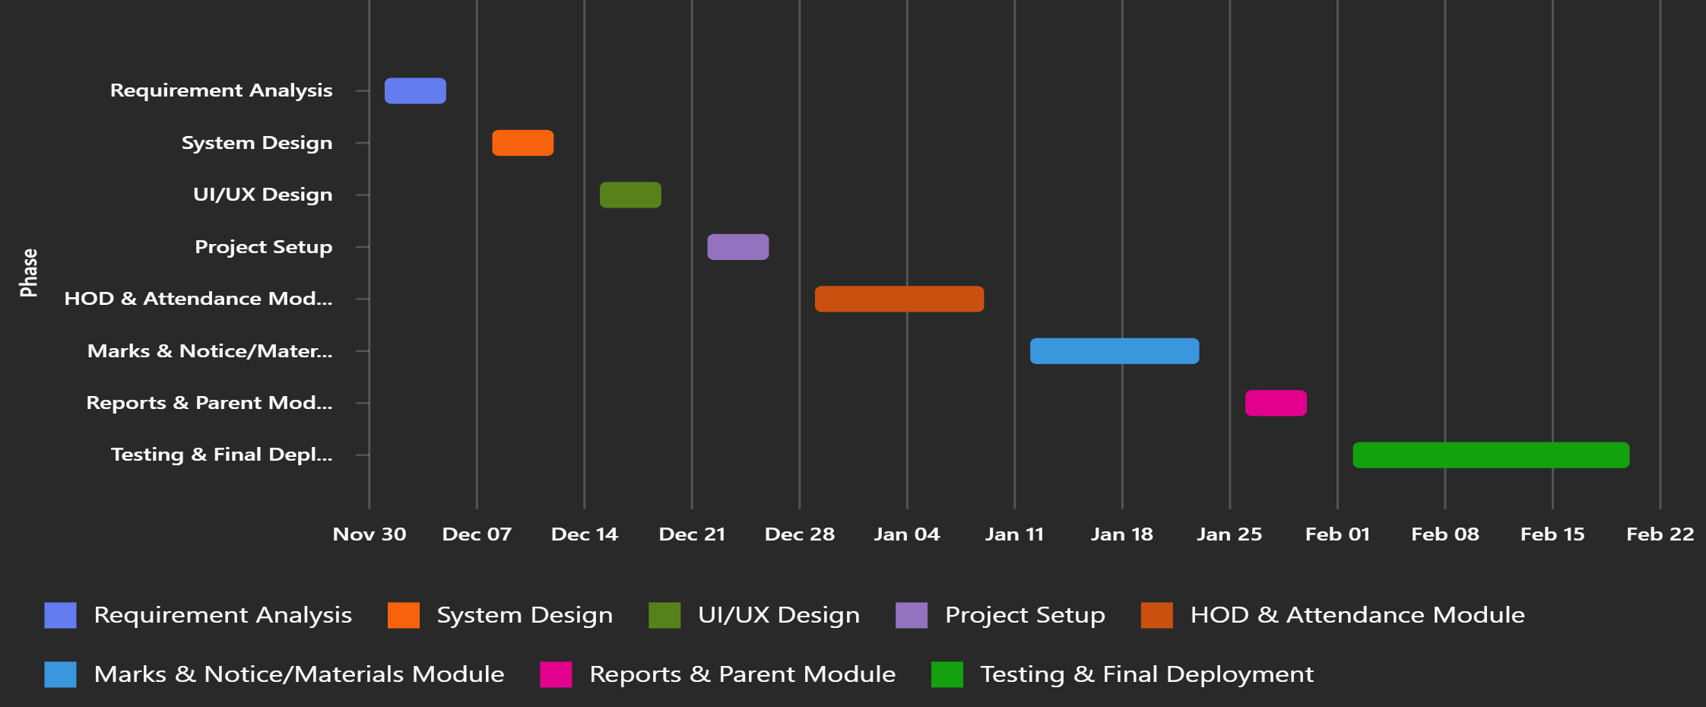

8. Team Members
- Prem Singh- Frontend development (UI/UX, responsive design, integration)
- Sital Mahato- Project lead & backend development (Laravel, database, API, deployment)
- Priti Dev- Presentation & QA support (slides, bug reporting, screenshots)
- Rabin Sardar- Documentation & testing support (proposal, user manual, QA)

9. References
Sharma, A., & Gupta, R. (2020). Academic Management Systems in Higher Education. International Journal of Computer Applications.
Singh, R., & Verma, A. (2021). Digital Transformation in Engineering Colleges: A Study on Department Automation Systems. Journal of Educational Technology.
Kumar, J. (2022). Educational Information Systems: Concepts and Applications. India: TechKnowledge Publications.
European Education Review. (2019). Automation and Digital Record Systems in University Departments.
Alharbi, A. (2020). Web-Based Educational Portals for Student Performance Tracking. International Journal of Information Systems.
Basnet, K., & Thapa, S. (2021). Impact of Online Academic Platforms in Nepalese Institutions. Nepal Journal of ICT and Education.
W3Schools. (n.d.). Web Development Technologies (HTML, CSS, JavaScript, React).
Retrieved from: https://www.w3schools.com
Laravel Documentation. (n.d.). Laravel Framework Overview & Features.
Retrieved from: https://laravel.com/docs
MySQL Documentation. (n.d.). MySQL Database Management System Architecture.
Retrieved from: https://dev.mysql.com/doc
GitHub Documentation. (n.d.). Version Control and Collaboration using Git.
Retrieved from: https://docs.github.com
OpenAI. (2025). ChatGPT (GPT-5.1) — AI Language Model used for content generation and documentation support.
Retrieved from: https://chat.openai.com

