

Amity University Online, Noida, Uttar Pradesh, India

In partial fulfilment of the requirements for the award of the degree

**Masters of Business Administration – Data Science**

**Title:** InsightNation - Government Data Analytics Platform for Citizen Opinion and Public Service Enhancement

**Guide Det:**

**Name:** Vasanthi Chandran

**Designation:**

**Submitted By:**

**Student Name:** PRANOY CHAKRABORTY

**Enrolment No:** A9920123006194

**Course Name:** Dissertation (MSDS600)

**Date:**

ANNEXURE B

**DECLARATION**

I, **Pranoy Chakraborty**, a student pursuing **MBA, Semester 4 (Specialization: Data Science)** at **Amity University Online**, hereby declare that the project work entitled **“InsightNation – Government Data Analytics Platform for Citizen Opinion and Public Service Enhancement”** has been prepared by me during the academic year **2023-2025** under the guidance of **Ms. Vasanthi Chandran, Project Guide from Qollabb**. I assert that this project is a piece of original bona fide work done by me. It is the outcome of my own effort, and it has not been submitted to any other university for the award of any degree.

Name and signature of the student

_________________________________

PRANOY CHAKRABORTY

**PLAGARISM REPORT**

This is to certify that I, **Pranoy Chakraborty**, enrolled in the 4th semester of the degree program “Master of Business Administration”, and undertaking the course by the title “Dissertation (MSDS600)”, for the third semester in the academic session of July’ 2023, have submitted this report under strict compliance of the guidelines specified by Amity University by keeping the percentage of plagiarism below the permissible limits.

This plagiarism in this report has been checked using the tool “Dupli Checker” and it came out to be 100%.

**ACKNOWLEDGEMENT**

I would like to convey my profound gratitude to **Ms. Vasanthi Chandran,** my professor and supervisor, for her invaluable guidance, mentorship, and steadfast support throughout this project. Her expertise and encouragement have been instrumental in enhancing my understanding of customer churn dynamics and the application of data analytical techniques.

I am also indebted for her astute advice, assistance, and generous dissemination of knowledge. Her guidance and motivation have empowered me to engage in rigorous research, address complex data challenges independently, and navigate intricate machine learning methodologies with confidence. Additionally, her moral support has been a significant source of strength throughout this endeavour.

Finally, I extend my heartfelt appreciation to all individuals who have contributed directly or indirectly to this project. Your support and encouragement have been invaluable, and I am deeply appreciative of the collective effort that has facilitated this undertaking.

**ABSTRACT**

In the era of data-driven decision-making, the need for responsive governance and citizen-centric public service delivery has become more critical than ever. Traditional approaches to understanding public sentiment and service satisfaction often rely on slow, manual surveys or narrowly scoped feedback loops, which limit the scope and accuracy of actionable insights. As societies continue to urbanize and digitalize, there is a growing need for governments and civic agencies to adopt more scalable, intelligent, and adaptive methods for interpreting citizen feedback and improving services in real time. In response to this challenge, the current project introduces InsightNation – a robust, AI- and ML-powered analytics platform designed to bridge the gap between public opinion and smarter public service enhancement.

This dissertation project, ‘InsightNation – Government Data Analytics Platform for Citizen Opinion and Public Service Enhancement’ serves as a data analytics platform that ingests, processes, analyzes, and visualizes multi-dimensional feedback from citizens across a wide spectrum of public service categories such as sanitation, transportation, parks and recreation, library services, and safety. The system employs modern techniques in natural language processing (NLP), statistical analytics, and supervised machine learning to mine actionable insights from structured survey data. It transforms raw citizen input into meaningful dashboards, predictive models, and strategic recommendations for government stakeholders, municipal planners, and civic organizations. By offering real-time visibility into what citizens are experiencing and expecting, the platform seeks to assist decision-makers in identifying gaps, measuring satisfaction, and forecasting future needs.

The project's architecture is designed for extensibility and scalability, allowing for flexible growth and adaptation. The backend pipeline is powered by Python and pandas for data wrangling, scikit-learn and SpaCy for machine learning and NLP, and Matplotlib/Plotly for visualization. The frontend is developed using Streamlit, allowing users to interact with the system through a clean, intuitive dashboard that supports file uploads, dynamic charts, chatbot-style Q&A, and visual summaries of citizen sentiment. Data input primarily consists of cleaned and structured CSV survey data collected from diverse urban populations, comprising multiple demographic segments and service categories. The dataset used for this project includes over 5,000 citizen records, each with detailed service-level feedback and open-text suggestions.

One of the core innovations of the InsightNation platform lies in its ability to apply sentiment classification to open-ended citizen responses using advanced NLP pipelines. After pre-processing textual feedback with SpaCy (including tokenization, lemmatization, stopword removal, and named entity recognition), the platform uses machine learning models such as Logistic Regression and Support Vector Machines (SVM) to classify sentiments into positive, negative, or neutral categories. These classifications are further aggregated and visualized to identify trends by city, age group, gender, or service type. The system’s learning pipeline is designed to be extensible to other models, including BERT or LSTM-based architectures, to improve classification accuracy in future iterations.

In addition to traditional charts and model outputs, InsightNation integrates conversational AI through Google’s Gemini LLM (via the Gemini API), enabling natural language interaction with the analytics platform. Users can ask contextual questions about trends, seek strategy advice, or request summaries of findings in plain English. This feature empowers non-technical stakeholders, such as municipal leaders or citizen engagement officers, to access AI-generated insights without needing to understand the underlying data science models. Moreover, this conversational layer includes tools for SWOT analysis, business-like recommendations, and memory-based Q&A to simulate expert consultants.

To ensure robust usability and modular growth, the platform is divided into distinct functional phases: dataset upload and cleaning, exploratory data analysis (EDA), NLP preprocessing, ML modeling, data visualization, and AI-powered advisory modules. Each phase is linked to an intuitive tab in the Streamlit interface and is supported by Python scripts organized in a standardized folder structure, ensuring clean codebase management and future scalability.

From a project management standpoint, InsightNation was developed over 12 structured weeks, adhering to an agile methodology with iterative development, testing, and refinement. Weekly milestones covered problem identification, system architecture, model experimentation, UI/UX design, performance validation, and final integration. The deliverables include a fully functional Streamlit-based analytics platform, trained ML/NLP models, custom visualization assets, and a detailed project report documenting methodology, results, findings, and strategic implications.

The outcomes of this project demonstrate the power and necessity of integrating AI and citizen feedback to improve public services. Through machine learning and interactive dashboards, decision-makers can now pinpoint areas of concern, recognize regional disparities, and deploy targeted interventions with data backing. Furthermore, the use of NLP ensures that even qualitative suggestions—often ignored in traditional feedback pipelines—are now incorporated into performance reviews and planning strategies. Ultimately, this results in a more participatory governance model where citizens feel heard and empowered, and where governments respond faster and more precisely to evolving public needs.

In conclusion, InsightNation redefines how governments and civic agencies can listen to and act upon public opinion using modern data science tools. It lays the groundwork for scalable public service intelligence that goes beyond static survey reports, offering a continuous, AI-augmented decision-making loop. The successful implementation of this platform sets a strong precedent for replicating this model across regions, departments, and even entire nations.

Future Scaling and Expansion: Looking ahead, InsightNation can be scaled to integrate real-time feedback channels such as mobile apps or social media APIs, allowing for live citizen sentiment tracking. Additionally, advanced AI integrations such as GPT-based summarization, multilingual feedback parsing, and smart alert systems for anomaly detection can enhance the platform’s utility in larger, more complex public service ecosystems.

Keywords: Public Service Analytics, Citizen Feedback, Data Science, Machine Learning, Natural Language Processing (NLP), Sentiment Analysis, Streamlit Dashboard, AI-Powered Governance, Google Gemini API, Civic Engagement, Public Satisfaction, Predictive Analytics.

# **CHAPTER 1 – INTRODUCTION**

In today’s era of digital transformation and data-driven governance, citizen feedback is no longer a passive form of communication—it has emerged as a powerful instrument to enhance the efficiency, transparency, and responsiveness of public service delivery. Government agencies, municipal bodies, and public institutions are increasingly recognizing the value of listening to the voice of the citizen, both as a metric of satisfaction and as a compass for strategic improvements. Against this backdrop, the need for structured, intelligent, and scalable analytics platforms that can process, analyze, and derive actionable insights from public opinion has become more critical than ever.

The capstone project titled **“InsightNation – Government Data Analytics Platform for Citizen Opinion and Public Service Enhancement”** is conceived as a strategic and technological response to the increasingly urgent need for responsive, data-informed governance. As societies grow more urbanized and citizens demand higher standards of public service delivery, it becomes critical for governing bodies to not only listen to feedback but to systematize its collection, processing, and analysis. This project addresses that precise challenge by building a platform that empowers public administrators, planners, and policymakers with data-driven insights derived directly from citizens’ lived experiences and service interactions.

At the heart of the InsightNation platform lies the recognition that citizen feedback is not just an afterthought or a box to be checked—it is a powerful diagnostic tool that can inform resource allocation, uncover systemic inefficiencies, and highlight areas of improvement in real time. The project is therefore anchored in the belief that **data is a dialogue**, and that turning qualitative and quantitative feedback into structured, actionable intelligence is essential for making public service delivery more efficient, inclusive, and accountable.

The scope of the platform encompasses feedback from multiple touchpoints within urban public services—including **sanitation facilities, public parks, transport infrastructure, library access, and local governance mechanisms**. These areas were deliberately chosen because they represent core dimensions of urban livability and are commonly encountered by a wide spectrum of citizens across age groups, genders, and geographies. By analyzing feedback across these domains, the project ensures that insights generated are both **comprehensive and multi-faceted**, reflecting the complex realities of public life.

Technically, the project integrates **data engineering, statistical analysis, machine learning (ML), and natural language processing (NLP)** into a seamless pipeline that takes raw citizen feedback—often fragmented and unstructured—and transforms it into clean, interpretable formats. These are then analyzed to detect patterns, identify satisfaction gaps, and prioritize areas needing urgent attention. The platform also enables **demographic-level segmentation**, allowing public agencies to customize their interventions based on city, age group, or gender, thereby aligning service delivery with the actual needs of their constituents.

Importantly, this project is not simply about creating dashboards or performing one-off analytics. Rather, it demonstrates the viability of a **scalable, modular, and policy-aligned architecture** that can be deployed by municipalities or civil organizations seeking to embed analytics into their feedback loops. It is a **proof-of-concept** that public feedback analytics can go beyond surveys and summaries, evolving into an engine for civic intelligence and smarter decision-making. Ultimately, InsightNation aims to bridge the long-standing gap between **what people say and what governments do**—not through guesswork or assumptions, but through **data, analysis, and insight**.

Public institutions across the world have historically struggled with inefficiencies, bureaucratic bottlenecks, and outdated feedback mechanisms. Paper-based surveys, occasional community meetings, and static suggestion boxes are often inadequate in reflecting the dynamic needs and grievances of a digitally connected and increasingly aware populace. While some developed nations have adopted e-governance portals and smart feedback collection systems, many regions—including several urban and semi-urban areas in developing countries—still lack real-time, analytics-backed systems for tracking service performance. This project aims to fill that void by building an intelligent data analytics platform tailored to the nuances of public service interactions.

**Contextual Relevance and Problem Background**

The conventional model of public service feedback collection is often fragmented, delayed, and unstructured. Citizens may provide feedback in multiple formats—verbal complaints, online reviews, social media posts, or structured forms—but public agencies typically lack the infrastructure to integrate and analyze these inputs holistically. Moreover, the absence of sentiment classification, thematic grouping, and performance dashboards makes it difficult for public officials to prioritize actions or track improvement over time.

With the proliferation of smart cities and digital citizenship initiatives, the time is ripe to introduce AI-powered platforms that bring structure to the chaos of public opinion. A data analytics-driven feedback platform holds the promise of quantifying subjective experiences, identifying recurring pain points, and highlighting regional variations in service delivery quality. For example, if transport services are routinely flagged as unsafe by female commuters in a particular city zone, such signals can help civic authorities deploy gender-sensitive policy interventions more effectively. Similarly, poor satisfaction scores for library access or cleanliness issues in public parks can be traced and resolved proactively if detected early through systematic analytics.

In this context, the InsightNation platform presents a transformative approach to civic management. By combining structured survey data, Natural Language Processing (NLP) for free-text suggestions, and visual analytics through dashboards, the platform equips administrators with a 360-degree view of public sentiment. Not only does this reduce reliance on intuition and anecdotal evidence, but it also enables a culture of evidence-based governance.

**Justification of Selecting the topic:**

The selection of this project topic is grounded in its societal impact, analytical complexity, and technological relevance. As an MBA student specializing in Data Science, the intersection of civic engagement, AI-driven insights, and service optimization offers a rich, multi-dimensional problem space that aligns well with academic objectives and real-world applicability. Moreover, this topic provides an opportunity to explore various facets of data science—data wrangling, statistical analysis, machine learning, NLP, and dashboarding—within the context of a high-stakes, socially beneficial domain.

From a societal standpoint, public dissatisfaction with services—be it poor sanitation, unreliable transportation, or underutilized civic amenities—has tangible repercussions. It not only erodes trust in public institutions but also hampers the quality of life in communities. By building a platform that can intelligently harness and analyze citizen sentiment, this project contributes meaningfully to solving a chronic problem that affects millions of people, particularly in urbanizing regions.

Technologically, the project aligns with current industry trends such as smart governance, civic tech innovation, and AI for social good. Leading global cities are investing heavily in platforms that can automate public feedback processing using data science. For instance, New York City’s 311 service, London’s open data portal, and Singapore’s Smart Nation initiative all represent institutional efforts to embrace data-led decision-making. This project aspires to bring similar capabilities within the reach of local municipalities and citizen engagement programs in developing nations, using open-source tools and scalable machine learning models.

Furthermore, the topic offers an academic advantage in that it encapsulates multiple modules from the MBA Data Science curriculum. The project involves data preprocessing, feature engineering, supervised learning (for sentiment classification), and unsupervised techniques (for clustering or topic modeling, where applicable). It also includes dashboard development using Streamlit, making it suitable for real-time data visualization and executive-level decision support.

In selecting this topic, the goal was not just to complete a project for academic fulfillment but to prototype a potentially scalable solution that could be deployed in real-life urban or civic contexts. The modular design and open-source architecture ensure that the platform can be extended to integrate with mobile apps, voice-based feedback systems, or even multilingual NLP models in the future. The implications of this work stretch beyond technical execution—they touch upon policy innovation, public-private partnership models, and the democratization of data access in governance.

**Current Landscape and Research Gaps:**

In recent years, the idea of citizen-centric governance has gained significant momentum globally, driven by a growing recognition that public participation is essential for building responsive and accountable government systems. Governments at national, state, and municipal levels are increasingly turning to digital platforms to solicit feedback from citizens on a wide range of public services. Whether it's about sanitation facilities, public transport, urban green spaces, safety in neighbourhoods, or the efficiency of local libraries, the demand for real-time citizen insights is escalating. However, despite this growing interest, the actual implementation and utilization of comprehensive feedback analytics platforms remain largely limited and underdeveloped.

Currently, most digital governance initiatives focus primarily on front-end engagement—developing mobile applications, web portals, or survey systems that allow citizens to register complaints, give ratings, or submit suggestions. While this infrastructure is critical, it addresses only the initial stage of the data lifecycle. What follows—namely, backend analytics, intelligent processing, and actionable insight generation—is often either absent or implemented in a rudimentary manner. These systems are frequently restricted to basic summary statistics or manual review processes, limiting their scalability and impact.

Even where basic analytics exist, they are often narrow in scope. For example, sentiment analysis, if employed at all, tends to be binary or polarity-based (positive vs. negative), without considering the nuanced themes, domain-specific terminology, or contextual variations embedded in feedback. Many models also fail to consider how feedback might vary based on demographics like age group, gender, or geographic location, which are crucial for equity-focused public service delivery. Furthermore, despite the diversity of service domains covered—such as sanitation, safety, transport, libraries, and public parks—there is little effort to develop multi-domain feedback models that reflect the complexity of citizen experiences.

Additionally, multilingualism in countries like India poses a significant challenge to NLP-based public opinion analytics. Many local feedback platforms struggle to effectively process regional languages or dialects, leading to the exclusion of non-English speakers from data-driven decision-making processes. Even when translations are performed, semantic context and emotional tone are often lost, leading to erroneous interpretations. This highlights a critical technological gap in natural language understanding tailored to culturally and linguistically diverse populations.

Data privacy and governance concerns also limit the deployment of large-scale feedback platforms. Many local government bodies lack the infrastructure or policies necessary to ensure secure data handling, leading to public distrust in feedback collection mechanisms. As a result, adoption rates remain low, and data quality suffers due to limited participation or superficial responses. Moreover, the lack of standardization in data formats and storage protocols across different municipal systems makes inter-agency data integration a significant bottleneck.

From a research standpoint, the academic and industry literature on public feedback analytics remains relatively sparse when compared to other domains like e-commerce, healthcare, or financial services, where customer sentiment and behavioral data have long been mined for strategic advantage. Numerous studies have developed sophisticated NLP models to analyze product reviews, patient feedback, or investment sentiment. However, analogous efforts in the public service domain—especially those that cut across multiple services and citizen attributes—are few and far between.

Even within existing civic research, many studies tend to be issue-specific (e.g., transport planning or sanitation improvement), failing to adopt a holistic, cross-service analytical approach. Moreover, while there is considerable literature on service delivery models and governance metrics, the incorporation of real-time citizen feedback into these models remains mostly theoretical. There is a lack of operational platforms that bridge academic research with practical implementation in this area.

This project, InsightNation, is positioned to address these deficiencies by creating an integrated analytics platform that is capable of ingesting, preprocessing, analyzing, and visualizing citizen feedback across multiple service domains. It does not merely aim to summarize responses but to derive patterns, trends, and insights that are both actionable and policy-relevant. The project leverages modern data science methodologies—including machine learning (ML), natural language processing (NLP), and interactive visual analytics—to build a pipeline that simulates how government agencies might meaningfully interpret large-scale public feedback.

The dataset used in the project comprises over 4,000 records, collected through structured citizen surveys spanning a diverse set of demographic attributes and public service areas. Each record includes responses about sanitation cleanliness, safety perception, transport satisfaction, library usage, and park facilities, among others. It also captures metadata such as city, gender, age group, and service usage frequency, enabling multi-dimensional slicing of the feedback.

Such a dataset offers a rich substrate for not just exploratory data analysis (EDA) and descriptive statistics, but also for advanced modeling and hypothesis testing. For example, the project investigates whether certain cities are underperforming in specific domains (e.g., library services), whether satisfaction levels correlate with age or gender, or what themes emerge in open-ended suggestions for public services. These questions are not just academically intriguing; they are deeply consequential from a public policy and urban governance perspective.

By embedding these questions into the design of its analytics workflows, the InsightNation platform seeks to provide a proof-of-concept for how public agencies can move from passive data collection to active, insight-driven decision-making. This approach not only bridges the gap between data and action but also contributes to the emerging field of digital public service innovation, where feedback loops between citizens and institutions are both real-time and data-informed.

In summary, the current landscape of public feedback analytics is fragmented and underdeveloped, particularly in its backend intelligence and multi-domain modeling capabilities. The research gaps in this space—ranging from sentiment analysis in public services to demographic-driven satisfaction modeling—are vast but addressable. InsightNation’s goal is to contribute a tangible step forward in closing these gaps by demonstrating the potential of a citizen feedback analytics platform that is technologically robust, ethically grounded, and policy-aligned.

**Real-World Implications**

In practice, platforms like InsightNation can serve multiple stakeholders. For municipal governments, it offers a tool to diagnose service gaps and respond to citizen needs in real-time. For non-governmental organizations (NGOs), it can serve as an advocacy tool to highlight underserved communities or services. For researchers and data journalists, it offers a mine of structured public sentiment data that can inform articles, studies, and investigations.

At a time when trust in public institutions is fragile, and citizen expectations are rapidly evolving, a data-backed feedback loop can serve as the foundation for collaborative governance. By involving citizens not just as complainants but as co-creators of urban experiences, platforms like InsightNation shift the paradigm from reactive to proactive administration.

Additionally, this approach has significant potential for scalability. With minor adjustments, the core architecture can be repurposed for use in education (student feedback), healthcare (patient satisfaction), or even electoral systems (voter sentiment). In an age where data is the new oil, civic data—properly refined and utilized—can be the fuel that powers smarter cities and more empathetic governance.

# **CHAPTER 2 - OBJECTIVE OF THE STUDY**

The present capstone project, **InsightNation – Government Data Analytics Platform for Citizen Opinion and Public Service Enhancement**, is underpinned by a multifaceted set of objectives that seek to bridge the often-cited gap between citizen expectations and public service outcomes. In an era where the volume of citizen-generated data is growing exponentially—through digital surveys, feedback forms, and other participatory governance platforms—the real challenge lies in converting this raw data into actionable insights. This project aims to do precisely that by designing and deploying a full-scale analytics pipeline powered by machine learning (ML), natural language processing (NLP), and large language models (LLMs), particularly Google Gemini.

The primary objective of this study is to develop a scalable, modular, and intelligent platform that can process citizen feedback at scale across multiple public service verticals. These include sanitation, transport infrastructure, park amenities, libraries, and general local governance. Specifically, the project seeks to achieve the following:

1. **To design a robust data pipeline** capable of integrating structured fields (such as age, gender, and city) with unstructured feedback (open-text responses) collected from citizens. This hybrid architecture is essential to capture both quantitative metrics and qualitative narratives around public service experiences.
2. **To perform detailed exploratory data analysis (EDA)** in order to identify hidden patterns, satisfaction gaps, and demographic trends. EDA not only helps in understanding citizen behavior but also provides the necessary foundation for feature selection and hypothesis formation in subsequent stages.
3. **To apply Natural Language Processing (NLP)** techniques for extracting sentiments, core issues, and thematic insights from free-text feedback. This includes text normalization, lemmatization, sentiment scoring, keyword extraction, and named entity recognition—all aimed at making the unstructured data machine-readable and insight-rich.
4. **To build and evaluate predictive ML models**, such as Logistic Regression, Random Forest, or Support Vector Machines (SVM), that can classify feedback by sentiment or predict satisfaction levels based on demographic and service-related features. The goal here is to derive predictive intelligence from historical patterns.
5. **To develop an interactive, administrator-friendly dashboard** using Streamlit and Plotly Express that provides real-time visualizations. This dashboard acts as the primary decision support system for policymakers and urban planners, showcasing key metrics like satisfaction scores, complaint clusters, and city-wise performance in an intuitive layout.
6. **To leverage the Google Gemini API**, a cutting-edge large language model (LLM), for advanced functionalities such as automated text summarization, strategic SWOT analysis generation, and conversational question-answering about the uploaded datasets. This creates an intelligent interface that enhances user understanding without requiring deep technical knowledge.
7. **To propose a scalable architectural framework** for future iterations of the platform, including continuous data ingestion from real-time feedback sources, multilingual processing for broader inclusivity, and cloud-based deployment for high-availability systems.

In terms of project scope, the study focuses on a real-world dataset of 4,164 citizen feedback entries, which include a mix of demographic attributes and feedback on several critical public services. The analysis spans both structured and unstructured dimensions of the dataset and includes the full data science workflow—from data preprocessing and EDA to model building and dashboard deployment. While the current version is built on a static dataset, future enhancements may include live data scraping from social media platforms, API-based data ingestion from municipal apps, and integration with IoT sensors in smart city environments.

Moreover, the scope also extends to **policy-level recommendation generation**, based on insights derived from the analytics pipeline. This helps translate technical outputs into real-world governance actions—be it reallocating municipal budgets, re-designing transport services, or enhancing the usability of public libraries and parks.

The **significance of this project** is following:

* **For citizens**, InsightNation represents a paradigm shift in civic engagement. It transforms feedback from a passive complaint system into a dynamic data source that drives real change.
* **For government administrators and urban planners**, the platform serves as a reliable decision-support tool that is grounded in actual user experiences rather than anecdotal evidence or legacy assumptions.
* **For technologists and AI practitioners**, the integration of the Gemini API showcases how generative AI can be harnessed in structured pipelines—not merely for generating text but for contextualizing, summarizing, and enhancing interpretability of complex feedback datasets.

By achieving these objectives, InsightNation positions itself as more than just a data analytics project. It becomes a **blueprint for digital governance transformation**, a template for civic-tech innovation, and a testament to how AI and data science can be leveraged for high-impact public outcomes.

# **CHAPTER 3 - LITERATURE REVIEW**

As the digital age has unfolded since the start of the 21st century, the very nature of governance is being redefined by the sweeping changes in human communication, economic practices, and social frameworks.Within this dynamic environment, the realm of governance and public administration has not remained immune to the pervasive influence of technological innovation. Indeed, data analytics has emerged as a potent and transformative force, offering a compelling pathway towards the realization of more accountable, responsive, and demonstrably efficient public service delivery systems. This profound evolution is not attributable to a singular factor but rather represents the confluence of several powerful and interconnected trends that have gained significant momentum in recent years.

Foremost among these driving forces is the rapid and ongoing digitization of public services. Across the globe, governments are increasingly leveraging digital platforms and technologies to deliver a wide array of services, ranging from citizen identification and tax administration to healthcare provision and educational resources. This digitization not only enhances accessibility and convenience for citizens but also generates vast quantities of structured data that can be harnessed for analytical purposes. Simultaneously, we have witnessed the proliferation of citizen-centric digital platforms, including e-governance portals, mobile applications, and online feedback mechanisms. These platforms empower citizens to interact with government agencies in novel ways, providing avenues for service requests, information access, and the articulation of their needs and preferences.

The omnipresence of social media platforms has further amplified the volume and velocity of citizen-generated data. Platforms like Twitter, Facebook, and Instagram serve as virtual town squares where individuals express their opinions, share their experiences with public services, and engage in discussions about governance issues. This unstructured data, while complex to analyze, offers invaluable real-time insights into public sentiment, emerging concerns, and the perceived effectiveness of government policies. Complementing these trends is the growing movement towards open government data (OGD). Governments worldwide are increasingly recognizing the value of making anonymized public datasets freely available, fostering transparency, enabling public scrutiny, and stimulating innovation by researchers, entrepreneurs, and civic society organizations.

In this evolving landscape, the expectations of citizens have also undergone a significant transformation. Today's digitally savvy populace demands not only seamless and efficient access to public services, often mirroring the user experiences they encounter in the private sector, but also expects mechanisms through which their voices can be effectively heard. Citizens increasingly seek opportunities to provide feedback on their experiences, register grievances in a timely manner, and contribute their suggestions for service improvement. They expect transparency in decision-making processes and accountability from public authorities.

Consequently, public authorities find themselves under escalating pressure to not only meet these heightened expectations but also to demonstrate tangible improvements in service quality, rigorously measure the performance of their initiatives, and provide data-driven justifications for their policy decisions. This necessitates a fundamental shift in how governments operate, moving away from traditional, often opaque, and hierarchical models of governance towards more participatory and transparent approaches that are fundamentally empowered by the strategic utilization of data.

Against this compelling backdrop, the InsightNation project emerges as a timely and potentially transformative initiative. It seeks to construct a sophisticated real-time data analytics platform specifically designed to leverage the rich tapestry of public feedback to inform smarter and more responsive decision-making processes within the realm of urban governance. InsightNation positions itself not merely as a technological artifact but as a vital tool for fostering deeper civic engagement, enabling more strategic and evidence-based policymaking, and driving a culture of continuous service improvement within urban administrative structures.

To effectively contextualize the ambitious goals of the InsightNation initiative within the broader global landscape of digital governance, and to lay a robust foundation for its development and implementation, this comprehensive literature review undertakes a critical synthesis of relevant global industry and applied research and development. The scope of this review encompasses several key domains that are directly pertinent to the InsightNation project's objectives. These include the overarching application of big data analytics within the sphere of governance, the crucial role of natural language processing (NLP) in effectively analyzing citizen feedback systems, the potential of machine learning (ML) to enhance public service decision-making processes, the design and impact of real-time citizen feedback platforms, the utilization of open government data (OGD) for insightful analytics, the power of data visualization in enhancing civic technologies and public understanding, and the critical ethical implications that invariably accompany these profound digital transformations within the public sector.

The overarching aim of this literature review is twofold: firstly, to effectively contextualize the InsightNation project within the existing global landscape of digital governance initiatives, drawing parallels with successful implementations and acknowledging the unique challenges and opportunities within the specific context of InsightNation's operational environment. Secondly, the review seeks to proactively identify key opportunities for innovation that InsightNation can leverage, to delineate best practices that should be adopted to ensure the project's success and sustainability, and perhaps most importantly, to highlight potential pitfalls and challenges that must be carefully navigated and mitigated to avoid unintended negative consequences. By providing this comprehensive and critical overview of the relevant literature, this review aims to inform the design, development, and deployment of the InsightNation platform, ultimately contributing to its effectiveness in fostering smarter and more responsive governance.

**Big Data and Public Service Innovation: Reshaping the Interaction Between Government and Citizens:** The advent and widespread adoption of big data technologies within the realm of e-governance have fundamentally redefined the traditional paradigms of interaction between public institutions and the citizens they serve. In addition, the utilization of big data has the capability to transform how public resources are distributed, resulting in enhanced efficiency and effectiveness. In their comprehensive work, Sharma & Pratap (2022) meticulously articulate how the strategic application of big data technologies can significantly enhance several critical dimensions of governance, including bolstering transparency in governmental operations, fostering greater responsiveness to citizen needs and demands, and enabling the personalization of public services to cater to diverse individual requirements.

The transformative power of big data in this context stems from its unique ability to integrate and analyze vast and diverse datasets. By seamlessly combining structured data, which typically includes information meticulously organized in databases such as census records, comprehensive household surveys, and detailed administrative records, with unstructured data, which encompasses a wider range of formats like textual data from social media platforms (e.g., tweets), valuable insights gleaned from customer reviews and feedback forms, the rich content of email communications, and even the nuanced information captured in voice transcriptions, governments can construct a far more holistic and nuanced understanding of the complex needs and evolving behaviors of their citizenry. This comprehensive view transcends the limitations of analyzing isolated datasets, providing a richer and more accurate picture of societal dynamics.

Building upon this notion, Kitchin (2014) eloquently describes this profound transformation as a significant shift towards what he terms "data-driven urbanism." In this emerging paradigm, urban centers are increasingly conceptualized as complex computational entities that possess the inherent capacity to adapt in near real-time to the dynamic and evolving needs of their residents. Such sophisticated approaches to urban governance enable the implementation of proactive strategies, empowering government agencies to effectively detect emerging patterns of fraudulent activity, accurately track fluctuations in public demand for specific services, dynamically allocate limited resources to areas of greatest need, and rigorously measure the actual impact and effectiveness of implemented policies.

To illustrate the tangible benefits of this data-driven approach, consider the healthcare sector. Raghupathi & Raghupathi (2014) provide compelling examples of how advanced analytics is being successfully employed to personalize individual treatment plans based on patient data, proactively anticipate potential disease outbreaks by analyzing health trends and environmental factors, and ultimately reduce systemic inefficiencies within the healthcare delivery system. These examples underscore the potential of big data to translate into tangible improvements in citizen well-being and resource optimization.

Despite the undeniable advantages and transformative potential of big data in revolutionizing public service delivery, several significant systemic barriers continue to impede the realization of its full potential. Key among these challenges are the persistent existence of data silos across various government departments and agencies, which hinder the seamless integration and analysis of crucial information. Furthermore, legitimate and paramount concerns surrounding the privacy and security of sensitive citizen data pose significant hurdles to widespread data sharing and utilization. The public sector also often faces a shortage of skilled personnel with the specialized expertise required to effectively manage, analyze, and interpret large and complex datasets. Finally, the inherent risk of algorithmic bias, where flawed or unrepresentative data can lead to discriminatory or unfair outcomes, necessitates careful attention and proactive mitigation strategies.

These multifaceted challenges underscore the critical need for the development and implementation of robust data governance frameworks within the public sector. Such frameworks must encompass clearly defined ethical guidelines that prioritize fairness, transparency, and accountability, establish consistent technical standards to ensure data interoperability and quality, and implement comprehensive organizational policies that govern data collection, storage, access, and usage. The InsightNation project, in its design and implementation, must proactively incorporate these crucial lessons learned from existing research and practical experience. This includes designing modular and interoperable data systems that facilitate seamless data sharing across relevant agencies while adhering to stringent security protocols, actively fostering a culture of collaboration and knowledge sharing among different government entities, and embedding ethical AI principles and fairness considerations from the very inception of the platform's development. By addressing these systemic barriers head-on, InsightNation can maximize its potential to leverage big data for smarter and more equitable governance.

**Natural Language Processing (NLP) in Citizen Feedback Systems: Unlocking Insights from Unstructured Data:** In the contemporary digital age, the sheer volume of unstructured feedback generated by citizens has witnessed an exponential surge. This feedback manifests in diverse forms, including open-ended comments in online surveys, textual narratives of complaints submitted through various channels, spontaneous expressions of opinion on social media platforms, and qualitative reviews of public services posted on dedicated platforms. This wealth of textual data, while rich in insights, has exposed the inherent limitations of traditional analytics tools that are primarily designed to process structured, numerical data. In this context, Natural Language Processing (NLP) has emerged as a crucial and indispensable enabler for effectively transforming this raw and often unwieldy textual information into actionable and valuable insights that can inform governance decisions.

Feldman (2013) astutely underscores the rapidly growing role of sophisticated NLP techniques such as sentiment analysis and topic modeling in systematically tracking and understanding public opinion across a wide range of policy domains. Sentiment analysis, for instance, allows governments to gauge the overall emotional tone (positive, negative, or neutral) expressed in citizen feedback, providing a valuable indicator of public satisfaction or dissatisfaction. Topic modeling, on the other hand, helps to identify the key themes, issues, and concerns that are most frequently discussed in the textual data, enabling policymakers to understand the specific aspects of public services or policies that are generating the most attention. By leveraging these techniques, governments can gain a more nuanced and real-time understanding of public sentiment, facilitating a more agile and responsive adaptation of services and policies to better align with citizen needs.

To illustrate the practical application of NLP in this domain, Saif et al. (2016) conducted a compelling study that applied aspect-based sentiment analysis to a large corpus of public transport reviews. This sophisticated method goes beyond simply identifying the overall sentiment and instead focuses on uncovering the sentiment expressed towards specific attributes or aspects of the service, such as cleanliness, punctuality, safety, and accessibility. This granular level of analysis allows for a much more precise identification of operational bottlenecks and the specific priorities of service users, enabling targeted interventions and improvements.

The practical application of Natural Language Processing (NLP) in governance has been greatly facilitated by the growing accessibility of robust and intuitive open-source tools. Libraries and frameworks like SpaCy and the Natural Language Toolkit (NLTK), along with sophisticated transformer models built on architectures such as BERT, have made these powerful capabilities far more attainable for government bodies and civic tech endeavours. Illustrative civic technology projects, such as GovTrack, OpenCongress, and MySociety, have effectively employed NLP methods to discern legislative sentiment in parliamentary discussions, pinpoint crucial issues raised in citizen feedback via online channels, and thereby bolster government transparency and accountability. Moreover, the Indian government's MyGov platform offers a pertinent illustration of using NLP for social media analysis to understand public responses to government actions and to improve communication approaches during public awareness campaigns. Notwithstanding these considerable strides in NLP and its successful integration into governance, certain fundamental obstacles remain. The inherent complexities of human language, including the pervasive use of sarcasm, humour, and ambiguity, can pose significant difficulties for accurate classification and interpretation by NLP algorithms. Moreover, in diverse and multilingual contexts such as India, the presence of multiple languages, regional dialects with significant variations, and the common phenomenon of code-switching (the mixing of languages within a single utterance) further complicate the task of robust and accurate text processing. The InsightNation platform, in its design, must proactively address these challenges through the implementation of customized preprocessing pipelines specifically tailored to the linguistic nuances of the target user base, the continuous retraining of NLP models with diverse and representative data to improve accuracy and robustness, and the incorporation of user-in-the-loop validation mechanisms where human experts can review and correct the output of NLP algorithms, particularly in complex or ambiguous cases. By acknowledging and actively mitigating these challenges, InsightNation can harness the full potential of NLP to extract meaningful insights from citizen feedback in a diverse linguistic environment.

Machine Learning in Public Sector Decision-Making: Automating Insights and Predictions

Machine Learning (ML) has rapidly evolved from a theoretical concept to a practical and increasingly indispensable cornerstone of modern public administration. Its ability to learn from data and identify complex patterns has positioned it as a powerful tool for facilitating predictive analytics, enabling more accurate risk scoring, optimizing the allocation of scarce resources, and even automating certain aspects of decision-making processes. According to the insightful analysis by Glauner et al. (2016), ML algorithms empower governments to make more informed and data-driven predictions about future public demand for services, detect anomalies or fraudulent activities in real-time as they occur, and efficiently assess the eligibility of citizens for various social welfare programs. These innovative applications of ML not only enhance the consistency and objectivity of decision-making processes but also significantly reduce the administrative burdens associated with manual processing and analysis.

The applications of machine learning within the public sector are diverse and continue to expand. Some of these are following:

Predictive Policing: ML algorithms analyze historical crime data, demographic information, and other relevant factors to forecast potential crime hotspots, allowing law enforcement agencies to optimize the deployment of patrol resources and may help in deterring unlawful actions (Lum & Isaac, 2016).

Smart Welfare Systems: Machine learning can be employed to ensure that social welfare benefits are accurately targeted to eligible individuals and families, thereby reducing instances of fraud, minimizing errors in distribution, and increasing the total efficiency of citizen welfare events and programs.

Public Health Management: ML models can be utilized to anticipate patient inflows at healthcare facilities, optimize the distribution of critical medical supplies such as vaccines, and even detect early signs of disease outbreaks by analyzing health records and other relevant data sources.

However, the increasing adoption of ML in public services is not without significant ethical and operational concerns that must be carefully considered and addressed. Eubanks (2018) provides a cautionary perspective, warning that poorly designed or implemented ML systems can inadvertently reinforce existing structural inequalities within society, disproportionately penalize already marginalized communities based on biased data, and significantly reduce the transparency and explainability of governmental decision-making processes. The issue of algorithmic opacity, often referred to as the "black box" problem, arises because the complex inner workings of some advanced ML algorithms can make it difficult, if not impossible, to understand or challenge the rationale behind automated decisions. The absence of openness may undermine the confidence of the public and obstruct accountability.

To effectively mitigate these inherent risks associated with the deployment of ML in public governance, the InsightNation project must proactively incorporate principles of explainable AI (XAI). XAI methods, such as SHAP (SHapley Additive exPlanations) and LIME (Local Interpretable Model-agnostic Explanations), provide techniques for understanding and interpreting the output of complex ML models. Furthermore, InsightNation should prioritize the development and deployment of fairness-aware modeling techniques, which are specifically designed to minimize bias and ensure equitable outcomes across different demographic groups. This commitment to both interpretability and fairness will be crucial in allowing administrators to audit the decisions made by ML systems, understand their underlying logic, and ultimately build and maintain public trust in these increasingly powerful technologies.

**Real-Time Citizen Feedback and Participatory Governance: Empowering Citizens and Enhancing Responsiveness:** Traditional methods of soliciting citizen feedback, such as infrequent annual surveys or static and often underutilized complaint boxes, are increasingly being recognized as inadequate in the dynamic and interconnected digital age. These outdated approaches are gradually being replaced by innovative and dynamic real-time feedback mechanisms that leverage digital technologies to empower citizens to participate more directly and continuously in the processes of governance. Simultaneously, these real-time systems enable public authorities to gain a more immediate, accurate, and nuanced understanding of emerging issues and citizen concerns, facilitating a more timely and effective response.

According to a comprehensive analysis by McKinsey (2018), governments that have strategically implemented and effectively leveraged real-time data platforms for citizen engagement have witnessed a significant increase in citizen satisfaction levels, often ranging from 20% to 40%. Exemplary platforms such as "FixMyStreet" in the United Kingdom, "Boston311" in the United States, and "IChangeMyCity" in India vividly illustrate this positive trend. These platforms typically allow citizens to easily report civic issues, such as potholes, malfunctioning streetlights, or sanitation problems, through user-friendly mobile applications or web portals. The backend systems of these platforms are designed to automatically categorize the reported issues based on their nature and location and efficiently assign them to the relevant government departments or agencies for resolution. Furthermore, sophisticated dashboards often track the real-time status of issue resolution, providing valuable metrics such as closure rates, average resolution times, and geographic trends in reported problems.

Building upon this concept, Liu et al. (2018) propose that the integration of these real-time feedback systems with advanced technologies such as Artificial Intelligence (AI) and the Internet of Things (IoT) infrastructure can pave the way for the creation of truly "smart governance ecosystems." For instance, sensors embedded in public assets, such as waste bins or water pipelines, can automatically trigger maintenance alerts when they detect anomalies or reach certain thresholds. Simultaneously, the integration with citizen feedback systems can create a closed-loop mechanism where citizens can confirm the resolution of reported issues, providing valuable validation data.

Despite the significant promise and demonstrated benefits of real-time citizen feedback systems, it is crucial to acknowledge that such systems often face the challenge of excluding digitally marginalized populations. Factors such as poor or unreliable internet access, low levels of digital literacy, and language barriers can significantly reduce the participation rates from rural, low-income, or otherwise underserved areas. To address this critical issue of digital inclusivity, scholars and practitioners recommend the adoption of hybrid feedback collection strategies that combine digital channels with more traditional methods such as SMS messaging, Interactive Voice Response (IVR) systems, and strategically placed public kiosks. Furthermore, providing comprehensive multilingual support within the digital interfaces and implementing user training programs can help to bridge the digital divide and ensure more equitable participation. The InsightNation project, in its design and deployment, must prioritize these recommendations to ensure inclusive feedback collection mechanisms that reach all segments of the population.

**Open Government Data (OGD) and Visualization: Fostering Transparency and Understanding:** Open Government Data (OGD) initiatives represent a fundamental commitment to enhancing transparency in governmental operations, fostering innovation within the public and private sectors, and empowering public scrutiny of government activities. These initiatives are characterized by the proactive release of anonymized datasets by government agencies for public access and use. Prominent examples of OGD portals include Data.gov

# **CHAPTER 4 - RESEARCH OBJECTIVES & METHODOLOGY**

The Research Methodology chapter is the foundation of any academic study, providing a structured roadmap for how the research was conceived, executed, and analyzed. In the context of this project, which blends data science techniques with real-world governance challenges, the methodology reflects both the technological sophistication of modern analytics and the participatory nature of public service design. This chapter outlines the research framework adopted to build the InsightNation platform, elaborating on the research objectives, the research problem, data acquisition and processing strategies, and the analytical methodologies employed. The focus remains not only on the tools and techniques used but also on the rationale behind each methodological choice.

## **CHAPTER 4.1 - RESEARCH OBJECTIVES**

The research objectives of this project lay the strategic foundation for the development and implementation of the **InsightNation** platform. These objectives are critical in steering the research in a focused direction, ensuring that every technical and analytical decision contributes to the broader goal of improving public service delivery through data science and artificial intelligence. By clearly articulating the objectives, the research maintains coherence, relevance, and practical applicability in the context of smart governance and citizen-centric public administration. The **InsightNation** platform aims to integrate data analytics with digital governance to bridge the gap between citizens’ expectations and the services delivered by municipal and government agencies. The following three core objectives have been identified to guide this research:

**Objective 1: To develop a data-driven analytics platform that collects, processes, and visualizes citizen feedback for evaluating public service quality**

The first and primary objective of this research is to design and implement a robust analytics system capable of handling diverse formats of citizen feedback data. In modern governance, citizen feedback is a rich but underutilized resource due to the challenges posed by unstructured and semi-structured textual data. The **InsightNation** platform addresses this issue by employing advanced techniques in data ingestion, preprocessing, and exploratory analysis. Through structured pipelines, the platform extracts meaningful information from raw feedback collected through surveys, complaint systems, and review forums.

By integrating Natural Language Processing (NLP) techniques, the platform can analyze sentiments, detect recurring themes, and highlight anomalies in service satisfaction. Machine learning models, especially classification and regression algorithms, are used to predict service ratings or categorize sentiment levels. The output is further enriched through visualization tools that make these insights accessible and actionable for non-technical stakeholders, such as policymakers and civic planners.

**Objective 2: To apply machine learning and sentiment analysis techniques on large-scale citizen feedback datasets for identifying patterns in public satisfaction**

The second objective focuses on leveraging data science methodologies—particularly sentiment analysis, supervised learning, and feature engineering—to extract actionable intelligence from the feedback corpus. While basic descriptive statistics provide a surface-level understanding of citizen experiences, the application of sentiment polarity scoring, text classification, and thematic clustering helps identify deeper, often hidden, patterns in the data. These patterns can reveal geographic or demographic disparities in service satisfaction, emerging concerns, and shifts in public opinion over time.

By using labeled and unlabeled datasets, the system can learn to classify feedback as positive, neutral, or negative, and correlate this sentiment with specific services such as public transport, sanitation, parks, and libraries. Such insights enable administrators to prioritize issues based on urgency and public sentiment intensity. Furthermore, predictive modeling can help forecast satisfaction levels or service outcomes based on current trends, thereby supporting proactive governance.

**Objective 3: To support evidence-based policy formulation by generating real-time, interactive visual dashboards for government decision-makers**

The third objective emphasizes the importance of effective data communication. Even the most advanced analytics are of limited utility if the results are not interpretable or usable by decision-makers. To bridge this gap, the research proposes the development of a Streamlit-based web dashboard that dynamically visualizes insights derived from the processed data. This dashboard will support real-time exploration of key metrics, including satisfaction trends, sentiment distributions, and geographic or demographic segmentation.

Government stakeholders can filter the data by location, age group, gender, or specific services to view relevant insights tailored to their administrative needs. The interface is designed to be intuitive, requiring no technical background to operate, thus promoting inclusive access to data. This tool serves as a crucial enabler of evidence-based policy decisions, allowing authorities to act on accurate, timely, and citizen-centric data.

## **CHAPTER 4.2 - RESEARCH PROBLEM**

In today’s rapidly urbanizing world, the dynamics of public service delivery have become increasingly complex. Cities and communities are growing not just in size but also in diversity, needs, and expectations. Citizens now demand more than just the provision of basic services—they expect efficiency, accountability, transparency, and above all, responsiveness from public institutions. However, the mechanisms traditionally used by government agencies to collect and respond to citizen feedback have not evolved at the same pace. Manual surveys, telephone hotlines, and paper-based grievance redressal systems are still commonplace in many regions, leading to delayed responses, inconsistent data collection, and limited citizen engagement.

These outdated mechanisms fail to offer a real-time or holistic understanding of the issues faced by residents. They are also resource-intensive, vulnerable to data loss, and often only scratch the surface of public sentiment. With the rapid adoption of digital technologies, the volume and variety of citizen-generated data have increased exponentially—ranging from online reviews and social media comments to mobile app feedback and open data portals. Yet, government institutions often lack the technological infrastructure and analytical expertise required to harness this data effectively. This results in the loss of valuable opportunities to understand citizen priorities, detect service delivery gaps, and preemptively address areas of discontent.

The lack of systems capable of processing and analyzing large-scale, text-heavy, and often unstructured citizen feedback has become a significant barrier to modernizing public governance. Additionally, fragmented departmental structures, poor data interoperability, and minimal use of artificial intelligence in decision-making contribute to an overall inefficiency in how public sentiment is translated into policy action.

Amidst this context, the central research problem that this project addresses can be articulated as follows:

**"How can modern data science techniques be leveraged to build a scalable, efficient, and user-centric analytics platform that processes public feedback and enhances the quality of government services through data-driven decision-making?"**

This problem is both timely and critical. In democratic societies, the legitimacy of public institutions depends heavily on their ability to respond effectively to citizen concerns. Trust in governance is no longer maintained solely through elections or policies; it now hinges on everyday interactions between citizens and public services. A single unresolved complaint or an ignored suggestion can erode public confidence, especially when citizens see little evidence that their voices are being heard or acted upon.

Moreover, while many governments have embraced digital platforms for communication, the transition to data-driven governance remains uneven and incomplete. Feedback may be collected through websites or mobile apps, but the backend systems required to analyze and interpret this information are often missing or underdeveloped. Data scientists and policy makers rarely operate in tandem, resulting in a disconnect between what the data says and how decisions are made.

The InsightNation platform is designed to close this gap. It envisions a unified, intelligent system that automates the collection, cleaning, analysis, and visualization of citizen feedback using state-of-the-art tools from natural language processing (NLP), machine learning (ML), and interactive data visualization frameworks. The platform aims to empower government departments with real-time insights into public sentiment, allowing them to respond more effectively, allocate resources more strategically, and build stronger, data-informed policies.

By addressing the critical disconnect between citizen input and government action, this research aims to redefine how public feedback is utilized in shaping service quality and governance outcomes in the digital era.

## **CHAPTER 4.3 - RESEARCH DESIGN**

The research design of the dissertation *InsightNation* project adopts a **quantitative-dominant mixed-method approach**, tailored to capture both the measurable and interpretive aspects of citizen feedback. This methodology allows the study to harness the strengths of structured numerical data while also extracting rich, contextual insights from unstructured textual responses. The nature of public feedback—comprising both standardized survey fields and open-ended suggestions—makes this combined approach especially suitable for understanding complex patterns in civic satisfaction, service usage, and emotional tone in citizen commentary.

The **quantitative component** of the research focuses on structured variables such as satisfaction ratings, frequency of service usage, and demographic attributes like age group, gender, and city. These variables allow for statistical modeling, pattern detection, and correlation analysis across different service categories. In contrast, the **qualitative component** draws from free-form text responses, including user-submitted complaints, suggestions, and observations related to public services such as transportation, sanitation, parks, libraries, and civic amenities. These textual inputs, when analyzed using natural language processing (NLP) tools, provide nuanced perspectives that are often missed in numeric feedback.

The research is implemented through a **six-phase design structure**, aligned with both data science best practices and agile development principles. Each phase contributes to the progressive development of the analytics platform, from conceptualization to deployment.

**Phase 1: Exploratory Design**: The initial phase is devoted to defining the scope and technical requirements of the platform. A comprehensive review of existing citizen satisfaction surveys, urban feedback platforms, and smart city governance frameworks is conducted. This stage also includes mapping the data schema, identifying relevant attributes for analysis, and drafting the system architecture for data ingestion and visualization. This groundwork ensures that the project is aligned with real-world governance needs and is grounded in domain-relevant datasets.

**Phase 2: Data Integration and Cleaning**: In this phase, the raw dataset—collected from public feedback channels—is cleaned and standardized. Common data quality issues such as missing values, duplicates, inconsistent labels, and irrelevant entries are systematically addressed. Data fields are categorized by thematic service domains (e.g., transport satisfaction, toilet cleanliness, park amenities) to facilitate targeted analysis. Standardization of text entries, conversion of categorical variables, and feature encoding also occur during this phase to prepare the dataset for subsequent modeling.

**Phase 3: Exploratory Data Analysis**: With a clean dataset in place, exploratory data analysis (EDA) is performed to identify patterns, anomalies, and insights within the structured data. Univariate analysis helps summarize individual variables such as satisfaction scores or visit frequencies, while bivariate analysis reveals relationships between variables—such as how service usage varies across age groups or cities. Visualizations such as bar charts, heatmaps, and distribution plots are used to communicate findings clearly and support the selection of relevant features for modeling.

**Phase 4: NLP and ML Modeling**: This critical phase leverages advanced NLP techniques to process the qualitative, text-based feedback. Using tools like SpaCy, textual suggestions are cleaned, tokenized, and lemmatized to prepare them for modeling. Supervised machine learning models, such as Logistic Regression and Support Vector Machines (SVM), are trained to classify sentiments—positive, negative, or neutral. The models are also evaluated for accuracy and precision. Feature importance analysis is performed to identify the key aspects of services that most influence public sentiment and satisfaction.

**Phase 5: Dashboard Design and Integration**: The analytical outputs—both statistical and textual—are integrated into an interactive dashboard built using Streamlit. The dashboard includes filters, graphs, satisfaction trend lines, and city-wise comparisons. A key feature is the use of the Gemini API to auto-generate natural language summaries of trends, enabling non-technical users to interpret insights easily. The dashboard is designed with usability in mind, allowing government stakeholders to explore the data dynamically.

**Phase 6: Testing and Policy Simulation:** In the final phase, the platform undergoes user testing with simulated government users to evaluate functionality, usability, and interpretability. The dashboard is tested under mock policy-making scenarios to validate its effectiveness in guiding evidence-based decisions. Feedback from test users is incorporated to refine features and improve the system’s responsiveness.

Overall, the research design emphasizes iterative development, user-centric design, and data-driven rigor. Each phase builds upon the last to create a robust platform that not only analyzes data but also transforms it into actionable intelligence for smarter governance.

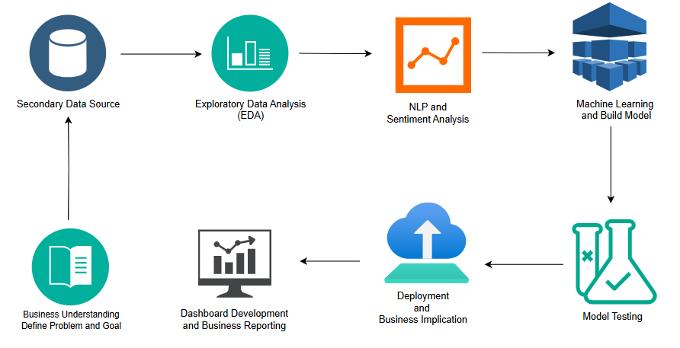

Figure 1: Research Design and Proposed Workflow

## **CHAPTER 4.4 – DATA STRUCTURE AND CHARACTERISTICS**

The dataset employed in the *InsightNation* project forms the foundational element for all subsequent analytics and modeling tasks. It encompasses a well-balanced mix of **structured**, **semi-structured**, and **textual data**, reflecting the multifaceted nature of citizen feedback in a modern urban environment. This diversity not only enhances the analytical depth of the project but also allows for a comprehensive understanding of both numeric trends and narrative insights across various domains of public service.

The data was collected from urban citizens, representing a simulated yet realistic snapshot of civic participation across multiple service categories. Key domains covered in the dataset include:

* Urban transportation systems
* Public sanitation facilities (e.g., toilets)
* Parks and recreational green spaces
* Public libraries and educational resources
* Local municipal services (e.g., waste collection, maintenance, etc.)

Each respondent provided both quantitative ratings and qualitative comments, contributing to a rich dataset capable of supporting multiple layers of analysis—from basic statistical summaries to advanced sentiment modeling.

**Data Types and Examples**

The dataset includes four broad categories of data, which are outlined below:

|  |  |  |
| --- | --- | --- |
| Data Type | Example Fields | Nature |
| Demographic Data | age_group, gender, city | Structured (Nominal/Categorical) |
| Quantitative Ratings | toilet_cleanliness, transport_satisfaction, library_satisfaction | Ordinal/Numeric |
| Usage Data | park_visit_freq, library_visit_freq, service_use_freq | Categorical/Ordinal |
| Open Text Feedback | library_suggestions, transport_suggestions, local_service_suggestions | Semi-structured (Free Text) |

This variety enables InsightNation to perform multidimensional analytics. While the numeric data supports statistical modeling and correlation analysis, the open-text fields allow for deeper contextual interpretation using natural language processing techniques. The hybrid nature of the dataset is pivotal in building a governance tool that is not only data-driven but also capable of understanding the nuanced concerns and sentiments of citizens.

**Data Format and Volume**

* **File Format:** CSV (Comma-Separated Values) — a widely supported and easy-to-ingest format for both analytics platforms and web dashboards.
* **Total Records:** 12,492 individual responses, providing a reasonably robust sample size for modeling.
* **Attributes/Columns:** 21 distinct variables, spanning demographic identifiers, usage patterns, service ratings, and feedback narratives.
* **Language:** Predominantly English with minimal linguistic inconsistencies; language normalization steps such as lowercasing and punctuation removal were applied during preprocessing.

The structured yet flexible data architecture ensures compatibility with downstream components of the platform, including the machine learning models, sentiment classifiers, and visual dashboard elements.

## **CHAPTER 4.5 - DATA COLLECTION METHOD**

The dataset used for the *InsightNation* project is based on a **simulated civic engagement dataset**, curated to closely reflect real-world conditions commonly observed in smart city governance and urban service feedback systems. While this implementation does not involve direct data scraping or real-time collection, the structure and variables mirror the practices adopted by many government departments in public sentiment tracking and service evaluation.

**Simulated Survey Methodology**

The methodology employed is based on a **cross-sectional survey approach**, aimed at gathering insights from a varied group of urban residents at one specific moment. This design allows for a broad snapshot of citizen opinions across various services and locations. The data collection process was modeled as follows:

* **Quantitative Feedback Collection:** Respondents were asked to rate their satisfaction with various civic services using Likert-style scales. Options typically ranged from "Very Satisfied" to "Very Dissatisfied," enabling ordinal-level measurement of user sentiment.
* **Open-Ended Comments:** Optional fields were included for each service domain, allowing participants to elaborate on their experiences, provide suggestions, or highlight specific complaints. These text fields are crucial for uncovering recurring issues or unmet needs that might not be captured through ratings alone.
* **Anonymity and Privacy:** All responses were anonymized to preserve participant confidentiality. No personal data that can identify individuals was gathered or stored..
* **Demographic Segmentation:** Citizens were categorized based on age group, gender, and city of residence. This enabled comparative analysis across demographic segments and regional service patterns.

**Real-World Equivalence**

In a live government deployment, such data could be collected through a combination of digital and physical channels, including:

* **Mobile applications or municipal web portals**, where residents can submit real-time feedback on services.
* **QR-code enabled survey links**, strategically placed at public facilities like buses, toilets, libraries, and parks to encourage quick digital submissions.
* **On-site kiosks or tablets** installed at civic centers and service counters for in-person feedback collection.
* **Periodic community outreach programs** using field agents to collect feedback from non-digital users.

While this academic project used a single static dataset for modeling and visualization, it was designed to **simulate a fully functional feedback collection pipeline**. This includes assumed automation in data ingestion, scheduled analytics runs, and dashboard updates — mirroring what a real-time governance solution might implement.

In conclusion, the dataset and its simulated collection framework effectively replicate the challenges and opportunities inherent in modern public feedback systems. They provide a strong foundation for building a scalable, responsive, and AI-enabled platform that can be adapted for real-world smart governance applications.

## **CHAPTER 4.6 - DATA COLLECTION INSTRUMENTS**

The cornerstone of the data collection process for the **InsightNation** project is a **structured digital questionnaire**, designed to capture both quantifiable service ratings and rich qualitative feedback from urban residents. The questionnaire acts as the primary instrument for collecting diverse citizen responses across various dimensions of public service delivery. It is assumed to follow best practices in public sector survey design, balancing clarity, comprehensiveness, and ease of response.

The questionnaire was designed to simulate a real-world civic engagement tool, such as those used by urban municipalities or smart city platforms to gather feedback from citizens. Its structure enables both **statistical analysis** of satisfaction levels and **textual analysis** of narrative inputs, supporting the mixed-method research design adopted in this project.

**Core Components of the Instrument**

The questionnaire was divided into multiple well-defined sections, each focusing on a distinct area of public service. The design ensures that data collected is both relevant for operational analysis and suitable for automated processing using natural language and machine learning models.

The following outlines the key components of the questionnaire:

* **Section A: Demographics**: This initial section collects basic personal information to enable segmentation and profiling of responses. It includes:
  + **Gender**: Male, Female, Other/Prefer not to say
  + **Age Group**: Categorized ranges (e.g., 18–24, 25–34, 35–44, etc.)
  + **City of Residence**: Allows geographic mapping and cross-city comparison of service experiences
* **Section B: Public Toilets Ratings**: Questions in this section assess citizen satisfaction with sanitation facilities. It includes:
  + **Cleanliness Ratings**: Based on frequency and quality of cleaning
  + **Perceived Safety**: Respondents rate how safe they feel using public toilets
  + **Amenities/Features**: Evaluation of availability and usefulness of features such as water, lighting, disability access, etc.
* **Section C: Transportation Services**: This section focuses on public transport systems. It captures:
  + **Overall Satisfaction with Transport**
  + **Safety Perception**: Includes safety for women, children, and elderly users
  + **Open Feedback**: An optional prompt for users to highlight issues or suggest improvements (e.g., overcrowding, punctuality, route coverage)
* **Section D: Parks and Green Spaces**: Aimed at understanding the usage and perception of recreational facilities, this section includes:
  + **Frequency of Visit**: Captures usage behavior (e.g., daily, weekly, rarely)
  + **Facility Ratings**: Amenities like benches, jogging tracks, play areas
  + **Problems Faced**: An open field where citizens can describe cleanliness issues, safety concerns, or maintenance problems
* **Section E: Libraries**: This section focuses on access to public knowledge and education spaces:
  + **Library Visit Frequency**: Tracks how often citizens use library services
  + **Satisfaction Levels**: Includes ratings on staff helpfulness, book availability, environment
  + **Open Suggestions**: Text field for citizens to express ideas on improving library services
* **Section F: General Local Services**: This final section takes a broader view of municipal services:
  + **Overall Local Service Satisfaction**: Aggregated rating across services not already covered
  + **Final Open-Ended Prompt**: Allows citizens to freely express any additional concerns, ideas, or positive feedback about their locality or civic environment

**Instrument Design Considerations**

The questionnaire was crafted with a dual focus on **usability** and **analytical compatibility**. To encourage participation, the survey interface was designed to be user-friendly, minimizing cognitive load and response fatigue. At the same time, each question was carefully framed to ensure that the responses would be directly usable in downstream analytical processes, including:

* **Structured MCQs**: Ideal for categorical encoding and correlation analysis
* **Ordinal Scales**: Useful for satisfaction trends and ranking service quality
* **Open-Ended Prompts**: Enable sentiment analysis and thematic extraction using NLP models
* **Minimal Noise**: Questions were curated to avoid ambiguity, redundancy, or irrelevant data collection

Additionally, the questionnaire design allows for seamless integration into digital platforms such as mobile apps, web-based feedback portals, and public service kiosks. This makes it scalable for real-world deployment in urban governance systems.

Overall, the structured questionnaire functions as a powerful, multipurpose tool that captures both the **breadth** and **depth** of citizen feedback. It forms the basis for data-driven insight generation, enabling a comprehensive understanding of public satisfaction and the factors influencing it.

## **CHAPTER 4.7 - SAMPLE SIZE**

The dataset used in the InsightNation project comprises a total of **12,492 citizen feedback records**, which serves as a statistically meaningful and analytically practical sample for the scope of public service analytics, natural language processing (NLP), and machine learning (ML) modeling. In the context of urban governance research and data science applications, this sample size is considered adequate to draw valid insights while maintaining operational efficiency for real-time analysis and deployment.

**Justification for Adequacy**

Several factors contribute to the suitability of this sample size for the project’s goals:

* **Statistical Relevance for Modeling**: With over 12K individual data points, the dataset provides sufficient variance and population diversity to support robust classification and sentiment analysis tasks. It enables the training and validation of supervised ML models such as Logistic Regression, Support Vector Machines (SVM), and ensemble methods with reduced risk of overfitting.
* **Feasibility of Demographic Subgroup Analysis**: The volume of responses allows for detailed analysis across demographic segments, such as gender, age groups, and regional representation. This makes it possible to identify targeted satisfaction trends — for instance, comparing transportation safety perceptions between age cohorts or analyzing library usage patterns by gender.
* **Computational Manageability**: From a deployment standpoint, this dataset size strikes an effective balance between richness and responsiveness. Unlike high-volume datasets that require cloud-based infrastructure or GPU acceleration, 12,492 records can be processed efficiently in a **Streamlit-based application** running locally on standard hardware. This makes the solution viable for testing and prototyping in an academic setting or limited-scale field deployment.
* **Scalability for Real-World Use**: While the current dataset is static and simulated, it mimics the input that might be captured in live smart governance systems. In real-world applications, the underlying architecture designed in this project can scale horizontally to accommodate tens or hundreds of thousands of records over time as more citizens provide input through digital platforms.
* **Alignment with Industry Benchmarks**: Many public service surveys and civic data science projects in policy research operate with sample sizes ranging from 1,000 to 10,000 respondents, depending on regional coverage and resources. Thus, the sample size chosen here fits comfortably within the lower-middle end of this range and is suitable for pilot-scale analysis and hypothesis testing.

In summary, the dataset size supports not only model training and dashboard functionality but also aligns with the real-world analytical needs of urban planners and municipal administrators seeking to understand citizen sentiment and service effectiveness.

## **CHAPTER 4.8 - SAMPLING TECHNIQUE**

The nature of the dataset used in the InsightNation project is **simulated and academic**, designed to emulate real-world conditions in public service feedback collection. Therefore, the sampling approach used can be best described as **non-probability purposive sampling**, also referred to as **judgmental sampling**. This technique involves the deliberate selection of data points that reflect a broad spectrum of experiences and demographics to ensure analytic relevance and coverage.

**Key Features of the Sampling Approach**

* **Purposive Sampling Methodology**: Instead of being randomly drawn from a large population, the dataset includes carefully selected entries to ensure that feedback is represented across a diverse range of services (toilets, transport, parks, libraries, etc.) and demographics. The goal is to maximize the diversity of perspectives, not statistical randomness.
* **Stratified Representation by Design**: The dataset includes participants across various **cities**, **gender identities**, and **age groups**, allowing the model to simulate a stratified population without requiring full population sampling. This intentional diversity supports scenario-based analysis, such as understanding youth concerns in public park facilities or comparing service satisfaction across urban locations.
* **Simulated Real-World Conditions**: While the data is not gathered through real-time citizen engagement platforms or API pipelines, it has been structured to reflect the **natural distribution of public service feedback** typically seen in civic analytics Responses to text exhibit genuine diversity, satisfaction ratings span a broad spectrum, and usage behaviors align with credible trends.
* **Utility for Prototyping and Model Development**: As the objective of the project is to design and test a functional data pipeline and dashboard for urban feedback analysis, purposive sampling offers practical advantages. It ensures that all target service categories are represented and that machine learning models receive varied inputs for training and testing purposes.
* **Limitations of Non-Probability Sampling**: It is acknowledged that this sampling method does not offer the statistical generalizability of probability-based approaches. As such, findings derived from this dataset are **indicative rather than definitive**, suitable for hypothesis generation and prototyping rather than final policy conclusions.

**Implications for Real-World Deployment**

In actual government implementations, the preferred sampling strategies would shift toward **systematic** or **stratified random sampling** techniques. These methods ensure:

* Balanced demographic representation
* Elimination of selection bias
* Greater statistical validity for public policy decisions

Data could be collected via live citizen portals, mobile surveys, or IoT-enabled kiosks across multiple geographic locations, with the sampling process automated to dynamically adapt to user demographics.

# **CHAPTER 5 – SYSTEM ARCHITECTURE AND IMPLEMENTATION**

The architecture and implementation of the dissertation were carefully designed to support a scalable, modular, and intelligent system capable of transforming raw citizen feedback into actionable insights for public service enhancement. This section details the technical blueprint, system workflow, tools, and processes that enabled the development of a data-driven government analytics platform.

The system integrates structured data pipelines, NLP-based sentiment classifiers, machine learning algorithms, interactive visualization components, and a conversational AI interface powered by Google’s Gemini API. Built entirely in Python and deployed via Streamlit, the architecture is optimized for local execution and real-time user interaction. The platform supports end-to-end analytics—starting from data ingestion and cleaning to advanced sentiment analysis and strategic summary generation.

This comprehensive implementation approach not only ensures technical robustness but also aligns with real-world governance needs for transparency, adaptability, and citizen-centric decision-making. Each component was designed with extensibility and interpretability in mind, making InsightNation a future-ready model for smart governance through AI-powered analytics.

## **CHAPTER 5.1 - OVERVIEW OF SYSTEM DESIGN**

This dissertation presents a comprehensive data analytics platform titled *InsightNation*, purposefully designed to empower data-driven decision-making in the public sector. The system serves as a full-fledged analytical engine to collect, process, analyze, and visualize citizen feedback across key public service domains—including transportation, sanitation, parks, libraries, and other local amenities. The overarching aim of the project is to support government bodies and civic authorities in making informed, evidence-based decisions that enhance service quality, improve citizen satisfaction, and promote transparent governance.

At the heart of *InsightNation* lies a modular and scalable system architecture that strategically combines traditional data science methodologies with cutting-edge artificial intelligence (AI) capabilities. This fusion is central to enabling advanced analyses such as sentiment detection, public opinion mining, demographic segmentation, and automated recommendations. The architecture supports both structured and unstructured data pipelines, ensuring the system can accommodate varied feedback formats, including numerical ratings and free-text responses.

**Core Technologies and Components**

The technical foundation of *InsightNation* is built on a hybrid stack comprising both conventional analytics tools and intelligent models. The static data analysis and visualization layers leverage Python-based libraries such as pandas, matplotlib, and seaborn for data wrangling, summary statistics, and exploratory analysis. These tools help in identifying trends, patterns, and anomalies in citizen feedback data—particularly with respect to service satisfaction across different regions, genders, and age groups.

For natural language processing (NLP) tasks, the system integrates spaCy for preprocessing and tokenization, and scikit-learn for implementing classical machine learning models, particularly Logistic Regression and Support Vector Machines (SVM). These are applied to perform sentiment classification on textual feedback collected from citizens. The NLP models are trained on a curated dataset of responses, enabling the system to infer the emotional tone—positive, negative, or neutral—behind qualitative suggestions or complaints.

To extend the system’s analytical capability into context-aware insight generation, the architecture incorporates Google’s Gemini Pro API. This large language model (LLM) integration allows the platform to deliver intelligent narrative insights, strategic reports, SWOT analyses, and conversational responses, all tailored to the context of user queries and feedback trends. By merging deterministic ML models with generative AI tools, *InsightNation* achieves a highly dynamic and user-responsive analytical framework.

**Deployment and Interface Design**

The platform is deployed as a locally hosted web application using Streamlit, which serves as the interactive front-end for end users, researchers, or policy analysts. Streamlit allows seamless integration between the backend processing logic and user-facing elements, offering an intuitive interface to upload datasets, visualize results, engage in conversational chats, and generate reports with just a few clicks.

Underneath this front-end lies a well-organized file and folder structure, including directories for raw and processed data, Jupyter notebooks, machine learning models, visual assets, source scripts, and final reports. This organized layout not only promotes modular development and code reusability, but also supports easier version control and collaborative enhancements in future iterations.

**Development Methodology**

The system was developed following a structured six-phase implementation plan, with each stage contributing incrementally toward building a robust and feature-rich solution. The phases are outlined below:

1. Requirement Gathering & Dataset Acquisition – Understanding user needs, finalizing service categories, and collecting citizen feedback data.
2. System Design & Folder Structure Setup – Establishing architecture, organizing directories, and setting up environment configurations.
3. Data Cleaning & Preprocessing – Standardizing input formats, handling missing values, and preparing data for analysis.
4. Machine Learning & NLP Modeling – Implementing sentiment analysis and classification pipelines to interpret textual feedback.
5. Dashboard Development & Visualization – Creating visual analytics modules for summary insights, demographic trends, and service evaluations.
6. Gemini API Integration for Insight Generation – Embedding AI-driven strategic tools to generate SWOT, summaries, and smart suggestions.

Each phase was validated through internal testing, performance checks, and usability evaluations to ensure the system met functional and analytical expectations.

**Design Principles and Public Sector Relevance**

The platform’s architecture is grounded in principles of transparency, reproducibility, and interpretability, which are vital in the context of public-sector analytics. Every insight generated—be it a visual trend, a classification label, or a Gemini-based recommendation—is traceable back to specific data sources or analytical rules. This fosters accountability in decision-making, allowing government stakeholders to trust and validate the insights used for policy formulation or service improvement.

In summary, *InsightNation* exemplifies a modern data analytics ecosystem tailored to civic governance, integrating traditional data science rigor with AI-powered innovation in a flexible and scalable architecture.

## **CHAPTER 5.2 - TECHNOLOGY STACK AND TOOLS USED**

The InsightNation platform is powered by a robust and thoughtfully curated technology stack that spans across all layers of modern data science and AI development. From data preprocessing and machine learning to real-time visualization and intelligent language model integration, each tool and framework was chosen based on its **reliability, scalability, ease of integration**, and **alignment with public-sector data analytics objectives**. The complete stack ensures that the system remains both technically sound and functionally user-friendly.

**Programming Language: Python 3.11**

Python 3.11 forms the **core programming environment** for the platform. As one of the most widely adopted languages in the data science community, Python offers a rich ecosystem of libraries and frameworks that streamline every stage of the analytics pipeline—from data ingestion and transformation to modeling, visualization, and deployment. Its extensive support for both classical ML (e.g., scikit-learn) and modern AI (e.g., Gemini API integration) made it the optimal choice for developing a multi-functional, end-to-end system. Python's syntax readability and versatility also enabled smooth team collaboration and modular script development.

**Frontend Interface: Streamlit**

The user interface was built using **Streamlit**, a modern Python framework designed for creating data applications with minimal frontend coding. Compared to traditional web frameworks like Flask or Django, Streamlit allows developers to quickly integrate backend logic and data pipelines directly into the UI layer. This results in a **faster prototyping and deployment cycle** and more responsive interaction between users and analytics components.

**Key reasons for using Streamlit include:**

* **Real-time user input processing**: Allows citizens, analysts, or stakeholders to upload CSV files and receive instant feedback.
* **Dynamic dashboards**: Interactive charts, scorecards, and summaries update based on user-selected parameters or uploaded datasets.
* **Integrated chat interface**: Enables direct communication with the Gemini API for insight generation.
* **Session management**: st.session_state was used to simulate memory, making chatbot conversations more contextually consistent.

Streamlit's compatibility with Python also ensures that no additional front-end technologies (like JavaScript or React) were required, reducing development complexity.

**Data Handling and Processing: pandas and NumPy**

For structured data operations, **pandas** served as the primary data analysis library. It was extensively used to handle CSV files—managing tasks such as loading data, handling missing values, filtering records, and generating derived features. With its DataFrame structure, pandas made it easy to group, aggregate, and transform data based on demographic variables like age, gender, and location.

**NumPy** was used in tandem with pandas, especially for numerical computations and vectorized operations. It provided the mathematical foundation for operations such as calculating mean satisfaction scores, scaling feature values, and constructing matrices for model training.

**Data Visualization: matplotlib and seaborn**

To make data-driven insights accessible and understandable, the system employs **matplotlib** and **seaborn** for all visualizations.

* **matplotlib** offers granular control over plot customization and was used for static and comparative plots.
* **seaborn**, with its high-level abstraction, was ideal for creating aesthetically pleasing statistical graphics and heatmaps.

**Key visualizations included:**

* Bar charts showing service satisfaction by age group and gender
* Line plots for tracking changes in service frequency over time
* Heatmaps to depict sentiment polarity across cities and service categories

These visuals were embedded directly into the Streamlit dashboard, making them interactive and user-responsive.

**NLP and Machine Learning: SpaCy and scikit-learn**

The open-text fields in citizen feedback—such as complaints, suggestions, and service reviews—required robust **natural language processing (NLP)** techniques. The platform utilizes SpaCy for tokenization, lemmatization, and part-of-speech tagging. Additionally, spaCy’s named entity recognition (NER) was explored to extract locations or keywords related to services.

For machine learning, **scikit-learn** was employed to develop and train a **Logistic Regression-based sentiment classifier**. This model was chosen for its interpretability and consistent performance. Text inputs were vectorized using **TF-IDF** features to capture semantic importance and fed into the classifier to predict whether a citizen’s response was **positive, neutral, or negative**.

The model was evaluated using metrics like **accuracy, precision, recall, F1-score**, and **confusion matrix**, ensuring its reliability before integration into the dashboard.

**LLM Integration: Google Gemini Pro API**

One of the most advanced features of *InsightNation* is its integration with the **Google Gemini Pro API**, a large language model (LLM) that brings generative intelligence to the platform. This API enables the system to go beyond deterministic outputs and provide **context-aware insights** that resemble human reasoning.

The Gemini API was integrated securely through HTTP-based API calls, where sanitized and structured prompts were sent based on either user queries or EDA summaries.

**Key use cases of Gemini API include:**

* Generating summaries of feedback trends across services
* Producing SWOT analyses for individual service categories (e.g., sanitation, transport)
* Answering user queries about service improvement strategies
* Converting visual and numerical insights into natural language reports

This LLM component enhances interpretability and provides non-technical users with actionable intelligence derived from complex data.

In conclusion, the combination of Python, Streamlit, pandas, spaCy, scikit-learn, and Gemini Pro API forms a **powerful and cohesive technology stack**. Together, they enable *InsightNation* to function as a professional-grade platform capable of analyzing public sentiment, modeling service satisfaction, and facilitating smarter, citizen-centric governance.

## **CHAPTER 5.3 - DATA FLOW AND SYSTEM WORKFLOW ARCHITECTURE**

The InsightNation platform employs a robust data flow and system workflow architecture meticulously crafted to transform raw citizen feedback into actionable governmental insights through a clear, modular, and sequential process. The process commences with data collection, the foundational layer of the architecture. This phase encompasses various channels through which citizen feedback is gathered, including online surveys, social media monitoring, call center logs, and potentially even in-person feedback mechanisms. Following data collection, the next critical phase is data ingestion and storage. Here, the incoming data undergoes initial validation and cleansing to ensure data quality. The third stage, data processing and transformation, is where the raw data begins to take a more structured and analytical form. The processed data then moves into the analysis and insight generation phase, the core of the InsightNation platform. Finally, the generated insights are presented in the visualization and reporting phase. This involves translating complex analytical outputs into easily understandable formats such as dashboards, reports, and interactive visualizations

The platform follows a six-phase development and processing workflow:

1. Data Acquisition
2. Preprocessing and Cleaning
3. Exploratory Data Analysis (EDA)
4. Sentiment Analysis and ML Modeling
5. Visualization and Dashboard Generation
6. LLM-Powered Insight Generation (Gemini API)

Each phase is supported by modular Python scripts and notebook environments to ensure clean separation of logic, testability, and ease of iteration.

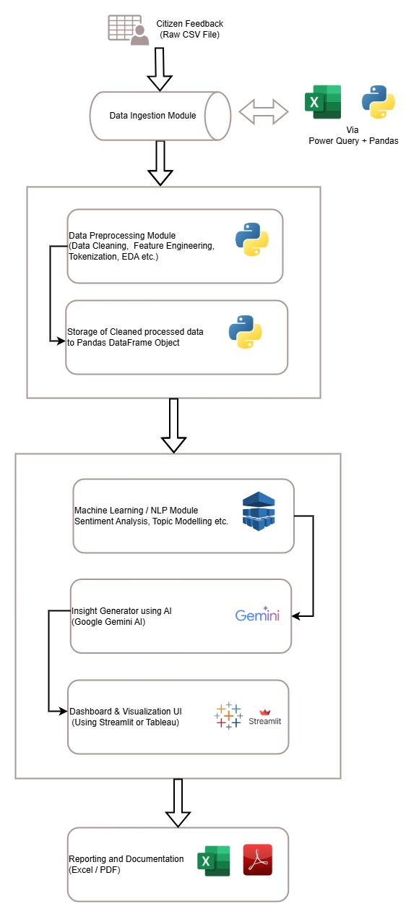

Figure 2: System Architecture

**Detailed Workflow Stages**

**Step 1: Data Acquisition**: The process begins with user-uploaded survey or citizen feedback data. These are CSV files collected via digital feedback forms or public data repositories. The files are uploaded via Streamlit interface and stored in the /data/raw/folder for version control.

* Input Source: CSV files with 21 well-defined columns
* User Interface: File uploader in Streamlit
* Raw Storage Path: /data/raw/

**Step 2: Data Cleaning and Preprocessing**: After upload, the platform automatically invokes a preprocessing script from the src/preprocessing/ module. This step handles:

* Removal of null or incomplete records
* Encoding of categorical variables (e.g., gender, city)
* Standardization of column names and formats
* Text normalization for free-text fields like transport_suggestions and library_suggestions

Cleaned data is stored in /data/processed/ for downstream use.

**Step 3: Exploratory Data Analysis (EDA)**: The EDA process visualizes trends in public satisfaction, service usage, frequency, and feedback across demographics. Plots and metrics are generated using matplotlib and seaborn, and include:

* Service satisfaction by age group or gender
* Most reported issues in parks or public toilets
* Heatmaps of regional satisfaction levels

EDA results guide both ML model decisions and prompts sent to Gemini for generating contextual insights.

**Step 4: NLP and Machine Learning Pipeline:** The text feedback columns are passed into an NLP pipeline built using spaCy and vectorized with TF-IDF. A Logistic Regression model is then trained on labeled sentiment data to classify:

* Positive
* Neutral
* Negative

Key steps include:

* Tokenization and lemmatization
* TF-IDF vectorization
* Model training and evaluation (F1-score, confusion matrix)
* Sentiment label assignment to each record

The results are saved as additional columns in the processed and cleaned dataset.

**Step 5: Dashboard and Visualization**

Using Streamlit, the processed data and predictions are visualized through dynamic dashboards. Key components include:

* Drop-down filters for demographic slicing
* Charts for sentiment distribution
* Tables summarizing service feedback by region and type

These visuals help decision-makers quickly identify pain points and successes in public service delivery.

**Step 6: Gemini API-Driven Insights**

The final step uses Google’s Gemini Pro API to generate higher-level insights. Depending on user interactions and processed results, the system dynamically constructs prompts such as:

* "Summarize the major complaints about city transportation service based on feedback."
* "Generate a SWOT analysis for public library services in urban zones."
* "Provide recommendations to improve satisfaction in public transport among females aged 26–35."

Gemini outputs are displayed in the dashboard and stored under /data/exports/ for report generation or archival.

**System Workflow Features**

* Modularity: Each step is independently testable and replaceable.
* Auditability: Cleaned data and model outputs are saved at each step.
* Reusability: Scripts for preprocessing, modeling, and visualization are reusable across multiple datasets.
* Scalability: The design supports easy transition from local to cloud-based deployment if needed.
* Transparency: All steps are visible to end-users via the Streamlit interface, fostering trust.

## **CHAPTER 5.4 - BACKEND ARCHITECTURE AND PIPELINE**

The backend architecture of the InsightNation platform is meticulously engineered to provide a robust and scalable foundation for its core functionalities: data processing, machine learning model development, and seamless integration with external Artificial Intelligence services. Embracing principles of modularity, traceability, and high performance, the backend is composed of distinct components, each dedicated to a specific stage within the overarching analytical pipeline. This structured approach ensures that the complex task of transforming raw citizen feedback into actionable public service insights is handled efficiently and reliably.

At the heart of the backend lies a well-organized file system. This includes dedicated directories for raw data ingestion, processed datasets, feature engineering scripts, trained machine learning models, evaluation metrics, and integration configurations. This clear file organization is crucial for maintaining traceability, allowing developers and data scientists to easily locate and manage the various artifacts produced and consumed by the system. Version control systems are often integrated to further enhance traceability and facilitate collaborative development.

The platform leverages a collection of scripts, primarily written in languages like Python, to automate various backend processes. These scripts handle tasks such as data cleaning and preprocessing, feature extraction and selection, model training and evaluation, and the deployment of machine learning models. Furthermore, scripts are responsible for orchestrating the data flow through the analytical pipeline and managing the interactions with external AI services for tasks like sentiment analysis or topic modeling.

The pipeline design is the central organizing principle of the backend architecture. It defines the sequential flow of data through the various processing stages. Typically, this pipeline involves steps for data ingestion, cleaning, transformation, feature engineering, model training (if applicable), prediction or insight generation, and finally, the storage of results. Workflow management tools are often employed to orchestrate these steps, ensuring that each component executes in the correct order and that dependencies are properly managed.

**Project Structure & Codebase Organization**

The system backend is organized into a well-defined directory structure that separates data, code, models, dashboards, and reports. This promotes maintainability and scalability during development and deployment.

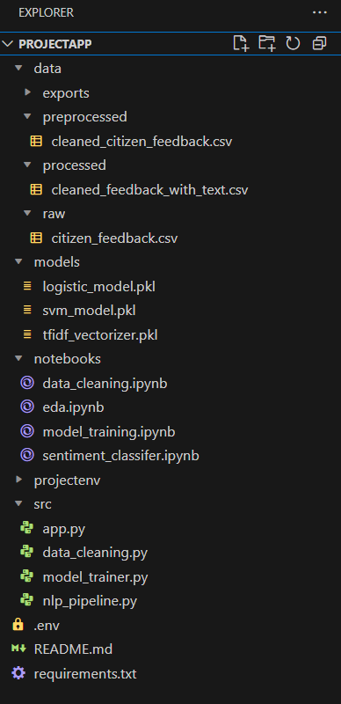

Figure 3: Project Structure in Visual Studio Code

Each folder plays a distinct role:

* **data/** – Stores input and output datasets across stages.
* **notebooks/** – Jupyter notebooks for visual EDA and experiments.
* **src/** – Contains all production-ready scripts grouped by function.
* **dashboard/** – Hosts the Streamlit app.
* **reports/** – Contains draft and final versions of documents.

**Data Cleaning Module (src/preprocessing/)**

This module handles all preprocessing required before analysis. Key functions include:

* Handling missing values
* Normalizing column names
* Encoding ordinal features
* Standardizing feedback formats

The cleaning script (clean_data.py) can be called standalone or via the Streamlit app, ensuring reproducibility.

**NLP Processing Pipeline (src/nlp/)**

This is a critical component for handling and analyzing open-text fields like:

* transport_suggestions
* park_issues
* library_suggestions

The NLP pipeline includes:

* Text normalization using spaCy
* Stopword removal, lemmatization
* Vectorization with TF-IDF
* Sentiment classification using Logistic Regression or SVM
* Model saving/loading via joblib

The outputs are stored in the processed data and made available to the dashboard.

**Visualization Engine (src/visualization/)**

The visualization module generates charts and plots using matplotlib and seaborn, including:

* Pie charts for gender distribution
* Bar plots for satisfaction scores
* Word clouds for common feedback
* Sentiment distribution plots

These charts are rendered dynamically in the dashboard, allowing real-time interaction.

**ML Modeling (src/ml/)**

The ML module trains and evaluates models on labeled sentiment data. Key components:

* Train-test split
* Hyperparameter tuning
* Cross-validation
* Model metrics (Accuracy, F1-score, Confusion Matrix)

Model outputs include predictions and probability scores, stored in the processed dataset and used in analytics.

**Gemini Integration Utility (src/utils/gemini_api.py)**

This script manages the connection to the **Google Gemini API** for LLM-based tasks. Responsibilities include:

* Prompt generation based on dashboard inputs
* API call execution and error handling
* Returning structured text responses
* Storing responses in exports/

This utility acts as the AI layer that transforms analytical outputs into actionable business insights.

**Backend Data Pipeline – Logical Flow**

The backend data pipeline can be summarized into five logical layers:

1. **Ingestion Layer** – Accepts input files via UI; saves to /data/raw/.
2. **Transformation Layer** – Cleans, encodes, and preprocesses the data.
3. **Analytical Layer** – Performs EDA and ML/NLP modeling.
4. **AI Insight Layer** – Uses Gemini to generate interpretive summaries and suggestions.
5. **Visualization Layer** – Renders data and insights in the Streamlit dashboard.

Each stage feeds clean outputs into the next, forming a clear chain of responsibility.

**Benefits of Backend Architecture**

The backend architecture of this Data Analytics platform plays a pivotal role in ensuring the system's efficiency, scalability, and future adaptability. It was deliberately designed with modularity, performance, and integration in mind, allowing the platform to evolve alongside changing analytical needs and technological advancements.

One of the key strengths of the backend is its extensibility. The modular coding framework allows new machine learning models, NLP pipelines, or additional data features to be added with minimal disruption to the existing workflow. For example, if a new citizen service or feedback category becomes available, developers can simply append new preprocessing scripts or model classes without reengineering the entire system. This ensures that the platform remains relevant and adaptable to growing datasets or emerging analytical use cases.

Another major advantage is traceability. The backend is built to log every transformation, prediction, and output at each step of the pipeline. This transparency allows users or analysts to trace results back to the exact input and processing stage that generated them. Such auditability is particularly valuable in public-sector decision-making, where accountability and reproducibility are crucial.

From a performance standpoint, the scripts are highly optimized for local execution. The entire system has been tested on a Windows 11 environment, ensuring efficient processing without dependence on cloud-based resources. This local-first approach reduces operational costs and ensures offline usability, especially useful in government settings where internet access might be restricted or monitored.

Lastly, the architecture is designed for interoperability. It supports seamless integration with third-party APIs—such as the Gemini Pro API—and is built in a way that allows for future migration to cloud-native services like Google BigQuery or Amazon S3. This future-readiness ensures the platform can scale and evolve with ease.

**Sample Execution Flow**

To better understand how components interact, here’s a simplified execution flow of a user session:

1. User uploads citizen feedback CSV
2. clean_data.py cleans and processes the file
3. Cleaned data passed into nlp/sentiment_model.py
4. Predictions saved in processed file
5. visualization/charts.py displays visual metrics
6. Gemini API receives prompts and returns recommendations
7. All outputs shown in Streamlit dashboard

This flow ensures smooth integration between traditional ML pipelines and generative AI-powered insights.

## **CHAPTER 5.5 – FRONTEND ARCHITECHTURE AND DASHBOARD DESIGN**

The frontend of the InsightNation platform plays a crucial role in ensuring accessibility, usability, and meaningful user engagement with data insights. Designed using the open-source **Streamlit** framework, the frontend serves as an interactive interface for analysts, policy researchers, and government officials to upload datasets, view analytics, explore sentiment insights, and receive strategic recommendations powered by Gemini AI. This section details the structure, components, and user workflows that define the frontend architecture and design philosophy of the InsightNation dashboard.

**Why Streamlit?**

Streamlit is a Python-based web application framework purpose-built for data apps. It was selected for the frontend implementation of InsightNation due to the following advantages:

* **Simplicity:** It allows for quick development using pure Python without needing HTML/CSS/JavaScript.
* **Interactivity:** Streamlit supports dynamic widgets like dropdowns, sliders, file uploads, and real-time visual updates.
* **Integration:** Easy compatibility with pandas, matplotlib, seaborn, scikit-learn, and APIs like Google Gemini.
* **Deployment-Friendly:** Supports local and cloud-based deployments with minimal configuration.

Given the analytical nature of InsightNation, Streamlit offered the right balance of power and simplicity to build a professional-grade public data platform in a limited timeframe.

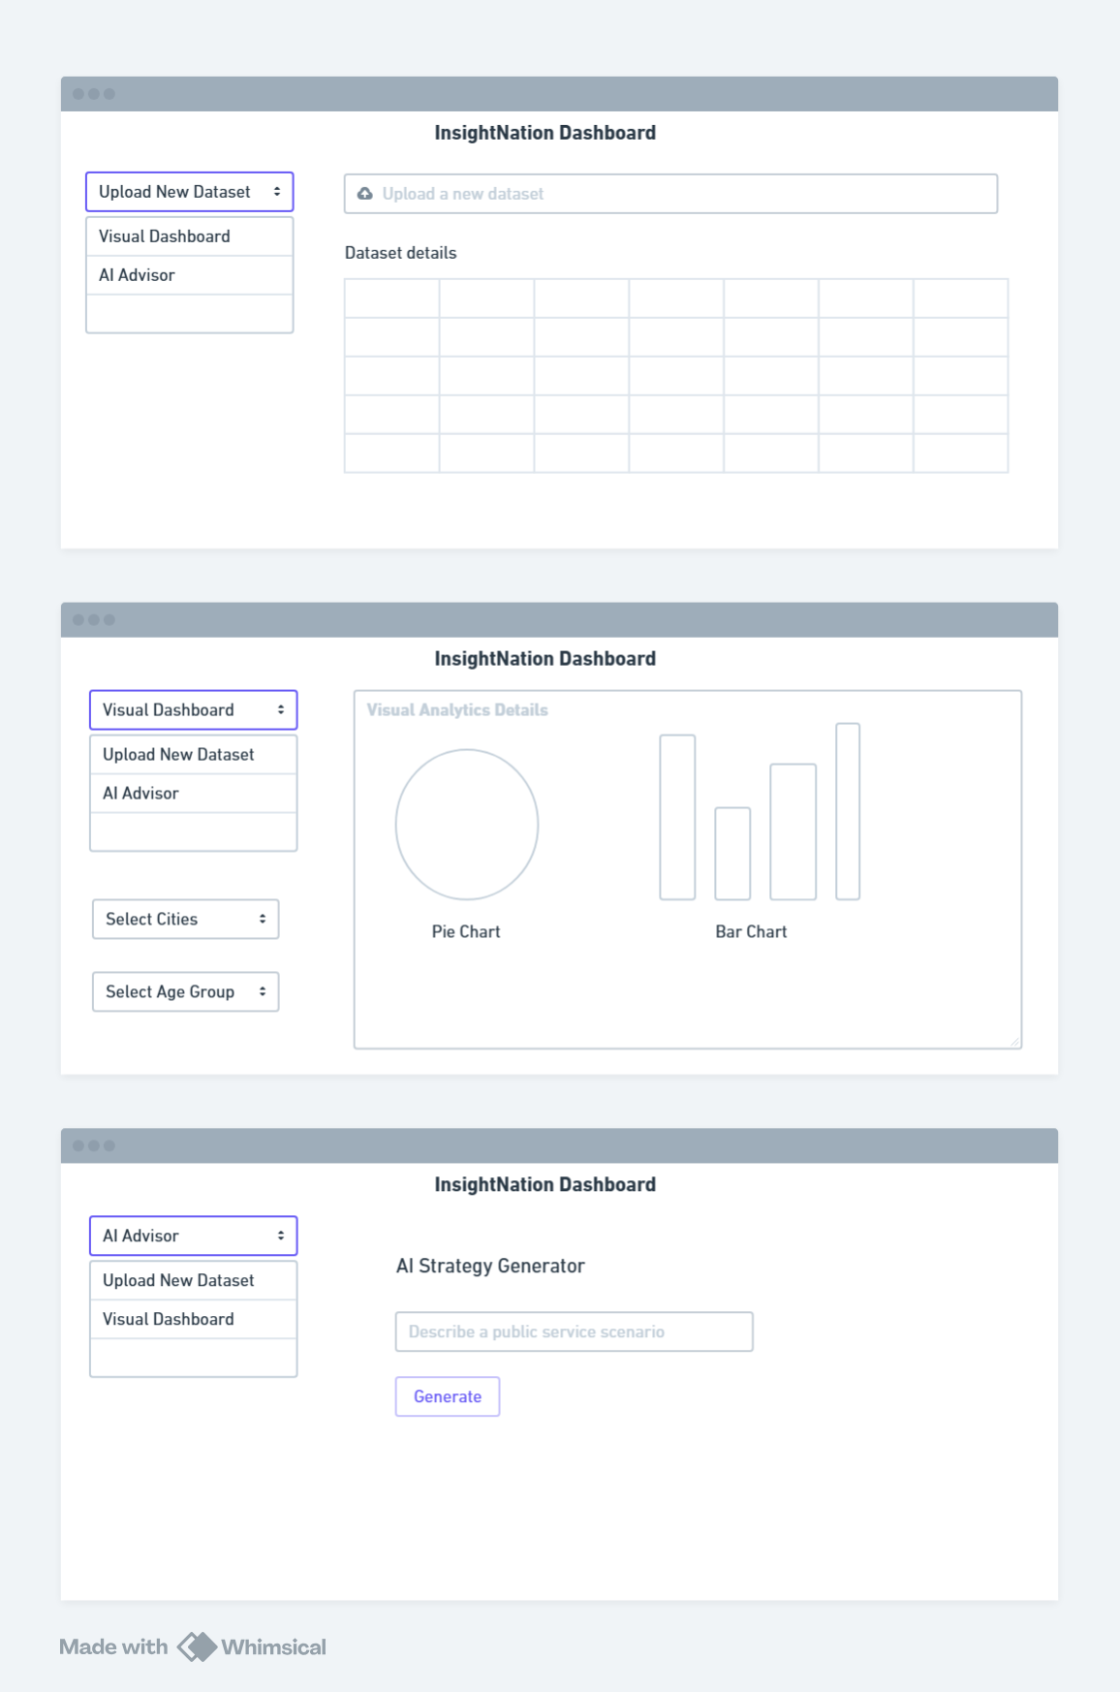

Figure 4: UI Wireframe Design

**Frontend Layout and UI Components**

The user interface is organized into a **multi-section vertical layout**, where each functional module is presented as an interactive panel. The main layout follows a logical flow:

1. Header and Title Section
2. Data Upload Section
3. Preview and Preprocessing Summary
4. Visual Analytics Dashboard
5. Sentiment SWOT Analysis
6. AI-Powered Strategic Insights (Gemini)
7. Conclusion and Export Panel

Each section uses Streamlit’s built-in widgets such as st.title(), st.file_uploader(), st.selectbox(), and st.expander() to create collapsible, interactive components.

**User Interaction Flow**

The user journey on the frontend dashboard follows a sequential, guided process:

**Step 1: Upload Data**

* A upload widget allows users to upload their citizen feedback datasets such as csv data.
* Once uploaded, the raw data is stored in the data/raw/folder and displayed using st.dataframe() for user confirmation.

**Step 2: View Preprocessing Summary**

* Backend cleaning is triggered upon file upload.
* Cleaned data is shown alongside summary statistics: number of rows, missing values, and standardization checks.
* Preprocessing status messages are logged to reassure the user.

**Step 3: EDA Visualizations**

Users can explore:

* Demographic charts (age groups, city-wise distributions)
* Service feedback distributions (toilet cleanliness, park amenities)
* Feature correlations using heatmaps
* Word Cloud of Feedback data

Each chart is dynamically generated using matplotlib or seaborn, rendered with st.pyplot() or st.plotly_chart() for interactivity.

All of this is rendered instantly upon model execution in the backend.

**Step 4: Strategic Insights from Gemini**

This panel is powered by the **Google Gemini API**, offering LLM-generated recommendations. For each section (e.g., transportation, public toilets, libraries), Gemini responds with:

* Summary of citizen satisfaction
* Major issues and suggestions
* Recommendations to improve services
* Potential policy frameworks to address gaps

Prompts are crafted dynamically based on uploaded data, ensuring customized outputs.

**Step 6: Export and Reporting Panel**

The dashboard allows users to:

* Export the cleaned and annotated dataset
* Download visualizations as PNGs
* Copy or download Gemini’s textual insights

**Key Streamlit Components Used**

The following Streamlit components and functions are foundational to the dashboard:

|  |  |
| --- | --- |
| Component | Purpose |
| st.title() / st.header() | Display headers and titles |
| st.file_uploader() | Upload CSV datasets |
| st.dataframe() | Preview raw/processed data |
| st.pyplot() | Display static visualizations |
| st.plotly_chart() | Render interactive visualizations |
| st.text_area() / st.write() | Show Gemini summaries |
| st.download_button() | Download reports, data, or charts |
| st.sidebar.selectbox() | Filter features or city-specific views |

Additionally, st.spinner() and st.toast() messages help maintain user engagement during data processing delays.

**Design Considerations**

The platform was designed with the following user experience (UX) principles:

* **Clarity:** Each section is explicitly labeled with tooltips and subheaders.
* **Feedback:** Users are notified at each step (upload, process, error handling).
* **Responsiveness:** Charts and results load dynamically to maintain engagement.
* **Minimalism:** A clean, distraction-free layout ensures the data remains central.

**Integration with Backend Functions**

The dashboard acts as a frontend trigger for backend operations. Each user action (like uploading data or requesting sentiment analysis) invokes Python functions from the src/ directory. For example:

* preprocessing.clean_data() is called when a file is uploaded.
* nlp.sentiment_model() is triggered when the user clicks “Analyze Sentiment.”
* utils.gemini_api.get_insights() fetches LLM-based advice upon request.

This modular interaction ensures backend logic can evolve without affecting the frontend interface.

**Scalability and Future Enhancements**

While the current version of the frontend is optimized for local deployment, it is designed to be **easily scalable** to cloud-hosted environments using:

* **Streamlit Sharing** or **Streamlit Cloud**
* **Docker containerization** for isolated deployment
* **Integration with cloud storage** (e.g., AWS S3, Firebase) for large dataset uploads

Planned enhancements include:

* User login and role-based access
* Real-time dashboard updates (using WebSockets)
* Multi-language support for wider accessibility
* PDF/Word report auto-generation for policy teams

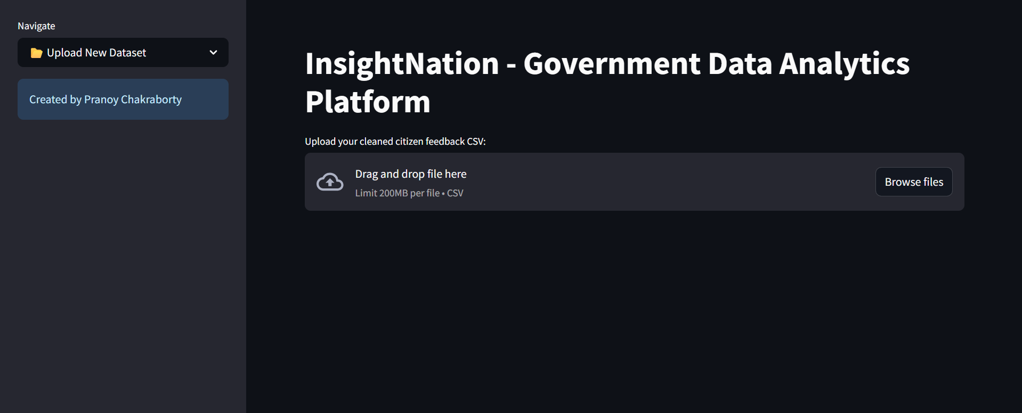Figure 5: Home Page of InsightNation Dashboard

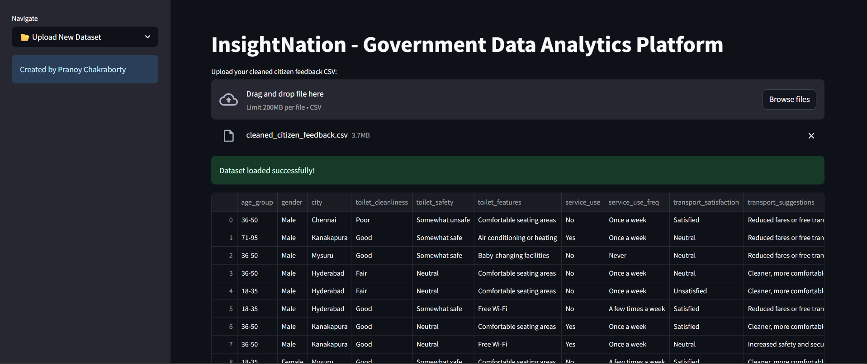

Figure 6: Uploaded Data

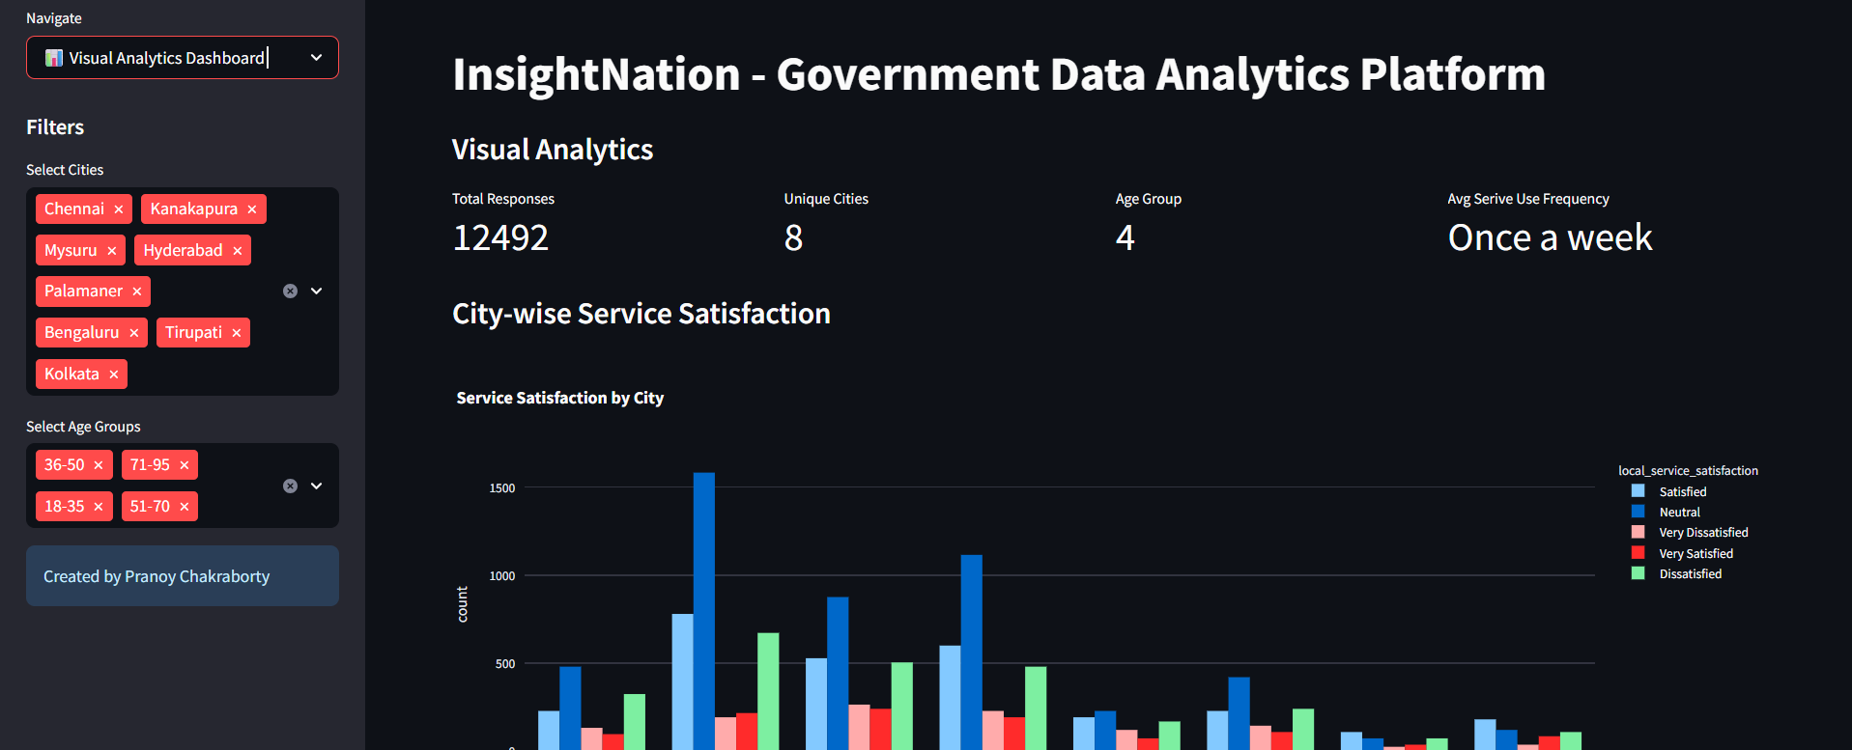Figure 7: Visual Analytics Dashboard

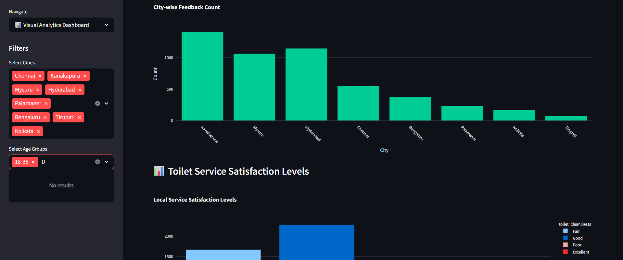Figure 8: Bar Charts based on City and Age Groups

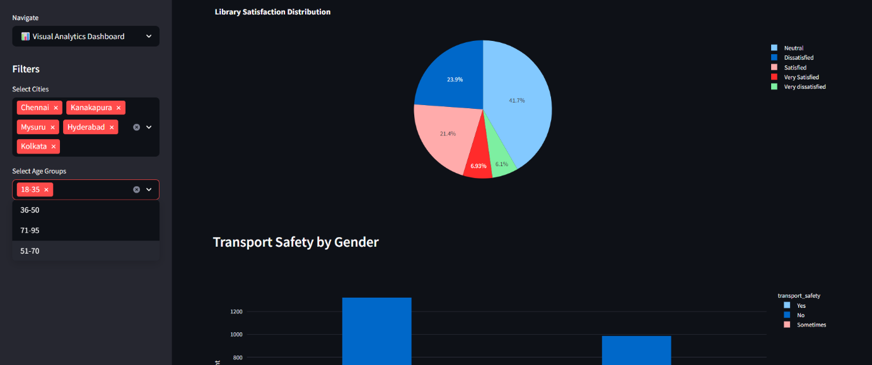Figure 9: Pie Chart based on City and Age Group

**Challenges in Frontend Development**

While Streamlit simplified development, several challenges emerged:

* **Session state management:** Handling long-running processes like ML predictions required careful use of st.session_state.
* **API latency:** Fetching results from Gemini took a few seconds, needing user feedback via spinners and loading messages.
* **Large data rendering:** For CSV files with 4,000+ rows, visual performance needed optimization through data sampling.

Each of these challenges was mitigated with best practices, improving user reliability and trust.

**Summary**

The frontend of InsightNation is more than just a user interface—it is a comprehensive, interactive experience that transforms raw citizen feedback into policy-ready insights. Through the use of Streamlit, Python, and other libraries, the dashboard creates a smooth end-to-end Analytics platform from data upload to actionable recommendations. The architecture remains modular, scalable, and ready for future enhancements, making it a robust public service analytics tool.

## **CHAPTER 5.6 - MACHINE LEARNING AND NLP IMPLEMENTATION**

Machine Learning (ML) and Natural Language Processing (NLP) form the analytical backbone of the InsightNation platform. Unlike traditional data analytics systems that rely mainly on structured, numeric data derived from closed-ended survey questions, this platform is designed to handle and extract value from the more complex and nuanced unstructured textual feedback provided by citizens. These textual responses, often found in suggestions, complaints, and open-ended commentary, offer a wealth of qualitative insight that numeric ratings alone cannot capture. Hence, the inclusion of robust NLP and ML components is not merely an enhancement—it is a necessity for meaningful public policy evaluation and actionable decision-making.

NLP techniques are employed to systematically process, clean, and analyze open-text responses within the dataset. These responses typically include citizen suggestions, grievances, or descriptions of their experiences with local services such as sanitation, transport, public parks, and libraries. The NLP workflow begins with essential preprocessing tasks such as tokenization, stop word removal, lowercasing, and punctuation stripping. Advanced preprocessing steps involve part-of-speech (POS) tagging, lemmatization, and named entity recognition (NER), which help in extracting structured linguistic features from otherwise unstructured inputs. These tasks are executed using the SpaCy library, chosen for its speed, accuracy, and compatibility with large-scale text analysis tasks.

Once the textual data is cleaned and prepared, it is vectorized using techniques such as TF-IDF (Term Frequency-Inverse Document Frequency). These numerical vectors are then fed into machine learning models to classify the sentiment behind the feedback. For sentiment analysis, InsightNation uses a Logistic Regression classifier developed using scikit-learn. Logistic Regression was selected for its balance between simplicity, interpretability, and performance, especially in binary and multiclass classification settings. The model was trained on labeled examples to distinguish between positive, neutral, and negative sentiments in citizen feedback.

The model's performance is validated using a standard train-test split, with metrics such as precision, recall, F1-score, and accuracy computed to assess effectiveness. Confusion matrices further help visualize model strengths and weaknesses, ensuring transparency in classification outcomes. This attention to evaluation is particularly important in public sector applications, where misclassification can lead to misinterpretation of public needs and misplaced resource allocation.

Beyond sentiment classification, the NLP-Machine Learning pipeline also supports keyword extraction and thematic clustering. These techniques enable the identification of recurring issues—such as "unclean toilets" or "unsafe transportation"—which can then be flagged for policy attention. The outputs from these models are stored in a structured format and seamlessly integrated into the visual analytics and dashboard layers of the system.

Finally, these ML and NLP components are designed to operate efficiently within the overall system architecture. They are modular, allowing for updates, retraining, or substitution without affecting other parts of the application. Their outputs also serve as input for higher-level analysis tools, including LLM-based insight generation via the Gemini Pro API. This layered integration of ML, NLP, and LLM capabilities ensures that InsightNation can deliver both statistical rigor and contextual depth in its analysis of citizen feedback.

# **10. CONCLUSION AND FUTURE SCOPE**

# **11. BIBLIOGRAPHY**