# [**Replace Employee ID With The Unique Identifier**](https://leetcode.com/problems/replace-employee-id-with-the-unique-identifier/description/?envType=study-plan-v2&envId=top-sql-50)

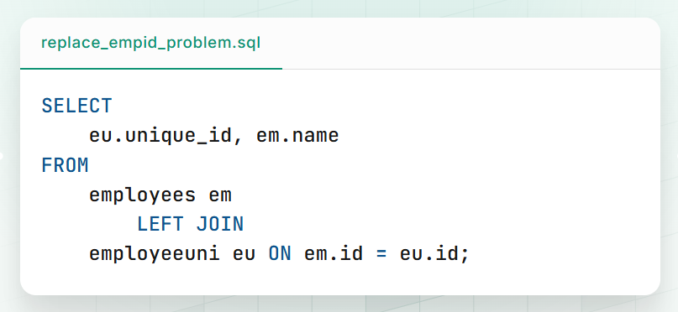

**Query Breakdown:**

* The query selects two columns:
  + **eu.unique_id** from the employeeuni table.
  + **em.name** from the employees table.
* The query uses a **LEFT JOIN**, which means:
  + All rows from the **employees** table will be included.
  + If a matching id is found in the **employeeuni** table, it will pull the corresponding unique_id.
  + If no match is found in employeeuni, the unique_id will be **NULL**.

**Purpose of the Query:**

The query retrieves a list of employees along with their **unique identifiers**, if available. It ensures that **all employees are included**, even if they don't have a unique ID in the employeeuni table.

1. [Product Sales Analysis I](https://leetcode.com/problems/product-sales-analysis-i)
2. [Invalid Tweets](https://leetcode.com/problems/invalid-tweets)
3. [Customer Who Visited but Did Not Make Any Transactions](https://leetcode.com/problems/customer-who-visited-but-did-not-make-any-transactions/description/)
4. [Rising Temperature](https://leetcode.com/problems/rising-temperature)
5. [Not Boring Movies](https://leetcode.com/problems/not-boring-movies)
6. [Average Selling Price](https://leetcode.com/problems/average-selling-price)
7. [Number of unique subjects taught by each teacher](https://leetcode.com/problems/number-of-unique-subjects-taught-by-each-teacher)
8. [Project Employees 1](https://leetcode.com/problems/project-employees-i)
9. [Employees Whose Manager Left the Company](https://leetcode.com/problems/employees-whose-manager-left-the-company)
10. [Students and Examinations](https://leetcode.com/problems/students-and-examinations)
11. [Employee Bonus](https://leetcode.com/problems/employee-bonus)
12. [Percentage of Users attended a contest](https://leetcode.com/problems/percentage-of-users-attended-a-contest)
13. [Monthly Transactions 1](https://leetcode.com/problems/monthly-transactions-i)
14. [Queries Quality and Percentage](https://leetcode.com/problems/queries-quality-and-percentage)pp
15. [Recyclable and Low Fat Product](https://leetcode.com/problems/recyclable-and-low-fat-products)
16. [Find Customer Referee](https://leetcode.com/problems/find-customer-referee)
17. [Big Countries](https://leetcode.com/problems/big-countries)
18. [Article Views 1](https://leetcode.com/problems/article-views-i)
19. [User activity for the past 30 days 1](https://leetcode.com/problems/user-activity-for-the-past-30-days-i)
20. [Average Time Processed Per Machine](https://leetcode.com/problems/average-time-of-process-per-machine)
21. [Game Play Analysis 1](https://leetcode.com/problems/game-play-analysis-i)
22. [Biggest Single Number](https://leetcode.com/problems/biggest-single-number)
23. [Classes More Than 5 Students](https://leetcode.com/problems/classes-more-than-5-students)
24. [Find Followers Count](https://leetcode.com/problems/find-followers-count)
25. [Product Sales Analysis 3](https://leetcode.com/problems/product-sales-analysis-iii)
26. [Customers who bought all products](https://leetcode.com/problems/customers-who-bought-all-products)
27. [Managers with at Least 5 Direct Reports](https://leetcode.com/problems/managers-with-at-least-5-direct-reports)
28. [The Number of Employees Which Report to Each Employee](https://leetcode.com/problems/the-number-of-employees-which-report-to-each-employee)
29. [Primary Department for Each Employee](https://leetcode.com/problems/primary-department-for-each-employee)
30. [Triangle Judgement](https://leetcode.com/problems/triangle-judgement)
31. [Consecutive Numbers](https://leetcode.com/problems/consecutive-numbers)
32. [Confirmation Rate](https://leetcode.com/problems/confirmation-rate/)
33. [Immediate Food Delivery](https://leetcode.com/problems/immediate-food-delivery-ii/description/)
34. [Exchange Seats](https://leetcode.com/problems/exchange-seats/description)
35. [**Nth Highest Salary**](https://leetcode.com/problems/nth-highest-salary/description/)