**Task 1**

Create a visualization that provides a breakdown between the male and female employees working in the company each year, starting from 1990.

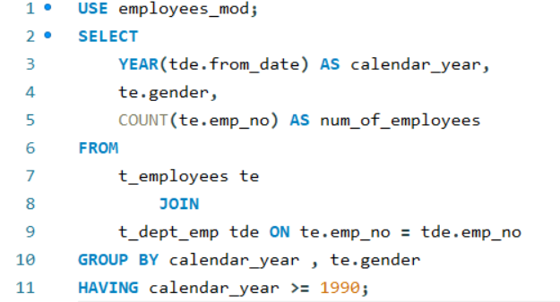

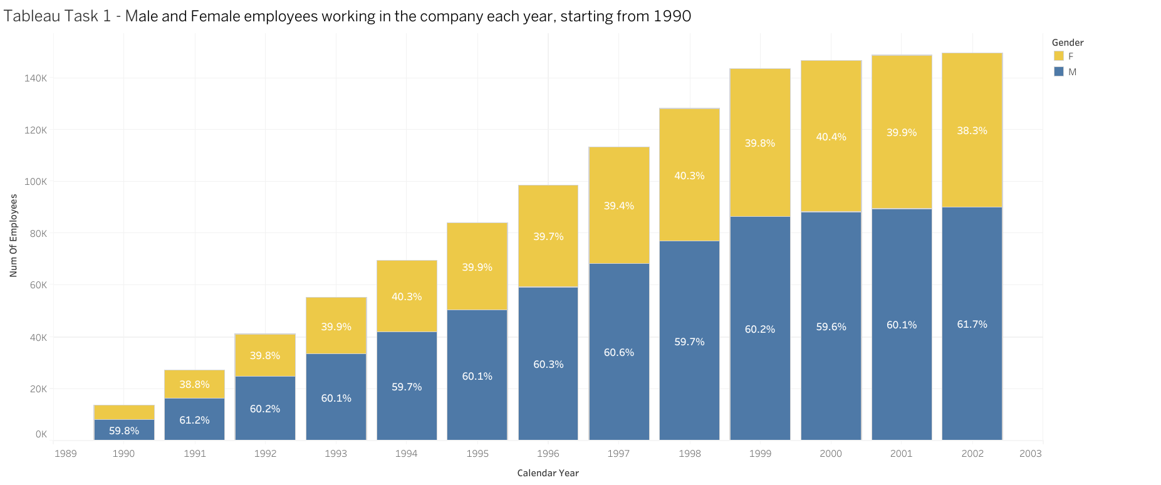

Link : <https://public.tableau.com/views/Book2_17358257931730/Chart1?:language=en-US&publish=yes&:sid=&:redirect=auth&:display_count=n&:origin=viz_share_link>

**Task 1 – Exercise 1**

How many female employees have signed their contracts before January 1, 1998

according to the data in the dept_emp table? Also, determine the relevant number for male employees.

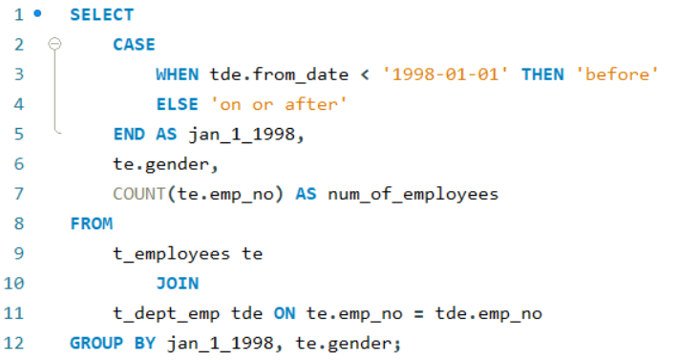

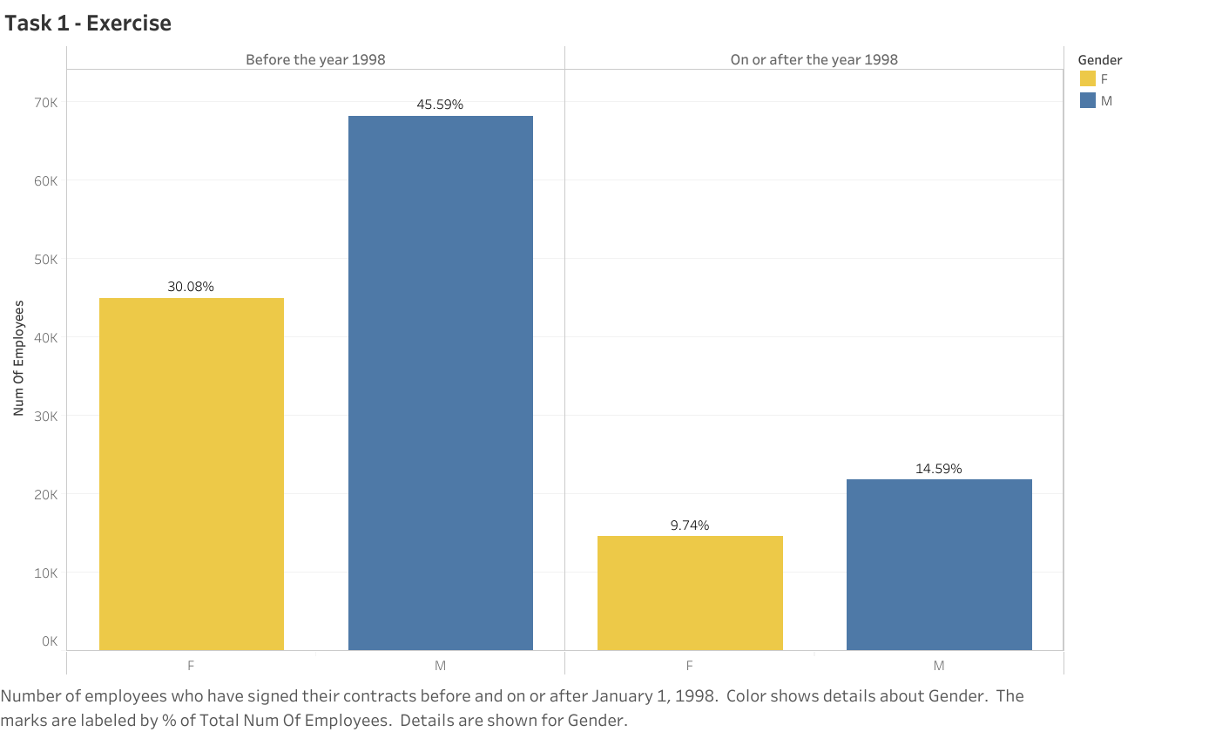

Link : <https://public.tableau.com/views/Task1_exercise/Sheet1?:language=en-US&publish=yes&:sid=&:redirect=auth&:display_count=n&:origin=viz_share_link>