# **Task 1**

Create a visualization that provides a breakdown between the male and female employees working in the company each year, starting from 1990.

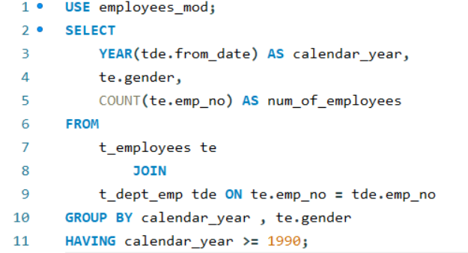

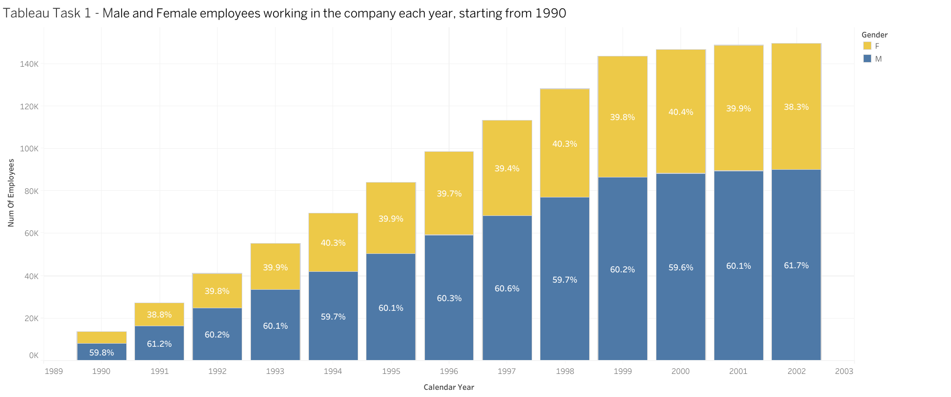

Link : <https://public.tableau.com/views/Book2_17358257931730/Chart1?:language=en-US&publish=yes&:sid=&:redirect=auth&:display_count=n&:origin=viz_share_link>

# **Task 1 – Exercise**

How many female employees have signed their contracts before January 1, 1998

according to the data in the dept_emp table? Also, determine the relevant number for male employees.

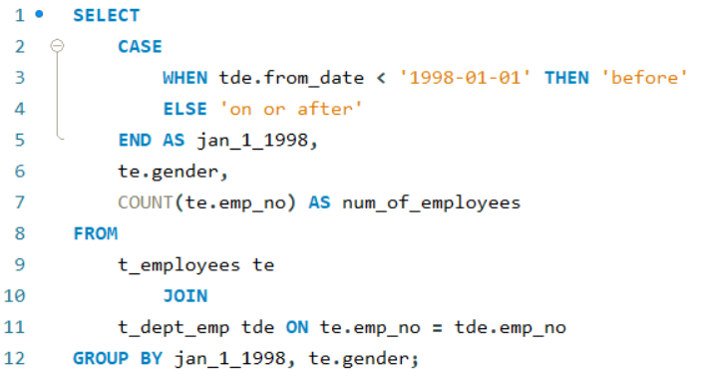

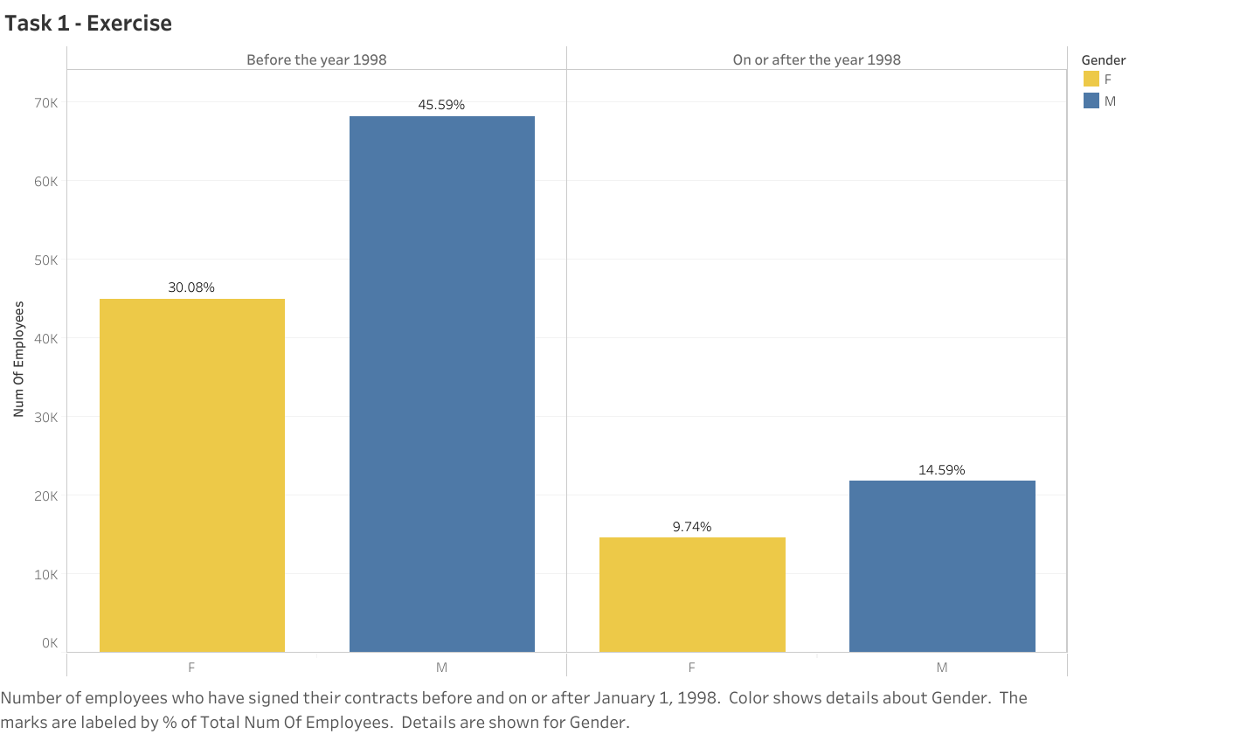

Link : <https://public.tableau.com/views/Task1_exercise/Sheet1?:language=en-US&publish=yes&:sid=&:redirect=auth&:display_count=n&:origin=viz_share_link>

# **Task 2**

Compare the number of male managers to the number of female managers from different departments for each year, starting from 1990.

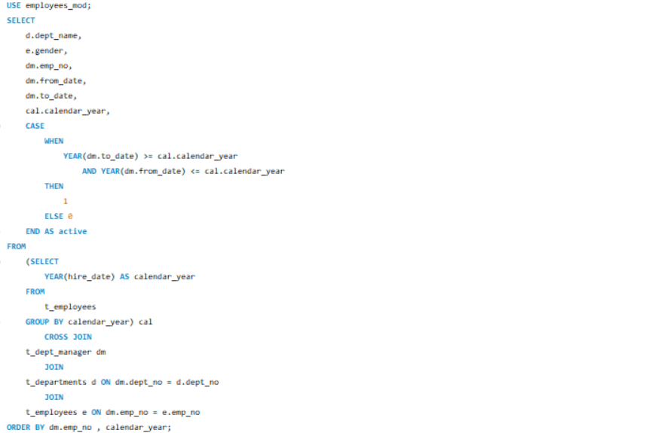

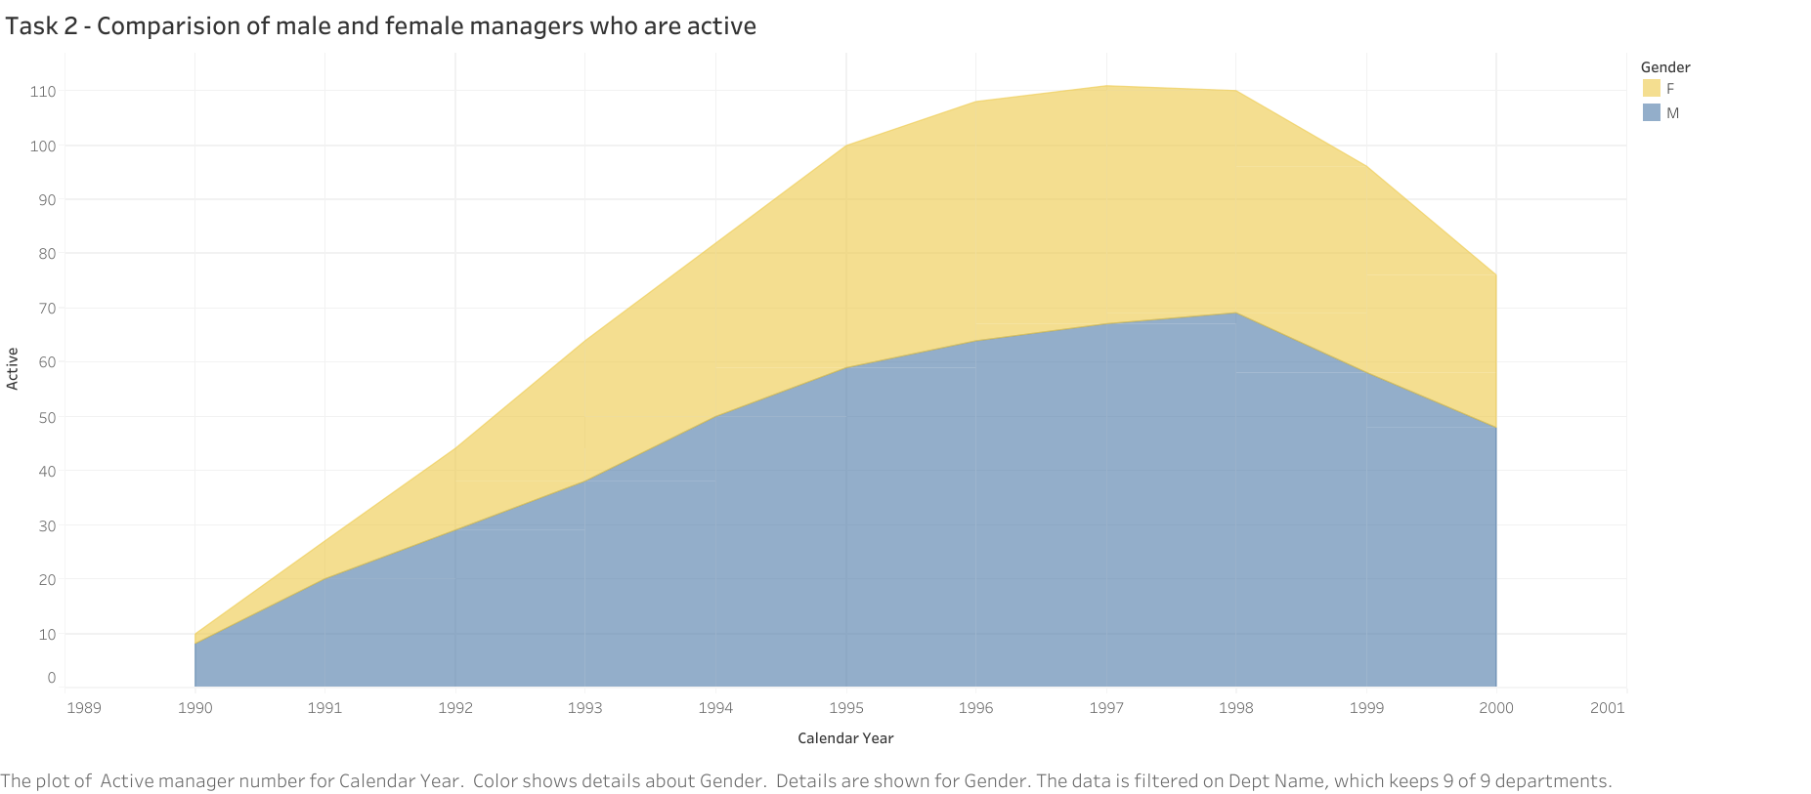

Link: <https://public.tableau.com/views/task2_17359290579960/Sheet1?:language=en-US&publish=yes&:sid=&:redirect=auth&:display_count=n&:origin=viz_share_link>

# **Task 2 – Exercise**

Use a subquery that cross-joins the employees table (with an alias e) with the dept_manager, departments, and employees tables (with aliases dm, d, and ee, respectively).

This subquery should be part of an outer query that retrieves data from the following five subquery columns:

department name (dept_name)

gender (gender)

employee number (emp_no)

start date (from_date)

and end date (to_date).

Additionally, the outer query should include a sixth column named currently_active which displays the value of 1 if the employee is currently working in the company, and 0 if they are not. For this task, assume 'currently active' means an employee whose contract end date is in 2024 or later.

Sort the results by employee number in descending order.

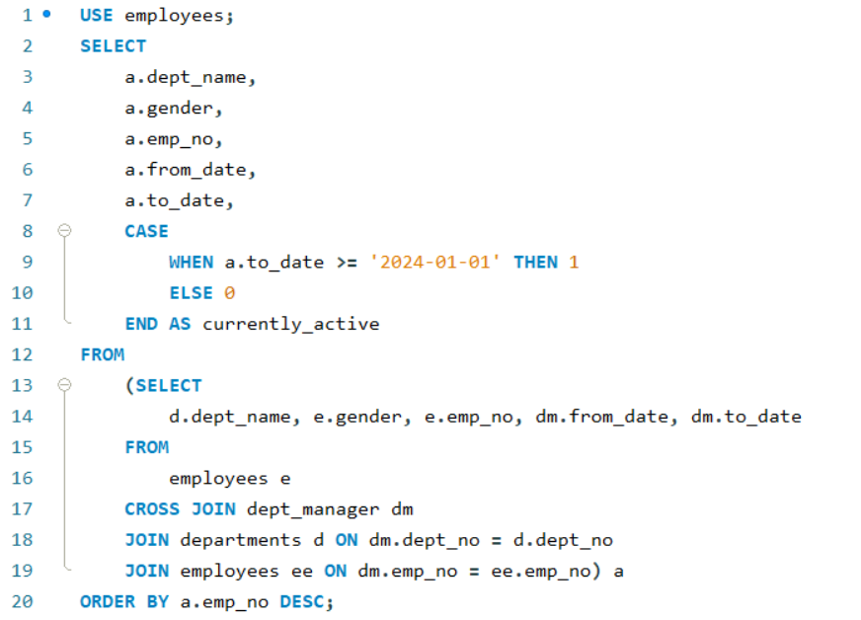

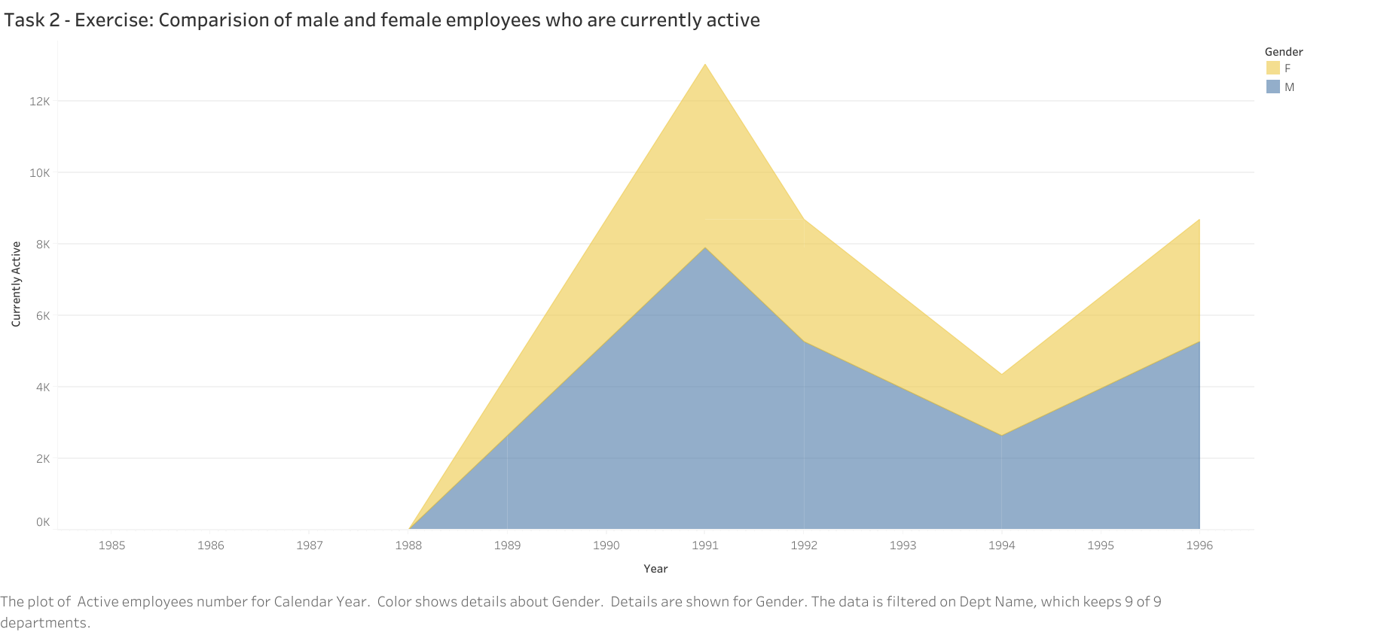

Link:

<https://public.tableau.com/views/task2_17359290579960/Sheet2?:language=en-US&publish=yes&:sid=&:redirect=auth&:display_count=n&:origin=viz_share_link>

# **Task 3**

Compare the average salary of female versus male employees in the entire company until year 2002,

and add a filter allowing you to see that per each department.

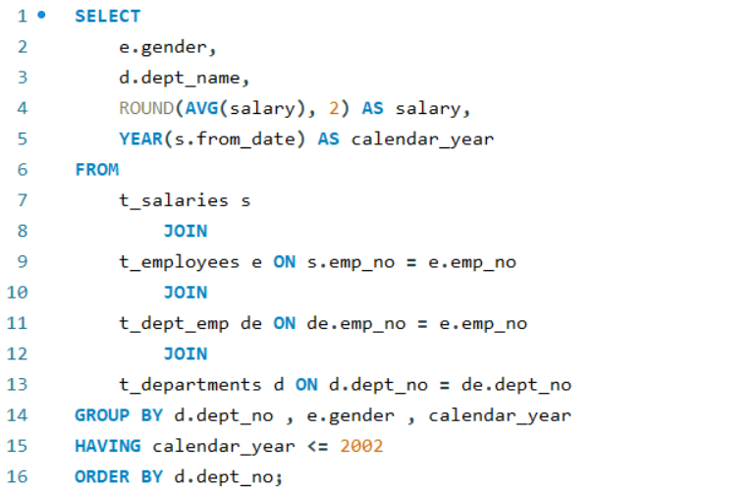

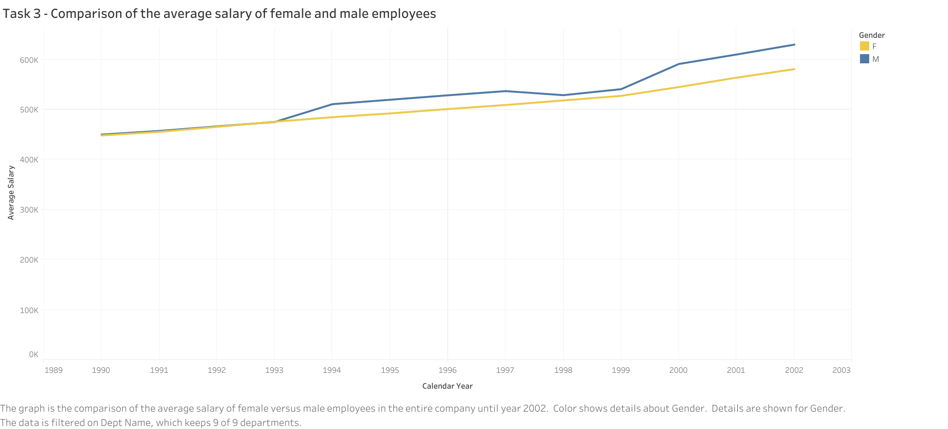

Link: <https://public.tableau.com/views/Task3_17360134926880/Task3?:language=en-US&publish=yes&:sid=&:redirect=auth&:display_count=n&:origin=viz_share_link>

# **Task 3 – Exercise**

Apply the column names suggested. In order from left to right, they refer to the employees, departments, salaries, and dept_emp tables, respectively.

Please note that the third column contains only average salary values rounded to the nearest cent.

The last column should contain 'before' or 'on or after' depending on whether the employee's start date (stored in the dept_emp's from_date column) is before or on or after January 1, 1998.

Group by the department number dept_no, employee's gender, and jan_1_1998 columns.

Retrieve only data about contracts signed in 1990 or later. Sort the obtained results by department number in ascending order.

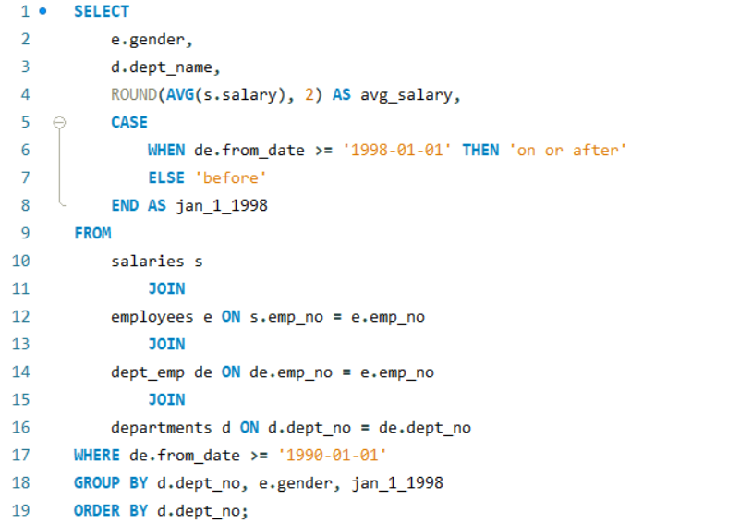

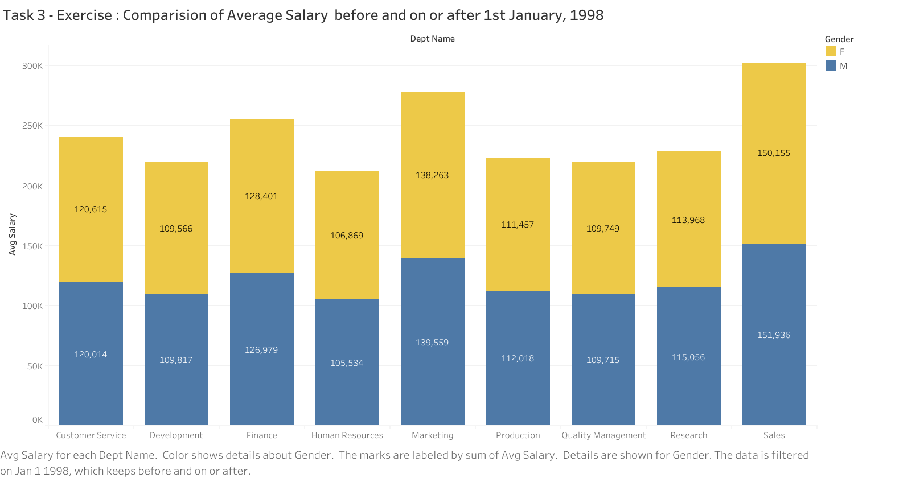

Link : <https://public.tableau.com/views/Task3-Exercise/Task3-Exercise?:language=en-US&publish=yes&:sid=&:redirect=auth&:display_count=n&:origin=viz_share_link>

# **Task 4**

Create an SQL stored procedure that will allow you to obtain the average male and female salary per department within a certain salary range. Let this range be defined by two values the user can insert when calling the procedure.

Finally, visualize the obtained result-set in Tableau as a double bar chart.

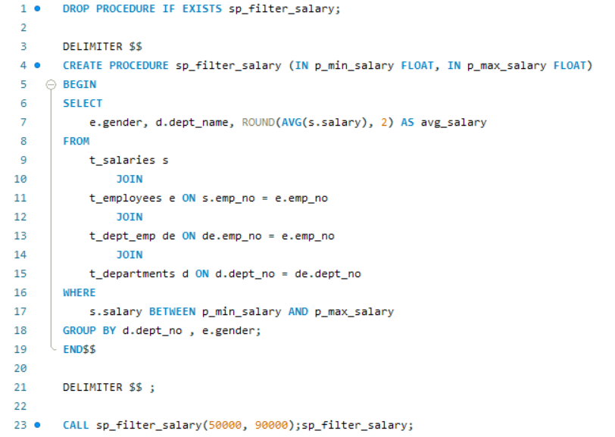

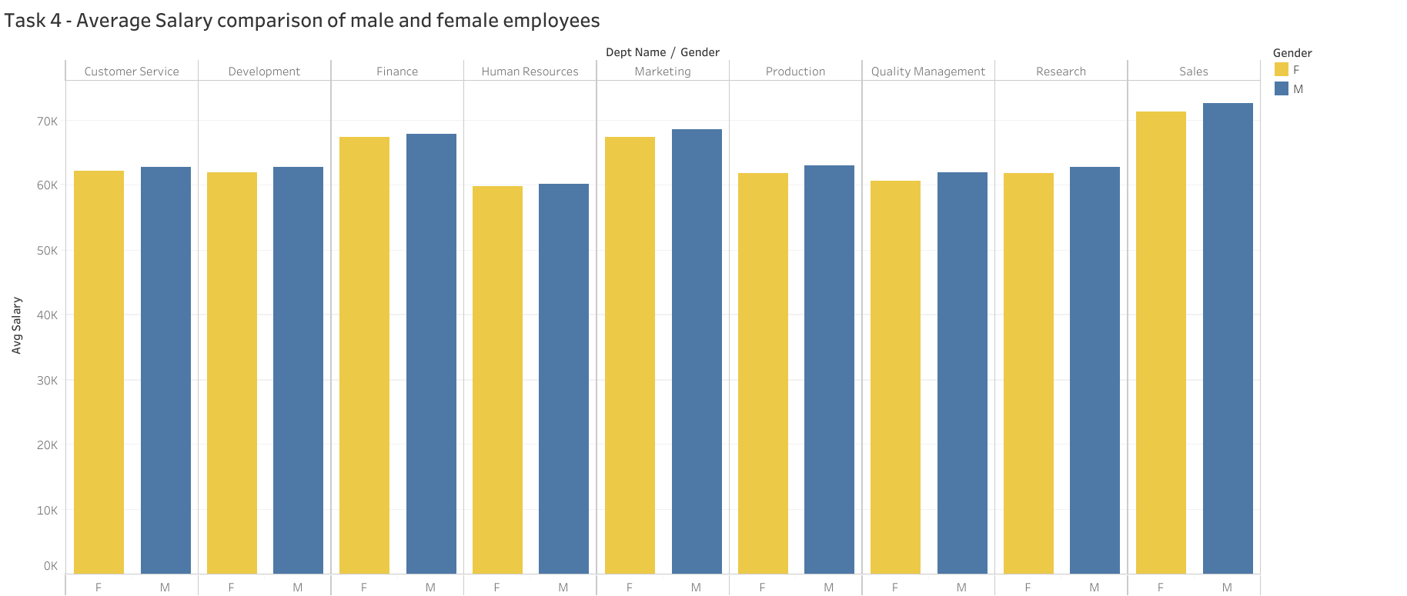

Link : <https://public.tableau.com/views/Task4_17360826774850/Task4?:language=en-US&publish=yes&:sid=&:redirect=auth&:display_count=n&:origin=viz_share_link>