1.Logout option by clicking on the name or profile

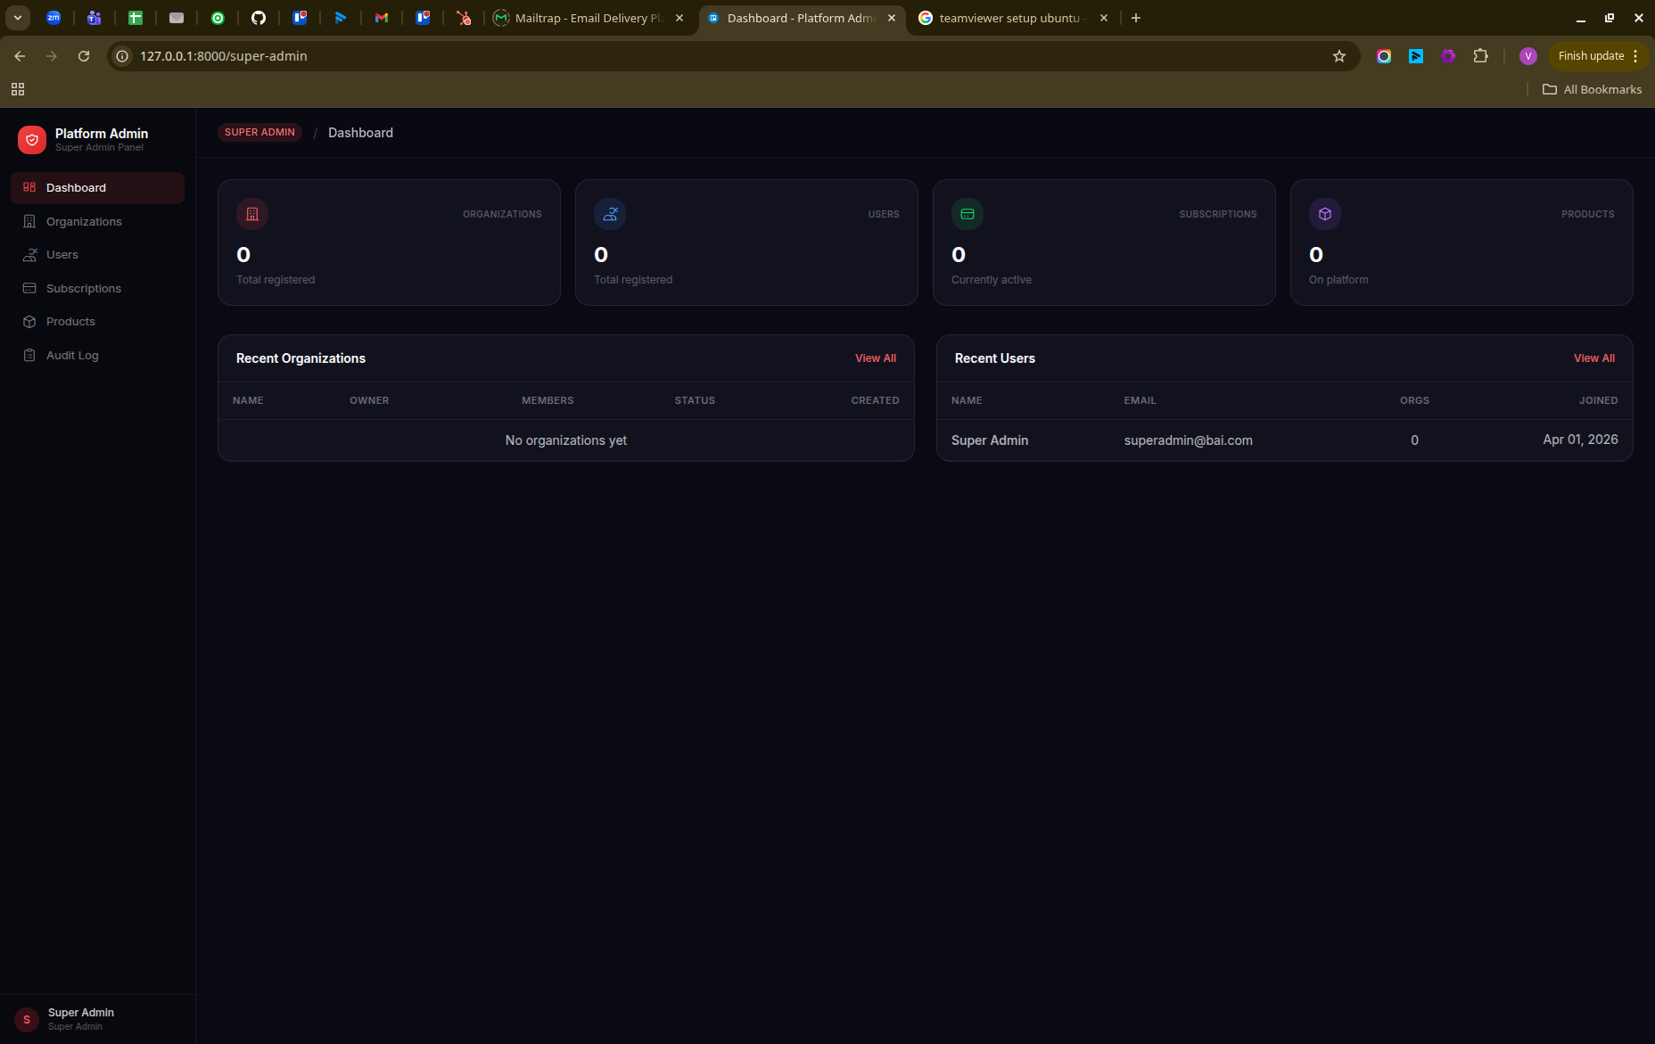
2. Need invite user functionality- in which when super admin sends invite ( admin can add promo code also )user gets mail and then he goes to regsitration with pre-filler email id then see subscription plan buy screen selects the plan enter promo code if have any then got success message and redirects to the dashboard. No need for stripe yet.
3. Got this error when enable or disble the product:
Symfony\Component\HttpKernel\Exception\MethodNotAllowedHttpException
vendor/laravel/framework/src/Illuminate/Routing/AbstractRouteCollection.php:130
The POST method is not supported for route super-admin/products/2. Supported methods: PUT.
http://127.0.0.1:8000/super-admin/products/2
4.

