Are you ready to unleash your luck and explore the exciting new games at Casino Games Online? With a growing collection of 25 games and two more on the way, including classic table games like Blackjack, Craps, and Roulette, as well as immersive 3D slot machines and Video Poker, the thrill of winning awaits. By September, the platform aims to offer over 50 games, all with transparent probabilities for fair play. Plus, the cashier accepts a variety of payment methods, from crypto to PayPal, making it convenient for you to dive into the action and start winning big. Join now and elevate your gaming experience to new heights!


Discover the Thrill of New Games at Casino Games Online

Get to Know the Exciting New Releases
This week marks the arrival of two dynamic new additions to our collection at Casino Games Online. First, we're rolling out an adventurous new 3D slot machine that will take you on a journey through ancient ruins, where each spin brings you closer to uncovering hidden treasures. The graphics are vibrant and engaging, promising a visually stunning gaming experience.
Next, video poker enthusiasts can look forward to a fresh variant that blends strategy with luck, offering an innovative twist on the classic game. This new release will challenge both seasoned players and newcomers alike, providing an opportunity to sharpen skills while aiming for the jackpot.
Each game comes with a detailed guide, helping you understand the gameplay quickly so you can focus on maximizing your winning potential. With transparent odds and a smooth interface, these games are not just fun to play, but fair and user-friendly too.
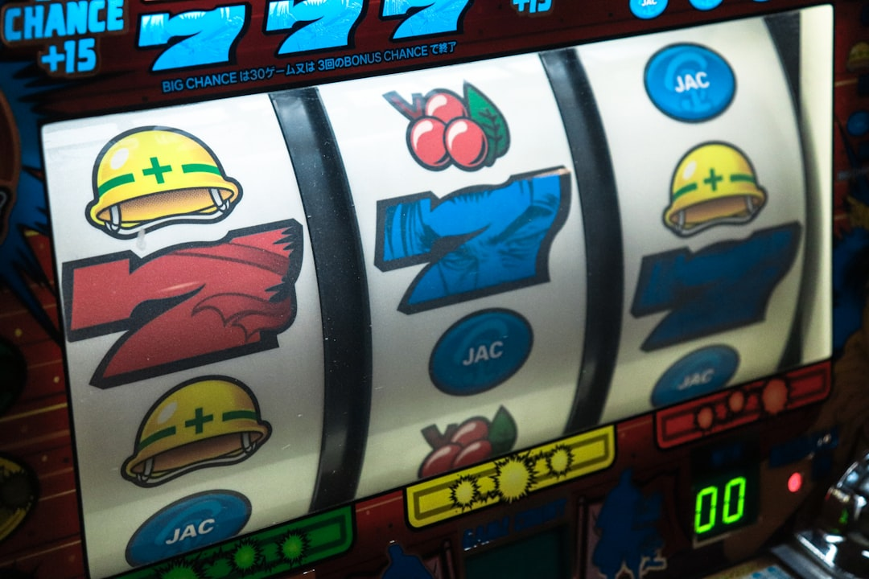

Uncover the Classics: Black Jack, Craps, and Roulette
While we're excited about the new releases, we can't overlook the timeless allure of classic casino games. Blackjack, craps, and roulette remain staples at Casino Games Online for good reason. Our Blackjack tables offer a seamless experience with intuitive controls and a design that feels like the real deal. Whether you're hitting or standing, the excitement of aiming for 21 is just a click away.
Craps enthusiasts will appreciate our authentic layout and easy-to-use interface that brings the thrill of the dice to your screen. Place your bets and roll your way to winnings with our immersive craps game.
Roulette players can enjoy the spin of the wheel with our European and American roulette options. The realistic wheel animations and diverse betting options provide a comprehensive roulette experience that's both engaging and fair.
Dive into these classics and enjoy a casino experience that combines the best of tradition and modern online convenience.


Elevate Your Gaming with Advanced Slot Machines

Experience the Realism of 3D Slot Machines
Step into the future of online gaming with our 3D slot machines at Casino Games Online. These slots offer a level of realism and immersion that's unparalleled in the online casino world. The rich visuals and animations breathe life into every spin, making each game a unique adventure.
Our 3D slots are not just about the aesthetics; they also feature compelling storylines and themes that pull you into the action. From exploring ancient civilizations to embarking on space missions, each slot machine offers a distinct narrative that enhances your gaming experience.
With bonus rounds and special in-game features, these 3D slots provide more than just the chance to win big—they offer a captivating gaming experience that keeps you entertained. Get ready to be whisked away to new worlds with every play on our state-of-the-art 3D slot machines.


Win Big with Video Poker
At Casino Games Online, video poker stands out as a player favorite, blending the excitement of slots with the strategy of poker. Our video poker games are designed for both beginners and experienced players, with clear, easy-to-understand interfaces and smooth gameplay.
Winning big in video poker requires a mix of luck and skill. Our games offer generous pay tables and a variety of betting options to suit every type of player. Whether you're aiming for a full house or a royal flush, the thrill of chasing that top payout adds to the game's appeal.
Moreover, our video poker games provide helpful hints and strategies, giving you insights on the best moves to make according to your hand. This feature not only enhances your chances of winning but also helps you become a better poker player. Try your hand at video poker today and experience the perfect combination of challenge and excitement.


Embrace Transparency and Convenience with Casino Games Online

Understanding the Odds: Full Transparency on Every Game
Transparency is key to a trustworthy online gaming experience, and at Casino Games Online, we take this seriously. We provide full disclosure on the odds of every game, ensuring that you have all the information you need to make informed decisions.
This transparency extends across our entire gaming platform, from slots to table games. Knowing the probability of winning helps you strategize and play more confidently. We believe in fair play, and by being upfront about the odds, we empower you to enjoy gaming with peace of mind.
In addition to transparent odds, we also offer clear and detailed instructions for each game. This means whether you're trying out a new game for the first time or returning to a favorite, you'll always know exactly how to play and what to expect regarding potential payouts.


Payment Made Easy: Cryptos, Paypal, and More
Casino Games Online has streamlined the payment process to make it as hassle-free as possible for our players. We accept a wide range of payment methods, from traditional options like Visa and MasterCard to a variety of cryptocurrencies including Bitcoin, ensuring that you can fund your account and cash out your winnings with ease.
Our platform supports digital wallets such as PayPal, Venmo, and CashApp, providing you with quick and secure transactions. This flexibility means that you can choose the payment method that best suits your preferences and needs.
We also prioritize security with all transactions, using advanced encryption and security protocols to protect your financial information. Deposits are swift, and we strive to process withdrawals just as quickly, so you can access your winnings without unnecessary delays. At Casino Games Online, we make sure that managing your funds is simple, secure, and convenient.


