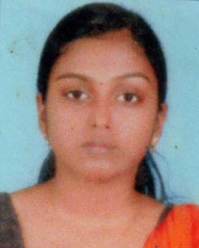**RESUME**

### PRIYAMVADA.S.S.

**Mobile No: +91 8281243718**

**+91 9961633347**

E-Mail : priyam.44794@gmail.com

**OBJECTIVE**

**T**o pursue a career in professional organization where I can utilize my skill and

abilities effectively as an active member and to contribute to the success and growth

of the organization.

**EDUCATIONAL QUALIFICATION**

* S.S.L.C
* PLUS TWO
* BCOM (Distant Doing)
* HOSPITAL ADMINISTRATION

**EXPERINECE**

* Worked as Telecaller and Office Staff in Educational Consultancy Eranakulam
* Worked as an Office Staff in Shipyard Island , Kochi

**PERSONAL STRENGTH**

* Ability to observe and analyze problems
* Fast Learner, willing to shoulder challenges and responsibilities
* Self motivated to learn new technologies
* Motivating team player
* Adaptable to any situation

**PERSONAL DETAILS**

Name : **Priyamvada .S.S**

Date of Birth : 16/11/1998

Gender : Female

Nationality : Indian

Marital status : Married

Religion : Hindu

Father’s Name : Suresh .S

Languages known : Malayalam, English

Permanent Address : Sameer Vilas

Nedumgolam P.O , Paravoor

Kollam (Dist)-691334

Communication Address : Maneesh Bhavan

Pallickal , Adoor

Pathanamthitta

**DECLARATION**

I hereby declare that the information above stated is true and correct to the best of

my knowledge and belief.

**PLACE :** Pallickal

**DATE**    :        **PRIYAMVADA .S.S**