**APPLICATION FOR EMPLOYMENT AS LABORATORY TECHNOLOGIST / BLOOD BANK**

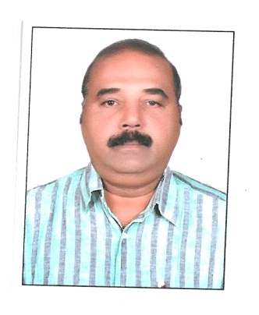**SANTHOSH KUMAR**

**ASWATHY,**

**THAMARAKKUDY P.O**

**KALAYAPURAM Via**

**KOTTARAKKARA , KOLLAM**

**PH : 6282913336 .**

**msk.aswathy@gmail.com**

**OBJECTIVE**

I am Graduate in Medical Laboratory Technology B.Sc. M.L.T from Medical College, Kerala, and also Degree holder in Chemistry B.Sc chemistry , I have more than 7 years working experience in India, 2 years in Kingdom of Saudi Arabia, 6 years in Sultanate of Oman and 18 yrs in Ministry of Health of U.A.E as Qualified Technologist since 02/07/2002 .

**professional qualification**

**B.Sc. Medical Laboratory Technology (three and a half year from Govt. Medical College, Kerala, India . Registered as medical lab technologist under DME , Kerala.**

**EDUCATIONAL BACKGROUND :**

* **S.S.L.C First Class**
* **Pre-Degree (Biology Group) First Class**
* **B.Sc. Chemistry Second Class**

**SEMINAR**

* Evaluation Certificate holder as “Charge Technician” from M.O.H of U.A.E (No.6/2000 dated 26.4.2000). Re Evaluated as Technologist (Blood Bank)
* Attended workshop on “Laboratory Diagnosis of Meningitis” conducted by Ministry of Health of Sultanate of Oman held on 1997 in Muscat.
* Attended “Introduction to Research ” workshops organized by M.O.H of Sultanate of Oman held in Muscat on 1998 and 2000.
* Published an article “Goals of Clot Culture over Blood Culture” in “LENS” Journal of M.O.H of Oman.

**DUTIES & RESPONSIBILITIES**

* As a Laboratory In charge, regulating the functions of laboratory, including supervision and giving orientation to new junior staff regarding their duties and policies.
* Maintain the highest possible standards for laboratory investigations.
* Performing Bacteriological culture and sensitivity of Biological specimens up-to the final reporting with full responsibility.
* Performing different sterile culture media for bacteriological culture.
* Screening for blood donors and collecting blood for transfusion.
* Maintain a voluntary donor register ideally so as to get any blood during emergency including fractional separations.
* Maintain the Lab records and respect the patient’s privacy and confidentiality.
* Performing and final reporting of lab tests for labour cards, Bacteriological analysis of water in public health.
* Responsible for maintaining lab inventories and stocks as per hospital policy.

.

**PERSONEL DETAILS**

* DATE OF BIRTH : 26-01-1964
* GENDER : Male
* MARITAL STATUS : Married (wife is Staff- Nurse, 2 children)
* NATIONALITY : Indian
* CONTACT : **6282913336 /7558845653**

**WORK EXPERIENCE**

* As laboratory Technician in Ministry of Health hospital at Sultanate of Oman for 6 years (06.01.1996 to 27.06.2002).
* As In-charge of Senior Laboratory Technician of a 200 bedded multi-speciality hospital in Kerala, India (25.04.1995 to 27.12.1995)
* As a Lecturer in Medical Laboratory Technology in Govt. Vocational Higher Secondary School in Kerala, India (25.07.1994 to 20.04.1995)
* As Senior Lab Technician in a polyclinic at Kingdom of Saudi Arabia (30.07.1992 to 05.04.1994).
* As Microbiologist Cum-In charge of Blood Bank and Haematology of a 200 bedded Multi- Speciality Co-Op Hospital in Kerala, India (03.03.1988 to 02.05.1992).
* Working as Qualified Medical Laboratory Technician under Ministry of Health of UAE since 02.07.2002 onwards in Blood Bank and various Departments.
* Working as Scientific Assistant of Blood Bank of SUT Royal Hospital , Trivandrum since 10/12/2019.

.

**DECLARATION**

I hereby declare that the information given is true to the best of my knowledge and belief

SANTHOSH KUMAR